Quick-reference food safety rules for sandwich-making events.
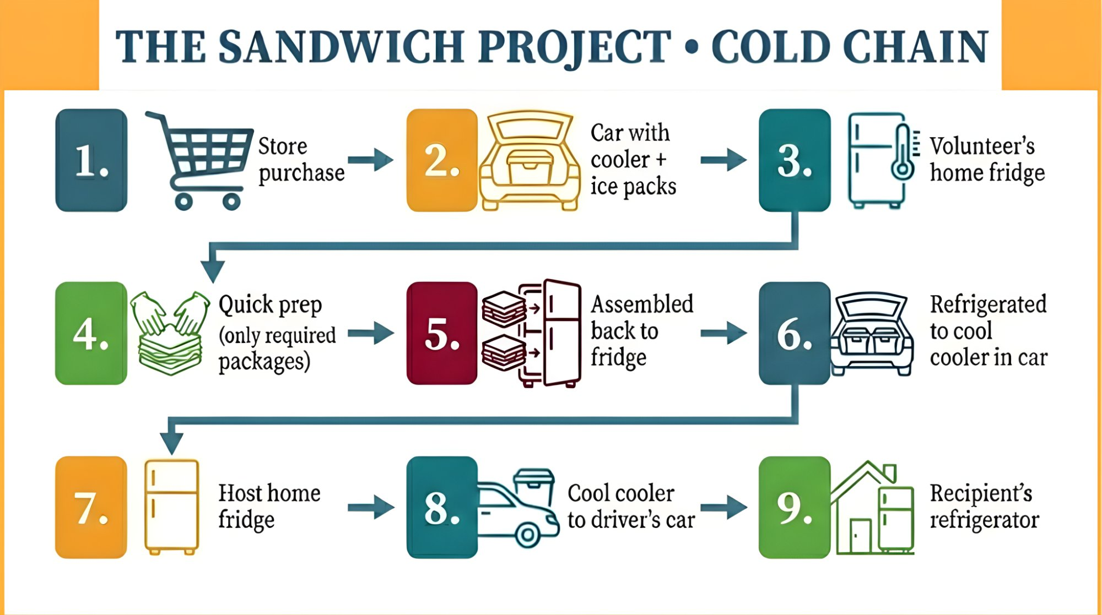
WHY IT MATTERS  Our sandwiches go to children, elderly, and immunocompromised people. Deli meat is high-risk — these rules keep recipients safe.  TWO PRINCIPLES  • Cold Chain — Meat stays ≤40°F from store to recipient. Every transfer is a risk.  • Danger Zone — 40–140°F = bacteria double every 20 min. Max 2 hours total in this range.  ⚠ 2-HOUR RULE: Deli meat above 40°F for more than 2 hours total = discard. No exceptions.  PURCHASING & STORAGE  • One person buys all the meat for the group.  • Pool funds via Venmo, cash, etc.  • Pre-packaged only — no deli counter.  • Check expiration: at least 7 days out.  • Transport in a cooler with ice packs.  • Store → cooler → fridge. No gaps, no detours.  • No fridge at your location? PB&J only. | ASSEMBLY  • Hair tied back or covered— hair and beard nets are best.  • Wash hands with soap and water— hand sanitizer doesn’t kill some food-borne illness-causing organisms.  • Gloves required — change them after touching phone, face, other surfaces.  • One package each of meat and cheese out at a time per table.  • When it’s empty, return to fridge for the next one. This is where runners come in handy.  MAKING THE SANDWICHES  • ~3 oz meat (about 3 slices) per sandwich.  • 2 slices cheese — one on each side of meat (moisture barrier).  • No condiments. No mayo, mustard, or extras.  • Bag individually. Press out air. Return bagged sandwiches to the bag your loaf of bread came out of.  • Label loaf bag using TSP-provided labels.  AFTER ASSEMBLY  • Refrigerate immediately.  • Coolers keep cold — they don’t make cold. No warm sandwiches in coolers.  ⚠ WHEN IN DOUBT, THROW IT OUT.

