RoboCupJunior Rescue Line 2023

Team Description Paper

HACKATRONICI

**Abstract**

Our robot is a Lego Mindstorm EV3 31313 with Education expansion kit. Its main capabilities are the extremely precise line-follower (segui-linea) with color sensors, with a third sensor in reflected light mode for crossovers (incroci) control and evacuation zone entry. The robot is equipped with an ultrasonic sensor for the recognition of the obstacle and walls of the evacuation zone.

In sensors, once the evacuation zone is identified, they will change order to detect the green or red triangle.

Our robot is very efficient in the line-follower, to have more time in the evacuation zone and have the chance to collect as many victims as possible.

1. **Introduction**
   1. **Team**

Our Group consists of four participants: Alessandro Chiarulli, 4th year, Gabriele Montrone, Giuseppe Clemente, Mario Recchia, all three of 3rd year, of the IISS Marconi Hack of Bari, in the Liceo Scientifico opzione Scienze Applicate.

1. **Project Planning**
   1. **Overall Project Plan**

Our main goal is to make as many points as possible with the line-follower, covering all possible exceptions, obstacles and crossovers. For the evacuation zone we used a simpler algorithm, also given the simplicity of the robot and the impossibility of adding more sensors.

We split into two groups, one took care of the structural part of the robot and, once finished, took care of the software part together with the other group.

The first step was to complete the line-follower. We’ve introduced all possible cases, so crossings, green crossings, line breaks, obstacles and speed bumps. Finally, we inserted the evacuation zone, with the control of the reflective sheet at the entrance, the recognition of the entrance to the left, right or center, the recognition of safe areas and the release of the rescue kit.

* 1. **Integration Plan**

For the line-follower we used a system with three sensors, two at the level of the engines and one forward. The two sensors behind recognize the line in the center and any green, while the sensor in front is in reflected light mode to recognize the reflective sheet at the entrance of the evacuation zone but is also used in the line-follower to recognize intersections.

For the obstacle and walls of the evacuation zone we used an ultrasonic sensor. To release the Rescue Kit, we used a medium engine, powerful enough to support its weight.

1. **Hardware**

Color sensors can recognize seven colors: black, blue, green, yellow, red, white, brown and no color. We also had to add the case in which it controls the blue for the line, since when it is straddling between white and black it could be confused and see blue, resulting less accurate.

The reflected light sensor, on the other hand, works by emitting a red light and measuring the intensity with which it is reflected. It works on a scale from 0 to 100, where 0 is very dark and 100 is very bright. In our case, if the reflected light is greater than 95 it means that it has found the evacuation zone, while if it is less than 10 it has found the black line.

Once it enters the evacuation zone, the robot changes the order of the sensors, making the one in front of color and those behind of reflected light. This way, we can identify the safe zones to store the victims sooner.

The ultrasonic sensor works by emitting sound waves and measuring the return echo. Depending on the time the sound takes to return to the sensor it’s able to measure the distance with a fairly high level of accuracy.

* 1. **Mechanical Design and Manufacturing**

The robot structure is made with the pieces of the EV3 kit. We tried to create a structure as efficient as possible in terms of weight, considering the ramps and the additional weight of the rescue kit. This is why most of the robot is empty, or in any case with only pieces of external structure.

The large motors used for movement are the most powerful of the EV3 kit, with an integrated rotation sensor that can provide accuracy to the degree. They are powerful enough to support the weight of the robot in the path and on the ramps, considering also the cases when there is a speedbump on the ramp.

For the Rescue Kit we used the medium engine, as less power is required to store it in the safe area. This also has a built-in rotation sensor, so you can make it rotate 135 degrees several times to make sure the rescue kit is no longer in the basket.

For the rescue we used an extremely simple mechanism. They are two arms on the sides of the ultrasonic sensor, with a space from the sensors of just over 5cm, to accommodate the balls and not let them escape.

Once the green or red triangle has been found in the Evacuation Zone, the robot moves away quickly, to release the balls, makes a 180-degrees turn and goes back to lay the Rescue Kit.

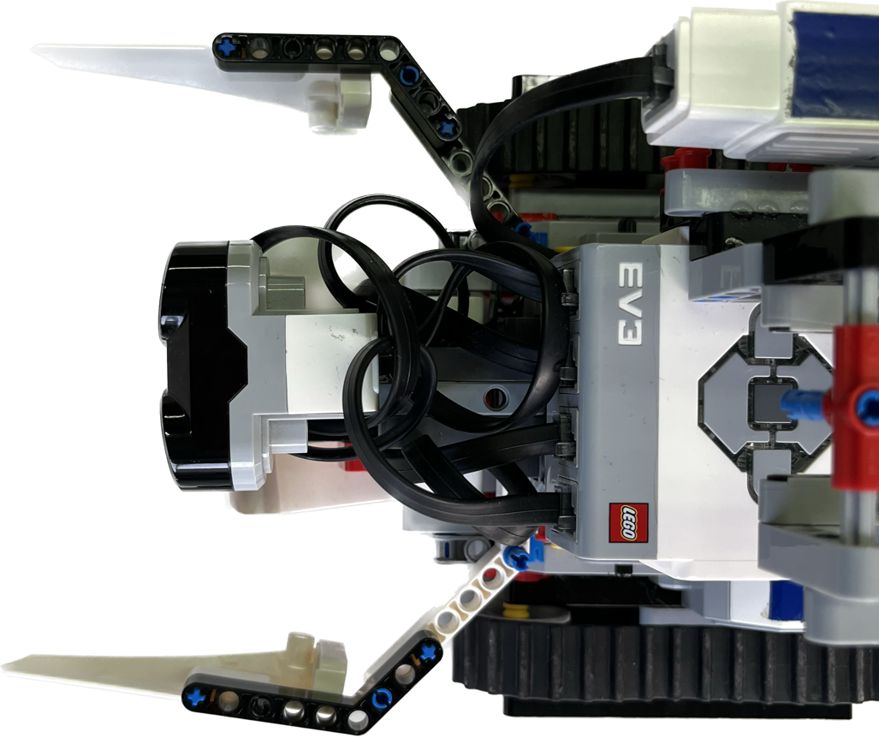

5.5cm

5.5cm

To test the follower-line we used the white tables in our laboratory with very complex paths, to be sure to cover all possible cases without making mistakes. We built the evacuation zone with recycled pieces of cardboard from the lab and for the line we used black insulation tape.

* 1. **Electronic Design and Manufacturing**

Control of the onboard electronics is handled by the main brick of the EV3 31313. It has 8 ports available, of which 4 input for sensor control and 4 output for motors. If the robot is connected to the computer, we can have in real time the values read by the sensors, useful for calibration and color control.

The robot is powered by 6 1.5V AA batteries.

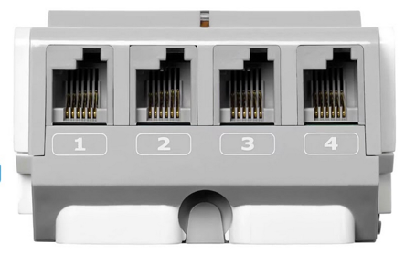

1. **Software**

For the robot code we used the integrated development environment of the EV3, with simple block programming but including all the blocks needed to make a complete path.

* 1. **General software architecture**

The general structure of our code is the following:

If the front sensor detects reflected light greater than 95% enters evacuation zone mode, otherwise the line-follower is performed. If the ultrasonic sensor detects a distance less than 10 cm, it enters the obstacle mode. If the robot has entered room mode first check which side the entrance is on, then start working on "snowplow", covering all the available surface until it finds the green triangle. When he finds it, he leaves the rescue kit.

* 1. **Innovative solutions**

To make the most of the development environment, we developed the code in multiple functions, one main with the line-follower, one for the evacuation zone and one for bypassing the obstacle. We also used the feature to create blocks to make the code cleaner and more understandable.

1. **Performance evaluation**

We found that the robot was very precise in following the line. Almost all cases of crossing are covered and, unless extremely unlucky cases, is always able to follow the line without getting lost. For the evacuation zone the discriminating factor is luck. Not having a precise mechanism to collect the balls, we must be lucky not to have too complex situations, such as balls stuck in the corners. In case the balls are well distributed in the room we found that most of the time it manages to collect them all. The rescue kit will be released a fly that will release the balls in the green triangle.

1. **Conclusion**

To participate in these races, we tried to use 100% of the potential of our robot, using all the features also present by the software. We prepared the robot to deal with all possible cases present in the paths, with particular attention to the line-follower. Despite the limited possibilities from the Lego kit, we tried to create a robot capable of performing the main purpose of the category.

**Appendix**

For more collaboration in the team, we used GitHub and the resources it offers. Being able to share code immediately without using physical media was extremely convenient and efficient for robot development.