Introduction:

The new title Sunchaser will be a science fiction roleplaying game produced by Poor Artist Games, comprised of Seth Rose and Nicholas Wenzel. Production will begin in January of 2020 and will span three months, with an expected launch date in early May 2020. The title will be produced in the GameMaker Studio 2 game engine and will be published on PC platforms. The production company of Poor Artist Games will handle all game design and development, in addition to creating the art assets used in the game. This development will be spread across the two lead designers, each focusing on all aspects of the project.

There will be stages along production with clear deliverable outlines for the publisher that will meet the requirements both the publisher and the team sets in advance. These deliverables will range from art assets to combat instances and will be scheduled across the development period. As with any commercial venture there is risk in the production of Sunchaser, however Poor Artist Games believes these risks are outweighed by the potential capital gains from sales of the product. Testing of the product will be intensive to ensure the highest quality product for the end consumer as well as the publisher. Finally, Poor Artist Games will do their level best to ensure a high quality and financially successful product by maintaining and following this plan through production.

Sequence of Tasks:

* Complete Art Assets
* Complete Story and Plot Definition
* Develop Character Details
* Complete Conversations Module
* Complete Combat Module
* Complete Over World Navigation
* Complete Narrative Choice Tracking System

Deliverables:

* Art Assets
  + One of our first deliverables will be the completion of the art assets used in the game. Since art is the main form of communication for a game the art is a crucial deliverable. These sprites include the sprites used in over world navigation, higher definition conversation and combat sprites, and environment sprites. These sprites will be in the 16 and 32-bit pixel art style with use of bright and high contrast colors reminiscent of the science fiction genre of the 1970s and 1980s. The art assets will be developed in using the built in sprite editor in GameMaker Studio 2 and will be entirely generated by the production team at Poor Artist Games.
* Story and Character Details
  + The narrative and character details is another main deliverable of the project. The personalities and character traits will be developed so that the game world feels real and meaningful. The two companions of the main character will have meaningful backstories and personalities that will make the player emotionally connected with their crew. The plot of the game will start with a simple premise of a broken ship and expand into a planetary conflict. Due to the nature of the game the narrative needs to be branching dependent on the choices the player makes, which makes for a unique experience for the end user. These story details will be developed internally by the lead writers at Poor Artist Games.
* Conversation Module
  + The first main deliverable that will be playable will be the conversation system used in the game. The player will be able to pick dialog options and pick narrative options which will effect both their relationships with other characters and organizations, in addition to effecting the ending of the game.
* Combat Module
  + The other main combat deliverable will be the combat system used in the game. This system will be a turn based system where the order of turns is based on the statistics of the individual entities involved in the combat. The player will be able to choose the actions for their entire party, and each character in the party will have unique actions. The enemies will be built on an AI that will decide which characters to hit based on their strength and their opponent’s weaknesses. There will be a small amount of random chance involved in the combat but success will be mostly based on the statistics of the entities involved.
* Overworld Navigation
  + The final main gameplay deliverable will be module that controls the overworld navigation. The overworld will be the highest level of conception and conversation and combat will be initiated from here. Moving the character and interacting with objects will be the main pillars of this deliverable, as well as the overworld itself.
* Narrative Tracking System
  + A meta deliverable that will be laid on top of the other systems is the narrative tracking system. This tracks the player’s choices and will track the narrative path the players take and the relationship statuses between the characters.
* Alpha Release
  + Combination of the conversations, combat and overworld navigation. No overarching narrative implemented
* Beta Release
  + Polished combination of combat, overworld navigation, conversation, with initial implementation of narrative and narrative tracking
* Final Release
  + Polished release of all modules and systems with full narrative and narrative tracking.

Dependencies:

Several of the deliverables can be developed independently such as the combat, conversation, and overworld navigation. While they all depend on the sprites and the narrative the backbone of the system can be developed without any of the others. The only major dependency is the narrative tracking system and narrative, which both need to exist for the other to work. The alpha release is dependent on the combat module, conversation module, and overworld navigation. The beta release is dependent on the polished combat, conversation, and overworld, in addition to the initial narrative and narrative tracking system. The final release is dependent on polished version of all prior deliverables.

Resource Estimation:

Assets: 4 weeks for complete asset coverage, can be done concurrently with gameplay development

Story and Character Details: 4 – 6 weeks, can be done concurrently with gameplay development

Conversations Module: 2 weeks

Combat Module: 3 weeks concurrent

Overworld Navigation: 2 weeks

Narrative Choice Tracking: 1 week

Alpha Combination: 2 weeks

Beta Combination: 2 weeks

Final Release 3 weeks

Project Risk Assessment:

As with any commercial venture there is inherent risk in the making of Sunchaser. However, we believe that these risks will be worth the monetary gain made by this product. Below can be seen a cost break down analysis that shows a very healthy return on investment over a five-year time period following the release of the product

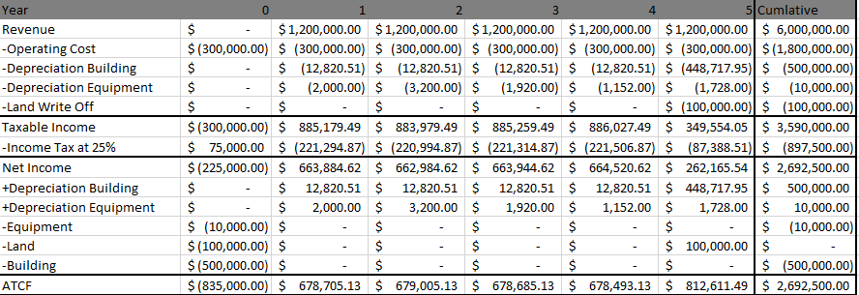



The above charts show the 5 year cost breakdown of the game along with projected sales, provided by the economic advisor at Poor Artist Games. The information above includes all tax information assumed at a 25% income tax rate, as well as the depreciation schedule for the building and equipment costs. Year 0, representative of the next three months of development will the financially riskiest period with a projected cost of $835,000. This initial cost includes the first year of salaries and other general operating costs of $300,000, staying consistent over the next five years. It also includes the cost of initial equipment such as development licenses, computers, office supplies that will only be incurred during Year 0. Year 0 also includes the costs of leasing land and office space for the new company, also only incurred in year one, and will be written off at the end of Year 5 when we plan on expanding the company to a larger location. After the initial costs of Year 0, we project that the product will sell an estimated 20,000 units per year at the standard price point of $60 US dollars per unit totaling to an expected revenue of 1.2 million dollars per year. After costs and tax, it is estimated the product will produce on average $600,000 of after tax cash flows per year, cumulatively earning 2.6 million by the end of Year 5. Below the breakdown shows the net present value of the investment at 1.8 million dollars in positive income, and an expected rate of return at 77% making this a viable economic investment.

Another major risk is the relative inexperience of the development team at Poor Artist Games. This being our first major product in the games industry, it is understandable that an investor or publisher would be warry of the potential risk in new game developers. However, this is mitigated the development team’s commitment to an excellent product and comprehensive education through the Colorado School of Mines.

Another potential risk along these same lines is the ever-present fear of feature creep that can sink even the best game developers into a series of delays or cancelations. This risk is mitigated by our well-developed plan and schedule that clearly defines the aspects that need to be a part of the end product without leaving time for feature creep to set in.