Nida Butt

Git Tutorial

02/22/16

Part 3:

1. What is GitHub? When was it created? Why? By who? What similar platforms exist? Why would you use such a platform? (Answer between 5 and 10 lines)

GitHub is a web-based hosted service for Git repositories. It offers all of the distributed revision control and source code management functionality of Git as well as adding its own features. Unlike Git, which is strictly a command line tool, GitHub provides a Web-based graphical interface and desktop as well as mobile integration. It also provides access control and several collaboration features, such as bug tracking, feature request, task management, and wikis for every project. GitHub was created in 2008 by Tom Preston-Werner, Chris Wanstrath, and PJ Hyett. Similar platforms that exist are BitBucket, Heroku, and GitLab. Developers use these types of platforms to store their projects and network with other programmers. These platforms allow developers to easily document their code and work with other programmers on a single project where they can use push and pull commands to view and update changes to their code.

Part 4a: Complete the Git tutorial: [https://try.github.io](https://try.github.io/). While doing the tutorial, save your work in the same file as earlier: *LastnameFirstnameGitTutorial-mm-dd-yyyy.docx* file.

Part 1.1:

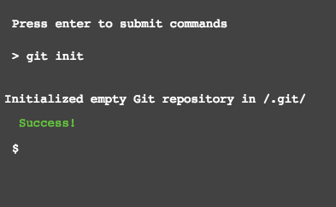

Part 1.2:

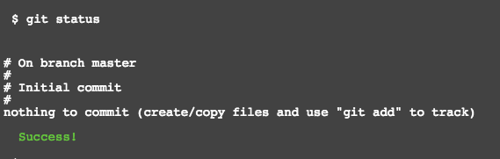

Part 1.3:

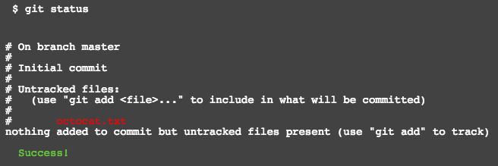

Part 1.4:

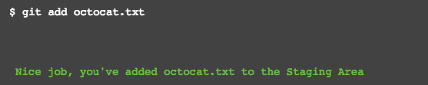

Part 1.5:

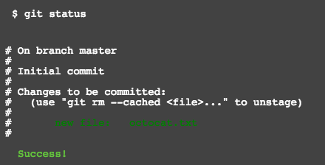

Part 1.6:

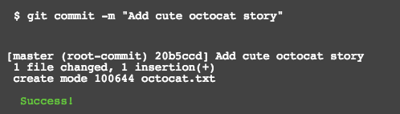

Part 1.7:

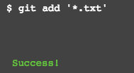

Part 1.8:

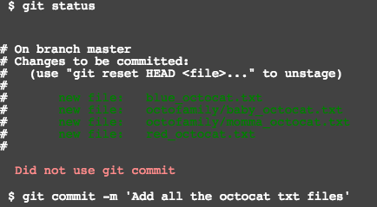

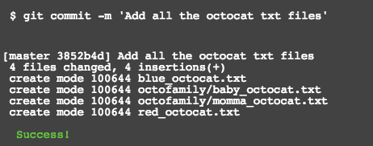

Part 1.9:

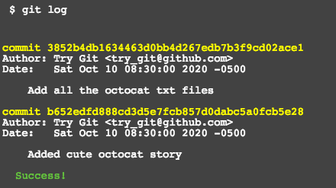

Part 1.10:

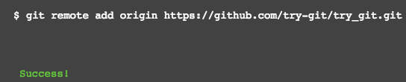

Part 1.11:

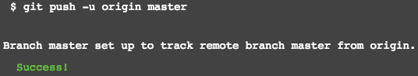

Part 1.12:

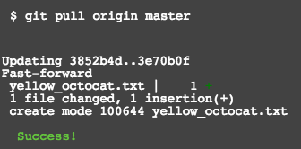

Part 1.13:

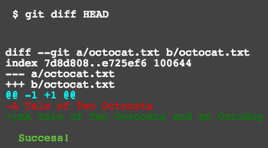

Part 1.14:

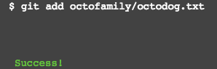

Part 1.15:

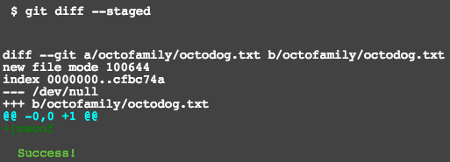

Part 1.16:

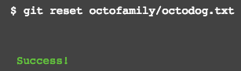

Part 1.17:

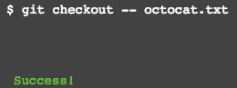

Part 1.18:

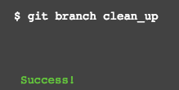

Part 1.19:

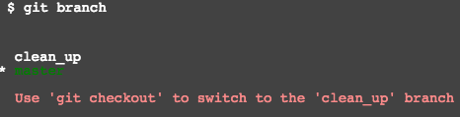

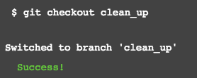

Part 1.20:

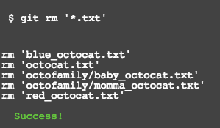

Part 1.21:

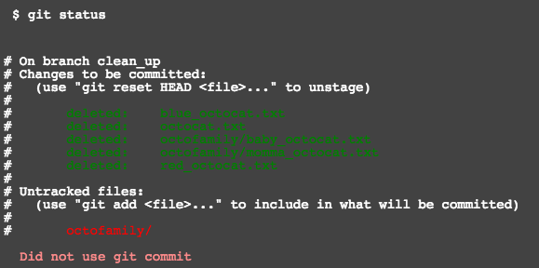

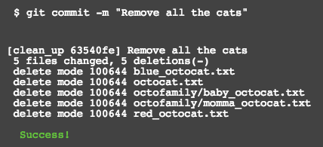

Part 1.22:

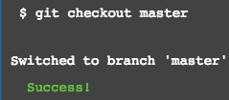

Part 1.23:

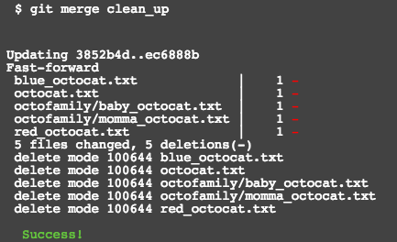

Part 1.24:

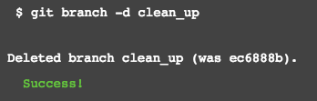

Part 1.25:

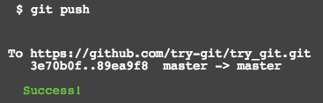

Part 5: Define the following terms in the context of Git (2 lines maximum):

* Repository – A repository is the most basic element of GitHub that contains all of the project files (including documentation), and stores each file’s revision history. Repositories can have multiple collaborators and can be either public or private.
* Commit – A commit, or “revision”, is an individual change to a file (or set of files). In Git, a unique ID is created when commits are made to keep record of what changes were made and by who. Commits usually contain a commit message, which is a brief description of what changes were made.
* Push – Pushing refers to sending your committed changes to a remote repository such as GitHub.com. If you want to change something locally, you’d want to push those changes so that others may access them.
* Branch – A branch is a parallel version of a repository. It is contained within the repository, but does not affect the primary or master branch allowing you to work freely without disrupting the “live” version. When you’ve made the changes you want to make, you can merge your branch back into the master branch to publish your changes.
* Fork – A fork is a personal copy of another user’s repository that lives on your account. Fork allows you to freely make changes to a project without affecting the original version.
* Merge – Merging takes the changes from one branch(in the same repository or from a fork), and applies them into another. This often happens as a Pull Request (which can be thought of as a request to merge), or via the command line.
* Clone- A clone is a copy of a repository that lives on your computer instead of on a website’s server somewhere, or the act of making that copy. With your clone, you can edit the files in your preferred editor and use Git to keep track of your changes without having to be online.
* Pull- Pull refers to when you are fetching in changes and merging them. For example, if someone has edited the remote file you’re both working on, you’ll want to pull in those changes to your local copy so that it’s up to date.
* Pull request- Pull requests are proposed changes to a repository submitted by a user and accepted or rejected by a repository’s collaborators. Once a pull request is sent, interested parties can review the set of changes, discuss potential modifications, and even push follow-up commits if necessary.