DEPARTMENT OF SOFTWARE ENGINEERING
CLOUD COMPUTING | COURSE CODE: CC

ASSIGNMENT 01

GitHub Identity, Student Portal Registration, and Ubuntu Server Installation

Assignment Number & Lab Title | Assign 01: GitHub Identity, Student Portal Registration, and Ubuntu Server Installation
Name | Nida Wajid
Registration No | FA24B1-SE-079
Department / Section | Software Engineering / Section A
Course Code | CC
GitHub Username | nidaawajid

Task 1: Install Gitea and Push a Repository from the Ubuntu Server

Step 1.1: Install and Run Gitea on the Ubuntu Server

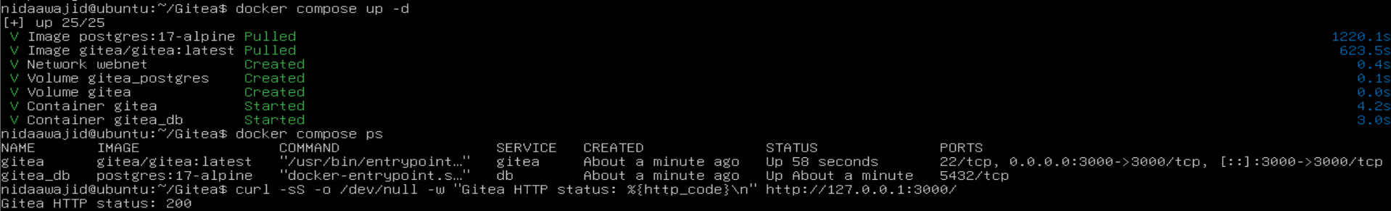
Screenshot Name: task1_gitea_running.png
Figure 1: Gitea and PostgreSQL containers running on the Ubuntu server with a successful HTTP status from port 3000.

Step 1.2: Create and Push the Initial Repository
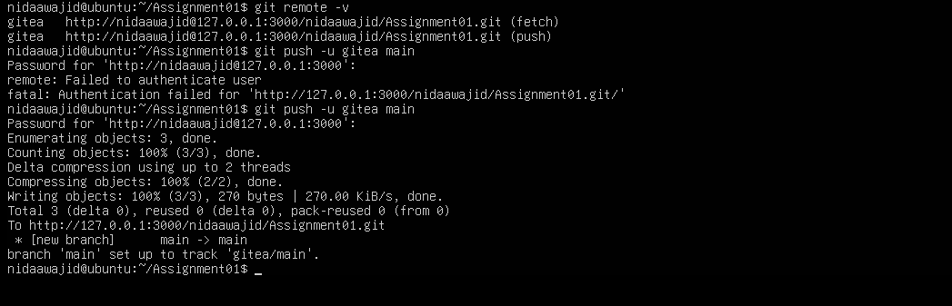
Screenshot Name: task1_gitea_push.png
Figure 2: Initial Assignment01 commit pushed successfully to the local Gitea remote with no token visible.

Step 1.3: Verify the Gitea Repository
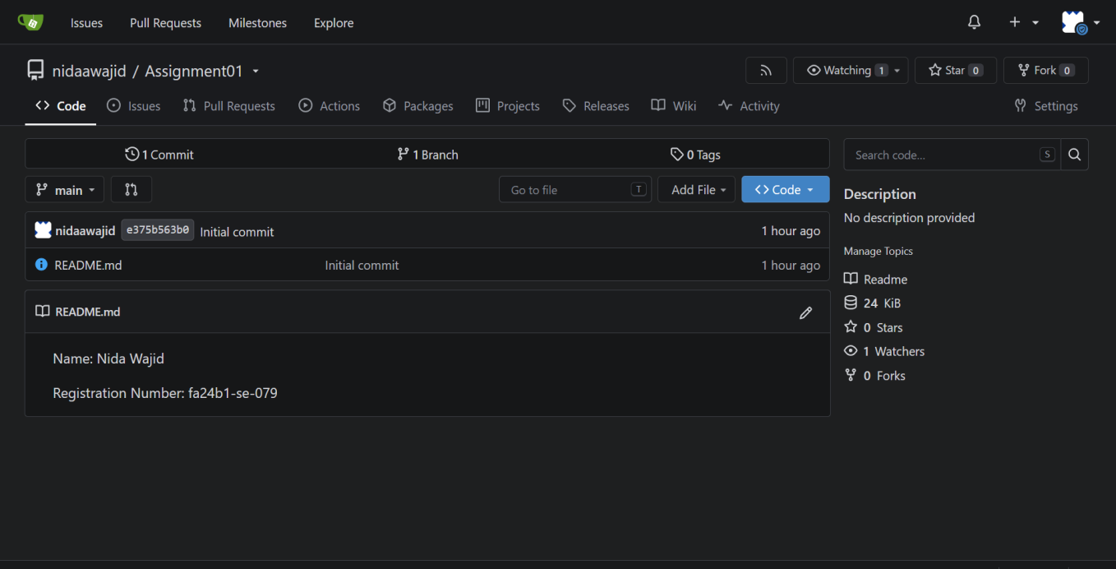
Screenshot Name: task1_gitea_repository.png
Figure 3: Public Assignment01 repository in Gitea showing the owner, repository name, and rendered README.md.
Task 1 result: Gitea was installed and run on the Ubuntu server, and a separate local repository was pushed to it over the local loopback interface.

Task 2: Push the Same Repository to GitHub

Step 2.1: Create the GitHub Repository and Verify Both Remotes

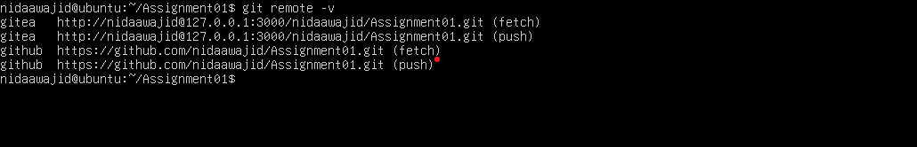
Screenshot Name: task2_remotes.png
Figure 4: Output of git remote -v showing both the gitea and github remotes without any token or password.

Step 2.2: Push to GitHub
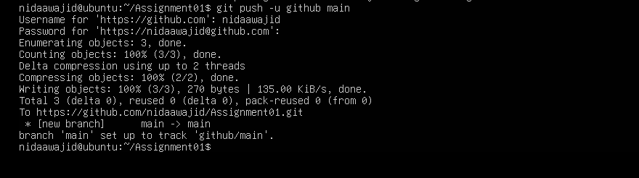
Screenshot Name: task2_github_push.png
Figure 5: Main branch pushed successfully to the GitHub remote from the Ubuntu server.

Step 2.3: Verify the GitHub Repository
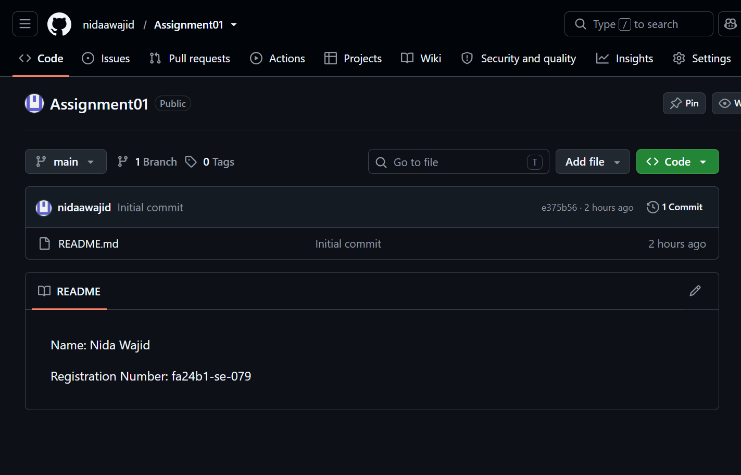
Screenshot Name: task2_github_repository.png
Figure 6: Public Assignment01 repository on GitHub with the rendered README showing name and registration number.
Task 2 result: The same local repository is connected to both Gitea and GitHub and is publicly available on GitHub.

Task 3: Track Three Large Files with Git LFS

Step 3.1: Configure Git LFS
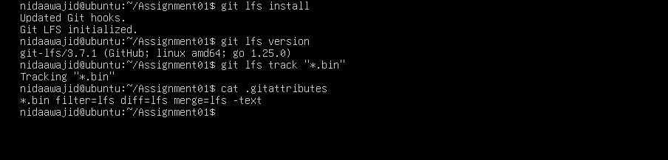

Screenshot Name: task3_lfs_setup.png
Figure 7: Git LFS initialized, its version confirmed, and the *.bin tracking rule shown in .gitattributes.

Step 3.2: Create and Verify Three LFS Files
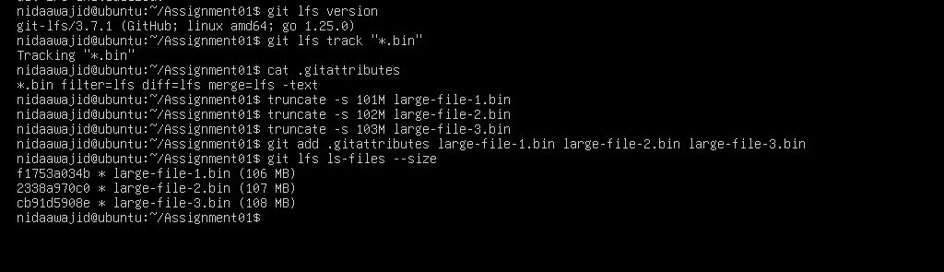

Screenshot Name: task3_lfs_files.png
Figure 8: Three .bin files, each larger than 100 MiB, listed as tracked by Git LFS with their sizes.

Step 3.3: Commit and Push the LFS Files
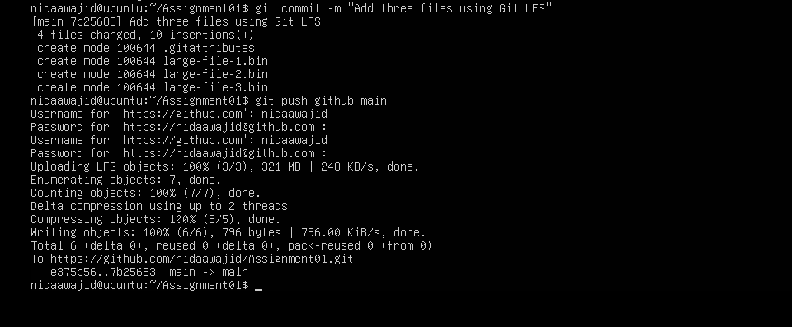
Screenshot Name: task3_lfs_push.png
Figure 9: Git LFS objects uploaded to GitHub successfully (3/3) along with the commit push.
Task 3 result: Three files larger than 100 MiB are tracked with Git LFS and pushed to the GitHub Assignment01 repository.

Task 4: Create a Portfolio or CV with GitHub Pages

Step 4.1: Create and Push the Portfolio Repository
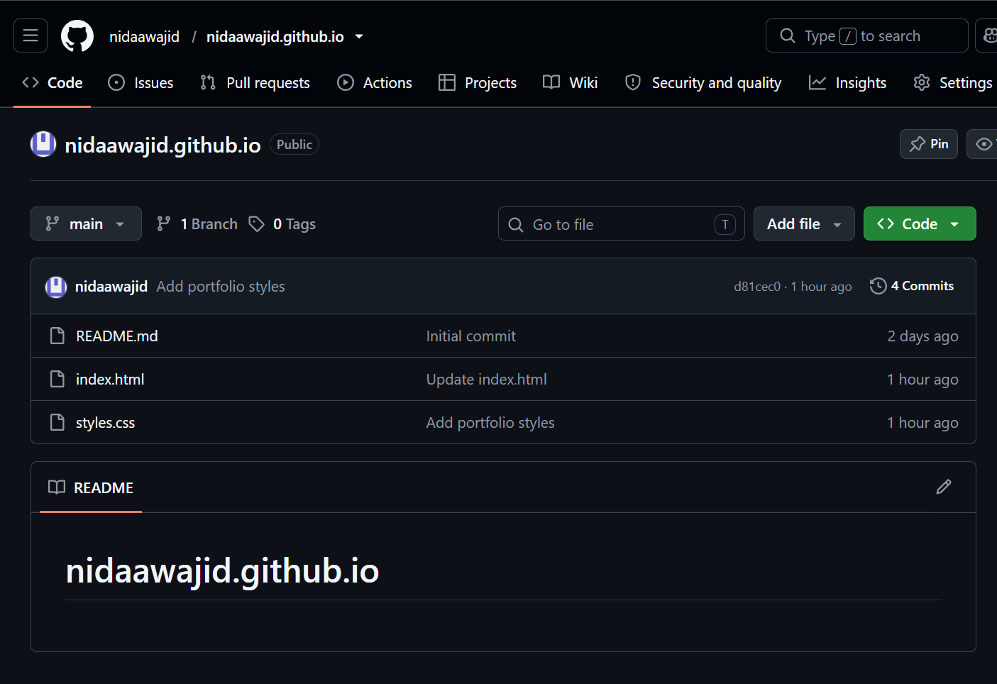
Screenshot Name: task4_pages_repository.png
Figure 10: Public nidaawajid.github.io repository showing the owner, repository name, index.html, and styles.css.

Step 4.2: Publish with GitHub Pages
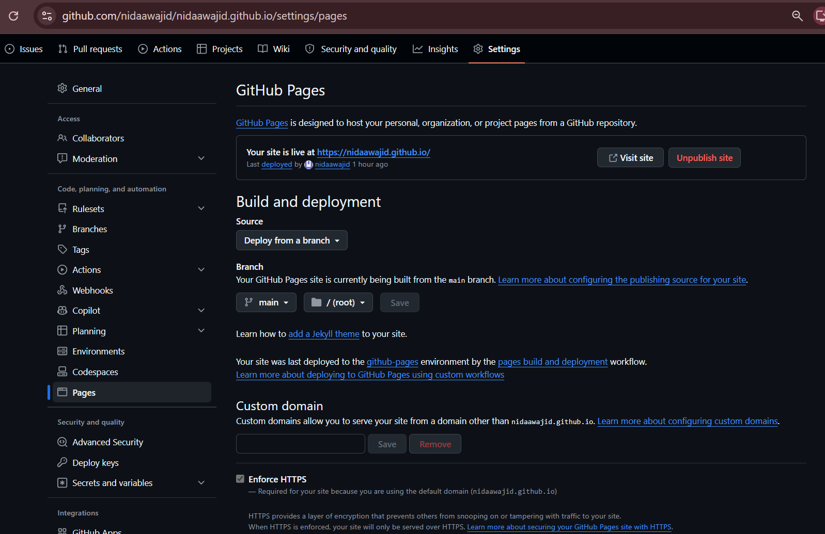
Screenshot Name: task4_pages_deployment.png
Figure 11: GitHub Pages settings showing the site published from the main branch (root) with a live status.

Step 4.3: Verify the Live Portfolio
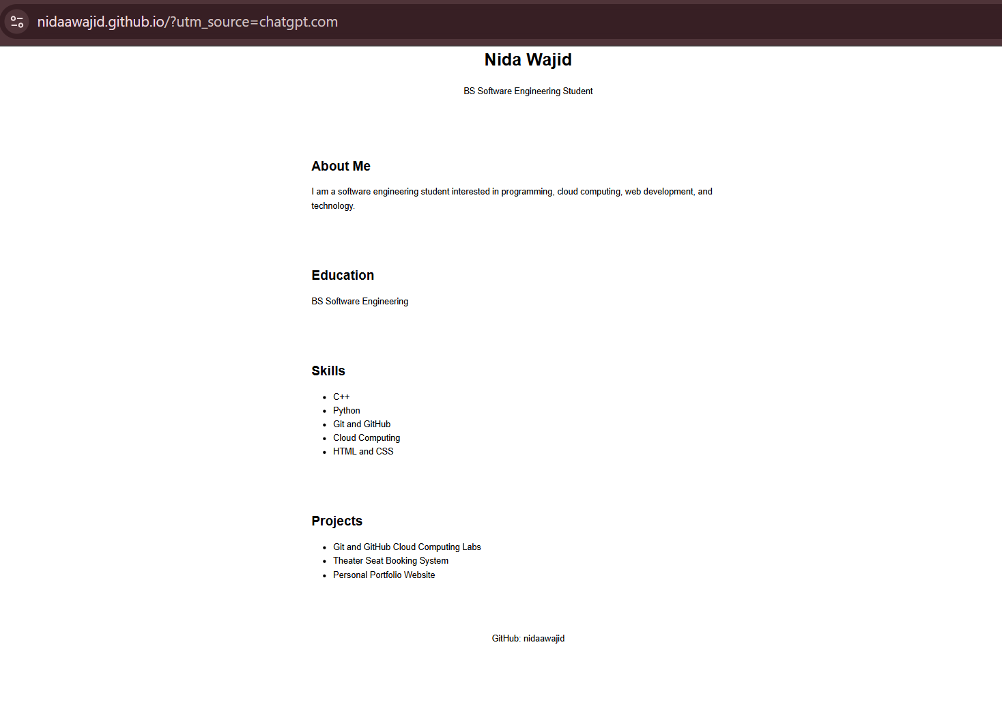
Screenshot Name: task4_portfolio_live.png
Figure 12: Live portfolio at https://nidaawajid.github.io/ displaying the required portfolio sections.
Task 4 result: The portfolio is stored in a public GitHub repository and published as a live GitHub Pages site.

