1. **Project Title**

Where Is Everybody?

1. **Team Members**

Nida Kayaduman

1. **Project Overview**

"Where Is Everybody?" is a mobile application that will allow users to easily find, review and access basic information about events such as various concerts, theaters and sports events. This platform will be designed to include day and date information of events, allowing users to discover events based on their interests. The expected result is that users can access fast and reliable information about any event and plan their social event calendar more effectively.

Nowadays, quick and easy access to information is essential. The development of "Where Is Everyone?" allows users to quickly and easily access a variety of activities, enabling them to utilize better use of their time. This application makes it straightforward to find activities that interest you, especially if you live a busy lifestyle. Thus, creating this framework will be important and useful.

Among the advantages is the ability for users to search for event information from multiple sources using a single application, which saves time, encourages users to take part in cultural and social events by providing details on various types of events, and offers financial advantages to event organizers in reaching their target audiences and marketing their events.

1. **Objective & Scope of the Project**

"Where Is Everybody?" The main purpose of the project is to provide a mobile application where users can get information about various events, discover events according to their interests and access event details. This platform will be specifically designed to cover social events such as concerts, theaters and sports competitions. At the end of the project, it is aimed to create a tool that facilitates users' event planning and provides quick and easy access to event information. The project will basically consist of two main parts: A backend application and a frontend application.

The backend application will be developed with Java Spring Framework, which will manage event data and provide data to the mobile application. MongoDB is the database system that will be used to store event data. API endpoints planned in the backend are:

* List Events: Allows users to view all events or events filtered by a specific category.
* Event Details: Provides detailed information (date, time, place, description, etc.) of a selected event.
* Search Event: Allows users to search for events by name, date, or category.

These endpoints are required to support the core functionality of the application, and new features may be added as the project progresses.

The mobile application, which will be developed using the Android Framework, will make it easier to discover events with a user-friendly interface. The application will consist of the following screens:

* Home Page/Event List Screen: A screen where users can view various events and the events can be sorted by categories.
* Event Detail Screen: A screen where users can get detailed information about the event, including date, time, location and other important details.
* Event Search Screen: A screen where users can search for specific events and filter by name, date or category.

1. **Background and Current Practice**

Eventbrite is a comprehensive platform that allows users to discover events around the world, purchase event tickets, and even create their own events. It simplifies the event management process by offering a variety of tools for event organizers. Eventbrite aims to promote events and increase ticket sales by reaching a wide user base.

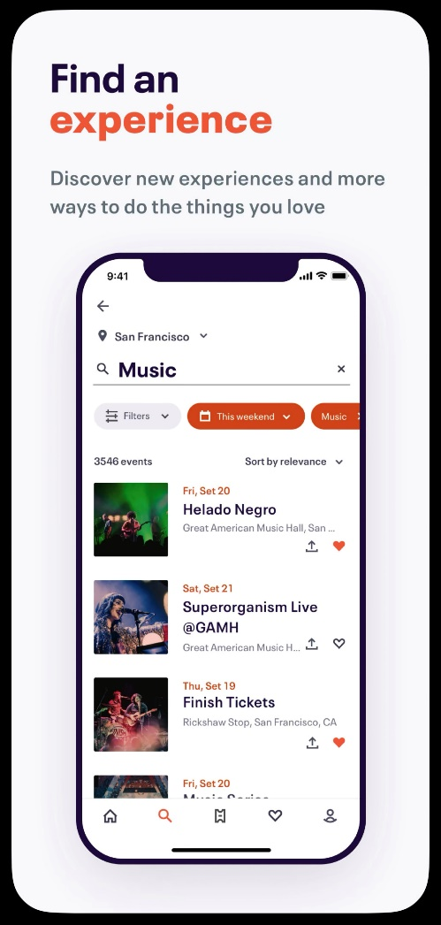

Songkick is a concert and live music event discovery service for music lovers. Users can follow the concert dates of their favorite artists, discover concerts near them and access ticket purchasing options. Songkick allows users to receive event recommendations customized based on their music preferences.

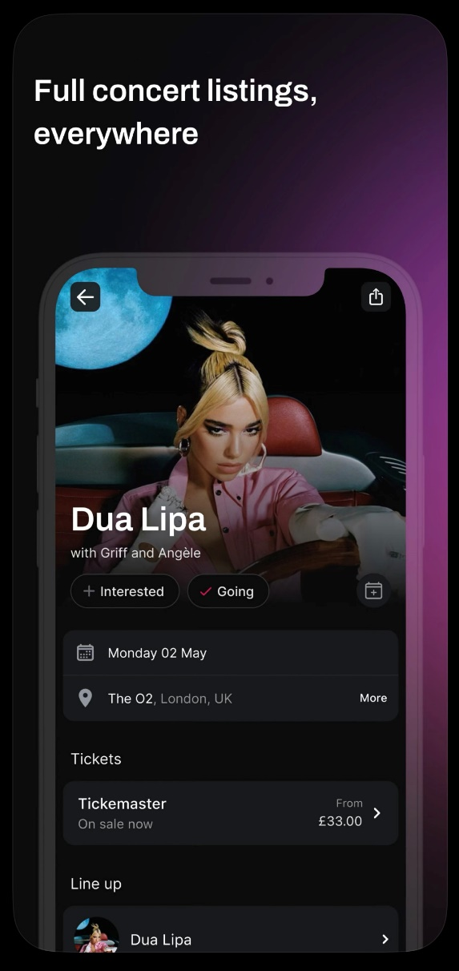 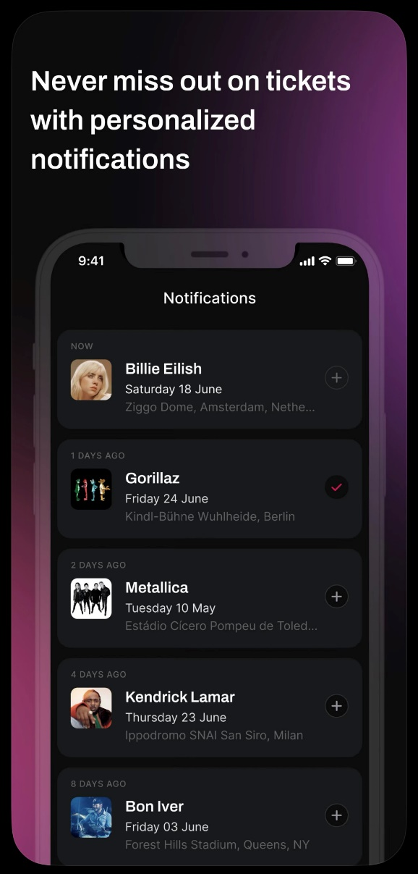

These applications set industry standards for user experience, data richness, and event diversity. Advances in technology in event discovery and management have made it simpler for users to find and participate in events while also providing more personalized experiences. This project aims to make it easier and faster for users to find events by leveraging advice obtained from existing apps. By focusing on specific types of events, such as concerts, theaters, and sporting events, it anticipates carving out a niche and providing value to users.

1. **Potential Customer/User Description**

This application is aimed at a diverse group of users who are interested in a variety of social, cultural, and sporting events. This system has significant benefits for people of all ages and interests, as well as organizations dealing with event management. College students and young adults are an active demographic in terms of attending events and socializing. This demographic is particularly drawn to concerts, festivals, theaters, and other social events.

Families seek out activities they can do with their children. This group is particularly interested in educational workshops, family festivals, and children's theaters. Tourists and out-of-town visitors may be interested in attending local cultural events, exhibitions, and festivals. Additionally, concert halls, theater organizations, sports clubs, and cultural centers can use this platform to promote their events and reach a larger audience. As a result, "Where Is Everybody?" appeals to a wide range of users, from young adults to families, from tourists to event organizers. This system can create value for both parties by bringing together individuals interested in social events and organizations and businesses operating in fields such as event management, tourism and entertainment.