ProVA (Productivity Voice Assistant)

  - A Project Report

Submitted in partial fulfilment of the requirements for the award of degree of

Bachelor of Science of (Data Science)
By

Nida M. Nadeem Qureshi & AunRaza ImranRaza Shaikh
Roll no: 26 Roll no: 34

Under the esteemed guidance of

MR. Pragnesh Shah



DEPARTMENT OF DATA SCIENCE

SHREE L. R. TIWARI DEGREE COLLEGE OF ARTS, COMMERCE &
SCIENCE, Mira Road

(Affiliated to University of Mumbai)
THANE, 401107 MAHARASHTRA
2025-26



CERTIFICATE

Department of Bachelor Science of (Data Science)

This is to certify this project report entitled ProVA (Productivity Voice Assistant), submitted to University of Mumbai, Maharashtra is bonified record of work done by Nida M. Nadeem Qureshi and Aunraza ImranRaza Shaikh for Academic Year 2025-2026 under the guidance of “Mr. Pragnesh Shah” from to .

Date of Evaluation:

Internal Examiner College Stamp
(Guide)

External Examiner Head of the Department

ACKNOWLEDGEMENT

I would like to convey my deep appreciation to my guide Mr. Pragnesh Shah for his valuable guidance and encouragement in completion of my project work.
I would also like to express my gratitude to our principal Dr. Sanjay Mishra for providing all the required facilities to accomplish my work.

- Nida M. Nadeem Qureshi and Aunraza ImranRaza Shaikh
DECLARATION

I hereby declare that project entitled “ProVA (Productivity Voice Assistant)” done at Shree L.R. Tiwari Degree college, not been in any case duplicated to submit to any other university for the award of any degree. To the best of my knowledge other than me, no one has submitted to any other university. The project is done in partial fulfilment of requirement for the award of degree of Bachelor of Science of (Data Science) to be submitted as V ^{th} semester project as a part of our curriculum.

- Nida M. Nadeem Qureshi and Aunraza ImranRaza Shaik

INDEX

Abstract
Chapter 1: Introduction
  - Background 10
  - Objectives 10
  - Purpose, Scope and Applicability
    - Purpose 10
    - Scope 11
    - Applicability 11
  - Achievements 11
  - Organization of Project 12
Chapter 2: Survey Technologies
  - Introduction… 13
  - Frontend Technologies… 13
  - Backend Technologies 14
2.4 UI/UX Design Tools 15
2.5 Database Technologies 15
2.6 Supporting APIs and Technologies 15
2.7 Development Tools 16
2.8 Version Control System 16
Chapter 3: Requirement and Analysis
  - Problem Definition 17
  - Requirement Specification 17
3.2.1 Functional Requirements 17
3.2.2 Non-Functional Requirements 18
3.2.3 Existing System Issues 18
3.3 Planning and Scheduling 18
3.3.1 Project Phases 18
3.4 Software and Hardware Requirements 18
3.4.1 Software Requirements 19
3.4 Hardware Requirements 19
3.5 Preliminary Product Description 19
3.6 Conceptual Models 20
3.7 Limitations 22
3.8 References 23
Chapter 4: System Design
  - Basic Modules 24
4.2 Procedural Design 25
4.2.1 Logic Flow 25
4.2.2 Data Structures 25
4.2.3 Algorithm Example 25
4.3 User Interface Design 26
4.4 Security Considerations 26
4.5 Test Case Design 27
4.6 Summary 27

ABSTRACT

Voice assistants such as Siri, Alexa, and Google Assistant have become woven into daily life, yet their functionality remains narrowly focused on entertainment, mobile utilities, and smart home control. Their contribution to professional desktop workflows—where tasks demand greater precision, structure, and versatility—remains minimal. This project introduces ProVA (Productivity Voice Assistant), a desktop-based, voice-driven system designed to automate productivity tasks and enable a hands-free, more accessible computing experience.

Developed in Python, ProVA employs a modular architecture that integrates key libraries: speech_recognition for voice input, pyttsx3 for text-to-speech output, pyautogui and smtplib for task automation, SQLite for lightweight data storage, and Tkinter for a minimal graphical interface supporting command logs and confirmations. Dedicated modules handle voice processing, email management, spreadsheet automation, file operations, reminders, and web search.

Prototype testing demonstrates that ProVA can reliably interpret and execute structured voice commands, underscoring its potential to enhance multitasking efficiency, broaden accessibility for differently abled users, and reduce dependence on traditional keyboard-and-mouse workflows. While its current implementation is constrained to English commands and structured phrasing, its modular foundation enables future scalability—ranging from natural language understanding and offline processing to integration with third-party platforms.
Chapter 1

Introduction

  - Background

In today’s digital era, voice-assist technologies respond to simple commands—See Siri, Google Assist, or Alexa—But voice recognition software is mainly used for controlling entertainment systems, performing Internet searches, or controlling smart devices around the home. For productivity workflows, voice-assist technologies are more aligned for composition, email management, file management, data entry and reorganization of digital reminders.

Everyone relies on devices for everyday repetitive digital tasks. This is especially true for professionals, students, and multitaskers. But, in a highly cognitive multitasking environment, constant switching between devices, and especially, the use of mice and keyboards, a significant drop in productivity or user frustration is probable. People with disabilities are especially at risk.

For this very reason, ProVA (Productivity Voice Assistant) was designed. It is a voice-enabled productivity application aimed at providing a hands-free, keyboard-less user experience. ProVA uses speech recognition and intent detection to open applications, compose emails, and manage spreadsheets, all by voice command. The system promises to improve productivity workflows by implementing automation tasks for set reminders, web searches, spreadsheets, and email management.

  - Objectives

The primary objectives of ProVA (Productivity Voice Assistant) are:
• To design a system that accepts voice commands in English and converts them into actionable tasks.

• To create a hands-free (keyboard-less) experience for users in managing productivity-related work.

• To automate essential desktop operations such as email composition, file handling, spreadsheet management, reminders, and web search.

• To provide an accessible and inclusive digital assistant for students, professionals, multitaskers, and differently abled individuals.

  - Purpose, Scope and Applicability
1.3.1 Purpose

ProVA (Productivity Voice Assistant) aims to provide a customised productivity assistant that boosts productivity and lessens dependency on gadgets that require manual input. The approach offers the following by emphasising production on all levels: academic, professional, and personal.
• A voice-activated, organic interface for standard desktop operations.

• Enhanced accessibility for individuals with disabilities who have trouble using keyboards and mouse.

• An efficient, multitasking workflow for professionals and students.

What makes ProVA different from general-purpose assistants is its commitment to productivity use cases.

1.3.2 Scope

ProVA's scope includes:
• Opening applications on the desktop

• Using voice to compose and send emails.

• Spreadsheet operations such as creating, editing, and computation.

• Messages can be typed and sent without human input.

•Web search through natural language voice queries.

• Time management reminders and task scheduling.

In an online desktop setting, the assistant presently concentrates on structured voice commands. Contextual memory for multi-step talks, offline processing using local models, and increased third-party tool integration are possible future improvements.

1.3.3 Applicability

ProVA (Productivity Voice Assistant) is applicable across multiple domains:

• Students: For managing notes, reminders, and For rapid academic searches.

• Professionals: For managing spreadsheets, emails, and multitasking at work.

• Differently abled users: To provide accessible computing without the need for keyboards or mouse.

• General users: For daily tasks like reminders, file management, and browsing, without manual effort.

1.4 Achievements

ProVA (Productivity Voice Assistant) represents a conceptual and developmental accomplishment at this point in time. The research shows that combining task automation and speech recognition may be done to build a portable, desktop productivity assistant. The system's accomplishment, even if it is still in the ideation and design stage, is:

• Determining the absence of desktop productivity voice assistants.

• Outlining a method for voice-activated task automation that follows a defined process.

The model's scalability allows it to adapt to future advancements in offline capabilities and natural language processing.

1.5 Organisation of Report

This report is structured to provide a comprehensive understanding of ProVA (Productivity Voice Assistant), its design, and its applications. The subsequent chapters are organized as follows:

• Chapter 2: Survey of Technologies – A review of existing voice assistants and supporting technologies for speech recognition, task automation, and system integration.

• Chapter 3: Requirements and Analysis – Definition of the problem, requirements specifications, and analysis of system needs.

• Chapter 4: System Design – Architectural design, modules, and interaction flow for ProVA.

Through this structured approach, the report aims to offer valuable insights into the development and significance of ProVA (Productivity Voice Assistant).

Chapter 2

Survey and Technologies

2.1 Introduction

Creating ProVA (Productivity Voice Assistant) involves careful decisions about technology. Unlike traditional applications that focus on graphical user interfaces, ProVA centers on voice interaction. This shift places greater importance on backend technologies, while the frontend remains supportive.

Since the system is initially built as a desktop application, we have prioritized lightweight and easy-to-deploy tools. Therefore, we have chosen Python along with SQLite for the prototype. This chapter reviews the main technologies used in ProVA, compares them to alternatives, and outlines their strengths and weaknesses.

2.2 Frontend Technologies

ProVA’s main interaction happens through voice, so the frontend is kept minimal. However, there are times when a visual interface is helpful—for instance, to display command logs, error messages, or confirmation prompts.

- Tkinter (chosen for the prototype)
Tkinter comes bundled with Python, making it easy to use without additional installations. It’s suitable for small windows, dialog boxes, or basic dashboards.

•Advantages: Lightweight, easy to integrate, no external setup.
•Limitations: Limited design flexibility; the interface appears outdated compared to modern applications.

- Alternative: PyQt / PySide
These frameworks offer a more modern look and a wide range of widgets. They are better suited for applications that may need a professional-grade desktop interface in the future.

•Advantages: Rich UI capabilities, modern appearance.
•Limitations: Steeper learning curve, larger package size.

- Future possibility: Web-based frontend (HTML, CSS, JS)
If ProVA develops into a web application, a browser-based frontend could be more practical. This would enable remote access and allow for multiple users.

•Advantages: Easy remote deployment, scalable for more users.
•Limitations: More complex development process and higher maintenance needs.

In summary, Tkinter is a practical choice for the initial desktop prototype, while PyQt/PySide or even a web-based interface could be relevant if ProVA evolves into a more advanced platform.

2.3 Backend Technologies

The backend is the heart of ProVA (Productivity Voice Assistant), as it is responsible for processing voice input, recognizing user intent, mapping it to tasks, and carrying out the required actions. Python has been selected as the primary programming language because of its large ecosystem of libraries, ease of integration, and suitability for rapid prototyping.

1) Speech Recognition

For voice input, ProVA uses the speech_recognition library, which supports the Google Web Speech API.

- Alternatives: Vosk (works offline), Whisper (high accuracy but computationally heavy), or cloud-based solutions like Google Cloud Speech and Microsoft Azure Speech.
- Comparison: Local libraries are cost-free and private but may lack accuracy. On the other hand, cloud APIs provide higher accuracy but depend on internet connectivity and may introduce subscription costs.

2) Text-to-Speech (TTS)

For converting text responses into spoken feedback, two libraries are considered: pyttsx3 (offline and lightweight) and gTTS (Google Text-to-Speech, requiring internet).

- Alternatives: Enterprise-level services such as Amazon Polly or Microsoft Azure TTS.
- Comparison: pyttsx3 is simple and works offline but produces robotic voices. Cloud APIs, while more natural and expressive, create a dependency on internet access and can add costs for frequent use.
3) Task Automation

Automation is achieved through Python libraries such as pyautogui (for simulating keyboard and mouse actions), os and subprocess (for launching files and applications), and smtplib (for sending emails).

- Alternatives: Advanced Robotic Process Automation (RPA) tools like UiPath or Automation Anywhere, which are more powerful but heavy, expensive, and not ideal for lightweight prototypes.
Summary: Python’s ecosystem offers a practical balance between simplicity and functionality for ProVA’s prototype. In future versions, enterprise APIs or RPA solutions could be introduced for scalability and robustness.

2.4 UI/UX Design Tools

Since ProVA (Productivity Voice Assistant) is voice-first, its user experience is centered around natural conversational flows rather than visual elements. The interface primarily acts as a launcher or as support for voice interaction.

- Optional GUI Tools: Tkinter can be used for simple dialog boxes or pop-ups, while PyQt offers more sophisticated designs if needed.
- Voice-first UX Principle: Instead of complex menus, the interaction model emphasizes fluid, natural dialogue.
Future Scope: A chat-based interface could be added for users who prefer typing instead of speaking.

2.5 Database Technologies

Persistent storage is essential for maintaining reminders, notes, logs, and user preferences.

a) SQLite (Chosen for Prototype):

- File-based and requires no dedicated server.
- Well-suited for offline, single-user environments.
- Limitation: Poor at handling concurrency, making it unsuitable for multi-user setups.
b) Alternative: PostgreSQL / MySQL:

- Full-scale relational databases that handle concurrency and complex transactions.
- More appropriate if ProVA evolves into a multi-user web application.
c) Alternative: NoSQL (MongoDB, Firebase):

- Schema-less and capable of handling unstructured or JSON-heavy data.
- Could be considered in future expansions where flexibility is required.
Summary: SQLite is sufficient for the desktop prototype, while PostgreSQL is recommended for enterprise-level or multi-user deployments.

2.6 Supporting APIs and Technologies

Several additional tools extend ProVA’s functionality:

- Web Search: Libraries such as requests, Beautiful Soup, or dedicated APIs allow ProVA to fetch online information.
- Reminders & Scheduling: Modules like schedule or apscheduler manage timed tasks.
- Email Integration: SMTP is used for sending and IMAP for reading emails.
Alternatives: APIs like Gmail API or Microsoft Graph API offer richer enterprise integration.

2.7 Development Tools

Development and testing of ProVA (Productivity Voice Assistant) rely on a mix of tools and practices:

- Programming Language: Python, chosen for its versatility.
- IDE/Editors: Visual Studio Code for lightweight use; PyCharm for advanced debugging.
- Package Management: pip and conda for dependency handling.
Testing: unittest and pytest frameworks ensure module-level reliability.

2.8 Version Control

Version control is managed through Git, with repositories hosted on GitHub. This ensures collaboration, version tracking, and secure backups throughout development.

Summary of Chapter

The technologies chosen for ProVA (Productivity Voice Assistant) emphasize simplicity, rapid development, and offline usability. Core voice features are implemented using Python libraries, while SQLite provides lightweight storage. Although Tkinter supports basic frontend needs, the design focus remains on smooth conversational interactions. For scalability, more advanced alternatives such as PostgreSQL, cloud-based APIs, or RPA frameworks can be integrated in the future, positioning ProVA to grow from a desktop prototype into a comprehensive productivity platform.

Chapter 3

Requirements and Analysis

3.1 Problem Definition

Professionals like data analysts often have to juggle multiple productivity tools—Excel for analysis, emails for communication, reminders for tasks, and different file management systems. Moving back and forth between these tools usually means navigating menus and typing commands, which slows down work and disrupts focus. For people with accessibility challenges, the heavy reliance on the mouse and keyboard adds yet another layer of difficulty.

Popular voice assistants such as Siri, Alexa, or Google Assistant are good at handling everyday tasks like setting alarms or controlling smart devices. However, they fall short when it comes to desktop-based professional workflows, particularly those involving structured data and spreadsheets.

ProVA (Productivity Voice Assistant) has been designed to close this gap. It is a desktop-focused, voice-driven assistant built with the needs of professionals in mind. With ProVA, users can:

- Open, create, and edit Excel sheets.
- Generate simple dashboards and pivot tables.
- Write and send emails. Set reminders and take notes.
- Manage files (open, rename, move, delete).
- Perform quick web searches.

This not only improves efficiency but also enables hands-free workflows that make technology more accessible to people with special needs.

3.2 Requirements Specification

3.2.1 Functional Requirements

ProVA (Productivity Voice Assistant) should be able to:

- Understand user voice commands and convert them into text.
- Recognize intent and match it to the correct task.
- Automate email composition, sending, and basic inbox reading.
- Open and edit Excel spreadsheets, including pivot tables and charts.
- Support note-taking and scheduling of reminders.
- Handle file operations such as opening, renaming, moving, or deleting.
- Conduct simple web searches and return results.
- Provide voice feedback or confirmation after completing a task

3.2.2 Non-Functional Requirements

- Accuracy: Reliable recognition of speech and correct task execution.
- Performance: Quick response time for common tasks.
- Usability: Commands should be simple enough for non-technical users.
- Portability: Compatible with Windows and Linux systems without requiring heavy setups. Security: Basic protection for sensitive data such as email credentials and files.
- Maintainability: A modular design that allows features to be added or removed easily.

3.2.3 Existing System Issues

- Lack of integration between existing voice assistants and tools like Excel.
- Dependence on cloud APIs and internet connectivity.
- Weak desktop-level integration in most current solutions.

3.3 Planning and Scheduling

3.3.1 Project Phases

Since ProVA (Productivity Voice Assistant) is in the proof-of-concept phase, development follows an iterative prototyping model. Small experiments (speech recognition, TTS, Excel manipulation) were tested individually to validate feasibility before integration.

The planned schedule (as shown in the Gantt chart) is:

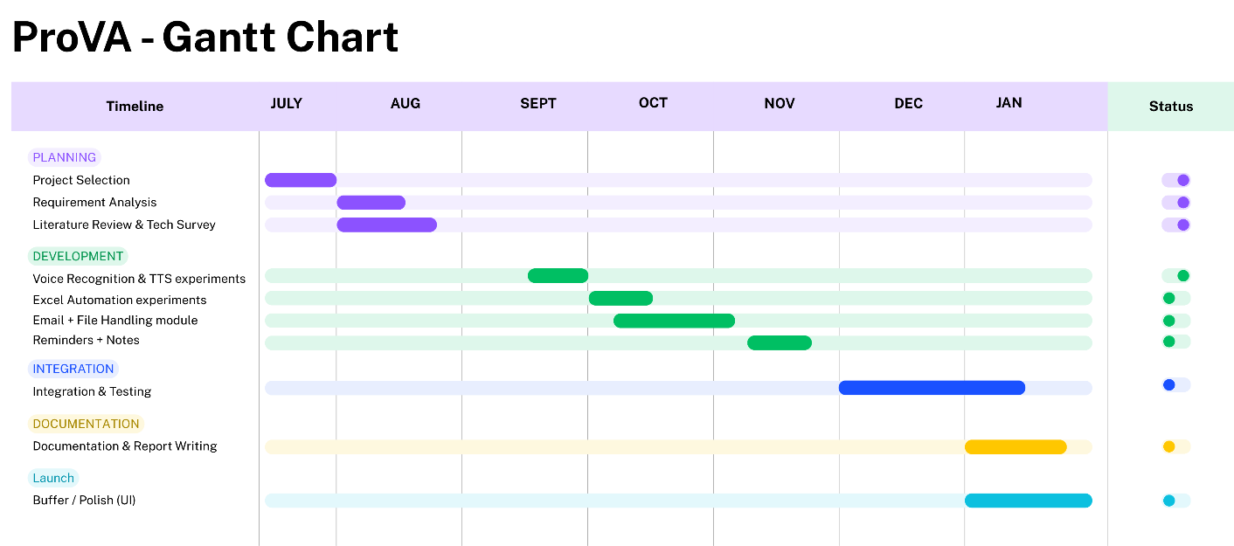

3.4 Software and Hardware Requirements

3.4.1 Software Requirements

- Operating System: Windows 10/11 or Linux
- Programming Language: Python 3.9+
- Storage: Excel (default), SQLite (lightweight), PostgreSQL (for scaling)
- IDE: VS Code or PyCharm
- Version Control: Git + GitHub
- Testing Tools: unittest, pytest

3.4.2 Hardware Requirements

- Processor: Intel i3 (multi-core) or AMD equivalent
- RAM: Minimum 4 GB (8 GB recommended)
- Disk Space: 1.5 GB free
- Microphone: Built-in microphone (laptop) or external USB microphone.
- Speakers/Headphones: For TTS output

3.5 Preliminary Product Description

ProVA (Productivity Voice Assistant) is essentially a desktop-based voice assistant aimed at professionals who deal with repetitive productivity tasks.

It allows voice-driven interaction with tools like Excel, email, and file managers, while also supporting reminders and notes.

The focus so far has been on validating individual components—speech recognition, text-to-speech, and Excel automation. The next stage is to bring all these modules together into a unified, working system.

3.6 Conceptual Models (Use Case Diagram)

- Data Flow Diagram (DFD): Shows how voice input is processed, converted into commands, and passed to modules like Excel, Email, Notes, Reminders, and File Manager.
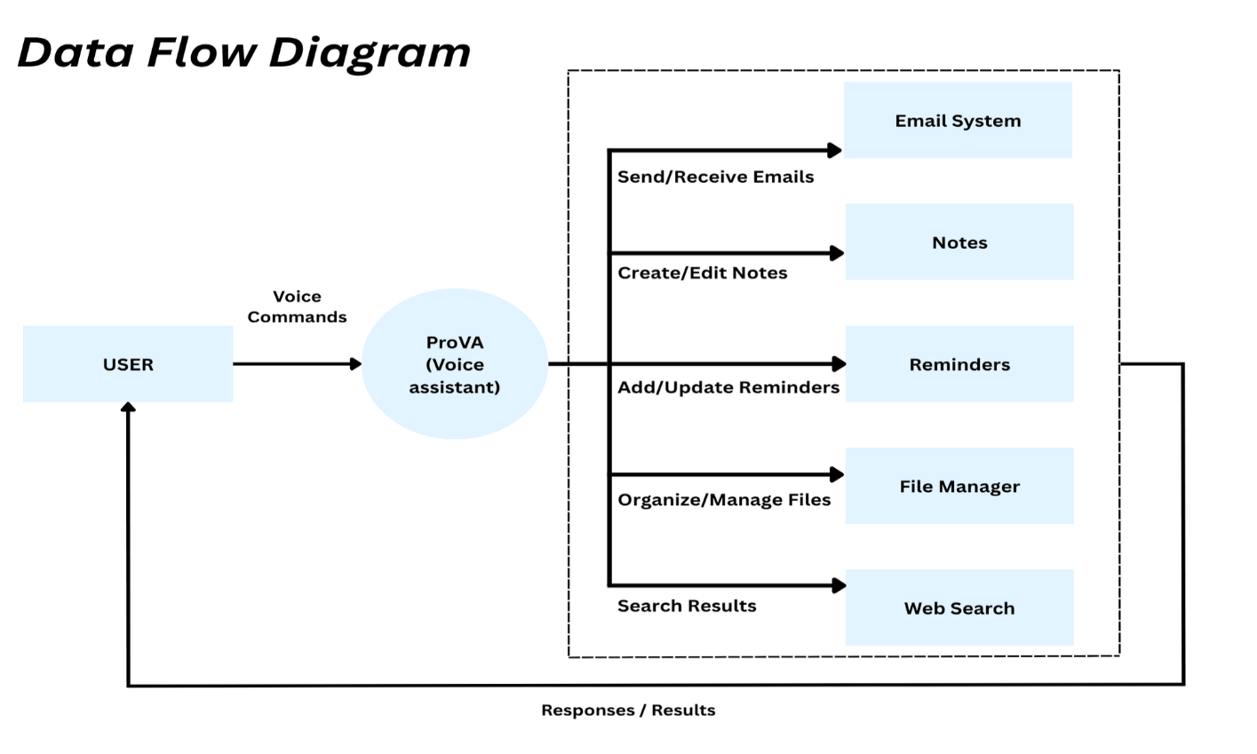

- UML Use-Case Diagram: Illustrates how users interact with the system (sending emails, creating spreadsheets, setting reminders, managing files, performing searches).

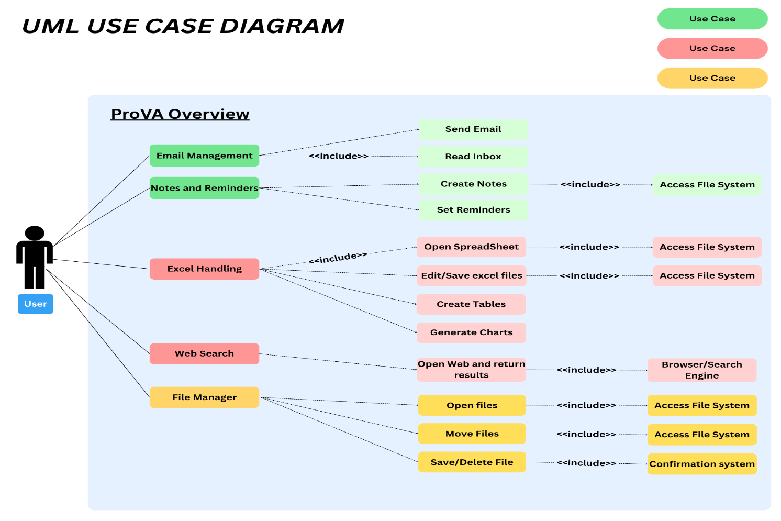

- UML Class Diagram: Highlights the core classes including:

  - VoiceProcessor
  - EmailManager
  - SpreadsheetManager
  - ReminderScheduler
  - FileManager
  - NoteManager

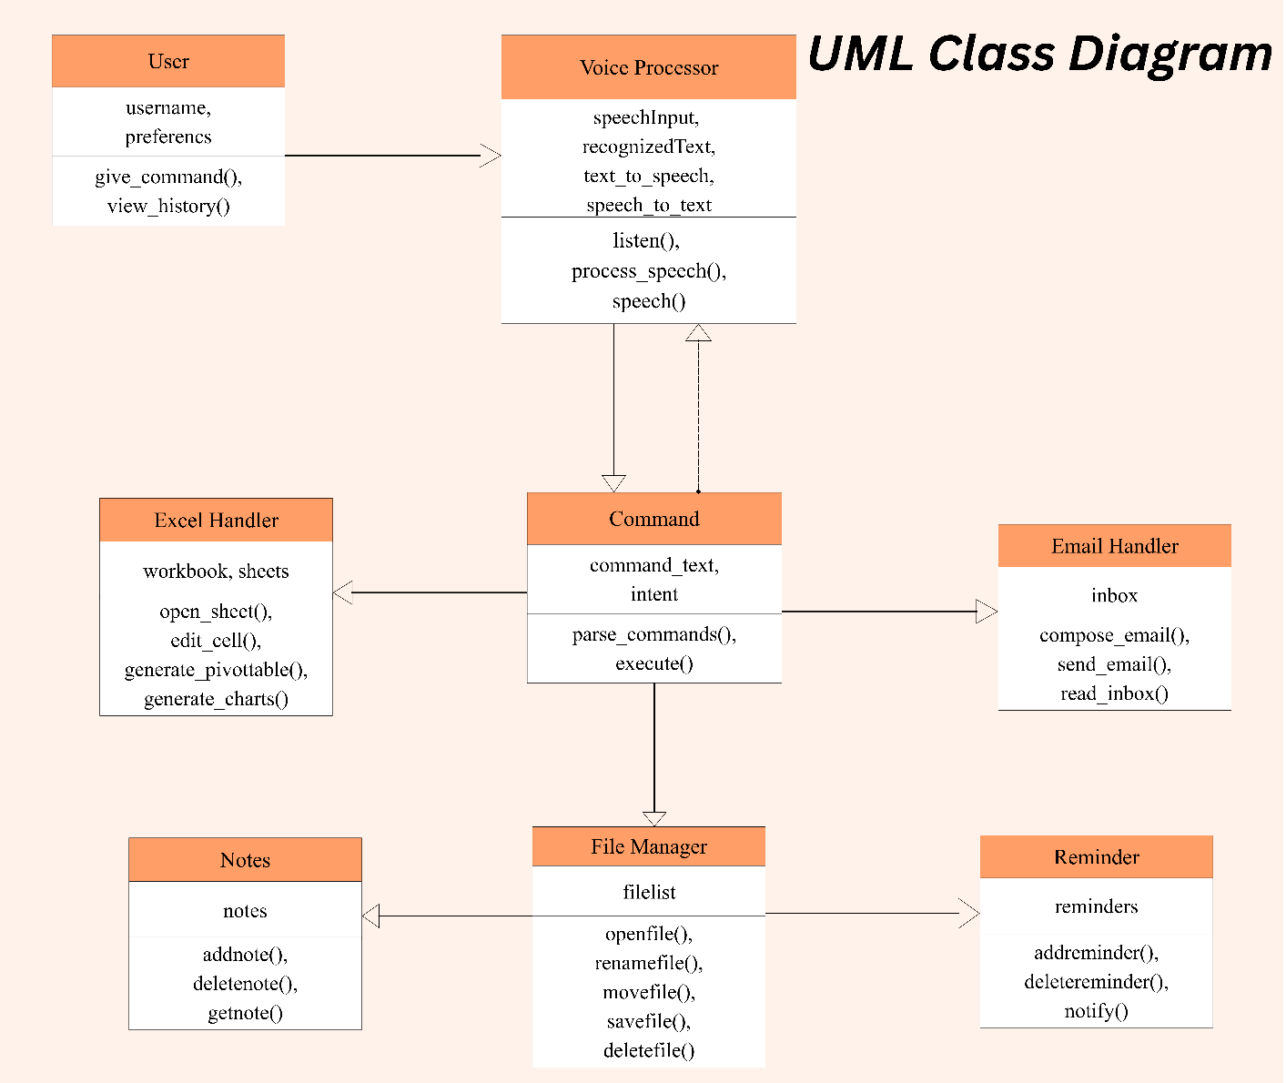

3.7 Limitations

- Currently supports English only.
- Commands must be specific (limited natural language understanding).
- Some features require internet connectivity.
- Functionality is limited to prototype-level commands.

3.8 References

- Python Software Foundation. (2023). Python Documentation. Retrieved from https://docs.python.org/3/

- OpenAI. (2022). Speech Recognition with Python (speech_recognition library guide). GitHub Repository. https://pypi.org/project/SpeechRecognition/

- Sweigart, A. (n.d.). 24 text-to-speech and speech recognition engines. In Automate the Boring Stuff with Python (3rd ed.). Retrieved from https://automatetheboringstuff.com/3e/chapter24.html (Automate the Boring Stuff)

- Loeber, P. (2025, January 23). Python speech recognition in 2025. AssemblyAI. Retrieved from https://www.assemblyai.com/blog/the-state-of-python-speech-recognition (AssemblyAI)

- “Python Speech Recognition Module in Python.” (n.d.). GeeksforGeeks. Retrieved from https://www.geeksforgeeks.org/machine-learning/python-speech-recognition-module/ (Automate the Boring Stuff)

- Dutsinma, F. L., et al. (2022). A systematic review of voice assistant usability: An ISO 9241-11 framework. PMC. Retrieved from https://pmc.ncbi.nlm.nih.gov/articles/PMC9063617/ (PMC)

- Cen, Z., & Zhao, Y. (2024). Investigating the impact of AI-driven voice assistants on user productivity and satisfaction in smart homes. Journal of Economic Theory and Business Management, v1n6a02. https://doi.org/10.70393/6a6574626d.323333 Retrieved from https://www.suaspress.org/ojs/index.php/JETBM/article/view/v1n6a02/v1n6a02 (Suas Press)

Chapter 4

System Design

4.1 Basic Model

- Voice Input & Processing Module – Captures audio through the microphone and converts speech into text using speech recognition techniques.

- Email Management Module – Interfaces with mail servers (SMTP/IMAP) to send, read, and manage emails programmatically.

- Spreadsheet Module – Reads, updates, and manipulates structured data in Excel/CSV files using data handling libraries.

- Notes & File Management Module – Creates, organizes, and manages notes or files with file system operations.

- System Utility Module – Executes OS-level commands to control applications, system settings, and basic utilities.

- Web Search & Information Module – Fetches and extracts information from the web via APIs or web scraping.

- Reminder & Scheduler Module – Manages time-based events, alarms, and task scheduling using timers and schedulers.

- Text-to-Speech (TTS) Module – Converts textual responses into human-like spoken output using TTS engines.

4.2 Procedural Design

4.2.1 Logic Flow

General workflow: 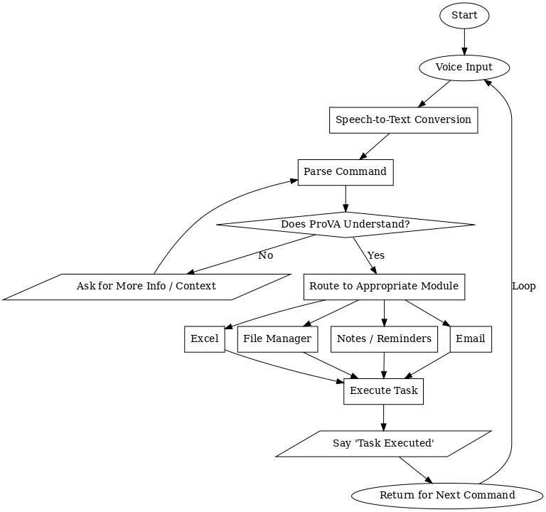
4.2.2 Data Structures

- Dictionary mappings: Keyword → Module.
- Lists/Queues: Store reminders and tasks in memory.
- Pandas DataFrames: Used for spreadsheet operations.

4.2.3 Algorithm Example

Excel Dashboard Automation

- Input: “Prepare dashboard.”
- Process: Load cleaned dataset → Create pivot table (e.g., sales by region) → Generate charts → Save
- Excel file with new dashboard tab.
- Output: Excel dashboard file with pivot tables and charts accessible to the user.

4.3 User Interface Design

ProVA (Productivity Voice Assistant) is voice-first but also provides a minimal GUI (using Tkinter/PyQt) for visibility and control.

External Components:

Input: Microphone.
Output: TTS responses + GUI logs.

Internal Components:

Command log console – displays recently executed commands.
Reminder/notes panel – lists upcoming tasks.
Status bar – shows listening or idle mode.
Control buttons – “Retry Command” and “Stop Listening.”

This setup balances simplicity with a necessary fallback for non-voice use.

4.4 Security Considerations

As a prototype, ProVA (Productivity Voice Assistant) has limited security in the MVP:

- Credentials: Stored locally in plain text. Future versions will include encryption and OAuth.
- File Access: Restricted to user-specified directories.
- Confirmation Prompts: Added for sensitive actions like file deletion.
- Future Enhancements: Role-based access, encrypted databases, and secure APIs.

4.5 Test Case Design

Testing combines unit tests and validation tests.

Sample Test Cases:

Test ID | Module | Input (Voice/Text) | Expected Output | Type
TC01 | Voice Recognition | “Open Excel” | Excel Launches | Positive
TC02 | Spreadsheet Module | “Prepare dashboard” | Pivot tables and  charts generated | Positive
TC03 | Email Module | “Send email to John” | Email draft prepared and sent | Positive
TC04 | File Management | “Delete file report.doc” | Confirmation + file deleted | Positive
TC05 | Reminder Module | “Set reminder 5 PM” | Reminder triggered at 5 PM | Positive
TC06 | Voice Recognition | Background noise | “Command not  recognized” error | Negative
TC07 | Email Module | Invalid recipient email | Error message returned | Negative
TC08 | Internet Dependency | “Search for Python docs” | Browser opens only if internet available | Negative

4.6 Summary

This chapter outlined the design of ProVA (Productivity Voice Assistant), including its modules, schema design, workflows, UI structure, and security measures. It also presented representative test cases to show how the system handles both expected and unexpected situations.
The modular design provides a clear roadmap for development while remaining practical for a proof-of-concept stage.

