**OBJECTIVE 1**

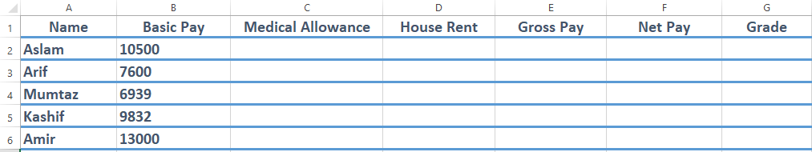**Q: Prepare and print the following data sheet according to the instructions:**

1. Calculate Medical allowance @**7% of Basic Pay** and House Rent **@45% of Basic Pay**. Calculate Gross Pay
2. Compute the **Tax** which is **5% of the Gross Pay** if the Gross Pay is greater than 15000, otherwise it is **3%**

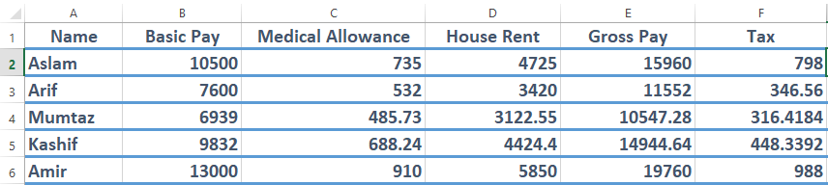

1. Compute the **Net Pay** by subtracting **Tax** from the **Gross Pay**

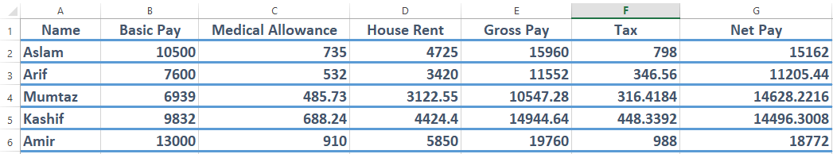

1. 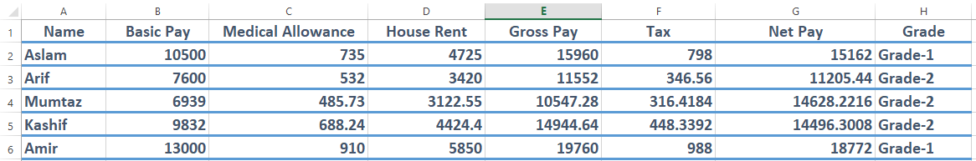Assign the **Grade-1** if the **Net Pay** of employee is greater than **15000** otherwise assign **Grade-2**

**OBJECTIVE 2**

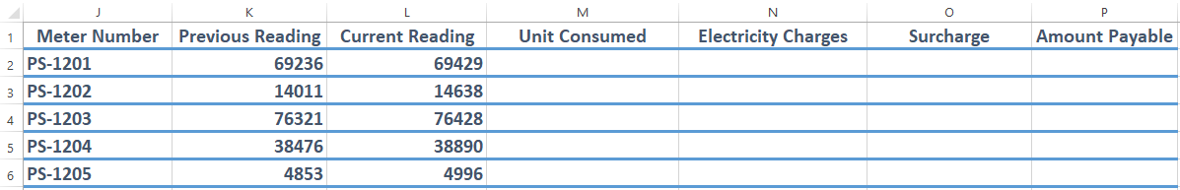**Q: Using spreadsheet, create and print a utility bill of electricity according to the instructions:**

1. Calculate units consumed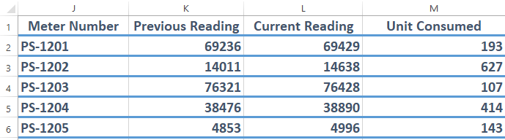
2. 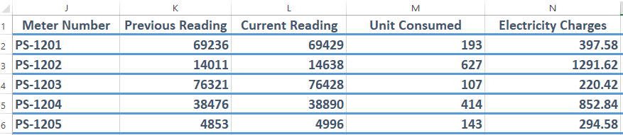Cost of 1 unit of electricity if Rs. 2.06
3. 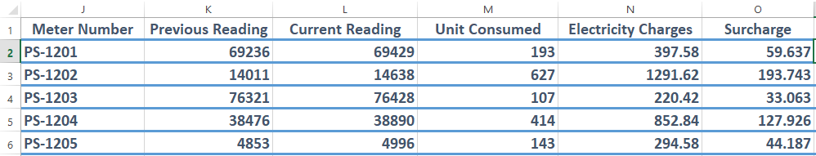Compute the Surcharge as 15% of electricity charges
4. Compute the amount due & Roundup the Amount Payable to one decimal place.

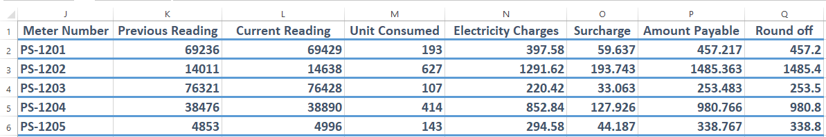

**OBJECTIVE 3**

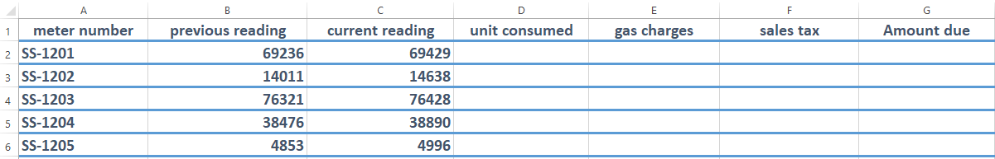**Q: Using spreadsheet, create & print a utility bill of Sui Gas**

1. Enter a formula to calculate units consumed

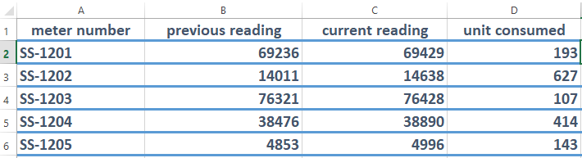

1. 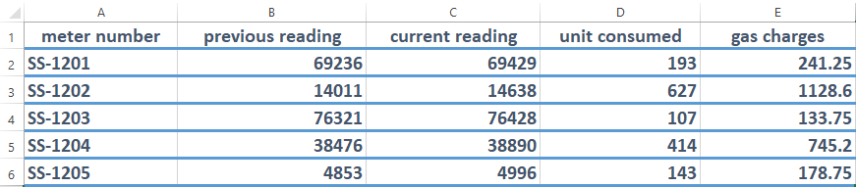Compute the gas charges which are RS 1.25/unit If the units consumed are less than 200, otherwise charges are RS 1.80/unit
2. 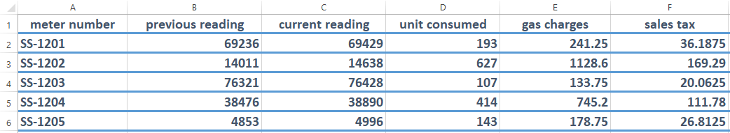Compute the sales tax as 15% of gas charges.
3. Compute the amount due

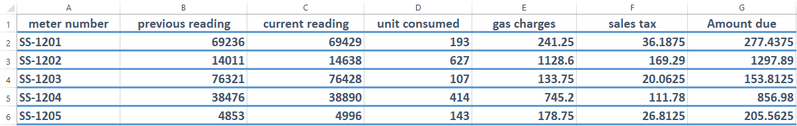

**OBJECTIVE 4**

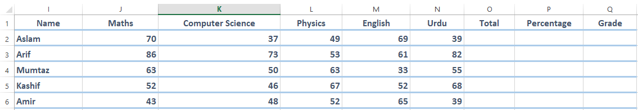**Q: Using spreadsheet, create and print marks certificate according to the following instructions.**

1. 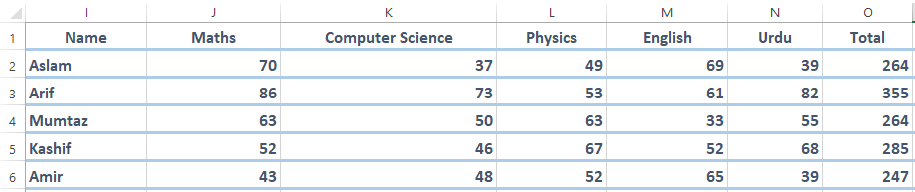Find the total marks of each student
2. 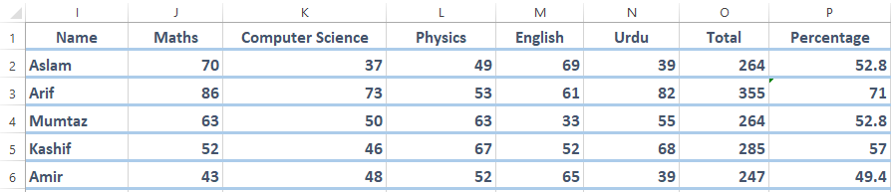Calculate the percentage of each student
3. Assign the Grade according to the following criteria:
4. If Percentage is greater than or equal to 70, print A Grade.
5. If Percentage is greater than or equal to 60, print B Grade.
6. 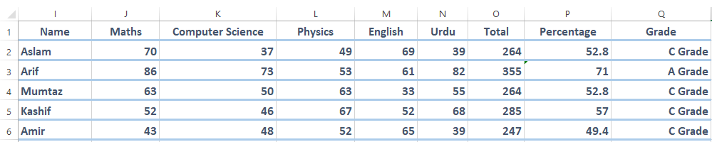If Percentage is less than 60, print C Grade.

**OBJECTIVE 5**

**Q: Create and print a spreadsheet with the following data & follow instructions.**

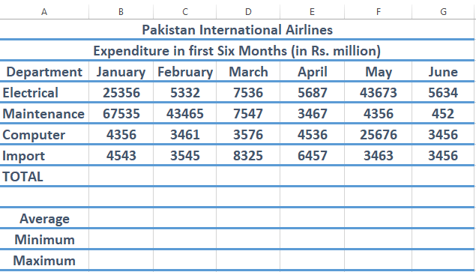

1. 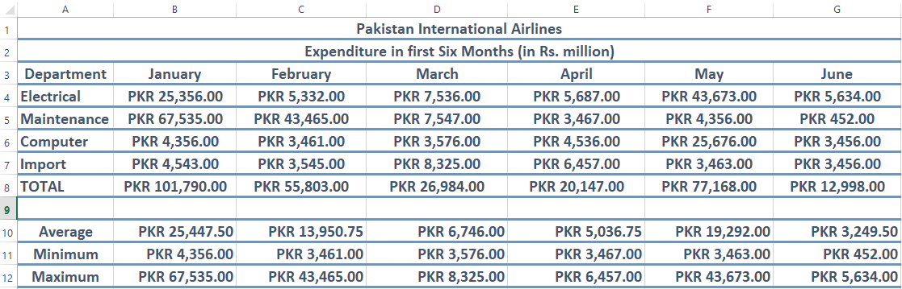Format the values as currency with 2 decimal places;
2. 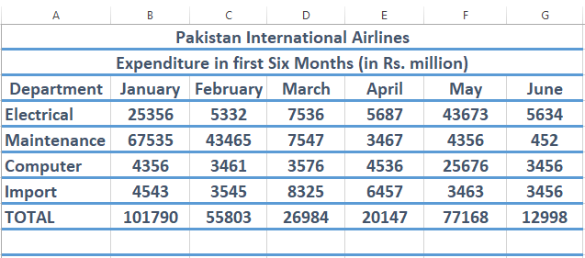Find totals for six months.
3. Find the Average, Maximum, and Minimum for the month of January

