MIDTERM PROJECT REPORT

AI Based Smart Parking
Analytics in Smart Cities
Camera based detection of empty and occupied parking bays
Prepared by
NIDDENA KIRAN

1 Project Overview

Problem statement
Parking availability can change faster than manual counts can be updated. Fixed cameras provide a way to observe several parking bays from one viewpoint. A useful system must locate each visible bay and distinguish an empty bay from an occupied one. Perspective, overlapping vehicles, shadows and missed detections can affect the resulting occupancy count.

Project aim
The project benchmarks object detectors for classifying visible parking bays as empty or occupied in fixed camera images. The benchmark will guide the choice of a prototype detector for a future parking availability system. This midterm report draws on the saved notebook outputs and the final manuscript [3] to document implementation progress and preliminary validation evidence.

Objectives
Objective | Approach
Prepare a labeled dataset | Audit images and labels, standardize the two classes and generate reproducible splits.
Implement the detector benchmark | Configure YOLOv8s, YOLOv5su, YOLO11s and RT-DETR-L in a shared notebook workflow.
Define evaluation measures | Use detection accuracy, precision, recall and processing time to compare checkpoints.
Plan parking analytics | Specify how detections could map to known bays and feed an availability dashboard.

Scope
The experimental scope is detection on stored images. The proposed system would associate detections with registered bays, track state over time and display occupancy. Live video evaluation, cross camera validation and demand forecasting are subsequent work.

2 Dataset and Method

Data preparation
The notebook uses a YOLO formatted derivative of PKLot [1, 2]. It scanned 6,483 candidate images and excluded 249 without matching labels and 492 with unknown occupancy annotations. The remaining 5,742 images represent 88.57% of the candidates. The labels use class 0 for empty bays and class 1 for occupied bays.
Table 1. Image split generated with seed 42.
Partition | Images | Purpose
Training | 4,306 | Fit the detector parameters
Validation | 861 | Track training and select checkpoints
Test | 575 | Evaluate selected checkpoints
Total | 5,742 | Retained images

Training setup
The benchmark runs in Google Colab on a Tesla T4 GPU with Ultralytics 8.3.40. Each detector was scheduled for 30 epochs using an image size setting of 640 pixels and the AdamW optimizer. The three YOLO models use a training batch size of 32, while RT-DETR-L uses a batch size of 8.

Evaluation plan
The detector predicts a bounding box and an occupancy class. Precision measures the share of detections that match a labeled bay, and recall measures the share of labeled bays recovered. Mean average precision (mAP) summarizes detection performance across both classes. Intersection over union (IoU) measures the overlap between the predicted and labeled boxes. The notebook reports mAP at IoU 0.50 and an average over ten IoU thresholds from 0.50 to 0.95. Processing time per image combines preprocessing, inference and postprocessing.
The test split contains 34,400 bay annotations, with 19,053 empty and 15,347 occupied. The random image split can place similar frames from the same viewpoint in different partitions, so an independent camera split is needed to assess transfer.

3 Progress and Preliminary Evidence
Table 2. Training status from the saved notebook logs.
Model | Completed epochs | Status
YOLOv8s | 30 of 30 | Planned training run completed
YOLOv5su | 30 of 30 | Planned training run completed
YOLO11s | 30 of 30 | Planned training run completed
RT-DETR-L | 6 of 30 | Execution stopped during epoch 7

Partial RT-DETR-L validation
Validation mAP at IoU 0.50 rose from 18.1% after the first epoch to 97.6% after the sixth. Over the same interval, mAP across IoU 0.50–0.95 rose from 5.54% to 69.1%. These values describe validation during an interrupted run. A completed run under matched evaluation settings is needed for a fair comparison.
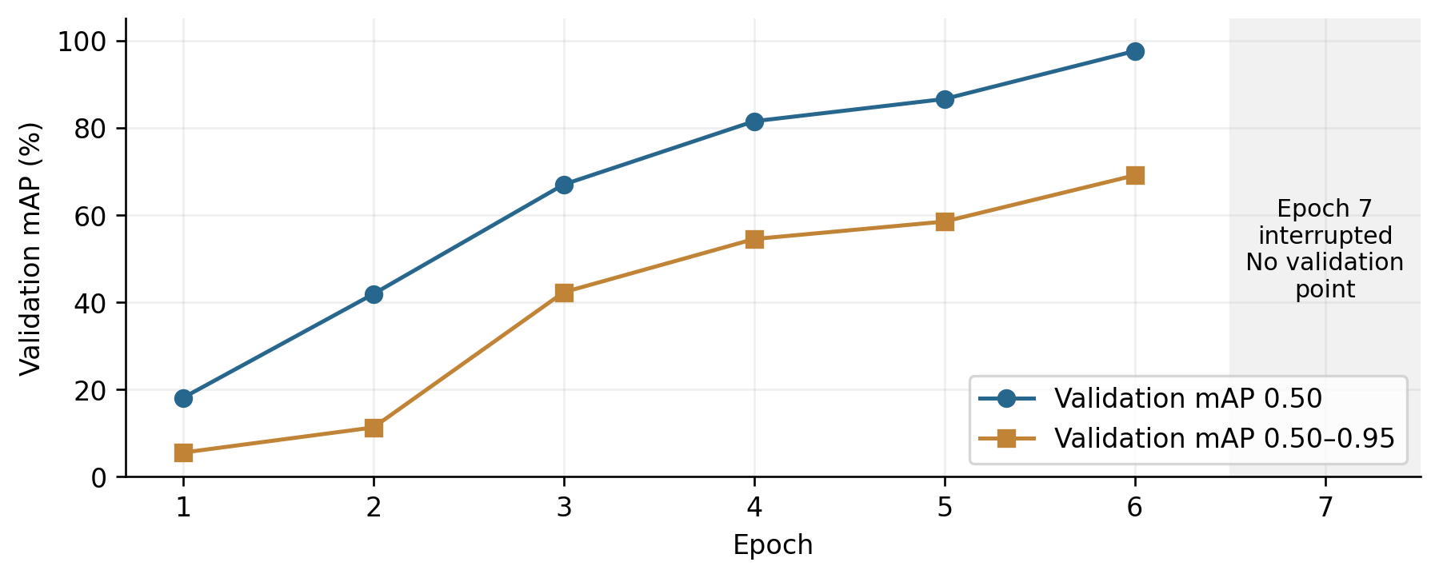
Figure 1. RT-DETR-L validation results for the six completed epochs. Source: saved notebook training logs.
The training log records a cancellation without establishing its cause. A separate out of memory error during test evaluation was handled by freeing GPU memory and evaluating the available checkpoint in half precision.

4 Remaining Work and Conclusion

Next milestones
Milestone | Completion evidence
Complete the RT-DETR-L run | Save the full training log and checkpoint metadata. Repeat test evaluation with matched precision settings.
Check transfer to another viewpoint | Build a split grouped by camera or date and report results on held out images.
Validate occupancy estimates | Compare predicted bay states and occupied counts with human annotations. Report unknown bays separately.
Test a live prototype | Measure delay from image capture to display, including state changes and stale observations.

Midterm conclusion
The project has established a reproducible data preparation and training workflow. Three detector runs reached the planned epoch count, and the notebook captured six completed validation epochs for RT-DETR-L. The next milestone is to complete the transformer run and test the chosen prototype on a new camera view before drawing conclusions about live parking operations.

References
[1] de Almeida, P. R. L., et al. (2015). PKLot: A robust dataset for parking lot classification. Expert Systems with Applications, 42(11), 4937–4949. https://doi.org/10.1016/j.eswa.2015.02.009
[2] duythanhng. Parking Lot Database for YOLO. Kaggle. https://www.kaggle.com/datasets/duythanhng/parking-lot-database-for-yolo
[3] Kiran, N. Project notebook, 00_MASTER_PARKING_BENCHMARK_COLAB.ipynb, and final project manuscript.

