AI Based Smart Parking Analytics
in Smart Cities
Benchmarking Object Detectors for Camera Based Occupancy Detection
NIDDENA KIRAN

Abstract
Camera based parking monitoring can reuse existing surveillance infrastructure, but reliable availability information requires accurate localization, occupancy classification and timely processing. This study evaluates the detection component of an AI based smart parking analytics system using YOLOv8s, YOLOv5su, YOLO11s and RT-DETR-L. A label audit retained 5,742 of 6,483 candidate frames from a YOLO formatted PKLot derivative. The resulting partitions contain 4,306 training, 861 validation and 575 test images; the test set contains 34,400 annotated spaces. Experiments used a Tesla T4 GPU and a planned budget of 30 epochs. The three YOLO models completed that budget. RT-DETR-L completed six epochs before execution was canceled during epoch 7, so its available checkpoint is treated as an intermediate baseline. YOLO11s achieved 99.5% mAP at IoU 0.50 and 98.8% mAP across IoU 0.50–0.95, with 20.0 ms of reported processing time per image. YOLOv8s was close in detection quality, while YOLOv5su had the smallest reported checkpoint. The study combines quantitative comparisons with annotation examples, training curves and a stored-image occupancy display. A proposed integration connects detections to stable bay states, utilization analytics and demand forecasting. The findings support YOLO11s as a prototype candidate on this split, while unequal training completion, possible scene overlap and unmatched timing settings prevent broader claims of architectural superiority or deployment readiness.
Keywords: Smart parking; parking occupancy; PKLot; object detection; YOLO11; RT-DETR; computer vision; occupancy analytics.

1 Introduction
Urban parking management depends on knowing where capacity is available and whether that information is still current. When occupancy records are incomplete or delayed, drivers cannot reliably distinguish a full facility from one with available bays. Operators also lose the historical evidence needed to understand utilization and plan services. A practical smart parking system therefore requires an accurate observation layer before it can support recommendations or forecasting.

Cameras can observe several spaces at once, making image based occupancy detection a useful alternative to installing a dedicated device in every bay. The same view, however, contains perspective distortion, shadows, changing illumination and partial occlusion. A vehicle in the foreground may cover a neighboring space, while distant bays occupy only a small region of the image. The detector must recognize both empty and occupied spaces and locate their boundaries consistently.
This paper studies that observation layer. Its experimental contribution is a comparison of four pretrained detectors adapted to two occupancy classes. Its system contribution is a design showing how these outputs can feed parking analytics. Detection measurements are reported separately from the functions that remain to be implemented.

1 Introduction and study objectives

1.1 Problem definition
The input to the evaluated system is a parking lot image. Its output is a collection of bounding boxes, each with an occupancy class and confidence score. Class 0 denotes an empty space and class 1 denotes an occupied space. This is a detection task because both the location and the class of each space must be predicted. It differs from a crop classifier that assumes the location of every bay is already known.
The operational question is broader than identifying the presence of cars. An empty bay is itself an object of interest, and a complete availability display requires an interpretation of all relevant spaces in a camera view. A car detector followed by geometric assignment and a direct empty or occupied slot detector are two different ways of constructing such a display. This work evaluates the latter formulation represented by the two-class labels in the selected dataset.
Three practical requirements guide the benchmark. First, predictions should preserve useful localization accuracy when the overlap requirement becomes strict. Second, processing should be short enough to support timely updates on the available hardware. Third, the deployed model should have a manageable computational and storage footprint. A model with the highest score under one criterion may not be the best choice once the other constraints are considered.

1.2 Objectives and contributions
The first objective is to document the data path from raw candidate frames to training, validation and testing. The audit identifies why frames were excluded and records the resulting class definitions and partition sizes. This supports interpretation of the reported results and gives a reproducible starting point for subsequent experiments.
The second objective is to compare YOLOv8s, YOLOv5su, YOLO11s and RT-DETR-L using the same image partitions and evaluation interface. The comparison includes overall mAP, precision, recall, class-specific average precision, processing stages, parameter counts and saved checkpoint sizes. It explicitly preserves the incomplete status of RT-DETR-L.

The third objective is to explain how image detections could become an operational occupancy stream. Stable bay identifiers, temporal consistency, missing observations and event logging are considered before discussing forecasting or recommendations. These functions are design proposals, rather than experimentally validated outcomes.

1.3 Scope of the evidence
The benchmark contains one run per model and one random image split. The test set is a held-out image partition from the same collection. Evaluating seed variability, transfer to unseen cameras or dates, and live video performance requires separate experiments.
Processing time covers the stages measured by the validator. A parking service would also need to account for acquiring video, transferring data and refreshing the interface.

2 Literature review
The literature addresses three linked tasks: observing occupancy, associating detections with physical bays and using those observations in a parking service. Studies use different datasets and metrics, so each result needs its own context.

2.1 Datasets and scene transfer
The original PKLot study introduced a substantial resource for parking-space classification under changing outdoor conditions. Its experiments distinguish performance on familiar views from performance on parking lots absent from training (de Almeida et al., 2015). That distinction is central to the present study: excellent results on randomly partitioned images do not by themselves establish transfer to another installation.
The official dataset description organizes imagery by camera view, weather and acquisition date. These attributes are useful beyond data collection because they can define more demanding evaluation groups. A future experiment can use them to prevent closely related frames from appearing in both training and testing.

2 Related work and research gap
Table 1 Selected literature and its relationship to the benchmark
Study | Approach | Relevance to this work
de Almeida et al. (2015) | PKLot and texture based classification | Establishes a parking dataset and scene transfer evaluation.
Amato et al. (2017) | Compact CNN for smart cameras | Motivates efficient image based occupancy estimation.
Rafique et al. (2023) | YOLOv5 vehicle detection and slot assignment | Shows a detection driven route to parking management.
Grbić and Koch (2023) | Vehicle detection, geometric clustering and ResNet34 | Separates slot discovery from occupancy classification.
Alkhudhayr (2025) | SSD–ShuffleNet with optimized SVM | Reference hybrid detector and classifier framework.
Zhao et al. (2024) | RT-DETR with hybrid encoder and decoder | Provides the transformer detector rationale.

2.2 Efficient visual occupancy detection
Amato et al. (2017) developed a compact CNN for decentralized occupancy detection on smart cameras and evaluated it with PKLot and CNRPark-EXT. This work makes edge efficiency a relevant design criterion. A detector benchmark on a T4 GPU, however, cannot substitute for measurement on a smart camera: memory, operators and execution backends can differ substantially.
Rafique et al. (2023) use YOLOv5 for vehicle detection within a parking management framework. Their paper reports 99.5% accuracy on PKLot and a separate custom-data evaluation with 96.8% accuracy and approximately 45 FPS. The present benchmark reports detection mAP for annotated spaces. These metrics and experimental conditions differ, so a direct numerical ranking would be misleading.
Grbić and Koch (2023) identify parking slots from vehicle detections across image sequences, use clustering in a bird’s-eye representation and classify discovered slots with ResNet34. Their approach highlights a problem that remains outside the present experiments: finding stable physical slot locations and preserving those identities when observations change.

2.3 Hybrid and transformer approaches
Alkhudhayr (2025) combines SSD–ShuffleNet with an optimized support vector machine for parking slot detection and classification. The reference framework reports 96.5% accuracy and 50 ms per frame. This study evaluates a separate detector pipeline.
RT-DETR offers another detector design. Zhao et al. (2024) use an efficient hybrid encoder and transformer decoder to avoid conventional non-maximum suppression. This motivates including a transformer alongside the YOLO candidates. The original paper’s COCO results describe a different experiment and cannot be transferred to the parking benchmark.

2.4 Research gap and study position
This study compares existing detectors on one two-class parking dataset, covering detection quality, processing time and resource footprint. It also specifies the functions needed to turn detections into reliable availability information.
An important distinction is maintained between detector selection and full-system validation. The current results can justify selecting a model for the next prototype. They cannot establish that an implemented recommendation service reduces search time, that a forecast is accurate, or that a system remains reliable after camera movement. Those questions require separate data and measurements.

3 Materials and methods
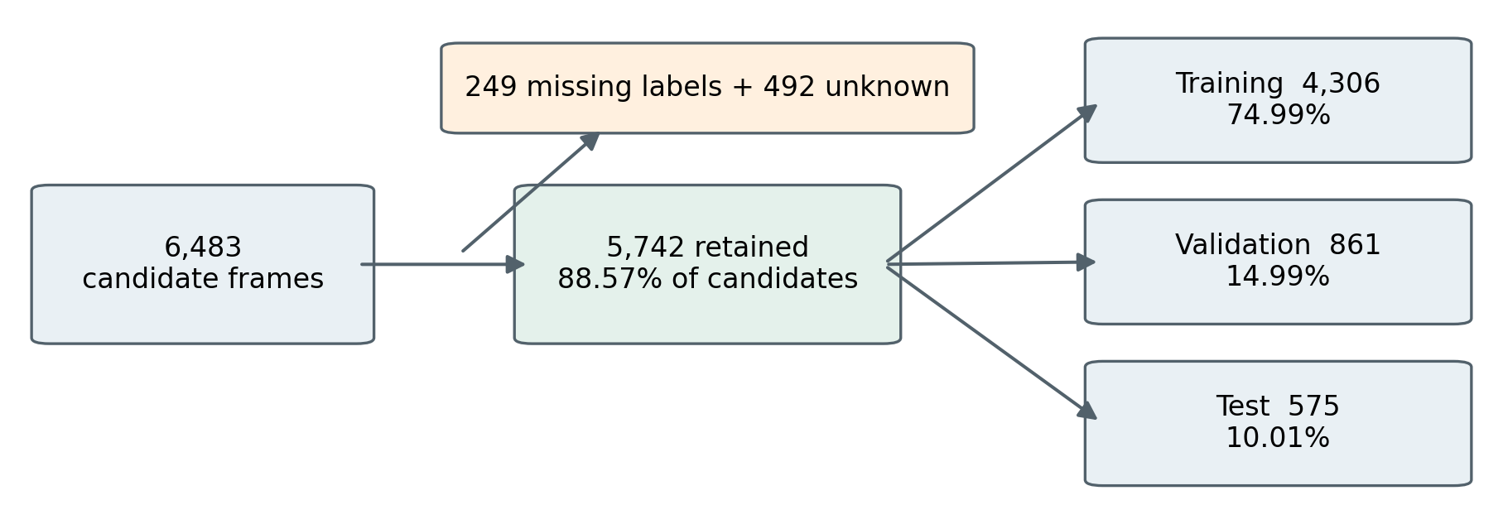
Fig. 1. Data preparation and image allocation. Percentages within the three partitions use 5,742 retained frames as the denominator. Exclusions total 741 frames.
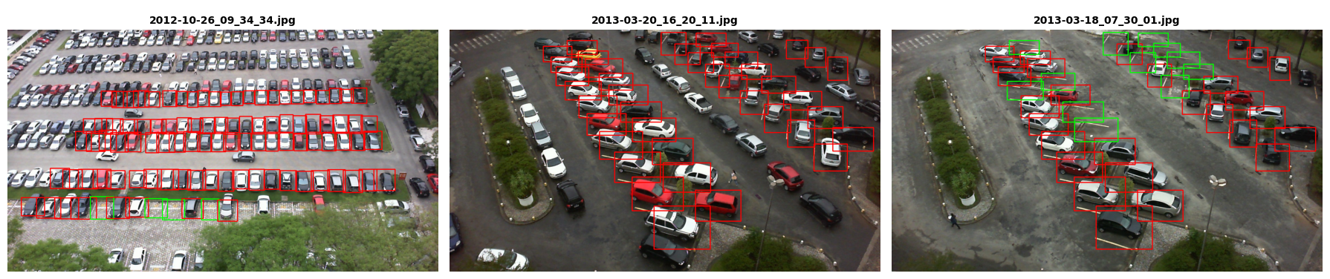
Fig. 2. Annotation examples extracted from the notebook. Green boxes indicate empty spaces and red boxes indicate occupied spaces. Images originate from the PKLot derivative used in the experiment.

3.1 Dataset source
The experiments use the Parking Lot Database for Yolo derivative distributed by duythanhng through Kaggle. The notebook records retrieval of dataset version 1. The original PKLot resource contains images from two parking lots observed through three camera views and includes sunny, cloudy and rainy conditions (de Almeida et al., 2015). The frame counts below refer to the derivative processed by this experiment, rather than the complete original resource or its individual-space crops.
The notebook recursively scans image files and looks for a label file with the same stem. A total of 6,483 candidate images enters this process. The audit excludes 249 images with no corresponding labels and 492 with unknown occupancy annotations. No further exclusions are reported under the empty or invalid label category. The retained set contains 5,742 frames, equivalent to 88.57% of the scanned candidates.

3.2 Annotation checks
The preparation code accepts recognized occupancy aliases and converts them into class identifiers. Each row must contain a class token and at least four coordinates. The normalized center coordinates, width and height must lie between zero and one, with positive width and height. A frame with an unknown occupancy token is excluded, rather than being assigned an invented target.
These checks establish syntactic usability. They do not prove that every box follows the visible boundaries of its bay or that every occupancy label is correct. The example annotations in Fig. 2 support visual inspection of the labeling scheme, but they do not constitute a complete manual audit. A later release should add image decoding checks, geometric boundary validation and review of a stratified sample of annotations.
Axis-aligned rectangles approximate parking spaces even when their physical outlines are oblique. That choice is consistent with the detector formulation used here. It also means that box overlap should be interpreted relative to the supplied rectangles, rather than as an exact measure of the shape of each physical bay.

3 Materials and methods continued
Table 2 Image partitions and available annotation totals
Partition | Images | Image share | Annotated spaces
Training | 4,306 | 74.99% | Not totaled in the saved summary
Validation | 861 | 14.99% | 48,876
Test | 575 | 10.01% | 34,400
Total retained | 5,742 | 100% | Not reported for all partitions
Shares are rounded independently and therefore do not sum to exactly 100.00% in the three partition rows.
Table 3 Occupancy class distribution
Class | Validation boxes | Test boxes | Test share
Empty slot 0 | 27,783 | 19,053 | 55.39%
Occupied slot 1 | 21,093 | 15,347 | 44.61%
Total | 48,876 | 34,400 | 100.00%

3.3 Partition construction
The notebook sorts eligible paths and shuffles them with seed 42. It takes the integer parts of 75% and 15% for training and validation, respectively, and reserves the remainder for testing. All four models share the same 4,306 training, 861 validation and 575 test images.
Validation supports checkpoint selection. The test partition assesses the selected checkpoints. Repeated selection based on test results would turn it into a development set. Future comparisons should reserve an untouched partition or follow a prespecified protocol.
The 34,400 test boxes correspond to an average of approximately 59.83 annotated spaces per image. Empty boxes account for 55.39% of test annotations. At image level, empty spaces appear in 494 frames and occupied spaces in 462. These image counts overlap because a frame may contain both categories; they must not be added to estimate the number of test images.

3.4 Preprocessing and augmentation
Each YOLO label records the class, normalized horizontal and vertical center, width and height. Training uses pretrained weights and an image size setting of 640. The detection library handles resizing and padding, so exact tensor dimensions can vary.

The saved trainer configuration records horizontal flipping, translation, scaling and color augmentation settings. It also lists mosaic and a close-mosaic setting. These are configuration records, rather than a measured comparison of augmentation strategies, and architecture-specific trainers may apply them differently. No augmentation ablation was performed, so improvements cannot be attributed to any one transformation.

3.5 Reproducibility boundaries
A fixed seed preserves the intended random allocation, but it does not ensure independent scenes. Frames captured near each other may share vehicles, background and illumination. The notebook does not group by date, camera or parking lot before splitting. The resulting scores therefore describe within-collection image generalization.
The notebook flattens source paths to filenames and can reuse a destination when its file count matches expectations. For stronger reproducibility, preserve relative paths, check for collisions, compare image and label hashes, and record the exact split in a versioned manifest.

3 Candidate detector architectures
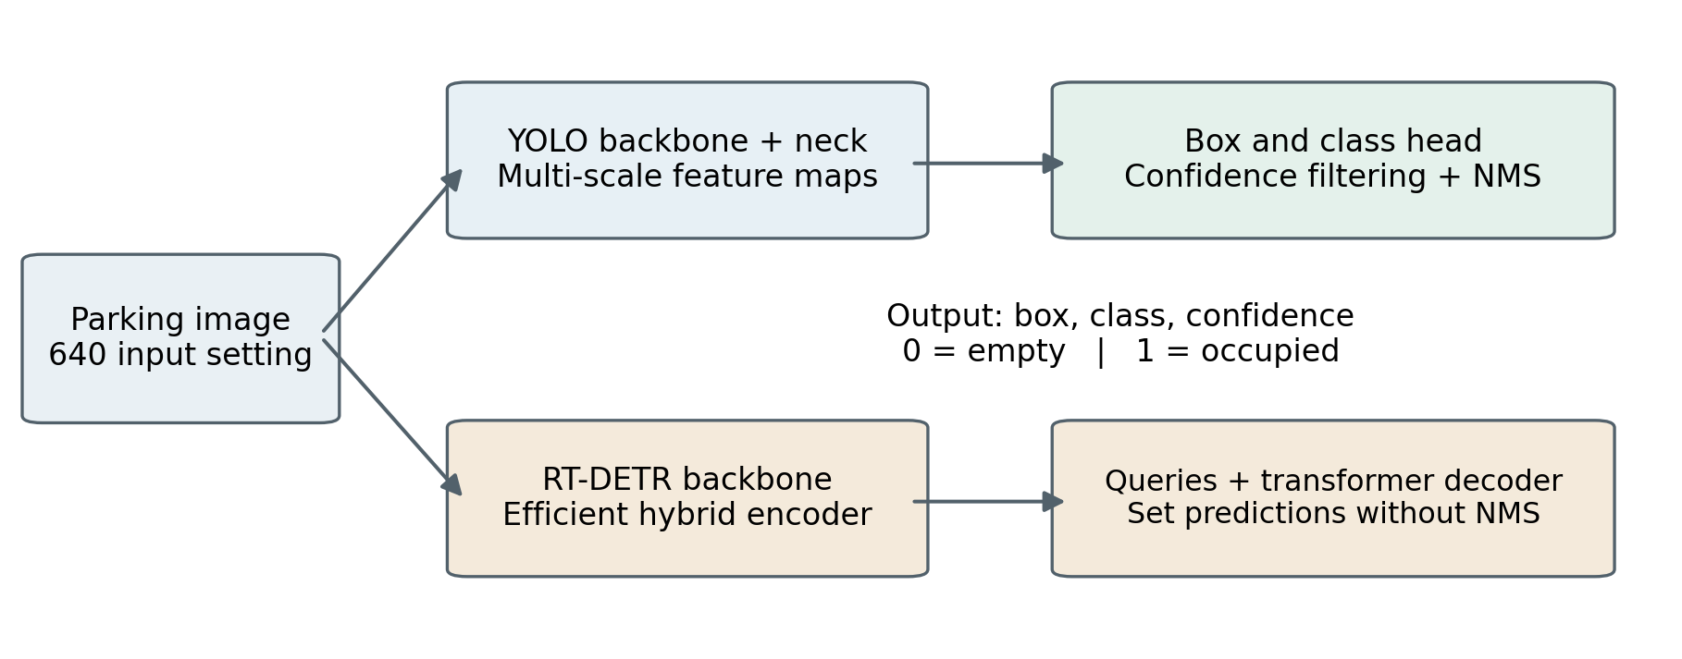
Fig. 3. Conceptual detector pathways. The diagram summarizes the main processing stages, not every layer in the implementations. Both pathways produce the same two-class parking output.
Table 4 Candidate models and notebook-reported model summaries
Model | Starting checkpoint | Parameters M | FLOPs G | Detection design
YOLOv8s | yolov8s.pt | 11.126 | 28.4 | Anchor-free split head
YOLOv5su | yolov5su.pt | 9.112 | 23.8 | Updated YOLOv5u head
YOLO11s | yolo11s.pt | 9.414 | 21.3 | Revised feature extraction
RT-DETR-L | rtdetr-l.pt | 31.988 | 105.3 | Hybrid encoder and decoder
FLOPs and parameter counts are taken from the model summaries in the evaluation output; the YOLO summaries are fused. FLOPs are model estimates, not measured device utilization.

3.6 YOLO candidates
YOLOv8s serves as the anchor-free baseline. Its feature extractor and neck supply multi-scale information to a split detection head, which predicts localization and class information (Ultralytics, n.d.-b). The small variant offers a practical starting point for the hardware available in this study.
YOLOv5su belongs to the updated YOLOv5u family. Ultralytics documents an anchor-free, objectness-free split head for this family (Ultralytics, n.d.-a). The suffix matters: the experiment does not use the original anchor-based YOLOv5s implementation, even though some console summaries shorten the model name. Keeping the full checkpoint name avoids conflating these variants.
YOLO11s is the third small YOLO candidate. The notebook configuration and model description identify C3k2 and C2PSA components, while the official documentation describes improvements to feature extraction and efficiency (Ultralytics, n.d.-c). The experimental comparison assesses the complete trained model; it does not isolate the contribution of either component.

3.7 Transformer candidate
RT-DETR-L introduces a different processing route through a hybrid encoder and transformer decoder. Query-based prediction provides a set of detections without conventional NMS (Zhao et al., 2024). This gives the benchmark architectural diversity, but the large variant is not capacity matched to the small YOLO models.
The recorded RT-DETR-L summary contains approximately 31.99 million parameters, compared with 9.41 million for YOLO11s. Its larger footprint and different optimization behavior are relevant experimental conditions. The incomplete run cannot establish whether a transformer architecture is inherently unsuitable for parking detection.
All models are adapted from pretrained checkpoints to the same two target classes. This controls the task definition while retaining each model’s own architecture and training implementation. A fair interpretation consequently concerns these model variants under the recorded settings, rather than every possible member of their respective detector families.

3 Training and evaluation protocol
Table 5 Experimental configuration
Setting | Recorded value
Execution environment | Google Colab; Tesla T4; 14.56 GiB reported memory
Software reported in output | Python 3.13.16; PyTorch 2.11.0+cu130; Ultralytics 8.3.40
Training budget and input | 30 epochs planned; image-size setting 640
Optimizer and schedule | AdamW; initial learning rate 0.001; cosine schedule; final factor 0.01
Training batches | 32 for the YOLO models; 8 for RT-DETR-L
Other training settings | AMP enabled; seed 42; 2 workers; pretrained initialization
Test evaluation | Test split; batch 1; confidence 0.001; IoU argument 0.7
Successful RT-DETR-L evaluation | Explicit half precision after GPU memory cleanup
Software versions are transcribed from the saved notebook output. Timing comparisons retain the precision-setting difference between the evaluation calls.

3.8 Optimization and checkpoint selection
The training loop uses AdamW, which decouples weight decay from the adaptive optimization update (Loshchilov and Hutter, 2019). The same requested initial learning rate and schedule are used across models, with a smaller batch for RT-DETR-L. Automatic mixed precision is enabled during training. A common schedule is a controlled starting point, but it is not evidence that each architecture received its individually optimal configuration.
The available best.pt file from each model is used for test evaluation. For RT-DETR-L this is a checkpoint from the incomplete run, rather than a checkpoint after 30 completed epochs. The training output also warns that a CUDA grid-sampling backward operation lacks a deterministic implementation. Seed 42 therefore does not establish bitwise reproducibility for the entire training process.

3.9 Detection quality measures
For a predicted box B and ground-truth box G, intersection over union is the area of their overlap divided by the area of their union:
$IoU(B,G) = \frac{|B ∩ G|}{|B ∪ G|}$ (1)
Precision P measures the proportion of predicted detections counted as true positives. Recall R measures the proportion of ground-truth objects recovered:
$P = \frac{TP}{TP + FP} , R = \frac{TP}{TP + FN}$ (2)

Average precision summarizes the precision–recall curve for a class at a specified overlap threshold. Mean average precision averages AP over the two classes:
${mAP}_{τ} = \frac{{AP}_{empty,τ} + {AP}_{occupied,τ}}{2}$ (3)
The stricter reported measure averages mAP over ten IoU thresholds, from 0.50 to 0.95 in steps of 0.05:
${mAP}_{0.50–0.95} = \frac{1}{10}\sum_{k=0}^{9}{mAP(0.50 + 0.05k)}$ (4)
This measure penalizes imprecise boundaries more strongly than mAP at IoU 0.50 alone. The evaluation call’s IoU argument of 0.7 is a prediction-processing setting; it is not a replacement for the ten thresholds used to compute the stricter mAP measure.

3.10 Processing time
Reported processing time is the sum of preprocessing, inference, loss and postprocessing entries returned by the validator. The loss entry is zero in the saved evaluation output. The corresponding stage throughput is calculated as FPS = 1000 / t, where t is the summed time in milliseconds. Capture, decoding, transfer, queueing and display costs are outside this quantity. The benchmark reports it as stage throughput rather than a demonstrated live-camera frame rate.

4 Experimental results
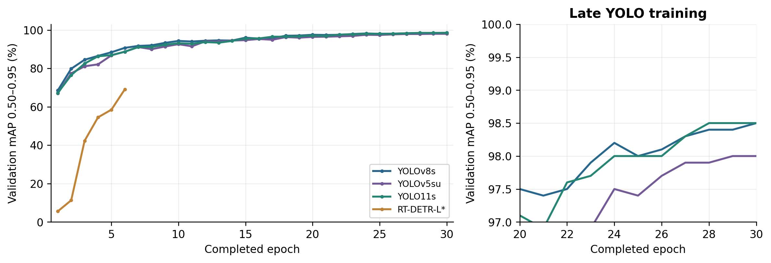
Fig. 4. Validation mAP 0.50–0.95 reconstructed from the printed epoch logs. The right panel enlarges late YOLO training. RT-DETR-L has six completed validation points; no values are extrapolated.
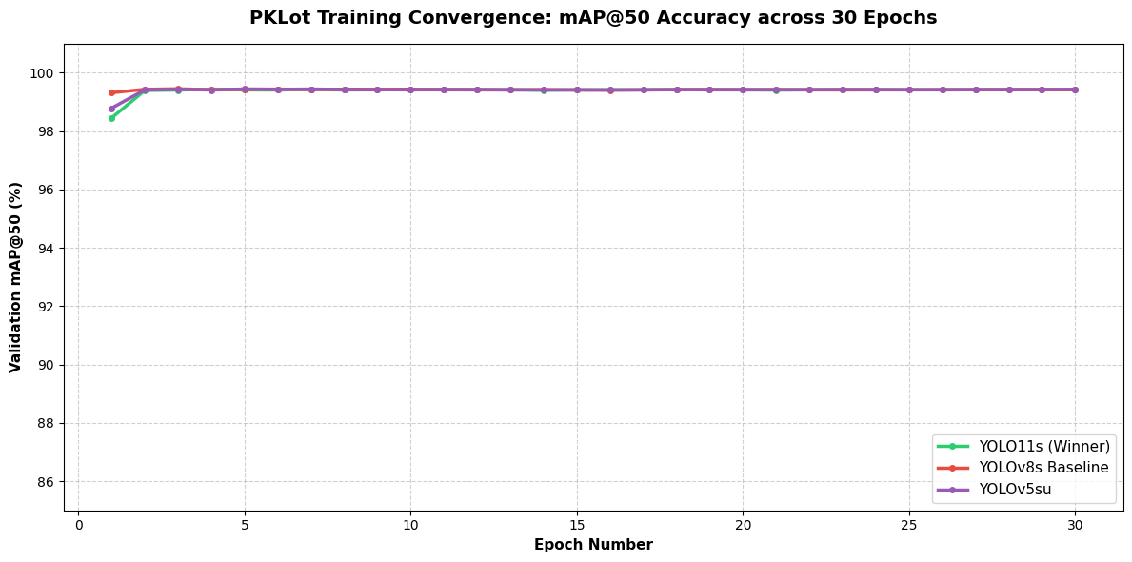
Fig. 5. Original notebook convergence chart for validation mAP at IoU 0.50. Its plotted curves cover the three YOLO models. The stricter measure in Fig. 4 provides greater separation late in training.

4.1 Training behavior
All three YOLO models complete the planned 30 epochs. Their validation mAP at IoU 0.50 approaches its final range early, as shown in Fig. 5. Once this easier localization criterion becomes nearly saturated, it offers limited resolution for distinguishing later improvements. The stricter mAP measure in Fig. 4 remains more informative about the refinement of bounding boxes.
The curves do not show a persistent decline in the recorded validation measure near the end of the YOLO runs. This is useful evidence about convergence on the chosen validation partition, but it does not establish generalization to new cameras. The training and validation partitions may contain strongly related scenes, and their relationship affects how the curves should be interpreted.

RT-DETR-L follows a visibly different early trajectory. Its first validation point is low, followed by substantial improvement over the next five completed epochs. The last saved point is still part of a short training history. Extending a line beyond that point would imply results that were never observed.
The figures use the values preserved in the notebook rather than rerunning the models. Printed epoch metrics have limited precision, so very small visual differences should not be treated as exact numerical estimates. Repeated runs and machine-readable metric exports would be required to quantify the stability of the final ranking.

4 Training completion and interrupted run
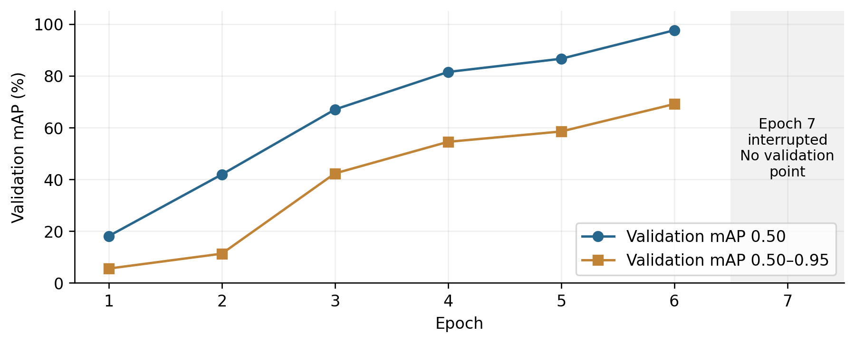
Fig. 6. RT-DETR-L validation progress over six completed epochs. Epoch 7 was interrupted at approximately 61% of its training batches, before another completed validation result.
Table 6 Training execution status
Model | Completed epochs | Batch | Recorded wall time min
YOLOv8s | 30 of 30 | 32 | 49.94
YOLOv5su | 30 of 30 | 32 | 47.91
YOLO11s | 30 of 30 | 32 | 50.94
RT-DETR-L | 6 of 30; epoch 7 partial | 8 | No completed-run total

4.2 What the interruption shows
RT-DETR-L completes six epochs with validation. In epoch 7, the log reaches approximately 330 of 539 batches and records “Canceled future for execute_request message before replies were done.” The cancellation identifies the interruption. Its underlying cause remains undetermined.
The sixth completed validation result is 97.6% mAP at IoU 0.50 and 69.1% mAP across IoU 0.50–0.95. The improvement from the first epoch to this point is substantial, so the six-epoch checkpoint should not be described as a fully converged result. Only 20% of the planned epoch budget has a completed validation record.

4.3 Separate evaluation failure and recovery
A later test-evaluation sequence successfully processes the three YOLO models but raises a CUDA out-of-memory error when it reaches RT-DETR-L. This is a separate event from the training cancellation. The recovery cell performs process and memory cleanup, then evaluates the existing RT-DETR-L checkpoint with half precision explicitly enabled.

That successful evaluation reports 97.58% test mAP at IoU 0.50 and 69.21% test mAP across IoU 0.50–0.95. The proximity to the final recorded validation values is consistent with evaluating an early checkpoint, but the saved output does not provide a checkpoint hash or an independently verified checkpoint epoch. The test result is therefore attributed to the available best.pt from the incomplete run.

4.4 Consequences for comparison
The interrupted model is retained as an intermediate baseline because it provides useful information about the experiment. It is marked with an asterisk in the remaining tables and charts. Its lower score cannot be interpreted as an equal-budget defeat of the transformer family.
A follow-up run should restore the last resumable training checkpoint, verify optimizer and scheduler state, and complete the planned budget in a clean session. If those states cannot be restored, the alternative is a documented new run from pretrained weights. Either route should produce fresh, traceable evaluation outputs rather than carrying forward manually entered summary values.

4 Overall detection performance
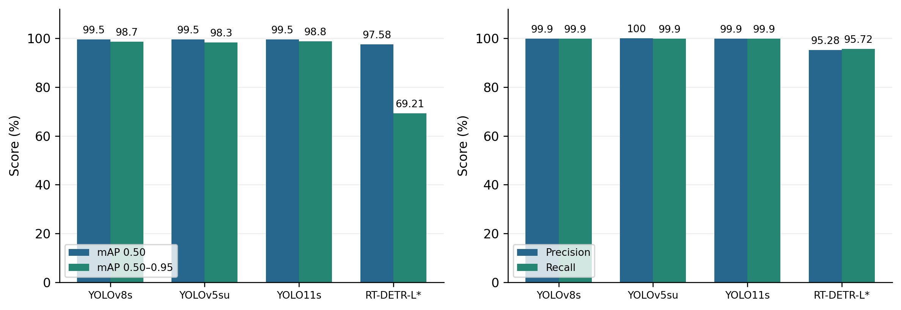
Fig. 7. Test-set detection quality from the evaluation records. RT-DETR-L* is the incomplete-run checkpoint. These are detection metrics, not image classification accuracy or live-system reliability.
Table 7 Overall evaluation on 575 test images and 34,400 boxes
Model | mAP 0.50 % | mAP 0.50–0.95 % | Precision % | Recall %
YOLOv8s | 99.5 | 98.7 | 99.9 | 99.9
YOLOv5su | 99.5 | 98.3 | 100.0 | 99.9
YOLO11s | 99.5 | 98.8 | 99.9 | 99.9
RT-DETR-L* | 97.58 | 69.21 | 95.28 | 95.72
YOLO values follow the rounded evaluator output and its summary transcription. RT-DETR-L values follow the successful evaluation summary. A rounded 100.0% does not prove an absence of errors.

4.5 Comparison of aggregate metrics
All three YOLO models report 99.5% mAP at IoU 0.50. Across IoU 0.50–0.95, YOLO11s scores 98.8%, YOLOv8s 98.7% and YOLOv5su 98.3%. The 0.1 percentage-point lead over YOLOv8s is descriptive. Assessing its stability requires repeated runs and uncertainty estimates.
The incomplete RT-DETR-L checkpoint scores 97.58% mAP at IoU 0.50 and 69.21% across IoU 0.50–0.95. The drop shows weaker performance under stricter localization criteria. Additional training could change the result.

4.6 Precision and recall interpretation
The YOLO models report high precision and recall at the evaluator’s operating point. A parking service would need a separate evaluation at its chosen threshold to measure the accuracy of bay states shown to drivers.

The distinction is especially relevant because the qualitative display uses confidence 0.25, whereas test evaluation begins at confidence 0.001 to retain detections for precision–recall analysis. A deployed service must choose its threshold using the cost of false availability and missed availability, then validate that operating point separately.

4.7 What cannot be recovered from the summary
The saved aggregate metrics do not provide a complete fixed-threshold confusion matrix. Rounding, class averaging and matching behavior prevent a reliable reconstruction of exact true-positive, false-positive and false-negative counts. No such counts are inferred here. A future evaluation should preserve per-image predictions and matched ground-truth assignments so that error categories can be inspected directly.
The current evidence favors YOLO11s for prototype selection because it combines the highest printed strict mAP with the shortest reported stage time. That is a practical choice within this experiment, rather than a claim that accuracy alone clearly separates it from YOLOv8s.

4 Class specific performance and error implications
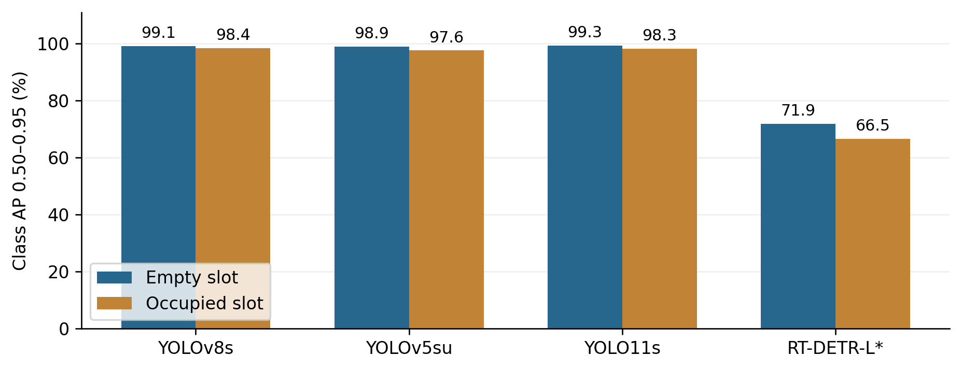
Fig. 8. Class-specific AP across IoU 0.50–0.95, transcribed from the test evaluator. RT-DETR-L* reflects the incomplete training run. The bars use a zero baseline.
Table 8 Class-specific precision and recall at the evaluator’s displayed precision
Model | Empty P % | Empty R % | Occupied P % | Occupied R %
YOLOv8s | 99.9 | 100.0 | 100.0 | 99.9
YOLOv5su | 99.9 | 100.0 | 100.0 | 99.9
YOLO11s | 99.9 | 100.0 | 100.0 | 99.9
RT-DETR-L* | 92.1 | 97.8 | 98.4 | 93.6
Class-specific YOLO empty-slot recall is printed as 1.0 in the evaluator. The table follows that output instead of the notebook chart’s manually entered 99.9 value.

4.8 Empty and occupied spaces
YOLO11s achieves 99.3% AP for empty spaces and 98.3% for occupied spaces across IoU 0.50–0.95. YOLOv8s scores 99.1% and 98.4%, respectively. YOLO11s has the higher overall mean, and YOLOv8s has the higher reported AP for occupied spaces.
YOLOv5su scores 98.9% for empty spaces and 97.6% for occupied spaces. All three YOLO models show lower strict AP for occupied spaces. Occlusion, vehicle appearance and box boundaries are possible explanations that would require a controlled analysis.
RT-DETR-L scores 71.9% AP for empty spaces and 66.5% for occupied spaces. Its lower empty-space precision and occupied-space recall may contribute to false availability. Quantifying that risk requires an evaluation of bay availability decisions.

4.9 Operational costs of mistakes
False availability directs drivers to unavailable bays. Missed availability hides usable spaces. Evaluate these errors separately because their costs depend on the facility, update frequency and whether the service recommends a specific bay.
Group errors by camera, bay size, weather, occupancy density and occlusion. Distinguish wrong class labels, missed detections, duplicate boxes and poor localization. Inspect distant bays separately because they occupy fewer image pixels.

4.10 Thresholds and confidence
Validate confidence thresholds and calibration on held-out sequences before using predictions for reservations or guidance. Keep low-confidence and missing observations in an unknown state. Treating missed detections as empty could produce false availability even with high aggregate mAP.

4 Processing time and resource footprint
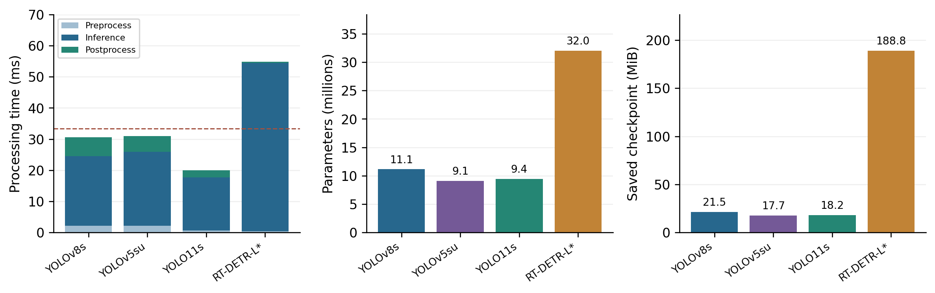
Fig. 9. Reported processing stages, parameter counts and saved checkpoint sizes. The dashed line is a 33.3 ms illustrative budget for 30 updates per second, not a measured application requirement. RT-DETR-L* uses explicit half precision.
Table 9 Timing and stored checkpoint comparison
Model | Pre ms | Infer ms | Post ms | Total ms | Stage FPS | File MiB
YOLOv8s | 2.2 | 22.3 | 6.1 | 30.60 | 32.7 | 21.5
YOLOv5su | 2.2 | 23.7 | 5.1 | 31.00 | 32.3 | 17.7
YOLO11s | 0.7 | 17.0 | 2.3 | 20.00 | 50.0 | 18.2
RT-DETR-L* | 0.4 | 54.0 | 0.4 | 54.77 | 18.3 | 188.8
Stage times are rounded to one decimal in the evaluator. Their rounded sum can differ from the total computed from unrounded entries. MiB denotes bytes divided by 1,048,576.

4.11 Measured processing stages
YOLO11s has the shortest reported total at 20.0 ms per image. Its inverse is 50.0 stage FPS. YOLOv8s and YOLOv5su record 30.6 ms and 31.0 ms, corresponding to 32.7 and 32.3 stage FPS. The RT-DETR-L checkpoint records 54.77 ms and 18.3 stage FPS after memory cleanup and explicit half-precision evaluation.
Relative to YOLOv8s, the recorded YOLO11s total is approximately 34.6% lower, calculated as (30.6 − 20.0) / 30.6. This derived comparison summarizes the listed timings. It does not isolate architecture as the cause because preprocessing and postprocessing times also differ, and session conditions were not repeatedly controlled.
The evaluation progress bar’s images per second is not the same quantity as inverse stage latency. It includes other validation work and synchronization. Neither quantity establishes complete camera-to-screen latency. A deployment benchmark should include decoding, queueing, transfers, temporal processing and dashboard updates, as well as the detector itself.

4.12 Parameters and checkpoint storage
YOLOv5su has the smallest reported parameter count and checkpoint size among the evaluated variants. YOLO11s is slightly larger, while YOLOv8s contains approximately 11.13 million parameters. RT-DETR-L contains approximately 31.99 million and its saved file is reported as 188.8 MiB in the successful comparison summary.
Checkpoint storage is not a direct measurement of inference memory. Training-state content, precision and serialization can affect file size. The notebook’s later resource chart hard-codes a 65.0 MB RT-DETR-L value; that figure is not the recorded size of the evaluated file. This comparison therefore uses 188.8 MiB and keeps parameter count on a separate scale from storage.

4.13 Timing limitations
The successful RT-DETR-L call explicitly enables half precision, whereas the earlier YOLO calls do not explicitly request the same setting. A matched rerun should standardize precision, warm-up, input handling and device state, and report repeated latency samples. Measurements on an edge device are also necessary before making a hardware deployment claim.

4 Qualitative occupancy display
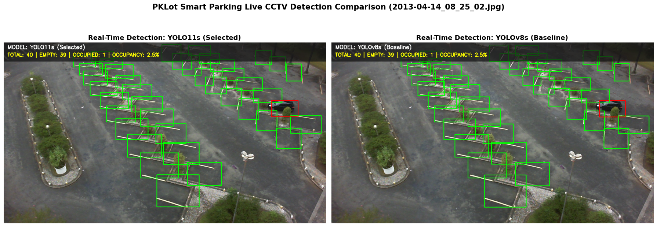
Fig. 10. Original notebook display for test image 2013-04-14_08_25_02.jpg. Both models show 39 empty and one occupied space among 40 detections. Although the figure’s original headings use “live” and “real-time,” the code processes one stored test image.

4.14 Demonstration procedure
The notebook applies YOLO11s and YOLOv8s to the same stored test image using a confidence threshold of 0.25 and an IoU setting of 0.5. Green boxes mark empty spaces and red boxes mark occupied spaces. The banner shows the detection count, class counts and occupancy percentage.
Both models detect 40 spaces in the example image, with 39 empty and one occupied. The display calculates occupancy as follows.
$Occupancy = 100 × \frac{N_{occupied}}{N_{empty} + N_{occupied}}$ (5)
The displayed occupancy is 100 × 1 / 40 = 2.5%. This describes the detections in the example. Measuring occupancy count accuracy requires comparison with ground truth.

4.15 Interpreting the visual evidence
The display turns detections into an availability summary. It also illustrates why errors can vary within a frame. Distant bays occupy fewer pixels, adjacent boxes can overlap and the camera may cover only part of the facility.
The notebook uses the first matching test file in its directory listing. The image illustrates the display procedure. A representative sample would require a defined selection method.

A qualitative review should cover multiple views and occupancy levels. Comparing each image with its annotations would reveal missed boxes, duplicates and incorrect class labels.

4.16 Counts versus registered capacity
Equation (5) uses the detection count as its denominator. A missed bay can therefore change the displayed occupancy even when the physical capacity and number of parked vehicles stay the same.
A deployed system should track a registered inventory of bays. Each bay can be empty, occupied or unknown. The dashboard should display unknown states and show how recently each bay was observed.

4.17 Required count evaluation
Compare occupied counts against ground truth for every test frame. Report mean absolute count error, the distribution of signed errors and the share of frames with an exact count. Group results by occupancy level to check for crowding effects.
A video evaluation should measure state change delay, occupancy flicker and consistency across repeated observations of the same bay. These measures require sequences of frames.

5 Proposed occupancy analytics integration
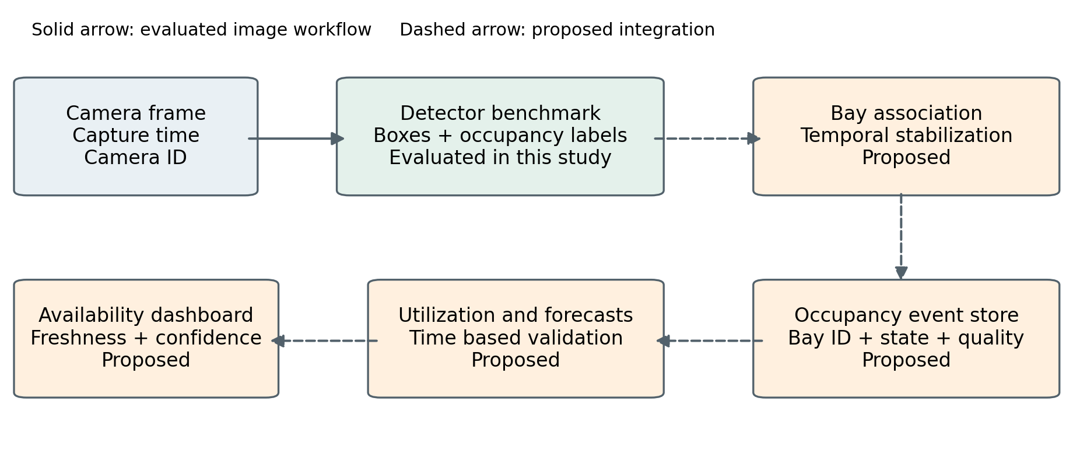
Fig. 11. Proposed integration of the evaluated detector with a parking analytics service. Dashed connections identify functions that are not implemented or evaluated by this benchmark.

5.1 Stable bay state and event logging
For each fixed camera, assign every physical bay a permanent identifier and a calibrated region or polygon. Associate predicted boxes with registered bays using overlap, center position and one-to-one matching. Retain an unknown state when matches are ambiguous.
A temporal layer would require consistent evidence before changing a bay’s state and expire stale observations when frames stop arriving. Evaluate whether reduced flicker justifies the extra delay in detecting changes.
Each accepted observation can be stored with camera identifier, bay identifier, capture time, occupancy state, confidence or quality flag and model version. State transitions provide a more compact event history than retaining every full image. Capture time should be distinguished from processing time so that the system can recognize delayed or out-of-order observations.

5.2 Utilization and peak demand
For N registered bays with valid observations, occupancy can be summarized as O(t) = Noccupied(t) / Nvalid(t), while unknown bays are reported separately. Time-weighted utilization should account for irregular sampling intervals rather than assume every record represents an equal duration. Peak periods can then be described from validated occupancy histories.

Descriptive analytics does not require a separate classifier merely to count empty and occupied outputs. The first implementation can calculate totals, utilization distributions and duration summaries directly from the event stream. Clustering could later explore recurring usage patterns, but it should address a defined question rather than be added solely to increase the number of algorithms.

5.3 Forecasting and recommendation
Forecasting requires chronological observations and evaluation on future intervals. A persistence forecast and a seasonal baseline should be established before testing ARIMA, Prophet or LSTM models. Forecast error should be assessed at explicit horizons, with training data restricted to observations available before each prediction time. The current random image split is not a forecasting protocol.
Slot recommendation would combine validated availability with constraints such as accessibility, entry location and reservation status. A simple rule or greedy allocation method can serve as the initial baseline. More complex optimization should be justified by a measurable benefit. No forecast accuracy, reduced search time or allocation improvement is claimed by the present detector experiment.
Plate recognition and access control remain optional extensions. They are not needed for the two-class occupancy benchmark. Keeping these functions separate helps define the minimum data and processing required for the first useful analytics prototype.

6 Discussion and deployment considerations
Table 10 Evidence required to move from detector benchmark to operational validation
Evaluation question | Required evidence | Current status
Unseen-camera transfer | Camera and date grouped partitions; cross-lot testing | Not tested
Stable occupancy counts | Ground-truth bay states and sequence-level errors | One image demonstration
Live processing performance | Capture-to-display latency, dropped frames and repeated timing | Validator stages only
Transformer comparison | Completed RT-DETR-L training and matched evaluation settings | Six complete epochs
Forecasting benefit | Chronological logs, baselines and future-interval validation | Proposed
Operational impact | Measured search time, utilization and service outcomes | Not measured

6.1 Practical interpretation
YOLO11s is a reasonable choice for the next prototype because it combines strong test-set detection quality with the shortest reported stage time in this experiment. YOLOv8s remains a close quality baseline, and YOLOv5su offers a slightly smaller saved model. The decision should remain revisable after matched timing tests and evaluations on unseen camera views.
A fixed camera installation can use a lower update frequency than the camera’s native frame rate if bay occupancy changes slowly. The appropriate interval depends on the required state-change delay and service behavior. A 30 FPS target is therefore an illustrative engineering reference, not a universal requirement for parking analytics. Sampling policy should be validated alongside the detector.

6.2 Camera and environment changes
Camera movement changes the relationship between image coordinates and physical bays. The service should detect or flag substantial view changes and require recalibration before issuing bay-level guidance. A highly accurate model on the previous view does not guarantee that the stored bay geometry remains valid.
Environmental testing should separate sunny, cloudy and rainy imagery and add genuinely new low-light or night data where needed. The official PKLot acquisition description does not provide a night-time test basis. Fog, glare, unusual vehicles, temporary obstructions and changed lot markings are further examples that require measured coverage rather than assumed robustness.

A useful validation design would hold out cameras and dates, group near-duplicate images and add an independent parking location. This would answer whether the model recognizes occupancy features that transfer beyond familiar backgrounds. It would also reveal whether the small observed differences among the YOLO candidates persist under a more demanding protocol.

6.3 Data minimization and monitoring
The initial analytics service can operate primarily on bay states and aggregate counts. Retaining these outputs instead of unrestricted video reduces the amount of visual information stored. If frames are kept for error review, their retention and access controls should be defined for that purpose. Plate recognition should be evaluated as a separate requirement rather than treated as necessary for occupancy estimation.
Operational monitoring should include stale-camera alerts, missing-bay rates, sudden count changes and inference failures. These signals are important because a detector can produce confident outputs while the overall service is using an outdated frame or an incorrect camera calibration. Model version and configuration identifiers should be logged so that unexpected changes can be traced.
These considerations describe implementation requirements. They do not establish that deployment costs, congestion, emissions or user waiting times have already improved. Such benefits require a prospective evaluation of the complete service in its intended setting.

6 Limitations and conclusions

6.4 Limitations of the comparison
The strongest limitation is unequal training completion. Three YOLO models receive 30 complete epochs, while RT-DETR-L provides only six complete validation epochs. The comparison describes available checkpoints; it cannot distinguish the effects of training duration, model capacity and architecture. Completing the transformer run is necessary before drawing a stronger conclusion about its suitability.
The second limitation is possible dependence between image partitions. Randomly splitting a collection of fixed-camera imagery can place related frames in both training and testing. The experiment does not quantify exact duplicates, near duplicates or temporal overlap. High mAP is therefore compatible with a substantially harder deployment problem on an unfamiliar camera.
Third, the benchmark contains one run per model. There are no repeated-seed estimates, confidence intervals or tests showing that the 0.1 percentage-point difference between YOLO11s and YOLOv8s is stable. The number of annotated boxes is large, but boxes within the same frame or camera are correlated. Any future uncertainty analysis should account for that grouping.
Fourth, timing settings and session conditions are not fully matched. The successful RT-DETR-L evaluation explicitly enables half precision after memory cleanup. The recorded stage times do not include the complete video application. Checkpoint size is also affected by serialization and saved state, so it cannot be treated as peak inference memory or a direct edge-deployment requirement.
Finally, occupancy analytics, forecasting, recommendation and monitoring are not experimentally evaluated. The stored-image display demonstrates the conversion from predictions to a count, but does not measure count error across the test set or temporal stability. A detection benchmark is an important component of a parking system, not evidence for every proposed system benefit.

6.5 Priorities for further experiments
Complete RT-DETR-L training with traceable checkpoints, then compare models under matched precision and timing settings. Export metrics directly from the evaluator to keep tables and charts consistent.

The second priority is a camera and date grouped evaluation with image hashes, collision-free filenames and a saved split manifest. Reporting by weather, bay scale and occupancy level would make the source of errors easier to understand. Repeated runs would then determine whether the model ordering is stable.
The third priority is a video prototype with registered bay identifiers. Its evaluation should measure occupied-count error, false availability, state-change delay, stale observations and end-to-end latency. Forecasting and recommendation should be added only after a sufficiently reliable chronological occupancy record is available.

7 Conclusion
This study evaluates four object detectors for empty and occupied parking-space detection using an audited PKLot-derived dataset. The data preparation retains 5,742 frames, with 575 images and 34,400 annotated spaces reserved for testing. The completed YOLO runs achieve high detection scores on this partition, while the RT-DETR-L result represents a six-epoch intermediate baseline after an interrupted seventh epoch.
YOLO11s provides the most favorable observed combination of overall strict mAP and reported processing time: 98.8% mAP across IoU 0.50–0.95 and 20.0 ms per image. YOLOv8s is close in accuracy, and YOLOv5su has the smallest reported checkpoint. These findings support selecting YOLO11s for a prototype while retaining the other YOLO models as relevant baselines.
The wider contribution is an explicit path from detections to validated occupancy analytics. Stable bay association, uncertainty handling and event logging must precede dependable forecasts or recommendations. Completing the interrupted run, strengthening scene separation and measuring the full video workflow are the next steps needed to establish performance beyond the present image benchmark.

References and data availability

Alkhudhayr, H., 2025. Internet of things based parking slot detection and occupancy classification for smart city traffic management. Engineering Applications of Artificial Intelligence 152, 110802. https://doi.org/10.1016/j.engappai.2025.110802.
Amato, G., Carrara, F., Falchi, F., Gennaro, C., Meghini, C., Vairo, C., 2017. Deep learning for decentralized parking lot occupancy detection. Expert Systems with Applications 72, 327–334. https://doi.org/10.1016/j.eswa.2016.10.055.
de Almeida, P.R.L., Oliveira, L.S., Britto Jr., A.S., Silva Jr., E.J., Koerich, A.L., 2015. PKLot – A robust dataset for parking lot classification. Expert Systems with Applications 42, 4937–4949. https://doi.org/10.1016/j.eswa.2015.02.009.
duythanhng, n.d. Parking Lot Database for Yolo. Kaggle, dataset version 1 used in the experiment. https://www.kaggle.com/datasets/duythanhng/parking-lot-database-for-yolo (accessed 10 November 2026).
Grbić, R., Koch, B., 2023. Automatic vision-based parking slot detection and occupancy classification. Expert Systems with Applications 225, 120147. https://doi.org/10.1016/j.eswa.2023.120147.
Loshchilov, I., Hutter, F., 2019. Decoupled weight decay regularization. International Conference on Learning Representations. https://arxiv.org/abs/1711.05101.
Rafique, S., Gul, S., Jan, K., Khan, G.M., 2023. Optimized real-time parking management framework using deep learning. Expert Systems with Applications 220, 119686. https://doi.org/10.1016/j.eswa.2023.119686.
Ultralytics, n.d.-a. Ultralytics YOLOv5. Model documentation. https://docs.ultralytics.com/models/yolov5/ (accessed 10 November 2026).

Ultralytics, n.d.-b. Explore Ultralytics YOLOv8. Model documentation. https://docs.ultralytics.com/models/yolov8/ (accessed 10 November 2026).
Ultralytics, n.d.-c. Ultralytics YOLO11. Model documentation. https://docs.ultralytics.com/models/yolo11/ (accessed 10 November 2026).
Zhao, Y., Lv, W., Xu, S., Wei, J., Wang, G., Dang, Q., Liu, Y., Chen, J., 2024. DETRs beat YOLOs on real-time object detection. Proceedings of the IEEE/CVF Conference on Computer Vision and Pattern Recognition, 16965–16974. https://openaccess.thecvf.com/content/CVPR2024/html/Zhao_DETRs_Beat_YOLOs_on_Real-time_Object_Detection_CVPR_2024_paper.html.

Data availability
The image derivative used for the experiment is publicly listed on Kaggle under Parking Lot Database for Yolo. The original PKLot dataset and its citation information are available from the Universidade Federal do Paraná visual computing group at https://web.inf.ufpr.br/vri/databases/parking-lot-database/.
The experimental record is the project notebook 00_MASTER_PARKING_BENCHMARK_COLAB.ipynb. Its saved outputs contain training logs, test metrics and figure data. The trained checkpoint binaries and complete prediction exports are not embedded in the notebook, and a public model repository is not specified.

Figure attribution
Figures 2, 5 and 10 are extracted from the project notebook. Figures 1, 3, 4, 6, 7, 8, 9 and 11 are prepared for this paper from the recorded experiment or the proposed system design. Parking imagery is attributed to the PKLot dataset and the derivative used in the benchmark. Conceptual diagrams do not represent additional experimental results.

