Assignment-4

Q1. Finding pixel value at x,y position using Mouse-callback.(Difficult)

Hint-1 : Out of index error implies that the value doesn’t exist at that location.

Hint-2 : Error only occurs in certain value of x.

Motive: To test debugging skills and improve their logical thinking.

Code snippet:

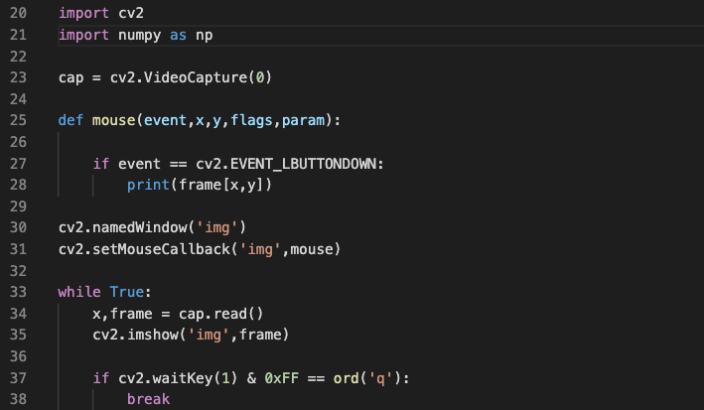

Q2. Crop an image using two mouse clicks to define the end points of the required area.

Q3. Warp an image using four mouse clicks to define the end points of the required area.