Assignment

Q1. Apply different filtering methods, to detect the edges of page provided in the image. Use of internet is not permitted.

Motive: 1. To build logical thinking and approach towards the used of filters.

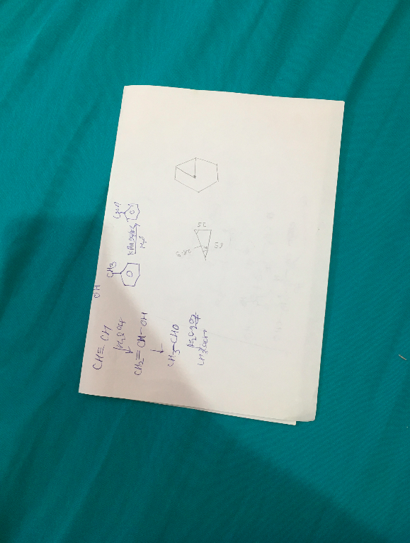

Input Output