Learning Poverty

Coursework for

7COM1079

Team Research and Development Project

Submitted by – **Team 12**

18050334

18000325

18055423

18057793

18055661

**Introduction**

**"Learning poverty** means being unable to read and understand a simple text by age 10"(World Bank, 2109). Several factors can be taken into account which make a difference in the percentage of learning poverty in the country. The authors of the report have investigated two such factors which are *GDP* and *taxes* to check the differences they are making on the percentage of learning poverty concerning the year.

The relation between the above-mentioned factors and the learning poverty can be tested by checking the correlation between learning poverty and each factor. Here, the two correlation methods have been used to infer the correlation thus it shows the relation between learning poverty and the factors that have been considered. GDP mainly depends on the leaning poverty of a country. Lesser the learning poverty rate, greater the economic condition of the country. The rules and regulation of the country which also includes the strategy on taxes makes the difference in the learning poverty. But the results that have been extracted are in support of the hypothesis.

**Background**

A report (World Bank, 2019) from the World Bank indicates that 53% of all children in low- and middle-income family are suffering from learning poverty, which decreases the human capital deficits. This is affected by the survival, quality contribution to the school and contribution to health and productivity (World Bank, 2019). The World Bank report (Bank, 2018) mentions that supporting child development has a large impact on the economy, which implies that the GDP is affected. It can also be noted that the taxes which is the government’s revenue can also be used to support child development.

This report answers two research questions:

**RQ1:** Does learning poverty affects the GDP of a country?

**RQ2:** Can the government tax be a factor that can affect learning poverty?

**Method**

The main dataset that has been considered is LPV (learning poverty) dataset which was obtained from *The World Bank and UNESCO Institute of Statistics*. The dataset on the factors (GDP, Taxes) that have been taken from *The World Bank.*

The dataset has been cleaned by sorting the country_code column according to alphabetical order and the year column into ascending order. The indicator column in the dataset has been split according to different indicators and the different indicators are put into different columns. The cleaning and combining dataset process is done using R programming.

The cleaned LPV dataset (Figure 1) is combined with GDP dataset (Fig 2) which is one of the factors that has been considered. The combining is done using R programming language and several tests have been done on SPSS platform to check the correlation between LPV and the factors (GDP and Taxes).

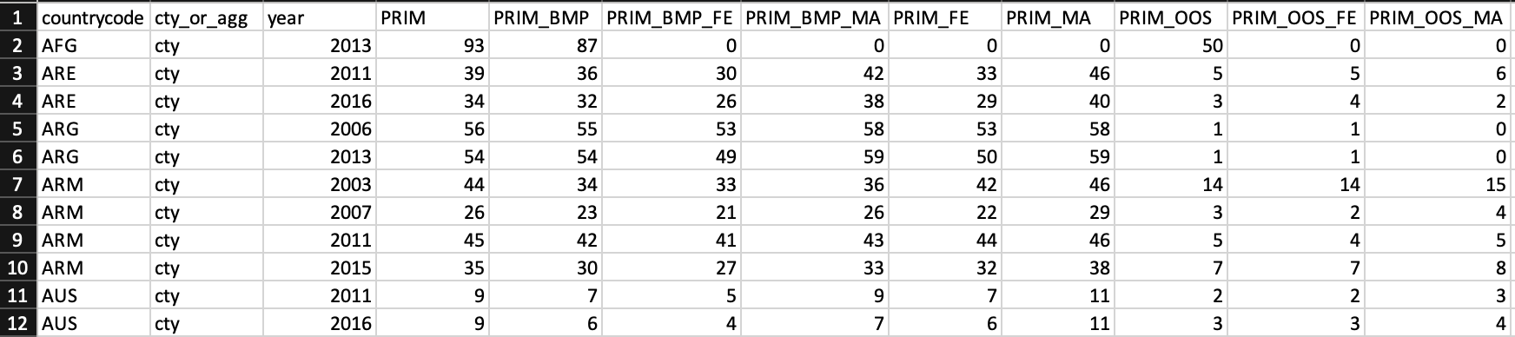

Figure 1. Cleaned LPV dataset

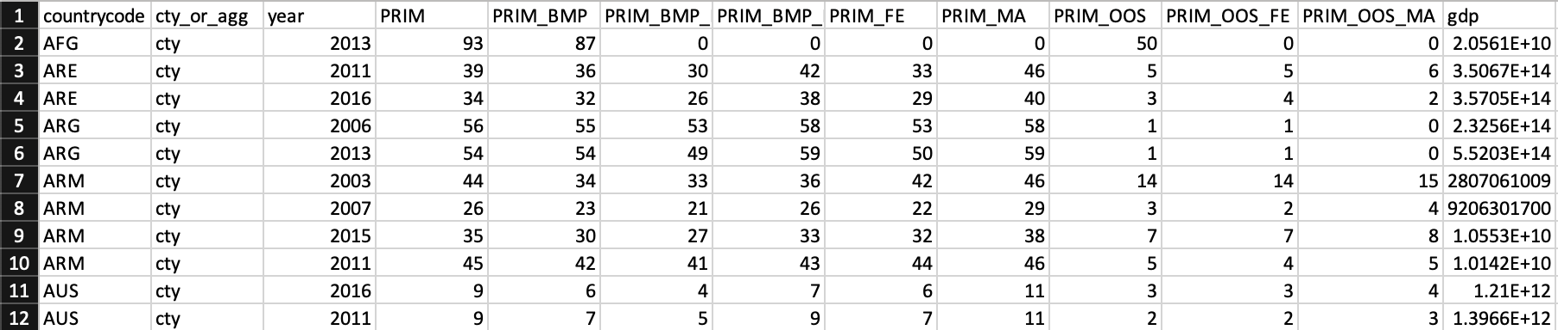

Figure 2. Combination of LPV AND GDP dataset

To check the relationship between the GDP, taxes and the indicators (PRIM, PRIM_BMP, PRIM_OOS), the Pearson Correlation tests and Kendall's Correlation tests have been conducted on Taxes and GDP against PRIM, Taxes and GDP against PRIM_BMP, GDP against PRIM_OOS and GDP against the sum of all these indicators.

**Results**

Figure 4. Pearson’s correlation on GDP and Learning Poverty

Two different correlation tests have been conducted on the dataset. In figure 4, the results of the Pearson’s correlation on GDP and different factors of learning poverty indicate a negative correlation. The same results have been obtained for tax and learning poverty which is shown in figure 5. A negative correlation is obtained GDP – Learning Poverty and Tax – Learning Poverty on applying Kendall’s correlation test.

Figure 5. Pearson’s correlation on Tax and Learning Poverty

Figure 6. Kendall’s correlation on Tax and Learning Poverty

Figure 5. Kendall’s correlation on GDP and Learning Poverty

**Discussion**

As shown in the results section, since the GDP, Tax and Learning Poverty are negatively correlated, implies that as the GDP and Tax increases, the learning poverty decreases. So, a better economy can give better support for child development and eradicate the learning poverty. To answer RQ1, as the GDP increase i.e. the economy of a country gets better, it can provide better support and infrastructure to the education system. As for RQ2, the increase in tax may pose a problem to the individual but it will give the government a source of revenue where it can implement the required infrastructure to increase its human capital deficits. Hence, the answer to RQ2 is that the government tax can be a factor that affects learning poverty.

**Conclusions**

The learning poverty is correlated to Taxes and GDP of a country. The test results show a negative correlation between Taxes and GDP against all the indicators which helps us understand that as the economy of a country increases the learning poverty decreases.

**Appendix**

Microsoft Azure: https://dev.azure.com/jt19abu/Team_12

Bitbucket: https://bitbucket.org/PriyaRajan03/learning-poverty/src/master/

Trello: https://trello.com/b/RdEK7Mlg/team-research-12-learning-poverty

**Reference:**

World Bank. 2019. Ending Learning Poverty : What Will It Take?. World Bank, Washington, DC. © World Bank. Available at: https://openknowledge.worldbank.org/handle/10986/32553 License: CC BY 3.0 IGO.

Bank, W., 2018. World development report 2019: The changing nature of work. Washington, DC.