Practical 1

Ionic 4 - Create and build first project or application (Android or iOS)

Introduction:
Ionic is an open source framework used for developing mobile applications.It provides tools and services for building Mobile UI with native look and feel.
Ionic and Cordova
While Cordova provides the solutions to use native mobile functionality and to create fully native applications, it doesn't include a UI SDK. With over 100 UI components, plus navigation and platform-specific styling, Ionic allows you to develop high performing, native-like apps.

Steps to install Ionic Cordova:
Note: npm i.e. Node Package Manager should be installed.
To check whether it is already installed type $node-v$ and $npm-v$.If not installed then install npm.
- Go to command prompt
- Type the following commands to install Ionic Cordova (-g means globally),
$npm install-g ionic cordova$
- To check if it is installed type,
$$ionic$$
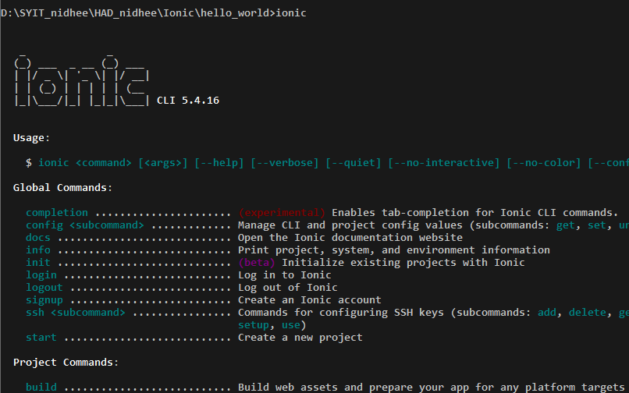

Start/build a new project:
Type the following commands in command prompt,
- $ionic start \text{hello_world} \text{blank}$
Here, project name is hello_world and template is blank. At this step you have to choose a one of the Framework from Angular and React. Choose Angular and press enter.
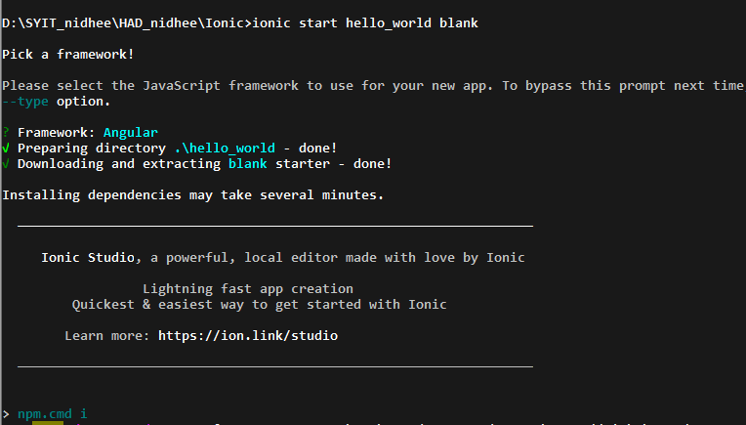

- Now the project named as hello_world will be build. Change the directory to hello_world,
$$cd hello_world$$
- To start the server type following command,
$$ionic serve$$
Remember: Copy the local host address and paste it in the browser.
To terminate/exit, press ctrl+c

Now, open the text editor and open the project hello_world.
Then go to
/src/app/home/home.page.html
Write the code as shown below:
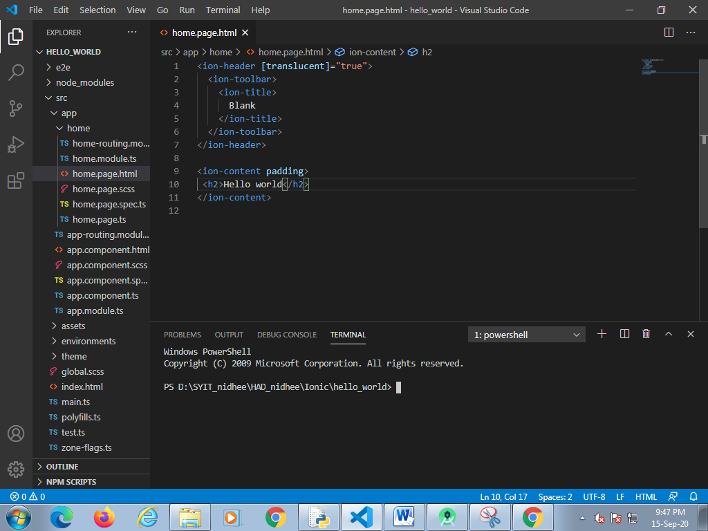
Now,
Again run the command ionic serve, you can now see the changes in the browser and you can now see the changes.

Build android:
Pre-requisites:
- Java jdk installation and JAVA_HOME
- ANDROID_HOME
- Android SDK build Tools
- Android SDK platforms Tools

Type the following command s in the prompt to build android apk,
ionic cordova platform add android
ionic cordova build android

