## 1.what is your business venture about along with your Target market

## Shadhimahal events is an organization which provide a set of services that can lead an organization to be the best in Industry. An event planner needs to analyze the market and competition before embarking upon a new venture. You have to consider whether the market is ready for the idea of event management or if couples in your area still prefer managing social events like weddings all by themselves. Event management is a profitable business model in urban markets, but the idea has not yet been widely accepted in rural markets.Don’t forget to measure the competition in your area and target just your local market to start. First I studied detailed about the market whether its ready for the idea of wedding planner consultant.

## Shadhimahal Wedding Consultants will offer its services mostly to the brides and grooms, as well as to the family members. The company will position itself as an experienced provider of wedding planning services. Unlike most of its competitors,Shadhimahal events will be offering a full range of services and thus provide the convenience of one-stop shopping for its clients. This will significantly reduce the customers' time and efforts preparing for such an important event as a wedding. Moreover, by utilizing numerous supplier contacts that the company owners have established and economies of scale,Shadhimahal Wedding Consultants will be able to pass on to its customers sizable cost savings.

## 2.Define your business objective

## Shadhimahal Wedding Consultants is a full service company that provides complete consulting services for weddings, holy unions and anniversaries. Our consultants are experienced and dedicated professionals with many years of event planning experience.Shadhimahal is unique in that we give our clients our undivided attention. We listen to their needs and work with them to create the event of their dreams. Our clients' wishes become our commands. Our services include weddings, honeymoons, receptions, anniversary consultations, budget planning, answers to etiquette questions, as well as full-service referrals to florists, hair stylists, entertainers, musicians, etc.

## 3.create the buyer’s persona as per the template shared

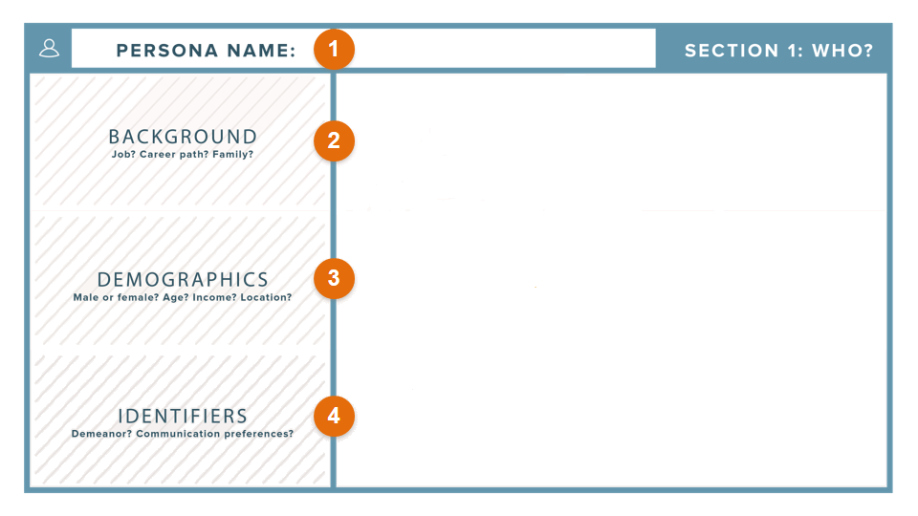

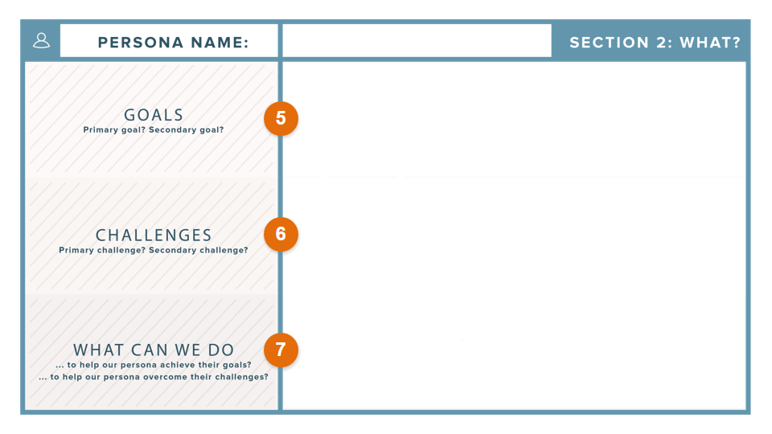

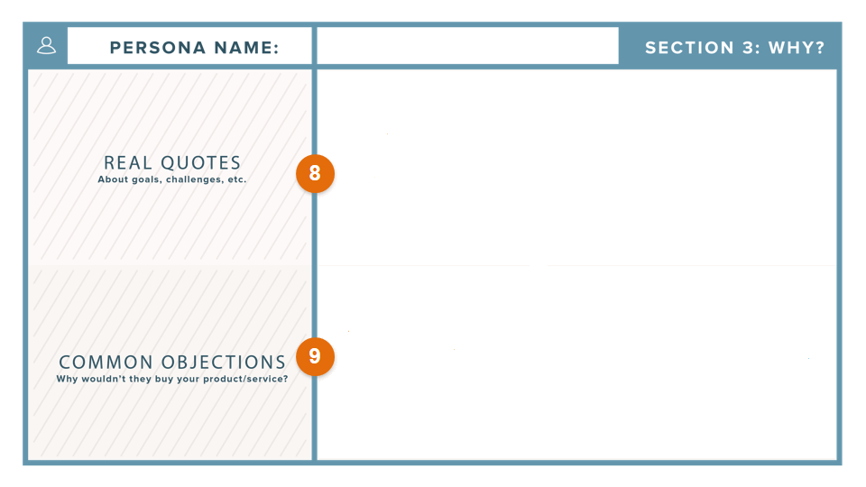

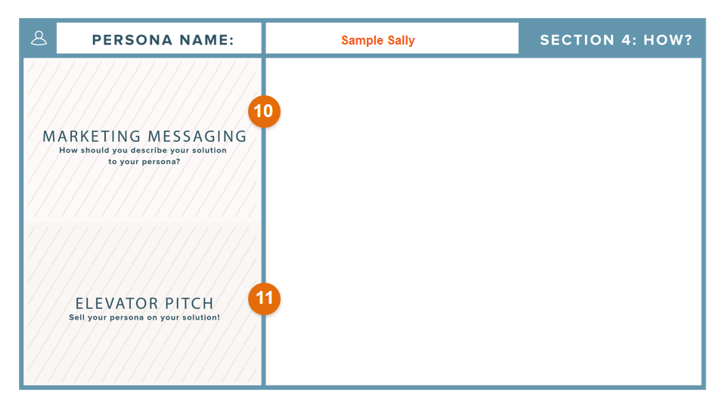

## 4.what will be your go to market strategy?

## The wedding planning business is a relatively new concept though marriage itself as an institution has survived through centuries. However, the concept has been embraced well by many entrepreneurs of today because of increasing market demands, low overhead costs of running such businesses and high profits assured. . Event management is a profitable business model in urban markets, but the idea has not yet been widely accepted in rural markets.

## Having a website is the cornerstone of any new venture. Even before print business cards,First I will launch a website for our company, publish ads in free classified sites and use social media extensively.Let people learn about our services from the web. Direct marketing campaigns should start from here only.

## Finding the first client is the biggest challenge to face and overcome. To get the first client,Ihave to promote the idea first, and then the brand,Only to the target market who is most likely to hire Our services. No point wasting money and time in aimless marketing campaigns.

## Manage the event successfully and hire a professional photographer to capture the best moments of the wedding event. Upload these photos on our site’s portfolio section.

## Staying in regular touch with existing and previous clients is actually a great way to remind them that we were always there, at their service. If those clients were satisfied with our services, they will refer your business to friends and colleagues.

## 5.How will you use Digital marketing for your business?

## First I will create a attractive website for our organization which includes our products and services

## Our website includes our services and products so I will promote my website maximum using google adwors.

## I will use social medias to promote our page(facebook,instagram,etc..)

## I use a youtube channel for uploading my videos.

## Work on my website’s searchability (SEO).