P. Sri Nidhi

VU21CSEN0300029

ADVANCE CODING – 2

1. [**Flatten Binary Tree to Linked List**](https://leetcode.com/problems/flatten-binary-tree-to-linked-list/)

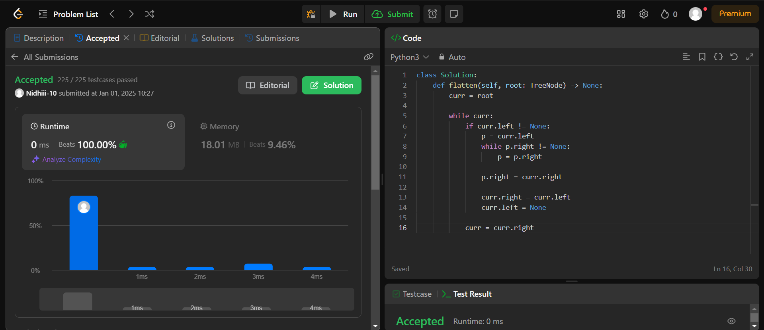

1. **Trapping Rain Water**

