Kth Largest Element in an Array

class Solution(object):

def findKthLargest(self, nums, k):

max_heap = [-num for num in nums]

heapq.heapify(max_heap)

for i in range(k - 1):

heapq.heappop(max_heap)

return -max_heap[0]

OUTPUT

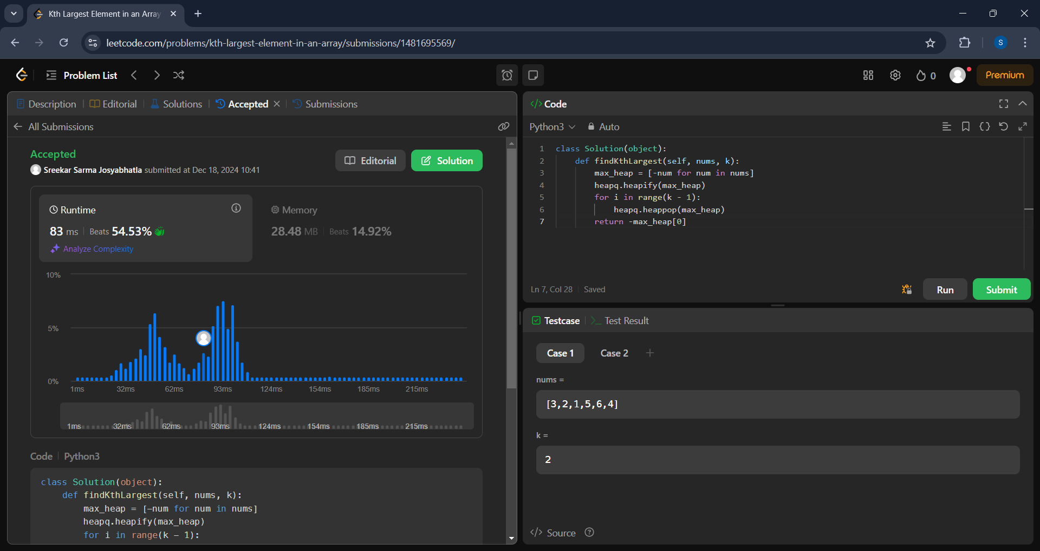

1. **Merge k Sorted Lists**

class Solution:

def mergeKLists(self, lists: List[ListNode]) -> ListNode:

if not lists:

return None

if len(lists) == 1:

return lists[0]

mid = len(lists) // 2

left = self.mergeKLists(lists[:mid])

right = self.mergeKLists(lists[mid:])

return self.merge(left, right)

def merge(self, l1, l2):

dummy = ListNode(0)

curr = dummy

while l1 and l2:

if l1.val < l2.val:

curr.next = l1

l1 = l1.next

else:

curr.next = l2

l2 = l2.next

curr = curr.next

curr.next = l1 or l2

return dummy.next

OUTPUT

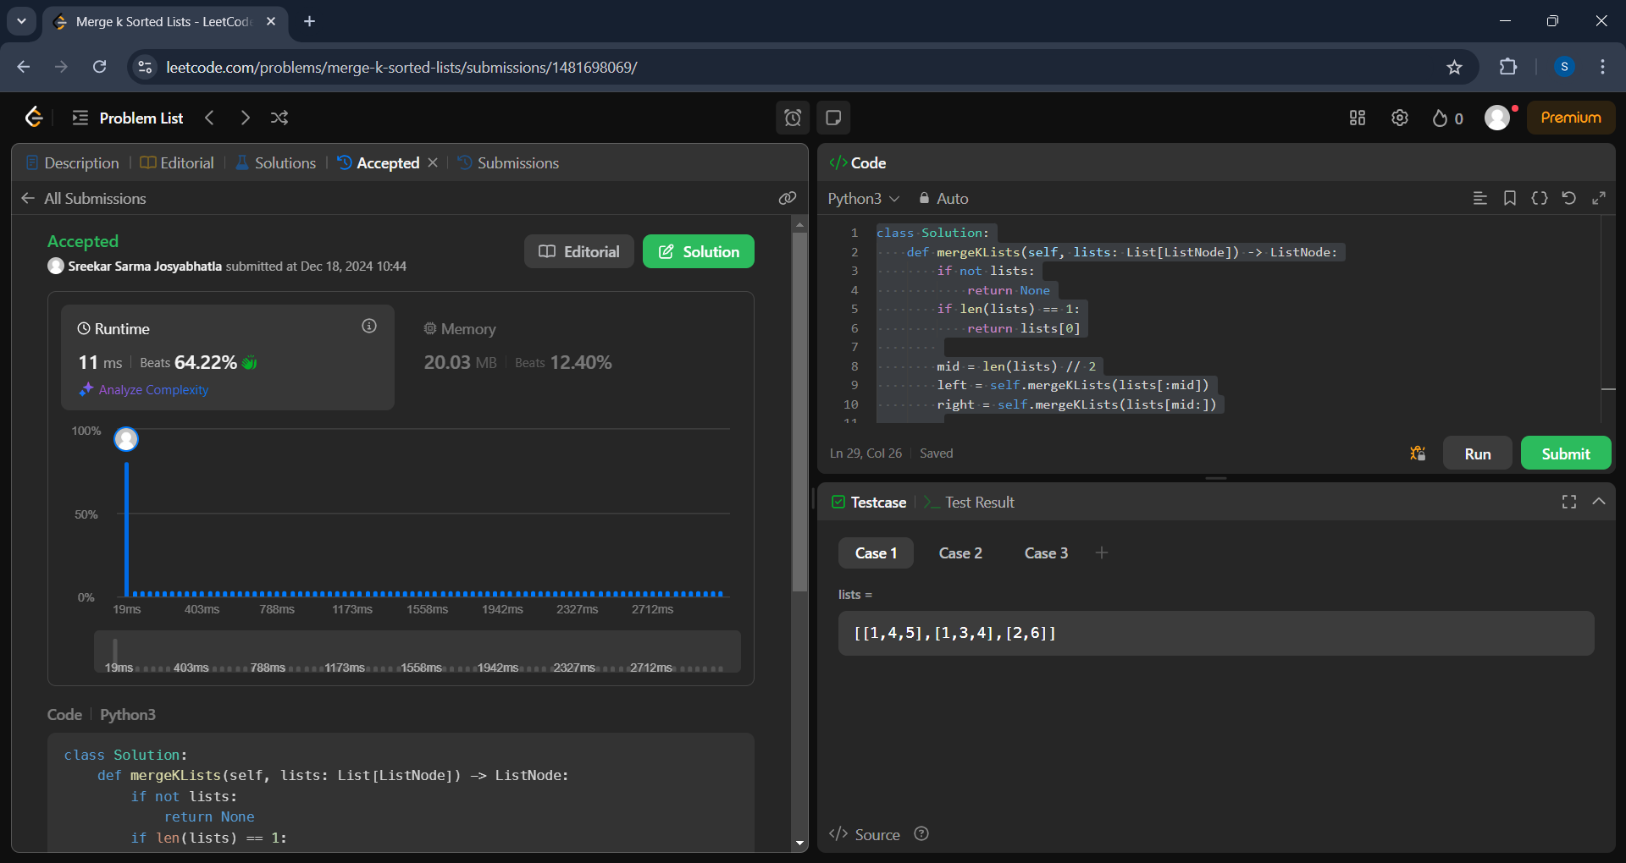

1. **Design Circular Deque**

class MyCircularDeque:

def __init__(self, k: int):

self.d = [0] * k

self.f = 0

self.r = 0

self.sz = 0

self.cap = k

def insertFront(self, v: int) -> bool:

if self.isFull(): return False

self.f = (self.f - 1 + self.cap) % self.cap

self.d[self.f] = v

self.sz += 1

return True

def insertLast(self, v: int) -> bool:

if self.isFull(): return False

self.d[self.r] = v

self.r = (self.r + 1) % self.cap

self.sz += 1

return True

def deleteFront(self) -> bool:

if self.isEmpty(): return False

self.f = (self.f + 1) % self.cap

self.sz -= 1

return True

def deleteLast(self) -> bool:

if self.isEmpty(): return False

self.r = (self.r - 1 + self.cap) % self.cap

self.sz -= 1

return True

def getFront(self) -> int:

return -1 if self.isEmpty() else self.d[self.f]

def getRear(self) -> int:

return -1 if self.isEmpty() else self.d[(self.r - 1 + self.cap) % self.cap]

def isEmpty(self) -> bool:

return self.sz == 0

def isFull(self) -> bool:

return self.sz == self.cap

**OUTPUT:**

