[Recipes](http://docs.google.com/index.html)

* Cuisine
  + [Gujarati](http://docs.google.com/gujarati.html)
  + Soutn Indian
  + North Indian
* Course
  + Main Course
  + [Desserts](http://docs.google.com/dessert.html)
  + Appetizers
* [Cooking Hacks](http://docs.google.com/hacks.html)
* Contact Us
* [Sign Up](http://docs.google.com/signup.php)
* [Login](http://docs.google.com/login.php)

1. [Home](http://docs.google.com/index.html)
2. [Dessert](http://docs.google.com/dessert.html)
3. Cake

**Chocolate cake recipe | Eggless chocolate cake recipe**

This Eggless Chocolate Cake is a simple and easy one bowl recipe suitable for both vegetarians and vegans alike. A delicious chocolate cake made with whole wheat flour. Unbelievably soft and spongy, this chocolate cake recipe will satisfy chocolate lovers and cake lovers alike.

RECIPE VIDEO

Recipe card for chocolate cake :

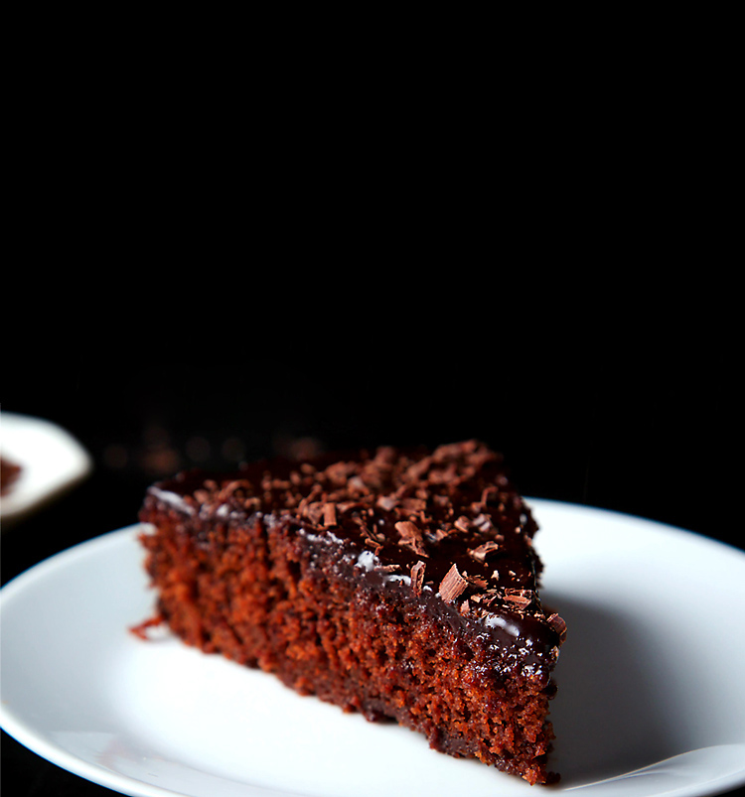

chocolate cake recipe | eggless chocolate cake

4.5 votes

Course:

Main

Cuisine:

Italian

Servings:

2 pizzas

Prep time:

2hrs 15 mins

Cooking time:

15 mins

Total time:

2hrs 15 mins

Ingredients

* 1 Pizza base
* 2 tablespoon pizza sauce
* And lots of mozarella cheese
* Pizza seasoning

#### Preparation

1. Preheat oven for 10 minutes at 180 degrees
2. Spread pizza sauce in pizza base
3. Spread mozarella cheese evenly in the pizza base
4. Sprinkle some oregano and chilly flakes and put it into the oven till the mozarella cheese melts.

And here is our margherita pizza is ready.. Yummm!!!!!

Notes:

* Firstly, to bake pizza on tawa refer how to make pizza on tawa recipe.
* Additionally, vary the topping according to your choice with basil leaves for extra flavours.
* Freeze leftover dough in a airtight container or zip lock bag greasing with oil. dough stays fresh for atleast a month.
* Also knead the dough well, else pizza will be chewy.
* Finally, bake the homemade veg pizza in very hot preheated oven else, the base of pizza will be raw.

Address

1010 Avenue, SW 54321, Rajkot

Call

9876543210

Mail us

foodrecipes@gmail.com

**Recepies**

Welcome to this food recipes page! Here, you'll get each and every type of recipes. We will share every type of recipes and also some cooking-kitchen hacks.