**SHOP O KART **

**INVOICE**

**Inv No:#4567**

**Order Date:1/8/2021**

**From:**

**SHOP O KART,**

**Xyz,**

**Ph No:45567789**

**To:**

**Sanjana patil,**

**Email:sanjanapatil@gmail.com**

**Ph No:1234567890**

***ORDER DETAILS:* 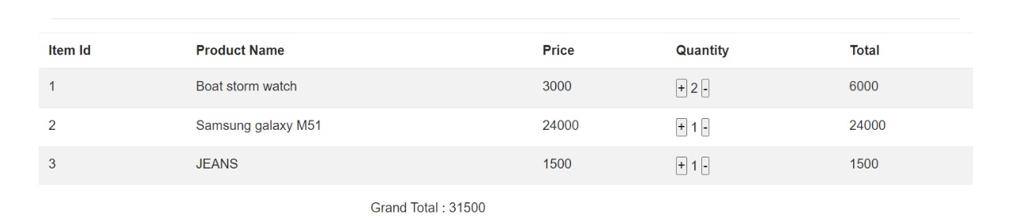**

**ESTIMATED DELIVERY:8/8/2012**