**Interesting findings on H_Baseball**

H_Baseball contains information on the salary of the baseball players, the team (62) for which they played, the positions (21) they held, and the years they played in **2009**, 2011, **2018**, and **2022**.

**Summary of all the interesting findings:**

1. From 2009 to 2018, we can see that there is no information for Florida Marlins in 2018. However, we can see new information about Miami Marlins. This is because Florida Marlins which was founded in 1991, began to play in 1993 in the suburb of Miami Gardens, and moved to the city in 2012, becoming the Miami Marlins at that time.
2. The total salary for Atlanta Braves increased from 2018 to 2022 by more than 100%.
3. Baltimore Orioles, on the other hand, dropped the total salary by almost $110,000,000.
4. Chicago White Sox and Philadelphia Phillies have an increased salary of around $100,000,000.
5. Cleveland Indians total salary dropped by around $70,000,000.
6. Los Angeles Dodgers total salary increased by around $140,000,000.
7. New York Mets’ and New York Yankees’ total salaries increased by an average of $85,000,000.
8. Pittsburgh Pirates’ total salary dropped by 50%.
9. San Diego Padres’ total salary increased by 300%.
10. San Francisco Giants’ total salary was reduced by almost $60,000,000.
11. The average salary of the New York Yankees in the year 2009 is $7,748,046. However, if we exclude the highest salary (Alex Rodriguez) and re-calculate the average, it comes up to $6,737,968.
12. The average salary of the San Francisco Giants in the year 2018 is $7,380,898. However, if we exclude the highest salary (Johnny Cueto) and re-calculate the average, it comes up to $6,853,803.
13. The average salary of the Los Angeles Dodgers in the year 2009 is $8,388,736. However, if we exclude the highest salary (David Price and Trevor Bauer) and re-calculate the average, it comes up to $6,957,750.
14. 160 players have changed teams.

USE H_Baseball;

SELECT COUNT(DISTINCT team)

FROM players;

USE H_Baseball;

SELECT COUNT(DISTINCT position)

FROM players

|  |  |  |  |  |  |
| --- | --- | --- | --- | --- | --- |
| **YEAR** | **NO. OF PLAYERS** | **SUM OF SALARY** | **AVG SALARY** | **MAX SALARY** | **MIN SALARY** |
| 2009 | 818 | 2,666,728,494 | 3,260,059 | 33,000,000 | 400,000 |
| 2018 | 877 | 3,957,697,825 | 4,512,768 | 34,083,333 | 545,000 |
| 2022 | 972 | 4,267,410,329 | 4,390,340 | 43,333,333 | 700,000 |

**SQL Query:**

**Number of Players**

USE H_Baseball;

SELECT year, COUNT(*) AS number_of_player

FROM players

GROUP BY year;

**Sum of Salary**

USE H_Baseball;

SELECT year, FORMAT(SUM(salary), "#,##0") AS sum_salary

FROM players

GROUP BY year;

**Average Salary**

USE H_Baseball;

SELECT year, FORMAT(AVG(salary), "#,##0") AS average_salary

FROM players

GROUP BY year;

**Maximum Salary by Year**

USE H_Baseball;

SELECT year, FORMAT(MAX(salary), "#,##0") AS max_salary

FROM players

GROUP BY year;

**Minimum Salary by Year**

USE H_Baseball;

SELECT year, FORMAT(MIN(salary), "#,##0") AS min_salary

FROM players

WHERE salary != 0

GROUP BY year;

**Sum of Salary by Teams by Year**

|  |  |  |  |
| --- | --- | --- | --- |
| **Team Name** | **2009** | **2018** | **2022** |
| Arizona Diamondbacks | 73,516,666 | 116,038,416 | 89,436,392 |
| Atlanta Braves | 96,726,166 | 83,306,041 | 176,705,000 |
| Baltimore Orioles | 67,101,666 | 148,160,873 | 37,801,500 |
| Boston Red Sox | 121,745,999 | 206,247,686 | 190,553,059 |
| Chicago Cubs | 134,809,000 | 181,810,002 | 142,778,500 |
| Chicago White Sox | 96,068,500 | 86,050,333 | 187,870,219 |
| Cincinnati Reds | 73,558,500 | 101,718,451 | 106,057,500 |
| Cleveland Indians | 81,579,166 | 136,652,167 | 66,831,100 |
| Colorado Rockies | 75,201,000 | 139,328,498 | 130,266,333 |
| Detroit Tigers | 115,085,145 | 111,286,000 | 129,543,200 |
| Florida Marlins | 36,834,000 | - | - |
| Houston Astros | 102,996,414 | 172,038,900 | 173,856,000 |
| Kansas City Royals | 70,519,333 | 115,483,116 | 89,174,150 |
| Los Angeles Angels | 113,709,000 | 171,248,332 | 160,613,096 |
| Los Angeles Dodgers | 100,414,592 | 157,496,785 | 293,605,745 |
| Miami Marlins | - | 85,843,000 | 79,075,000 |
| Milwaukee Brewers | 80,182,502 | 90,827,856 | 129,098,242 |
| Minnesota Twins | 65,299,266 | 129,560,000 | 126,383,190 |
| New York Mets | 149,373,987 | 172,761,459 | 266,998,338 |
| New York Yankees | 201,449,189 | 161,305,917 | 243,213,214 |
| Oakland Athletics | 62,310,000 | 62,652,500 | 52,410,000 |
| Philadelphia Phillies | 113,004,046 | 93,188,166 | 220,867,447 |
| Pittsburgh Pirates | 48,693,000 | 84,585,833 | 43,976,800 |
| San Diego Padres | 43,734,200 | 73,716,532 | 217,218,286 |
| San Francisco Giants | 83,026,450 | 221,426,944 | 155,439,000 |
| Seattle Mariners | 98,904,166 | 165,303,943 | 96,515,400 |
| St. Louis Cardinals | 88,528,409 | 146,916,999 | 160,558,497 |
| Tampa Bay Rays | 63,313,034 | 69,605,999 | 78,857,112 |
| Texas Rangers | 68,178,798 | 128,821,249 | 120,760,500 |
| Toronto Blue Jays | 80,538,300 | 164,122,200 | 165,657,288 |
| Washington Nationals | 60,328,000 | 180,193,628 | 135,290,221 |

USE H_Baseball;

SELECT year, team, FORMAT(SUM(salary), "#,##0") AS sum_salary

FROM players

WHERE salary != 0

GROUP BY year, team;

Salary != 0 because there is a row that has no information in it just NULL values.

The highest and the lowest total salaries are highlighted in yellow and green respectively.

**Average Salary by Team by Year**

|  |  |  |  |
| --- | --- | --- | --- |
| **Team Name** | **2009** | **2018** | **2022** |
| Arizona Diamondbacks | 2,722,839 | 4,144,229 | 2,794,887 |
| Atlanta Braves | 3,335,385 | 2,872,622 | 5,354,697 |
| Baltimore Orioles | 2,580,833 | 5,108,996 | 1,350,054 |
| Boston Red Sox | 4,058,200 | 6,445,240 | 6,146,873 |
| Chicago Cubs | 5,392,360 | 6,992,692 | 4,079,386 |
| Chicago White Sox | 3,694,942 | 3,187,049 | 5,367,721 |
| Cincinnati Reds | 3,198,196 | 3,178,702 | 2,946,042 |
| Cleveland Indians | 3,021,451 | 4,555,072 | 2,025,185 |
| Colorado Rockies | 2,785,222 | 4,804,431 | 3,947,465 |
| Detroit Tigers | 4,110,184 | 4,121,704 | 3,810,094 |
| Florida Marlins | 1,315,500 | - | - |
| Houston Astros | 3,814,682 | 5,734,630 | 5,608,258 |
| Kansas City Royals | 2,712,282 | 3,725,262 | 3,074,971 |
| Los Angeles Angels | 4,061,036 | 6,342,531 | 5,019,159 |
| Los Angeles Dodgers | 4,016,584 | 5,430,924 | 8,388,736 |
| Miami Marlins | - | 2,682,594 | 2,550,806 |
| Milwaukee Brewers | 3,083,942 | 3,243,852 | 4,303,275 |
| Minnesota Twins | 2,251,699 | 4,318,667 | 4,076,877 |
| New York Mets | 5,334,785 | 5,758,715 | 8,343,698 |
| New York Yankees | 7,748,046 | 5,760,926 | 7,600,413 |
| Oakland Athletics | 2,225,357 | 2,088,417 | 1,690,645 |
| Philadelphia Phillies | 4,185,335 | 3,213,385 | 6,496,101 |
| Pittsburgh Pirates | 1,872,808 | 2,916,753 | 1,256,480 |
| San Diego Padres | 1,561,936 | 2,377,953 | 6,388,773 |
| San Francisco Giants | 2,965,230 | 7,380,898 | 4,857,469 |
| Seattle Mariners | 3,532,292 | 5,903,712 | 3,016,106 |
| St. Louis Cardinals | 3,278,830 | 5,247,036 | 5,351,950 |
| Tampa Bay Rays | 2,183,208 | 2,578,000 | 2,319,327 |
| Texas Rangers | 2,350,993 | 4,025,664 | 3,895,500 |
| Toronto Blue Jays | 2,876,368 | 5,659,386 | 5,343,783 |
| Washington Nationals | 2,080,276 | 6,006,454 | 3,979,124 |

USE H_Baseball;

SELECT year, team, FORMAT(AVG(salary), "#,##0") AS avg_salary

FROM players

WHERE salary != 0

GROUP BY year, team;

**Salary of each player for the highest salaries teams by Year**

**Year 2009 – Highest Average – New York Yankees**

|  |  |  |
| --- | --- | --- |
| **Name of the Player** | **Position** | **Salary** |
| Rodriguez, Alex | Third Baseman | 33,000,000 |
| Jeter, Derek | Shortstop | 21,600,000 |
| Teixeira, Mark | First Baseman | 20,625,000 |
| Burnett, A.J. | Pitcher | 16,500,000 |
| Sabathia, CC | Pitcher | 15,285,714 |
| Rivera, Mariano | Pitcher | 15,000,000 |
| Posada, Jorge | Catcher | 13,100,000 |
| Damon, Johnny | Outfielder | 13,000,000 |
| Matsui, Hideki | Outfielder | 13,000,000 |
| Nady, Xavier | Outfielder | 6,550,000 |
| Cano, Robinson | Second Baseman | 6,000,000 |
| Pettitte, Andy | Pitcher | 5,500,000 |
| Swisher, Nick | Outfielder | 5,400,000 |
| Wang, Chien-Ming | Pitcher | 5,000,000 |
| Marte, Damaso | Pitcher | 3,750,000 |
| Molina, Jose | Catcher | 2,125,000 |
| Cabrera, Melky | Outfielder | 1,400,000 |
| Bruney, Brian | Pitcher | 1,250,000 |
| Ransom, Cody | Third Baseman | 455,100 |
| Veras, Jose | Pitcher | 432,975 |
| Chamberlain, Joba | Pitcher | 432,575 |
| Ramirez, Edwar | Pitcher | 422,450 |
| Gardner, Brett | Outfielder | 414,000 |
| Coke, Phil | Pitcher | 403,300 |
| Albaladejo, Jon | Pitcher | 403,075 |
| Pena, Ramiro | Infielder | 400,000 |

|  |  |
| --- | --- |
| **Average Salary of New York Yankees including Alex Rodriguez’s Salary** | **Average Salary of New York Yankees excluding Alex Rodriguez’s Salary** |
| 7,748,046 | 6,737,968 |

Use H_Baseball;

SELECT name, position, FORMAT(salary, "#,##0") AS player_salary

FROM players

WHERE team = 'New York Yankees'

AND year = 2009

ORDER BY salary DESC;

USE H_Baseball;

SELECT FORMAT(AVG(salary), "#,##0") AS avg_salary

FROM players

WHERE year = 2009

AND team = 'New York Yankees'

AND name != 'Rodriguez, Alex'

GROUP BY team;

**Year 2018 – Highest Average – San Francisco Giants**

|  |  |  |
| --- | --- | --- |
| **Name of the Player** | **Position** | **Salary** |
| Johnny Cueto | Pitcher | 22,666,666 |
| Buster Posey | Catcher | 22,177,778 |
| Jeff Samardzija | Pitcher | 19,800,000 |
| Pablo Sandoval | Third Baseman | 19,600,000 |
| Hunter Pence | Outfielder | 18,700,000 |
| Brandon Belt | First Baseman | 17,200,000 |
| Brandon Crawford | Shortstop | 15,200,000 |
| Mark Melancon | Pitcher | 15,000,000 |
| Andrew McCutchen | Outfielder | 14,750,000 |
| Evan Longoria | Third Baseman | 14,500,000 |
| Madison Bumgarner | Pitcher | 12,000,000 |
| Sam Dyson | Pitcher | 4,425,000 |
| Joe Panik | Second Baseman | 3,450,000 |
| Tony Watson | Pitcher | 3,250,000 |
| Austin Jackson | Outfielder | 3,000,000 |
| Will Smith | Pitcher | 2,500,000 |
| Nick Hundley | Catcher | 2,500,000 |
| Cory Gearrin | Pitcher | 1,675,000 |
| Hunter Strickland | Pitcher | 1,550,000 |
| Derek Holland | Pitcher | 1,500,000 |
| Gregor Blanco | Outfielder | 1,000,000 |
| Ty Blach | Pitcher | 565,000 |
| Gorkys Hernandez | Outfielder | 561,500 |
| Kelby Tomlinson | Second Baseman | 560,000 |
| Josh Osich | Pitcher | 558,000 |
| Chris Stratton | Pitcher | 552,500 |
| Roberto E Gomez | Pitcher | 550,000 |
| Reyes Moronta | Pitcher | 545,500 |
| Julian Fernandez | Pitcher | 545,000 |
| Pierce Johnson | Pitcher | 545,000 |

|  |  |
| --- | --- |
| **Average Salary of San Francisco Giants including Johnny Cueto’s Salary** | **Average Salary of San Francisco Giants excluding Johnny Cueto’s Salary** |
| 7,380,898 | 6,853,803 |

Use H_Baseball;

SELECT name, position, FORMAT(salary, "#,##0") AS player_salary

FROM players

WHERE team = 'San Francisco Giants'

AND year = 2018

ORDER BY salary DESC;

USE H_Baseball;

SELECT FORMAT(AVG(salary), "#,##0") AS avg_salary

FROM players

WHERE year = 2018

AND team = 'San Francisco Giants'

AND name != 'Johnny Cueto'

GROUP BY team;

**Year 2022 – Highest Average – Los Angeles Dodgers**

|  |  |  |
| --- | --- | --- |
| **Name of the Player** | **Position** | **Salary** |
| Price, David | LHP | 32,000,000 |
| Bauer, Trevor | RHP | 32,000,000 |
| Freeman, Freddie | 1B | 25,440,196 |
| Turner, Trea | SS | 21,000,000 |
| Turner, Justin | 3B | 19,579,357 |
| Betts, Mookie | OF | 18,658,692 |
| Bellinger, Cody | OF | 17,000,000 |
| Kershaw, Clayton | LHP | 17,000,000 |
| Kimbrel, Craig | RHP | 16,000,000 |
| Taylor, Chris | OF | 15,000,000 |
| Muncy, Max | 1B | 13,000,000 |
| Heaney, Andrew | LHP | 8,500,000 |
| Anderson, Tyler | LHP | 8,000,000 |
| Urias, Julio | LHP | 8,000,000 |
| Treinen, Blake | RHP | 8,000,000 |
| Buehler, Walker | RHP | 7,250,000 |
| Hudson, Daniel | RHP | 6,000,000 |
| Kahnle, Tommy | RHP | 3,725,000 |
| Duffy, Danny | LHP | 3,000,000 |
| Barnes, Austin | C | 2,750,000 |
| Alberto, Hanser | 3B | 1,600,000 |
| Ferguson, Caleb | LHP | 762,500 |
| Smith, Will | C | 730,000 |
| May, Dustin | RHP | 730,000 |
| Rios, Edwin | OF | 730,000 |
| Gonsolin, Anthony | RHP | 720,000 |
| Graterol, Brusdar | RHP | 720,000 |
| Gonzalez, Victor | LHP | 720,000 |
| Phillips, Evan | RHP | 720,000 |
| Lux, Gavin | 2B | 720,000 |
| Vesia, Alex | LHP | 720,000 |
| Bruihl, Justin | LHP | 710,000 |
| Cleavinger, Garrett | LHP | 710,000 |
| White, Mitchell | RHP | 710,000 |
| Nelson, Jimmy | RHP | 700,000 |

|  |  |
| --- | --- |
| **Average Salary of Los Angeles Dodgers including David Price and Trevor Bauer’s Salary** | **Average Salary of Los Angeles Dodgers excluding David Price and Trevor Bauer’s Salary** |
| 8,388,736 | 6,957,750 |

Use H_Baseball;

SELECT name, position, FORMAT(salary, "#,##0") AS player_salary

FROM players

WHERE team = 'L.A. Dodgers'

AND year = 2022

ORDER BY salary DESC;

USE H_Baseball;

SELECT FORMAT(AVG(salary), "#,##0") AS avg_salary

FROM players

WHERE year = 2022

AND team = 'L.A. Dodgers'

AND name != 'Price, David'

AND name != 'Bauer, Trevor'

GROUP BY team;

**Players who changed teams**

USE H_Baseball;

SELECT p1.year AS year1, p2.year AS year2, p1.name, p1.team AS team1, p2.team AS team2

FROM players AS p1

INNER JOIN players AS p2

ON p1.name = p2.name AND p1.team != p2.team AND p1.year < p2.year;

Some of the players who changed teams are as follows:

|  |  |  |  |  |
| --- | --- | --- | --- | --- |
| **Year 1** | **Year 2** | **Name** | **Team 1** | **Team 2** |
| 2011 | 2018 | Jonathan Lucroy | Milwaukee Brewers | Oakland Athletics |
| 2009 | 2022 | Romo, Sergio | San Francisco Giants | Seattle |
| 2011 | 2018 | Max Scherzer | Detroit Tigers | Washington Nationals |
| 2011 | 2018 | Justin Upton | Arizona Diamondbacks | Los Angeles Angels |
| 2011 | 2018 | Daniel Descalso | St. Louis Cardinals | Arizona Diamondbacks |

**San Diego Padres Increase in Salary**

Use H_Baseball;

SELECT year, name, position, team, FORMAT(salary, "#,##0") AS player_salary

FROM players

WHERE team LIKE 'San Diego%'

AND (year = 2022 OR year = 2018)

ORDER BY salary DESC;

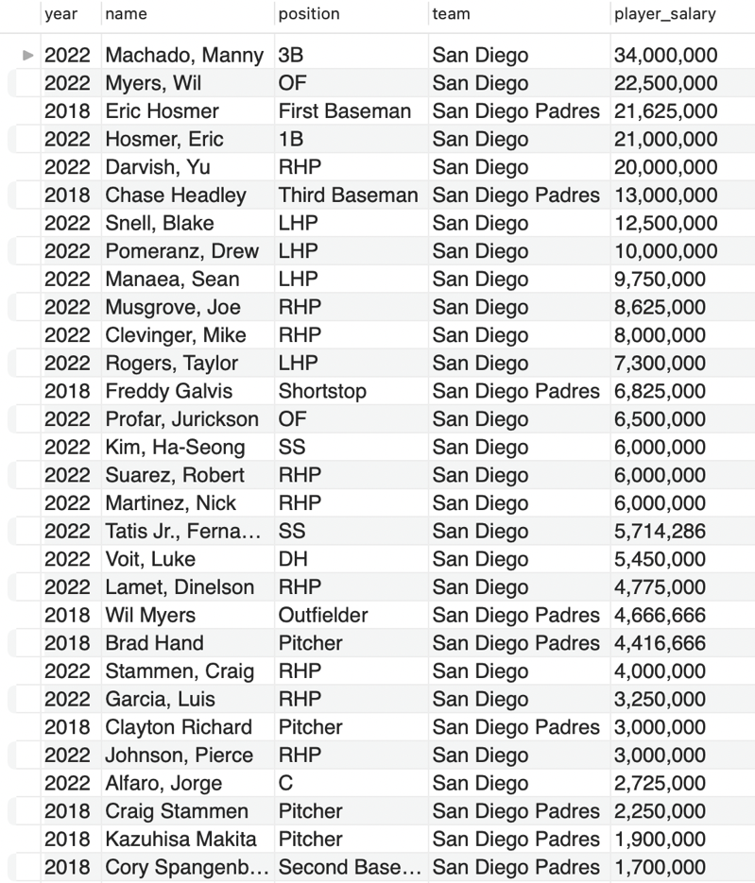

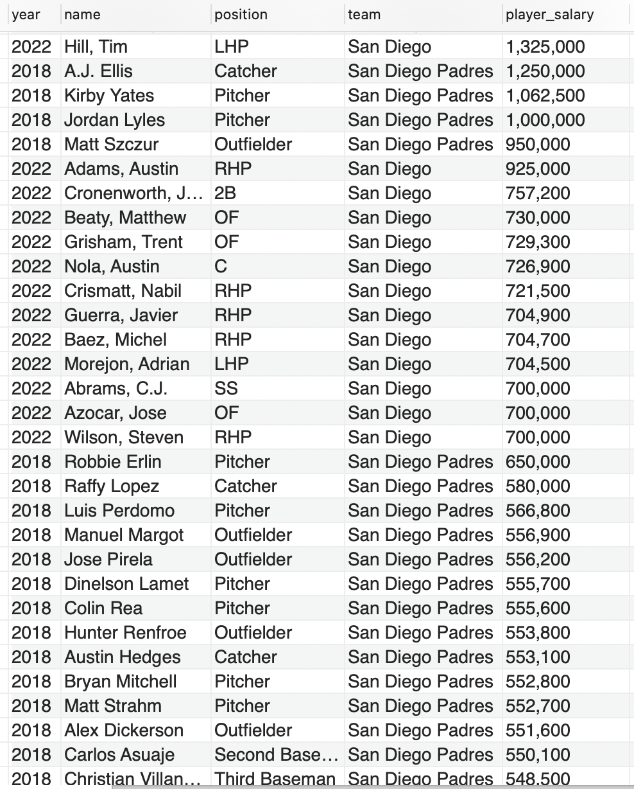

**Players who have been playing in the same position since 2011 – 154 players**

Use H_Baseball;

SELECT p1.name, p1.year, p2.year, p1.position, p2.position

FROM players AS p1

INNER JOIN players AS p2

ON p1.name = p2.name AND p1.year != p2.year AND p1.position = p2.position AND p1.year < p2.year;

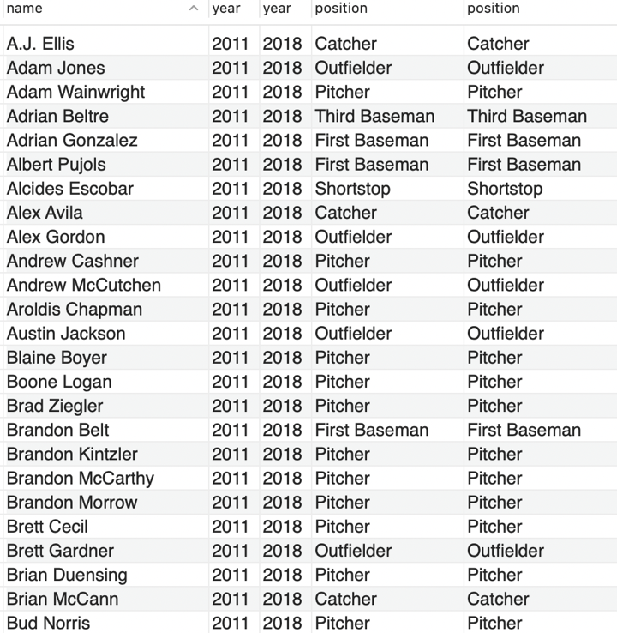

Video Link: <https://youtu.be/f5mYRzhr0DU>