**TASK 3**

**Registration ID: SIRSS2256**

**Name: Nidhi Thakkar**

**Topic: Linux Commands**

Q1 : Go the the current user location /home/[user] and from there go to Documents folder

- Create a folder with your firstname & your surname

- Create any file inside the firstName folder

- Now try to see the content of both folder from current location now

- Go to again /home/[user] path

- Remove the file you have created inside the firstname folder from the current path of /home/user

- also remove the surname folder with the file.

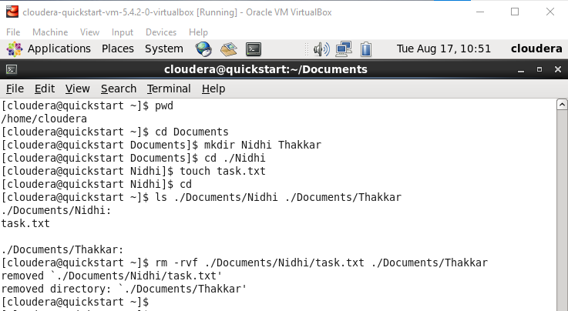

Q2 Copy the whole source folder with the files & subdirectory inside the destination directory like backup of source folder

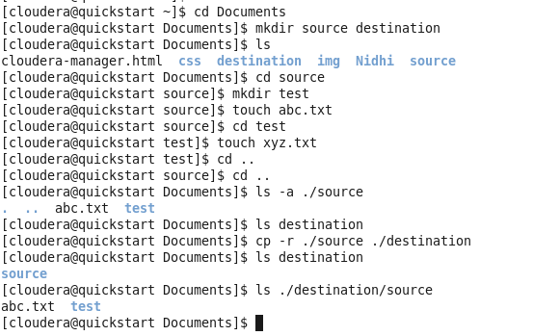

Q3 create a source and destination folder

- Inside the source created the subdirectory & some files here

- Try to copy only the subdirectory and content inside the destination using the -r & -v option

- Try to copy any file from source to destination but changing the name to capData.txt [While doing the copying]

- Move the source folder into the destination

- change the moved folder name to any other folder name

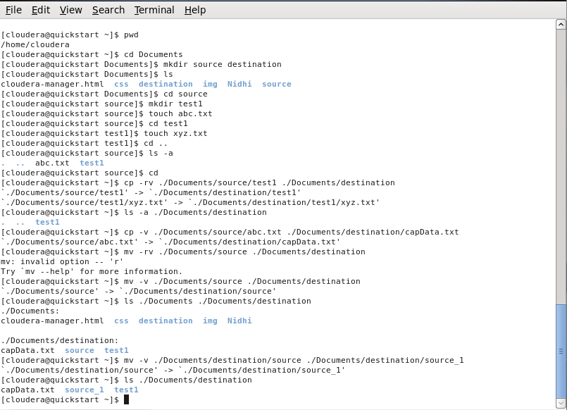

Q4: Try to locate the file which is starting with the letter {a} and ending with the letter {t}

- N number of characters can be in between

- Find out any file which starting with the letter { s } & last second character can be {z} only & size shoudld be 5 character

- Finding all the file & folder only in the current directory don't have to list subdirectory contents & letter {am} in between the filenames

- Get files starting with a letter { a } & second letter can be { l or t } only eg algo.txt atno.txt

- Get all the files starting with letter {A-T} or {a-z} or {0-7}

- Get file whose second letter is {d} & last character can be from { o to z} only

