**TASK 4**

**Registration ID: SIRSS2256**

**Name: Nidhi Thakkar**

**Topic: Hadoop and Unix**

Q19 : You need to create a user with the userid as 5000  
    - At the same time of creating the user set the password for the user  
        - Set the secondary group of that user as {sales}  
        - also add the comment as in form of date when creating user  
        - Set the shell of that user to {sh shell }   [Using a single command]

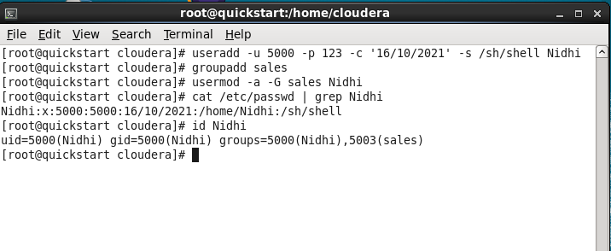

Q20 : Try to add the user into the marketing group  
    - After that add the user into the sales group  
    - make sure the user is the part of both group

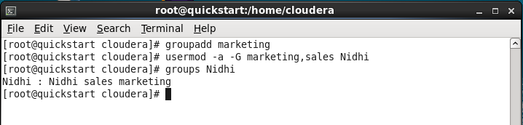

Q22 Set the user password using the stdin based on command line interface (CLI)   
    [Hint: Pipe operator]

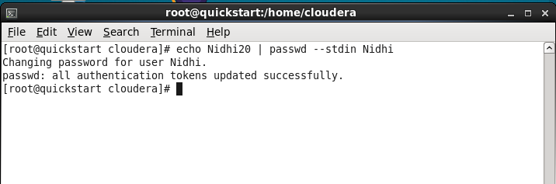

Q23 : Create any four user ram, shyam, babu, aman

- Set their account to expire in 90 days

- Create a group sales & marketing add ram, shyam to sales

- add babu, aman to marketing

- make sure all the four user got the home directory

- give a comment "Capgemini users" at time of creating the user

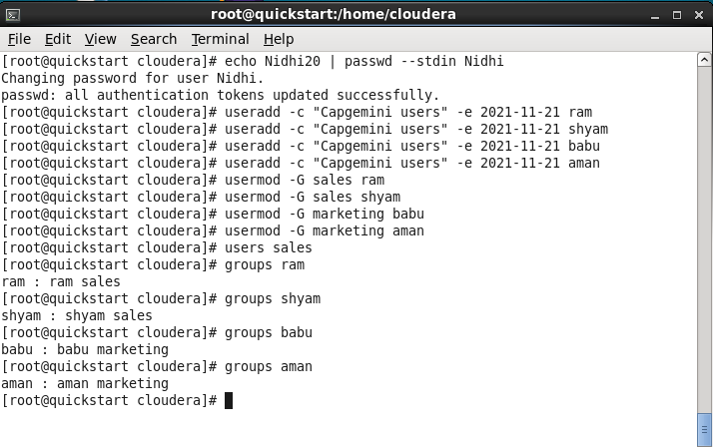

Q24 : Change the user to the lock phase so that he/she can't login to the system also try to unlock them

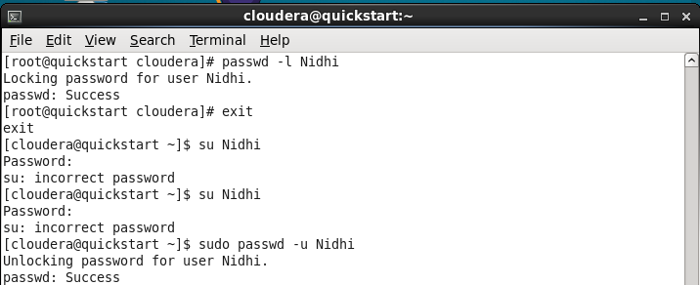

Q25 : Set the password inactive period for any newly created user as 3 days

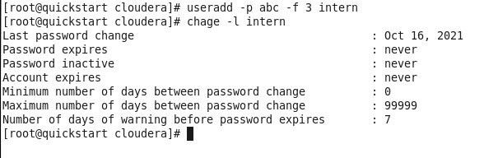

Q24 : Creating a folder testing change its owner & group

- Now create an another folder inside the same, change their owner & group also to the different values

- verify the owner & group

- Change the testing folder again to the previous value

- verify the owner & group to the folder created inside the testing

- Also change the details of all the testing & folder present inside it using a single command

( changes to folder & the files & sub-directory should be changed using a single commands)

