Create a SLURM job script to build and install Python3 from source.

#!/bin/bash
#SBATCH --job-name=python_build
#SBATCH --output=python_build_%j.out
#SBATCH --error=python_build_%j.err
#SBATCH --time=01:00:00
#SBATCH --nodes=1
#SBATCH --ntasks=1
#SBATCH --cpus-per-task=4
#SBATCH --mem=4G
#SBATCH --partition=caribou_node

echo "======================================"
echo "Job ID : $SLURM_JOB_ID"
echo "Node : $(hostname)"
echo "Start Time : $(date)"
echo "======================================"

# Variables
PYTHON_VERSION=3.12.2
PREFIX=$HOME/python3.12
BUILD_DIR=$HOME/python_build

# Create build directory
mkdir -p $BUILD_DIR
cd $BUILD_DIR

# Download Python
wget https://www.python.org/ftp/python/${PYTHON_VERSION}/Python-${PYTHON_VERSION}.tgz

# Extract
tar -xzf Python-${PYTHON_VERSION}.tgz
cd Python-${PYTHON_VERSION}

# Configure
./configure \
--prefix=$PREFIX \
--enable-optimizations

# Build
make -j $SLURM_CPUS_PER_TASK

# Install
make install

# Verify
$PREFIX/bin/python3.12 --version

echo "Python build completed successfully!"
echo "End Time: $(date)"

// Python3 has been built and installed using the slurm job script.
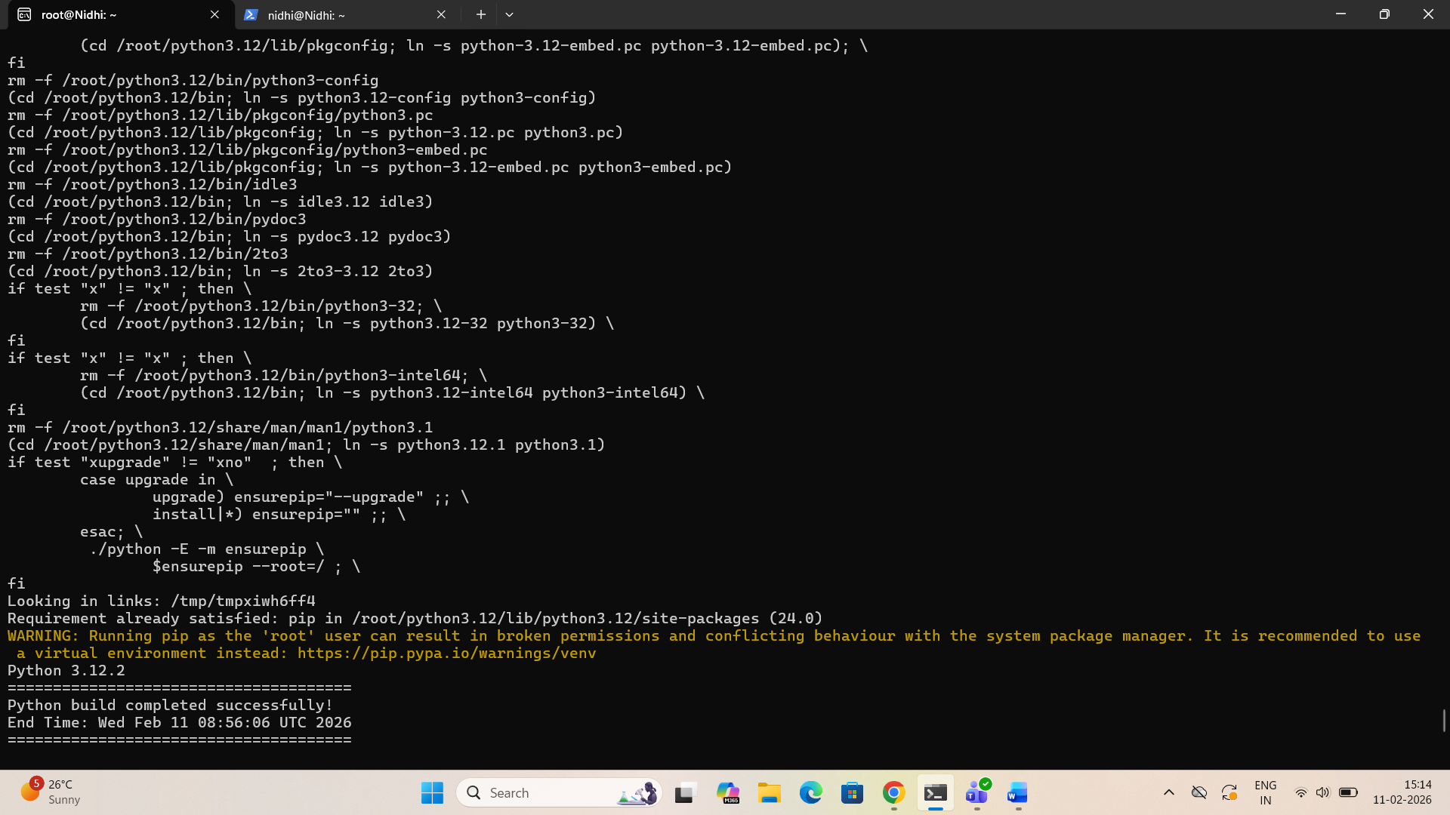

//Python has been added in the list.

//Initially the node was in idle state, as soon as I ran the job it came to running state, then I killed the running job and submitted some more new jobs.
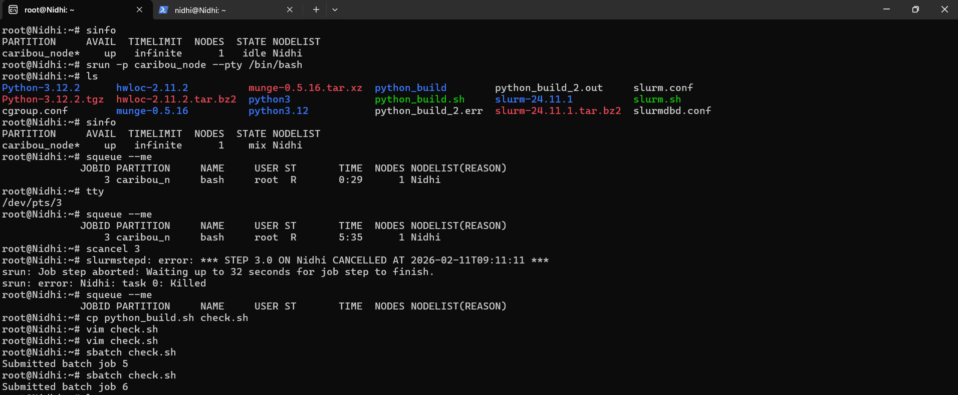

//submitting job script without installation of python check.sh
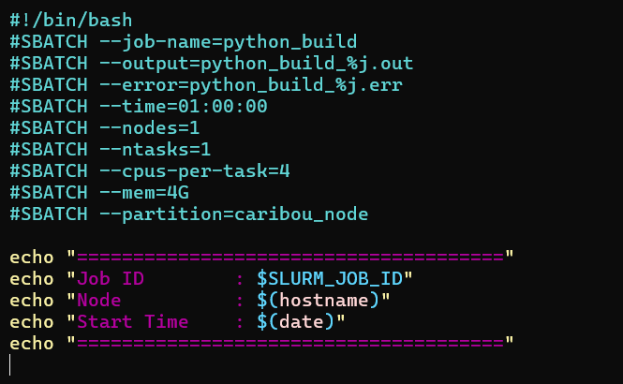

// output file of build.
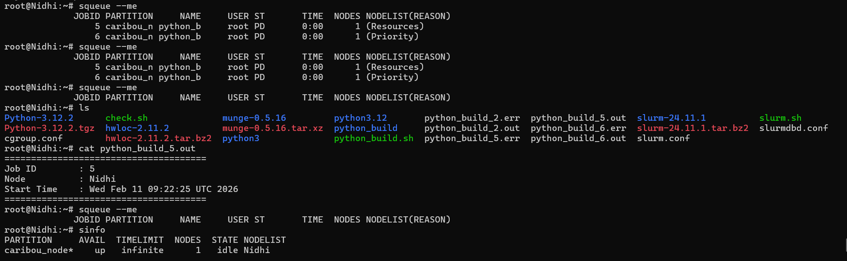

//Another terminal, where I tried to run jobs of same node.
