- Write a C program that:
- Creates arrays of size
  - 10²
  - 10³
- Calculates sum
- Measures execution time

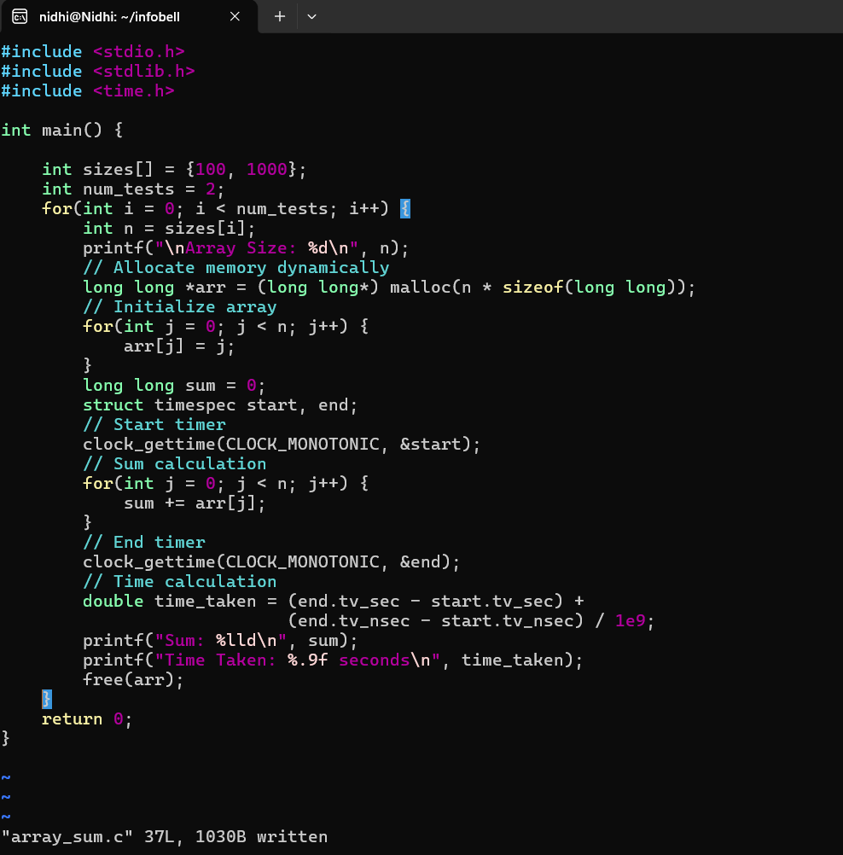

OUTPUT:
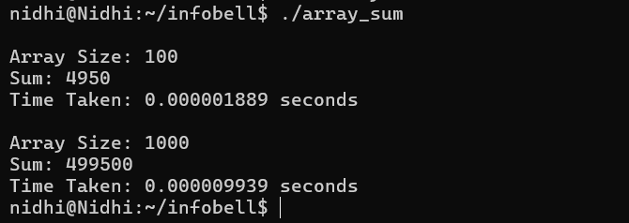

- Calculate the run time for accessing elements in row-wise and column wise for 2-d array.

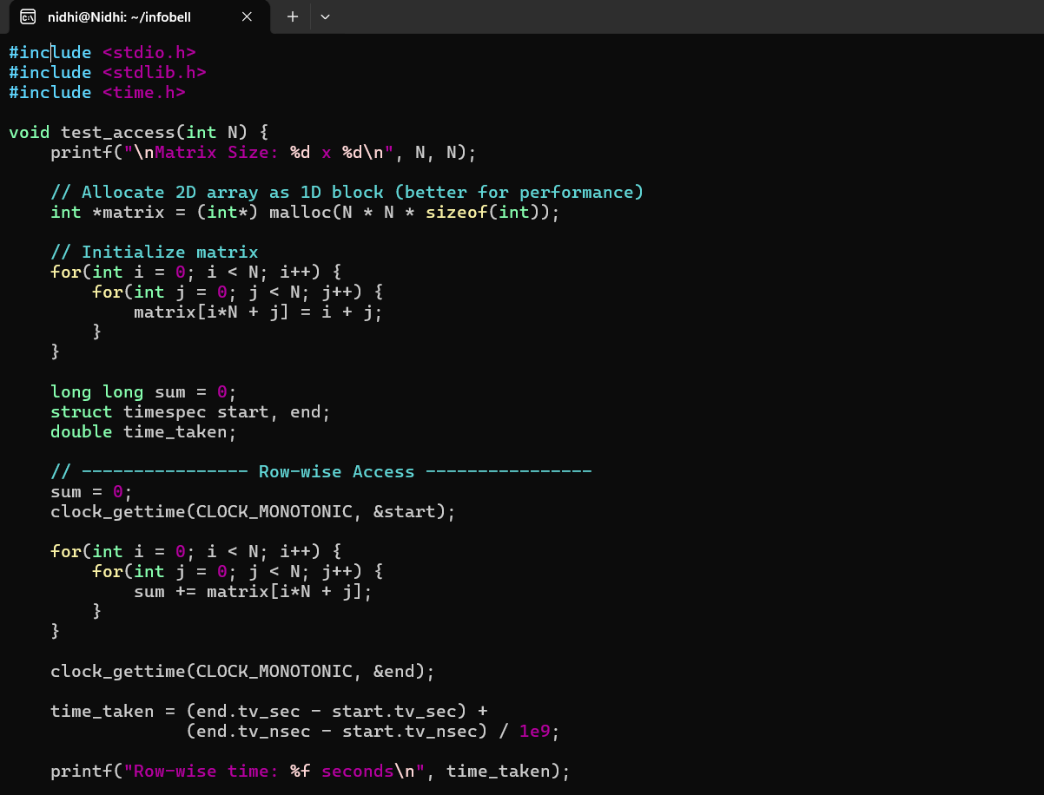
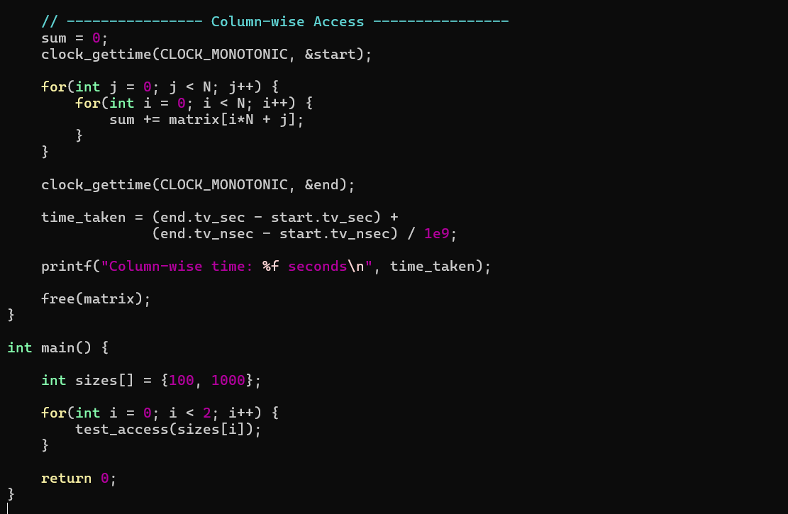

OUTPUT:
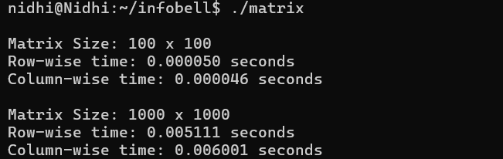

Difference between both the programs:

The first program works with a 1D array and simply calculates the sum of all elements. It measures basic sequential memory access performance, where elements are accessed continuously in memory. Since the access pattern is always linear and cache-friendly, the execution time mainly depends on the array size (O(n)).

The second program works with a 2D array (matrix) and compares row-wise and column-wise traversal. It demonstrates how memory layout affects performance. In C, arrays are stored in row-major order, so row-wise access is faster because it follows contiguous memory locations. Column-wise access is slower because it jumps across memory, causing more cache misses. This program highlights cache locality and memory optimization concepts.

