*Title:* EYE DETECTION USING CASCADE OBJECT DETECTOR SYSTEM.

*Matlab Code:*

FOR IMAGE 1

%To detect Eyes

EyeDetect = vision.CascadeObjectDetector('EyePairBig');

//'EyePairBig' is used to detect a pair of eyes

%Read the input Image

I=imread('Potter.bmp'); //imread to read an image

BB=step(EyeDetect,I); //[bbox](https://in.mathworks.com/help/vision/ref/vision.cascadeobjectdetector-system-object.html" \l "d120e72902) = detector([I](https://in.mathworks.com/help/vision/ref/vision.cascadeobjectdetector-system-object.html" \l "d120e72787),[roi](https://in.mathworks.com/help/vision/ref/vision.cascadeobjectdetector-system-object.html#d120e72869)) detects objects within

the rectangular search region specified by roi. Here roi is Potter image .

figure(1);

imshow(I);

rectangle('Position',BB,'LineWidth',8,'LineStyle','-','EdgeColor','c'); //rectangle function

title('Eyes Detection'); //title of an image

Eyes=imcrop(I,BB); //imcrop is used to crop the image

figure(2);

imshow(Eyes); //imshow is used to display the image

Figure 1:

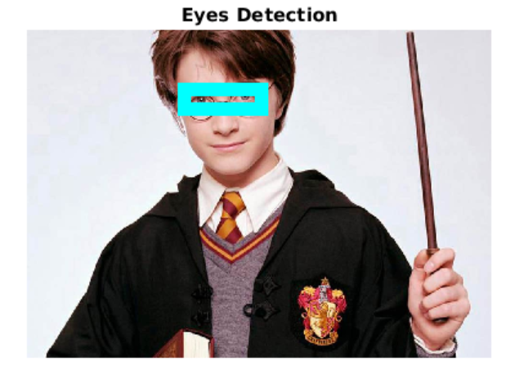

Figure 2:

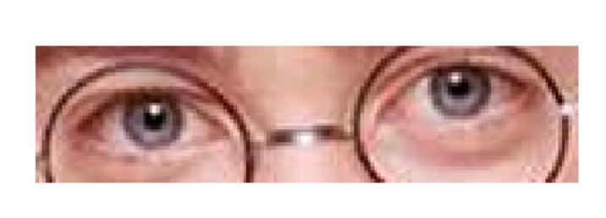

Screenshots:

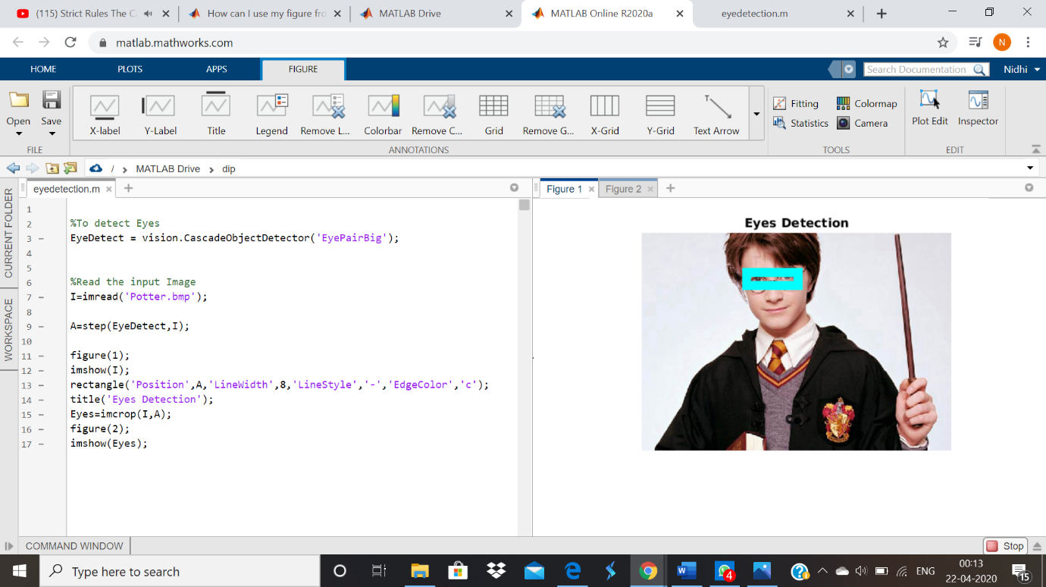

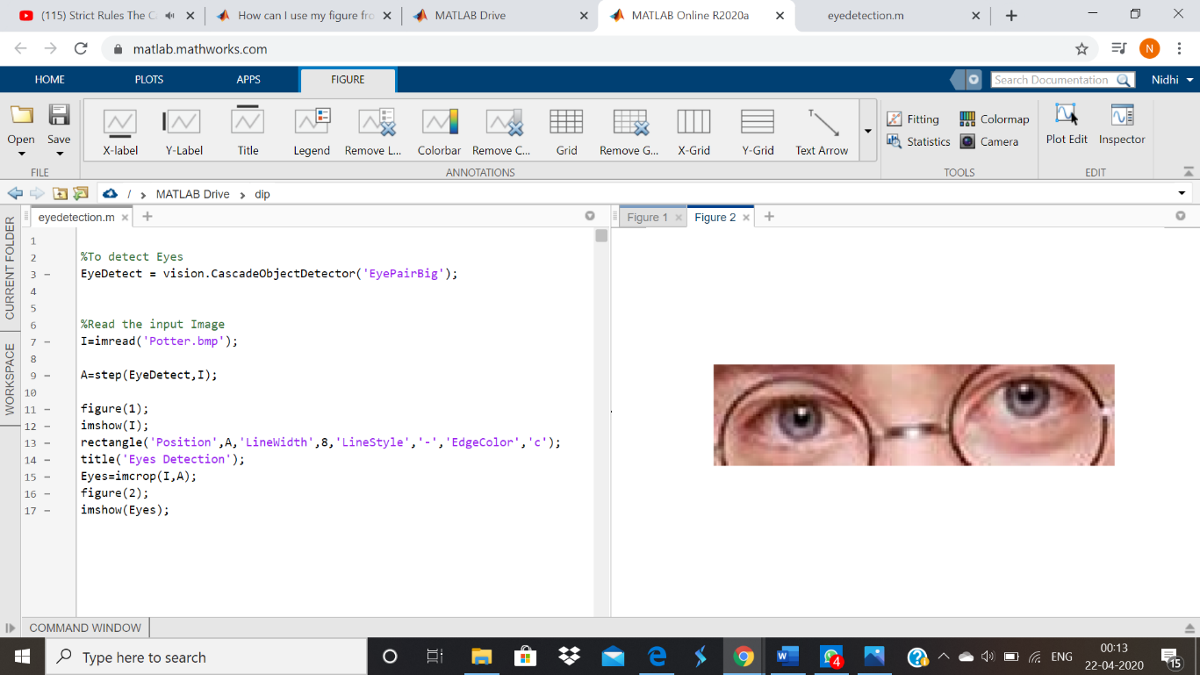

For Image 2:ELIZA

Figure1: 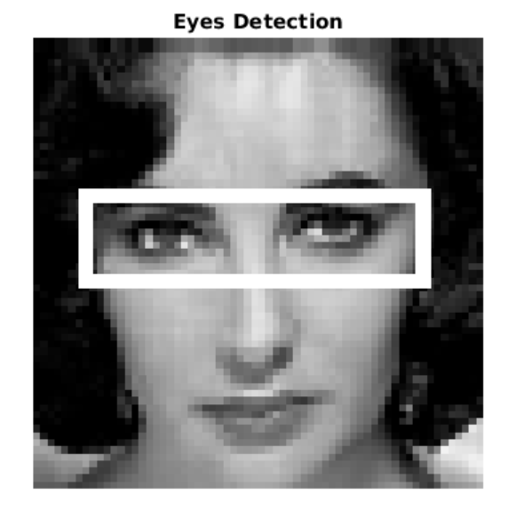

Figure 2: 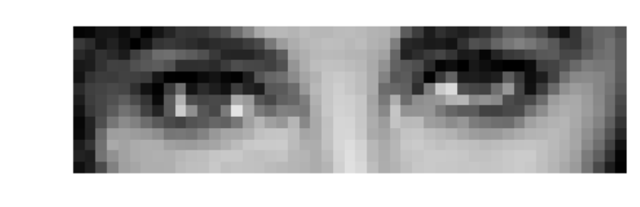

Screenshots:

