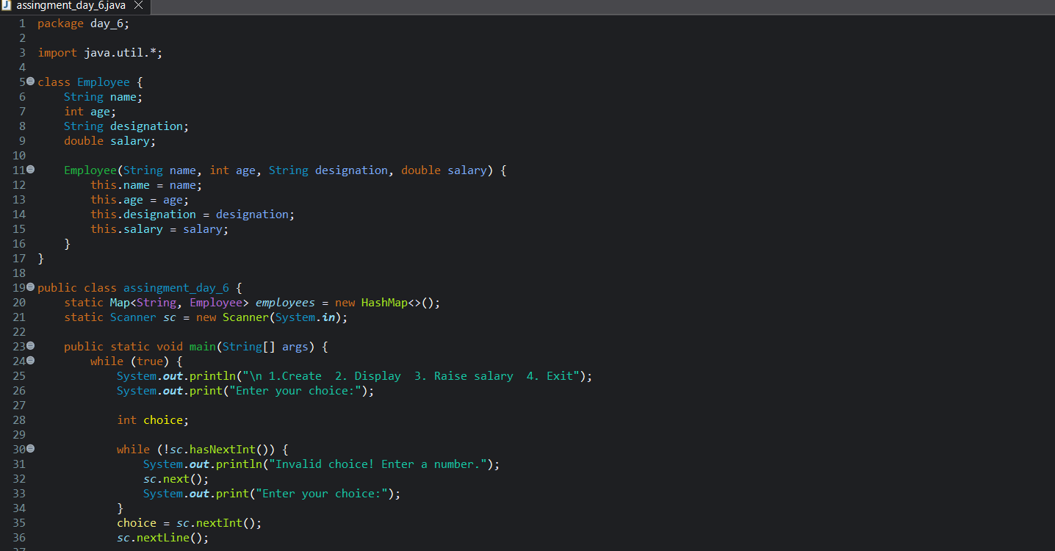
Console based Employee Management System
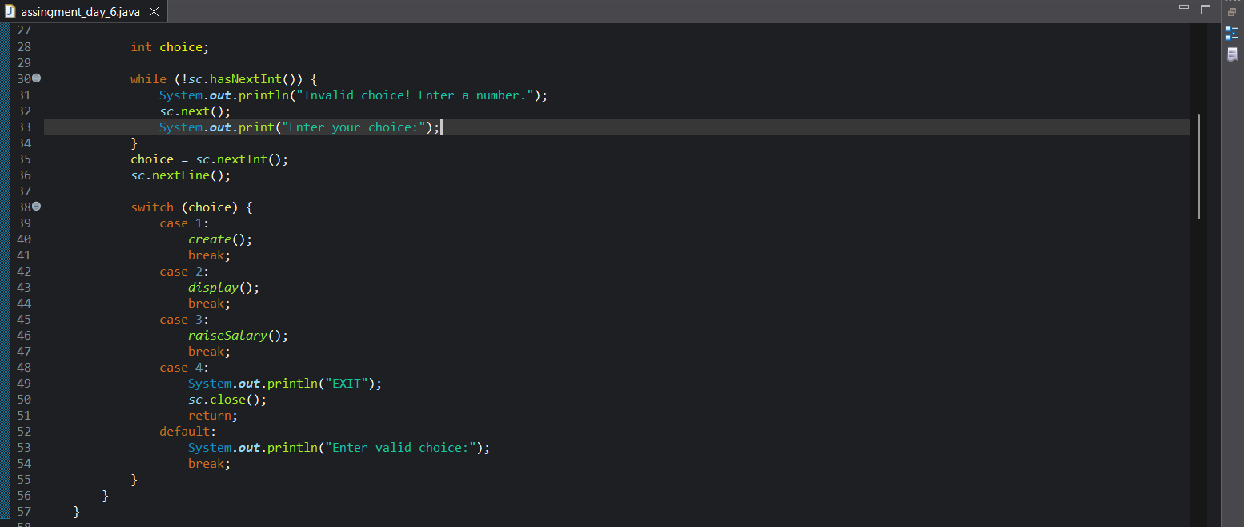
1. Console-based Employee Management System in Java for creating, displaying, and updating employee records
2. Uses HashMap<String, Employee> for storage, with Employee as a wrapper class (name, age, designation, salary)
3. Supports adding multiple employees, displaying all records, and raising a specific employee's salary by 1–10% via name lookup
4. All inputs validated with re-prompt loops — invalid entries don't crash the program.

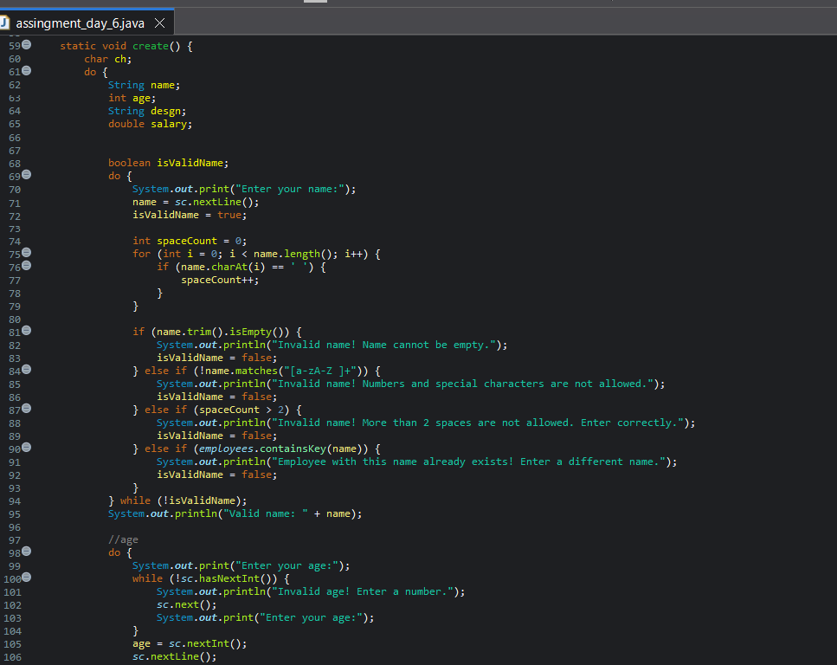
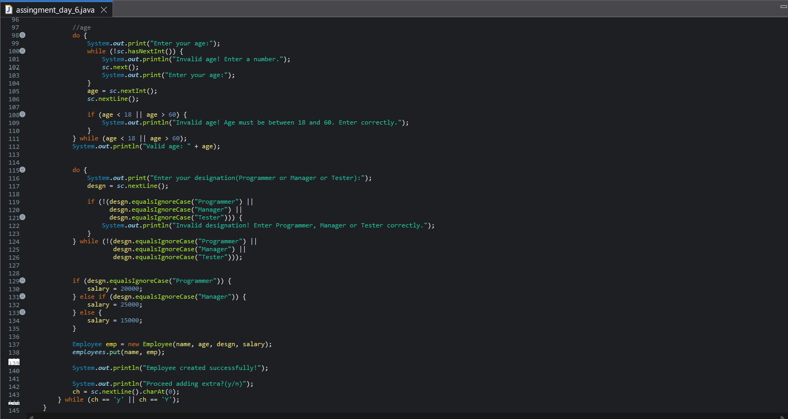

Case 1: Create
- Validate-then-store pattern — each field re-prompts in a loop until it passes its rule
- Salary is auto-derived from designation, not entered manually
- A new Employee object is built and stored in the HashMap with name as the key
- Outer loop lets you repeat this for multiple employees
- Name: rejected if it has more than 2 spaces, or if it already exists in the HashMap (no duplicates)
- Age: must be a valid integer between 18 and 60
- Designation: must match "Programmer", "Manager", or "Tester" (case-insensitive) — nothing else accepted
- These checks matter because designation directly drives the auto-salary assignment, so it must be one of exactly three known values.

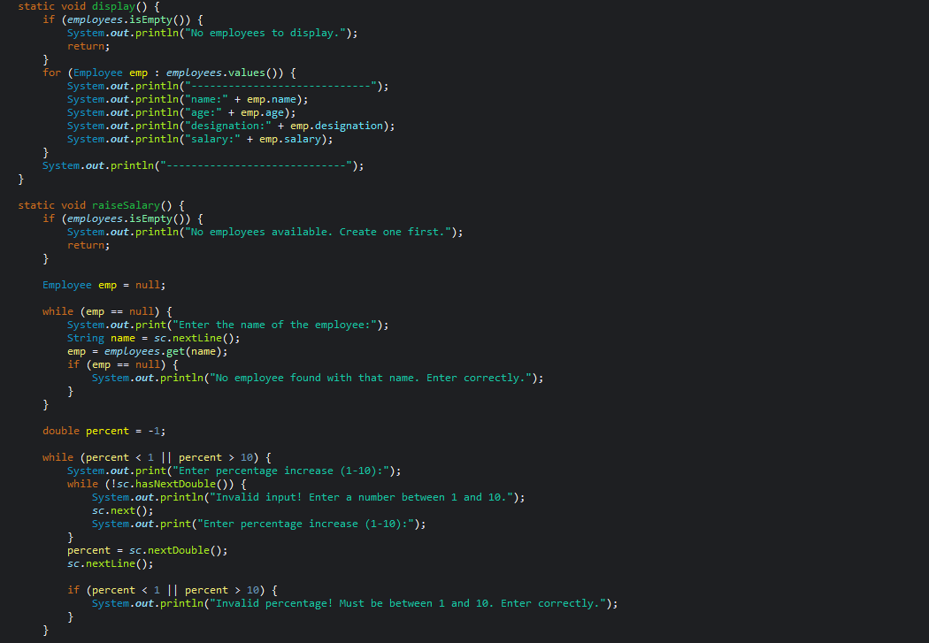

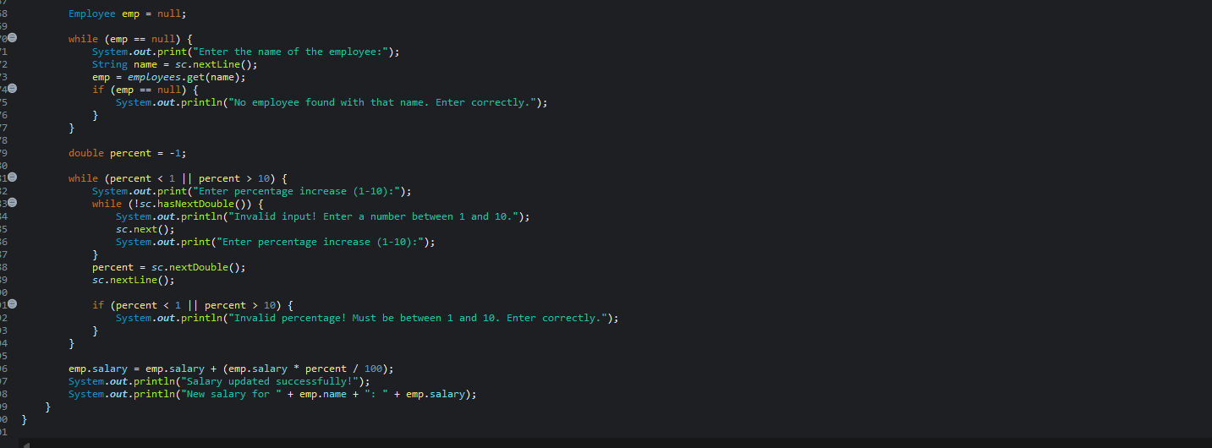

Case 2: Display
- Iterates over employees.values() and prints every object
- Doesn't need to know employee count or names in advance
- Works only because each employee is a separate stored object, not shared static fields.

Case 3: Raise Salary
- Direct lookup via employees.get(name) — no searching through everyone
- Since the object is stored by reference, changing emp.salary updates it inside the map itself
- Percentage validation loop follows the same reject-and-reprompt pattern as Case 1, applied to a 1–10 range

Output screenshots
