

**Project On:**

**Title: Insurance Premium Prediction**

**By: - Nidhi Patel**

**Date: - 27/05/2023**

Contents

1. Landing Page
2. Prediction Results

**1. Landing Page**

Insurance Premium Prediction Homepage is deployed using Flask. Landing Page have 6 features Age, Sex, BMI, No of Children, Smoker or not, Region and Predict button to predict the premium.

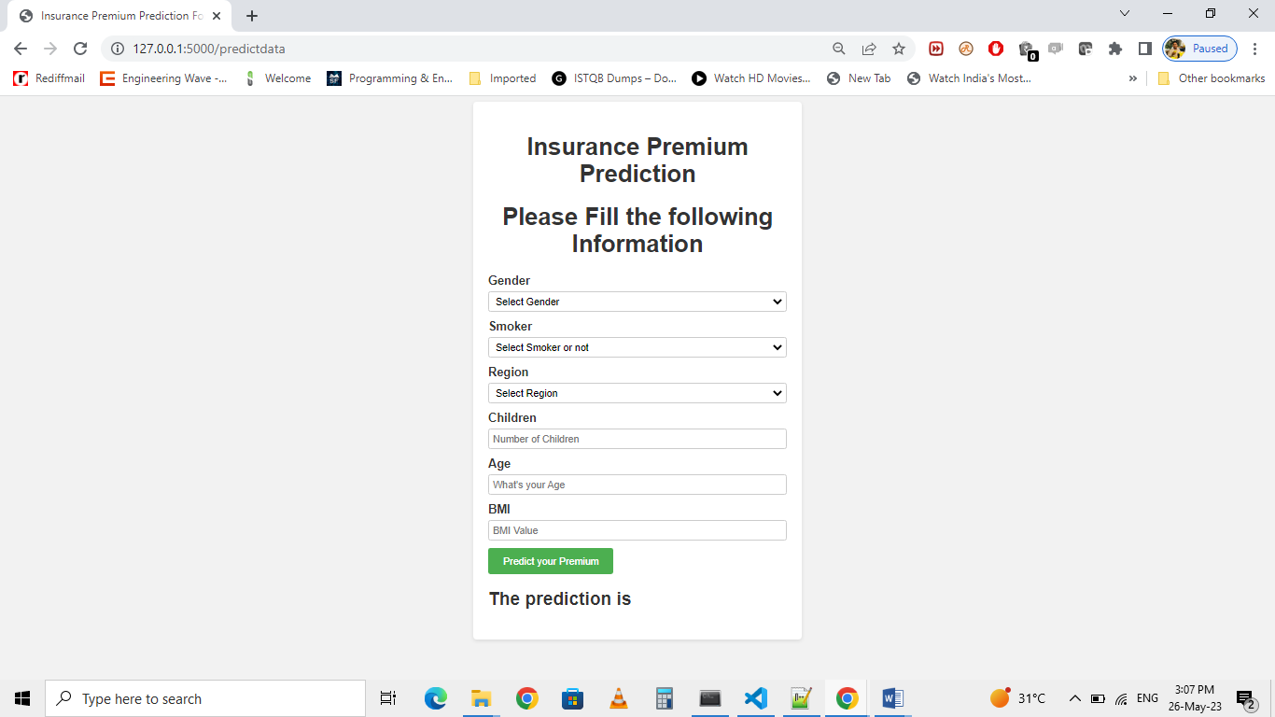

**2. Prediction Results**

User provides all the information and then clicks on predict button. The predicted result displays.

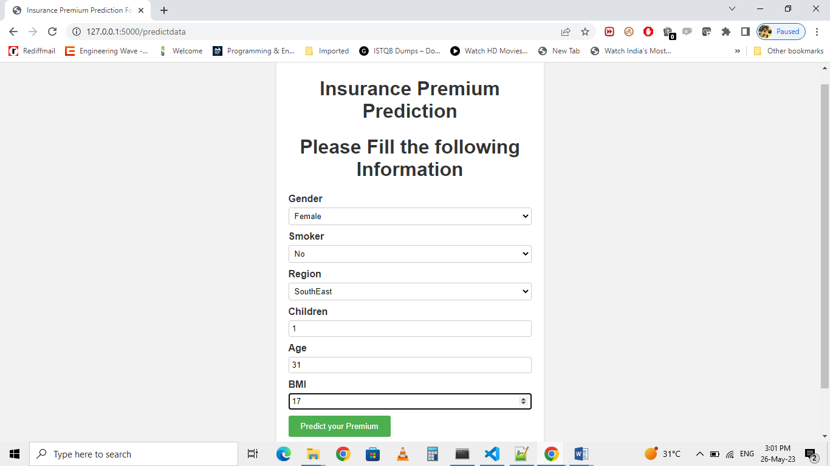

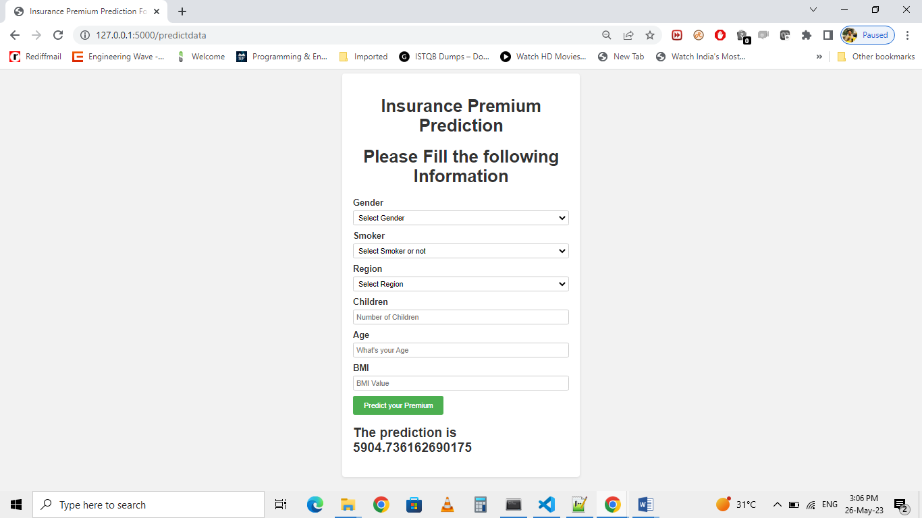**Predicted Premium:**

**Screenshot of application after deployment:**

