**PIZZA SALES SQL QUERIES**

A. KPI'S

**1.Total Revenue:**

SELECT SUM(TOTAL_PRICE) AS TOTAL_REVENUE FROM PIZZA_SALES;

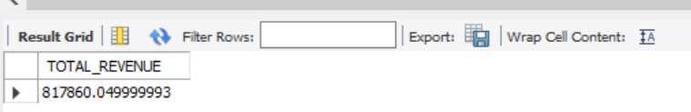

**2.Average order value:**

SELECT SUM(TOTAL_PRICE) / COUNT(DISTINCT ORDER_ID) AS AVERAGE_ORDER_VALUE FROM PIZZA_SALES;

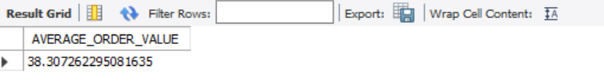

**3.Toal pizzas sold:**

SELECT SUM(QUANTITY) AS TOTAL_PIZZA_SOLD FROM PIZZA_SALES;

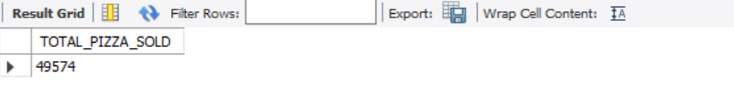

**4.Total orders:**

SELECT COUNT(DISTINCT ORDER_ID) AS TOTAL_ORDERS FROM PIZZA_SALES;

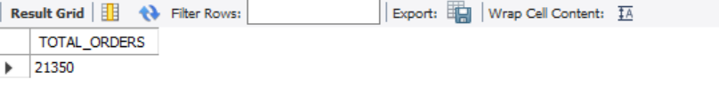

**5.Average pizzas per order:**

SELECT CAST((CAST(SUM(QUANTITY) AS DECIMAL(10,2)) / CAST(COUNT(DISTINCT ORDER_ID) AS DECIMAL(10,2))) AS DECIMAL(10,2)) AS AVERAGE_PIZZAS_PER_ORDER FROM PIZZA_SALES;

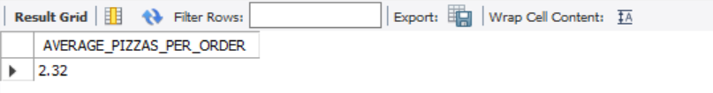

1. Daily Trend For Total Orders:

SELECT DAYNAME(ORDER_DATE) AS ORDER_DAY, COUNT(DISTINCT

ORDER_ID) AS TOTAL_ORDERS FROM PIZZA_SALES

GROUP BY DAYNAME(ORDER_DATE);

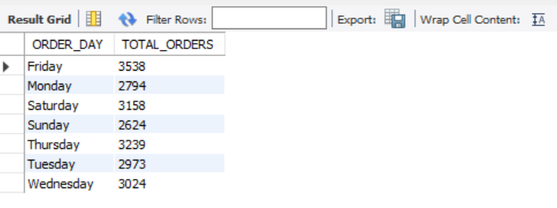

1. Hourly Trends For Total Orders:

SELECT HOUR(ORDER_TIME) AS ORDER_HOURS, COUNT(DISTINCT ORDER_ID) AS TOTAL_ORDERS

FROM PIZZA_SALES

GROUP BY HOUR(ORDER_TIME);

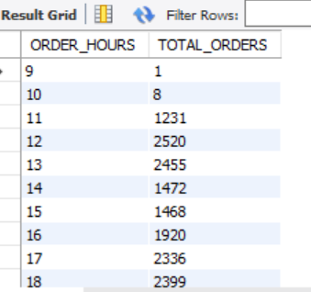 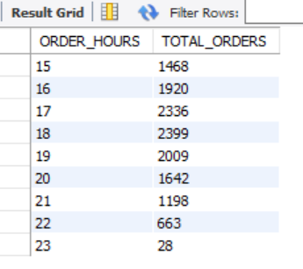

D.% Of Sales By Pizza Category:

SELECT PIZZA_CATEGORY , SUM(TOTAL_PRICE) AS TOTAL_SALES ,

SUM(TOTAL_PRICE)*100/(SELECT SUM(TOTAL_PRICE) FROM PIZZA_SALES)

AS PCT FROM PIZZA_SALES group by PIZZA_CATEGORY;

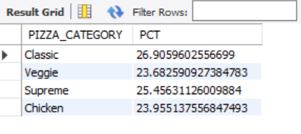

E.% Of Sales By Pizza Size:

SELECT PIZZA_SIZE , CAST(SUM(TOTAL_PRICE) AS DECIMAL(10,2)) AS TOTAL_SALES ,CAST(SUM(TOTAL_PRICE)*100/(SELECT SUM(TOTAL_PRICE) FROM PIZZA_SALES) AS DECIMAL(10,2))AS PCT FROM PIZZA_SALES group by PIZZA_SIZE ORDER BY PCT DESC;

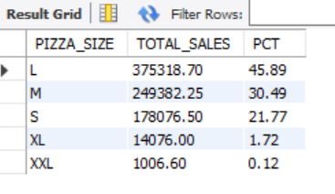

F. Total Pizzas Sold By Pizza Category:

SELECT PIZZA_CATEGORY , SUM(QUANTITY) AS TOTAL_PIZZAS_SOLD FROM PIZZA_SALES

GROUP BY PIZZA_CATEGORY;

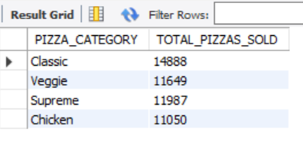

G. Top 5 Best Sellers By Total Pizzas Sold:

SELECT PIZZA_NAME , SUM(QUANTITY) AS TOTAL_PIZZAS_SOLD FROM PIZZA_SALES

GROUP BY PIZZA_NAME

ORDER BY SUM(QUANTITY) DESC LIMIT 5;

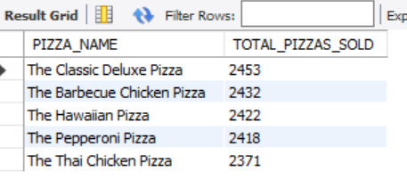

H. Bottom 5 Worst Seller By Total Pizzas:

SELECT PIZZA_NAME , SUM(QUANTITY) AS TOTAL_PIZZAS_SOLD FROM PIZZA_SALES

WHERE MONTH(ORDER_DATE) = 1

GROUP BY PIZZA_NAME

ORDER BY SUM(QUANTITY) ASC LIMIT 5 ;

