Mutual Fund Analytics Capstone Project – Final Report

Executive Summary

This project focuses on analyzing mutual fund performance using historical NAV data stored in PostgreSQL. The objective was to perform end-to-end data analytics, including data extraction, exploratory data analysis (EDA), fund performance evaluation, risk analysis, and dashboard development.

The project analyzed 40 mutual funds with a total of 46,000 NAV records covering the period from January 2022 to May 2026. Various analytical techniques such as Alpha-Beta analysis, Fund Scorecard generation, Benchmark comparison, Rolling Sharpe Ratio calculation, and VaR/CVaR risk analysis were implemented. Tableau dashboards were developed to visualize performance insights.

1. Problem Statement
Investors often find it difficult to compare mutual fund performance across multiple schemes and evaluate risk-adjusted returns. Large amounts of NAV data require systematic analysis to derive meaningful investment insights.

The objective of this project is to build a data analytics solution that enables:

- Performance comparison of mutual funds
- Risk assessment of investment schemes
- Benchmark evaluation
- Dashboard-based visualization for decision-making

---

2. Project Objectives

The primary objectives were:

- Store mutual fund data in PostgreSQL
- Perform data cleaning and transformation
- Conduct Exploratory Data Analysis (EDA)
- Calculate Alpha and Beta metrics
- Create Fund Scorecards
- Compare fund performance against benchmarks
- Measure risk using Sharpe Ratio, VaR, and CVaR
- Develop Tableau dashboards for visualization

---

3. Data Sources

The project used historical NAV data of mutual funds.

Dataset Information:

- Total Funds Analyzed: 40
- Total NAV Records: 46,000
- Data Period: January 2022 – May 2026

Key Tables:

- nav_history
- scheme_performance
- fund_master
- benchmark_indices
- portfolio_holdings
- investor_transactions
- monthly_sip_inflows
- category_inflows

---

4. ETL Design

Extract

Data was extracted from PostgreSQL database tables.

Transform

Data preprocessing included:

- Missing value handling
- Date formatting
- Data type conversions
- Aggregations and calculations

Load

Processed data was used for:

- Python analytics
- Tableau dashboard creation
- Risk calculations

---

5. Exploratory Data Analysis (EDA)

EDA was performed to understand:

- NAV distribution
- Fund growth trends
- Historical performance patterns
- Data completeness

Key Findings:

- Dataset contains complete NAV history.
- Multiple funds have more than 1,150 NAV observations.
- NAV values vary significantly across schemes.
- Long-term trends indicate varying growth patterns among funds.

---

6. Alpha and Beta Analysis

Alpha and Beta metrics were calculated to evaluate fund performance against market benchmarks.

Alpha

Alpha measures excess return generated by a fund compared to expected market return.

Beta

Beta measures fund volatility relative to the benchmark.

Key Insights:

- High Alpha funds demonstrated superior performance.
- Low Beta funds showed lower market sensitivity.
- Alpha-Beta analysis helped identify efficient funds.

---

7. Fund Scorecard Analysis

A comprehensive scorecard was developed using:

- Returns
- Risk metrics
- Alpha
- Beta
- Sharpe Ratio

Benefits:

- Easy comparison of mutual funds
- Ranking of top-performing schemes
- Identification of stable investment options

---

8. Benchmark Comparison

Fund returns were compared with benchmark indices.

Analysis Included:

- Relative performance
- Outperformance detection
- Underperformance analysis

Observations:

- Several funds consistently outperformed benchmarks.
- Some schemes showed benchmark tracking behavior.

---

9. Tableau Dashboard

An interactive Tableau dashboard was developed to visualize:

- Fund performance
- Return comparison
- Risk metrics
- Scatter plots
- Performance distributions

Dashboard Features

- Interactive filters
- Performance comparison charts
- Risk-return visualization

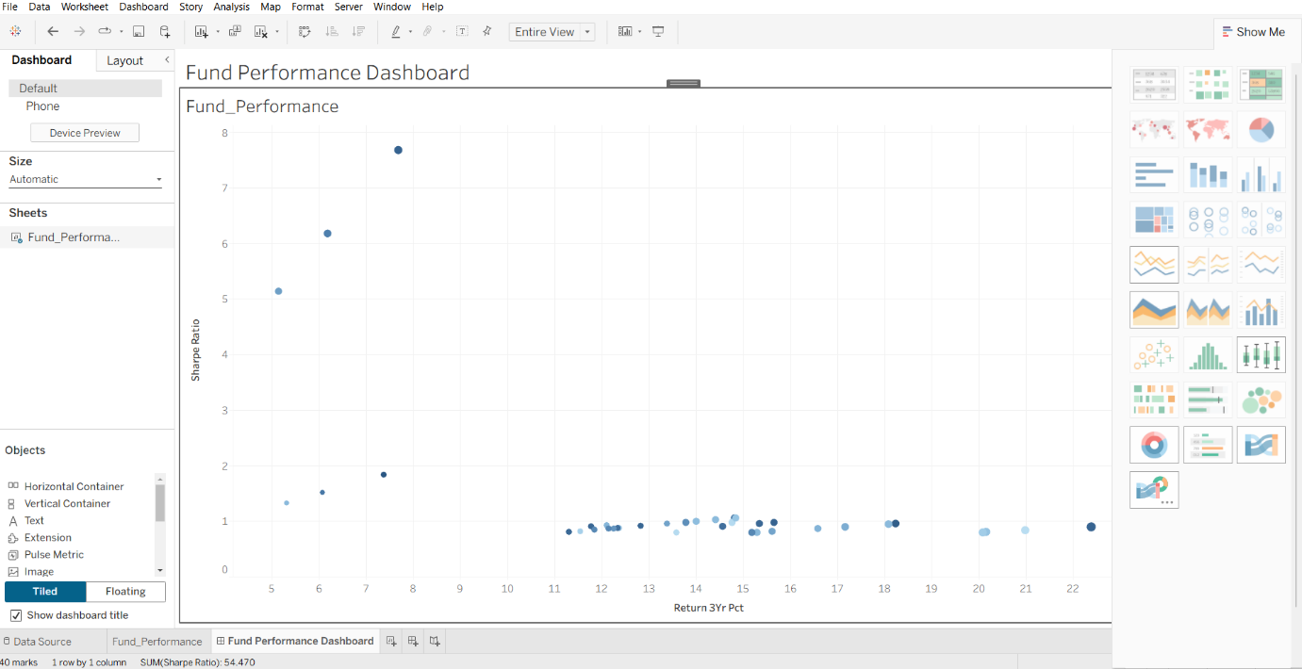

10. Rolling Sharpe Ratio Analysis

Rolling 90-Day Sharpe Ratio was calculated to measure risk-adjusted performance over time.

Observations:

- Sharpe Ratio fluctuated across different market periods.
- Positive Sharpe values indicate favorable risk-adjusted returns.
- Negative values indicate periods of weak performance.

Visualization
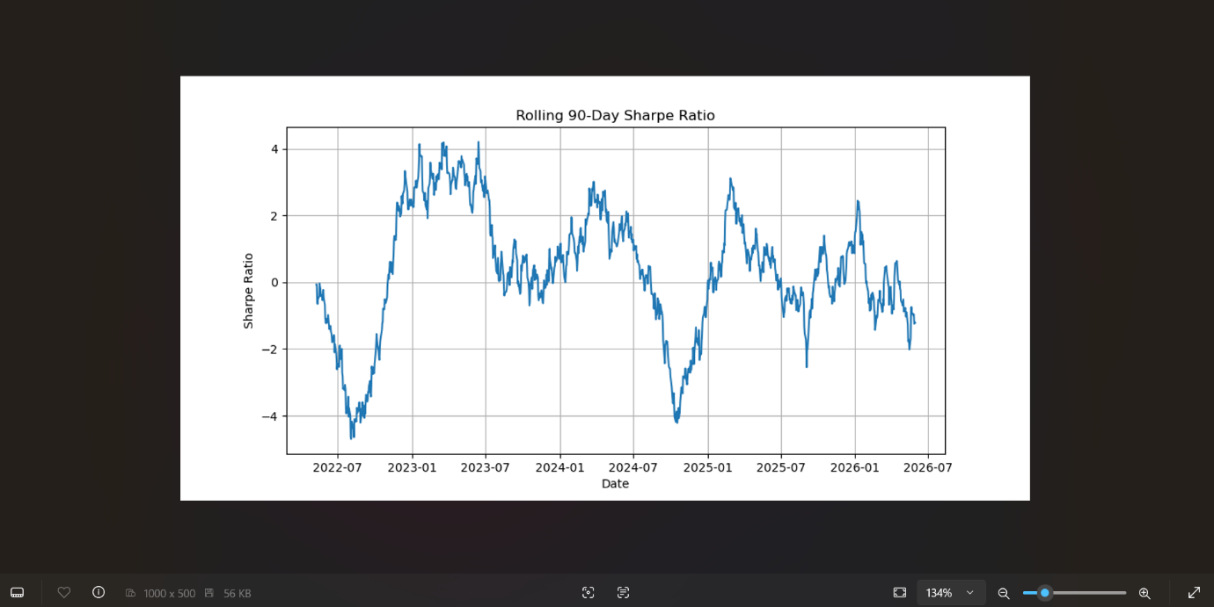

11. VaR and CVaR Risk Analysis

Risk analysis was performed using:

Value at Risk (VaR)

Measures maximum expected loss at a given confidence level.

Conditional Value at Risk (CVaR)

Measures average loss beyond VaR threshold.

Observations:

- VaR values remained within acceptable ranges.
- CVaR highlighted extreme downside risk scenarios.

Sample Output:

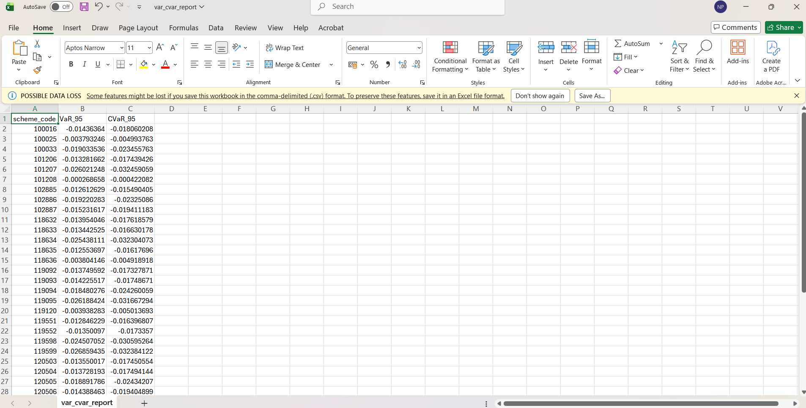

12. Technologies Used

- PostgreSQL
- Python
- Pandas
- NumPy
- Matplotlib
- Jupyter Notebook
- Tableau

---

13. Limitations

- Analysis based on historical data only.
- Market conditions may change in future.
- External economic factors not included.
- Limited benchmark coverage.

---

14. Recommendations

- Include real-time NAV feeds.
- Add predictive analytics models.
- Integrate machine learning forecasting.
- Expand benchmark coverage.
- Develop web-based dashboard deployment.

---

15. Conclusion

The Mutual Fund Analytics project successfully achieved all objectives. Historical NAV data was analyzed using PostgreSQL and Python. Advanced analytics including Alpha-Beta analysis, Fund Scorecard generation, Benchmark Comparison, Rolling Sharpe Ratio, and VaR/CVaR risk analysis were completed successfully.

The Tableau dashboard provides an effective visualization platform for evaluating fund performance and investment risk. The project demonstrates a complete end-to-end financial analytics workflow suitable for investment analysis and decision support.

Thank You

