Project Report

**On**

**Let’s Bid**

**Submitted By:**

Dave Hiral D (166250307008)

Parmar Priyanka J (166250307040)

Trivedi Devangi L (166250307053)

**SEM-5**

**COMPUTER ENGINEERING**

**In**



**GOVERNMENT POLYTECHNIC**

**JAMNAGAR**

**Government Polytechnic, Jamnagar**

**Computer Engineering**

**2018**

**CERTIFICATE**

**Date:**

This is to certify that the dissertation entitled **“Let’s Bid”** has been carried has been carried out **by Dave Hiral, Parmar Priyanka, Trivedi Devangi** under my guidance in fulfillment of the Diploma Engineering in Computer (5th Semester) of Gujarat technological University, Ahmadabad-Government Polytechnic Jamnagar during the academic year 2018-2019.

**Internal Guide Head of the Department**

H.C.SATASIYA K.M.SHAH

**ACKNOWLEDGEMENT**

Every work that one complete successful stand on the constant encouragement, goodwill and support of the people around. We hereby, avail this opportunity to express our heartfelt gratitude to a number of people who extended their valuable time, and cooperation in developing this project.

We would like to thank this opportunity to our deep gratitude and sincere thanks to my respected internal guide **H.C.SATASIYA** and external guide provide us with the all valuable guidance, encouragement, support and constructive criticism without which this project would not have been materialized.

Last but we would like to thanks our parents and a family member whose love and support has allowed us to achieve this goal.

**ABSTRACT**

We create this project as part of our college diploma computer engineering students. The students have a chance to have practical knowledge of the **WEBSITE** exposure as to gain control over programming languages. The objective of practical training of diploma computer engineering level is to develop among the students a feeling of **WEBSITE** making in order to develop practical base in them as supplement to the theoretical study of the computer application in general.

An online auction system permits a user to get benefits of web technologies. The project provides the facility to seller or buyer, provide best price benefits to buyer and also user. Using our system users get platform for selling or buying items.

This is the area of computer technologies. Each and every field are utilizing he computer and related technologies for belter work. People are likely to stay at home and work on finger tips. So making computer systems that make people work from home is useful.

Organizing the selling (Bidding) is important for user who wants to sell the product according to highest price user. So, user bid product according to his convenient. And buy product according to seller convenient.

Or in another point of view, in completing the diploma in computer engineering the student go in the degree college or in company for a job. This website is very useful for this type of students.

So, our website’s main purpose of providing the self -checking of student for themselves.

**INDEX**

|  |  |  |
| --- | --- | --- |
| **Sr. No** | **Topic** | **Page No.** |
| 1 | INTRRODUCTION   * 1. Project Characteristic   2. Project Overview and Advantages   3. Project Scope | 6-9 |
| 2 | Software Requirement Specification  2.1 User characteristic  2.2 Functional requirement  2.3 Non-Functional requirement | 10-19 |
| 3. | SYSETM ANALYSIS MIDELING – USER BASED   * 1. Feasibility study   3.2 Process model   * 1. User based modeling   3.2.1 Use case Diagram  3.2.2 Use cases | 20-32 |
| 4. | SYSTEM ANALYSIS AND DESIGN – DATA BASED  4.1 Data Modeling  4.1.1 E-R (Entity Relationship) Diagram  4.2 Behavioral Modeling  4.2.1 Data Flow Diagram  4.2.1.1 context Level Diagram (Level 0)  4.2.1.2 DFD - Level 1  4.2.1.3 DFD - Level 2 | 33-45 |
| 5. | SYSTEM DESIGN – UML  5.1 Activity Diagram | 46-50 |
| 6 | CODING AND TESTING  6.1 Sample code  6.2 Sample test cases | 51-61 |
| 7. | SYSTEM INTERFACE DESIGN  7.1 System Screenshot | 62-76 |

**CHAPTER NO: 1**

**INTRODUCTION**

1. **Introduction**
   1. Overview
   2. Scope
   3. Process Model
2. **INTRODUCTION**

Since, the internet has become a popular place to buy and sell goods, online auctioning services have made their way into most homes. Online auction system is web based application, so the main advantage is that there is no more system compatibility requirement problem. The main advantage of online auction system is that the user can have the varied classes for their investment, and through this system user can invest in their own selected firm.

* 1. **OVERVIEW**

This system provides an easy solution to users to buy or sell their product with maximum profit online.

SRS includes two sections overall description and specific requirements;

* Overall description will describe major role of the system components and interconnections.
* Specific requirements will describe roles and functions of the actors.
* Advantages of online auction

Convenience

- Bidders are able to participate in an online auction from anywhere and at any given time. Auctioneers are not needed to run the auction.

Rich Information

-All information of each product is in one central space, the catalogue on the website. All relating documents are also found on the website and many auction companies add audio and video to show their stock and products

Time saving and money saving

- Online auction saves the time money for both buyers and sellers. Buyers do not need to travel to participate in auction while sellers is not need to set up a live event.

No physical location or multiple physical locations

-Products do not need to be moved to one central location for an auction to be held. The units can be at multiple locations for viewing purposes or alternatively can be catalogued with all the information needed for the buyer to buy site unseen.

Compare prices

-The main advantage of bidding via online is that it provides the opportunity to compare the price online. The bidder can do a small research regarding the product price and quality with other online auction site before participating in the bidding.

* 1. **SCOPE**

This project investigates the entry threshold for providing a new auction service channel via the real options approach, where the entry threshold is established by using an online auctioning system designed for the use of normal users (individuals), industrialist, entrepreneurs, organization and academicians under transaction rate uncertainty.

1.Login: -

Customer must have a valid UserId and password to login to the system.

If a wrong password is given the user will be redirected to login page.

After the valid user logs in then user will be redirected to index page of auction site.

**1.3 PROCESS MODEL: -**

* We prefer RAD “Rapid Application Development “model for our project this is a high speed adaptation of the linear sequential model.

Reason: -

* There are many several reason for choosing RAD model which are specified below:
* Main reason is, component based design.
* There are different-different modules available in market.
* So, we need to just collect it for our project.
* Using those modules we can focus extra on our project.
* So, it results in less effort and best result.
* We can achieve working model within 60 to 90 days using this model. This is well organized, well-planned and effective for user.
* In short it requires less time which is admirable.
* Here not just only one but many development teams are working parallel on model to complete within a time period.
* So, it decreases the time to development and testing.
* We can use past used component here.
* Fully customer involvement is needed.
* It is most suitable for where is system is modularized, where all requirement specification are well understand and managed.

**CHAPTER NO: 2**

**SOFTWARE REQUIREMENT SPECIFICATION**

2.1User characteristic

2.2Functional requirement

2.3 Non-Functional requirement

**2. SRS (SOFTWARE REQUIREMENT SPECIFICATION).**

System Requirements are expressed in a software requirement document. The software requirement specification (SRS) is the official statement of what is required of the system developers. This requirement document includes the requirements definition and the requirement specification. The software requirement document is not a design document. It should set out what the system should do without specifying how it should be done. The requirement set out in this document is complete and consistent. The software specification document satisfies the following:

* It specifies the external system behaviors.
* It specifies constraints on the implementation.
* It is easy to change.
* It serves as reference tool for system maintainers.
* It records forethought about the life cycle of the system.
* It characterizes acceptable response to undesired events.

**2.1 USER CHARACTERISTICS**

The users of the system will be users with different levels of technical expertise. Any user with a basic understanding of the internet and auction should be able to make use of the available functionality of the system.

There are four different types of users.

Guests: These are visitor of the site which don’t have an account or logged in.

Users: these are the users of the site who have an account and logged in.

Administrators: These are the special member of the site who manages the site.

Seller: These are user who want sell his item to site.

**2.2 Functional Requirement**

**UC1: Login**

Primary Actor: User

Precondition: User has registered first. Then he/she is login to the system.

Main Success Scenario:

1. User enters login id and password.

2. System checks id and password are valid or not.

3. If valid then login successfully to the system.

Exception Scenario:

1. Otherwise System shows the message to enter correct id and password.

**Input**: admin username and password.

Condition 1 – invalid username or password.

Condition 2 – successfully login.

**Output**: admin will successfully log in or invalid details.

**Process**: here the admin will be validated against the system’s database.

UC2: **Put an item up for auction**

Primary Actor: Seller

Precondition: Seller has logged in

Main Success Scenario:

1. Seller posts an item (its category, description, picture, etc.) For auction

2. System shows past prices of similar items to seller.

3. Seller specifies the starting bid price and a date when the auction will close

4. System accepts the item and posts it

Exception Scenarios:

2. A) There are no past items in this category.

*System tells the seller this situation

UC3: **Make a bid**

Primary Actor: Buyer

Precondition: The buyer has logged in

Main Success Scenario:

1. Buyer searches or browses and selects some item

2. System shows the rating of the seller, the starting bid, the current bids, and the highest bid; asks buyer to make a bid

3. Buyer specifies a bid price

4. System accepts the bid; Blocks funds in bidders account

5. System updates the maximum bid price, informs other users, and updates the records for the item

Exception Scenarios:

3. A) the bid price is lower than the current highest

*System informs the bidder and asks to rebid

4. A) the bidder does not have enough funds in his/her account

*System cancels the bid, asks the user to get more funds

UC4: **Complete auction of an item**

Primary actor: Auction System.

Precondition: the last date for bidding has been reached.

Main Success Scenario:

1 .Select highest bidder; send email to selected bidder and seller informing final bid price; send email to other bidders also

2. Debit bidder's account and credit seller's

3. Unblock all other bidders' funds

4. Transfer from seller's account commission amount to organization's account

5. Remove item from site; update records

Exception Scenarios: None

UC5: Create user.

Primary Actor: Admin.

Description: Admin create users for his system.

Pre-Condition: admin first create a log-in form for the new user.

Post-Condition: User must be log-in to the system.

Main Success Scenarios:

1. To create a new user, admin show his advertisement to the user.

2. User sees the ads and visit to system and buy a product.

3. Admin checks user requirement.

4. Then admin checks user feedback for the products.

Exception Scenarios:

Admin must be a valid person or a computer with know all the information about the system.

UC6: Search Product

Primary Actor: Users.

Description: User searches the product into the system.

Pre-Condition: User must be login to the system.

Post-Condition: User searches his product.

Main Success Scenarios:

1. User searches the product.

2. User enters the details which product he wants.

3. System checks the product is available or not.

4. User checks the product is good or not.

Exception Scenarios:

1. User cannot search the product without log-in to the system.

UC7: Delete a product.

Primary Actor: Admin.

Description: Admin delete the product.

Pre-Condition: None.

Post-Condition: Items is deleted from the web store.

Main Success Scenarios:

1. Login to the system.
2. Confirm login.
3. Select category of the product.
4. Product content will remove from web store. His page is also deleted.
5. Delete the product.

UC8: logout.

Primary Actor: user.

Description: user wants logout from the system.

Pre-Condition: user must log in to the system.

Post-Condition: user logged out from the system.

Main Success Scenarios:

1. User request for logout.
2. User logged out from system.

**2.3 NON-FUNCTIONAL REQUIREMENTS**

**Reliability**

The system should be reliable. This software should not crash frequently.

**Availability**

The system shall be available to all users 24/7.

**Security**

The Security is major issue; the application software should be secure. Security is important because the application software is web based. Security will be provided through Access Control Mechanism. The application software will have secure password authentication and will prevent illegal access to Members accounts.

**Maintainability**

The Auction Website will be designed in such a way that it can be maintained in future.

**CHAPTER NO: 3**

**SYSTEM ANALYSIS MODELING – USER BASED**

* 1. Feasibility Study
  2. User based modeling

3.2.1 Use Case Diagrams

**3.1 FEASIBILITY STUDY**

**Economic Feasibility:-**

Economic feasibility is the most important and frequently used method for evaluating the effectiveness of the proposed system. It is very essential because the main goal of the proposed system is to have economically better result along with increased efficiency. Cost benefit analysis is usually performed for this purpose. It is the comparative study of the cost verses the benefits and savings that are expected from the proposed system. Since the organization is well equipped with the required hard ware, the project was found to be economically.

**Time Feasibility:-**

Project Start Date:-18-06-2018

Project End Date:-22-10-2018

**3.2.1 Use case diagram**

**Customer**

**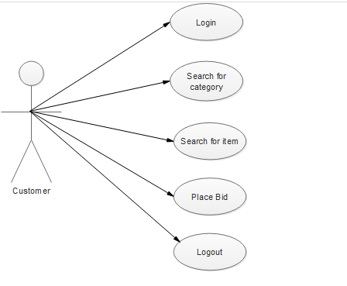  
Admin**

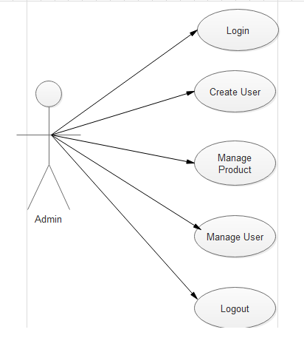

**Seller**

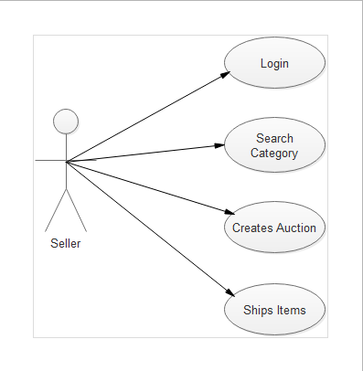

**CHAPTER NO: 4**

**SYSTEM ANALYSIS AND DESIGN DATA BASED**

4.1 Data modeling

4.1.1 Data Dictionary

4.1.2 ERD

4.2 Behavioral Modeling

* + 1. Data Flow Diagram
       1. Context Level Diagram (Level 0)
       2. DFD – Level 1
       3. DFD – Level 2

**4.1.1 Data Dictionary**

**Tables:**

Category

|  |  |  |  |  |
| --- | --- | --- | --- | --- |
| S.R No. | Field Name | Data type | Constraint | Description |
| 1 | Id | Int(100) | Primary | Id of the product category |
| 2 | Name | Varchar(100) | Not null | Name of the category |

Product

|  |  |  |  |  |  |  |  |  |  |  |  |  |  |  |  |  |  |  |  |  |  |  |  |  |  |  |  |  |  |  |  |  |  |  |  |
| --- | --- | --- | --- | --- | --- | --- | --- | --- | --- | --- | --- | --- | --- | --- | --- | --- | --- | --- | --- | --- | --- | --- | --- | --- | --- | --- | --- | --- | --- | --- | --- | --- | --- | --- | --- |
| |  |  |  |  |  | | --- | --- | --- | --- | --- | | S.R No. | Field Name | Data type | Constraint | Description | | 1 | Id | Int(100) | Primary | Id of the product. | | 2 | Cat_id | int(100) | Foreign key | Category id of the product. | | 3 | Name | Varchar(200) | Not null | Name of the product | | 4 | Price | Bigint(100) | Not null | Price of the product | | 5 | Photo | Varchar(100) | Not null | Image of the product | | 6 | Detail | Varchar(10000) | Not null | Detail of product | |

Users

|  |  |  |  |  |
| --- | --- | --- | --- | --- |
| S.R No. | Field Name | Data type | Constraint | Description |
| 1 | Id | Int(100) | Primary | Id of the user for internal use. |
| 2 | Name | Varchar(100) | Not null | Name of the user. |
| 3 | Mobile no | Bigint(10) | Unique | Contact no of the user. |
| 4 | Address | Varchar(1000) | Not null | Address of the user. |
| 5 | Email_id | Varchar(100) | Not null | Email id of the user |
| 6 | Password | Varchar(100) | Not null | Password of the user |
| 7 | Photo | Varchar(100) | Not null | Image of the users |

Admin

|  |  |  |  |  |
| --- | --- | --- | --- | --- |
| S.R No. | Field Name | Data type | Constraint | Description |
| 1 | Id | Int(100) | Primary | Id of the admin for internal use. |
| 2 | Email_id | Varchar(50) | Not null | Email id of the admin. |
| 3 | password | Varchar(30) | Not null | password of the admin. |
| 4 | name | Varchar(50) | Not null | name of the admin. |
| 5 | photo | Varchar(100) | Not null | Photo of the admin |

Bid

|  |  |  |  |  |
| --- | --- | --- | --- | --- |
| S.R No. | Field Name | Data type | Constraint | Description |
| 1 | Id | Int(11) | Not null | Id of the user for internal use. |
| 2 | Prod_id | Int(11) | Foreign key | Id of the product |
| 3 | Cust_id | Int(11) | Foreign key | Id of customer |
| 4 | Bidprice | Int(11) | Not null | Bidprice of product |

**Feedback**

|  |  |  |  |  |
| --- | --- | --- | --- | --- |
| S.R No. | Field Name | Data type | Constraint | Description |
| 1 | Id | Int(5) | Not null | Id of the feedback |
| 2 | user_id | Int(5) | Foreign key | Id of the user |
| 3 | Subject | Varchar(1000) | Not null | Subject of feedback |
| 4 | Message | Varchar(1000) | Not null | Message |

**4.1.2 E-R (Entity Relationship) Diagram**

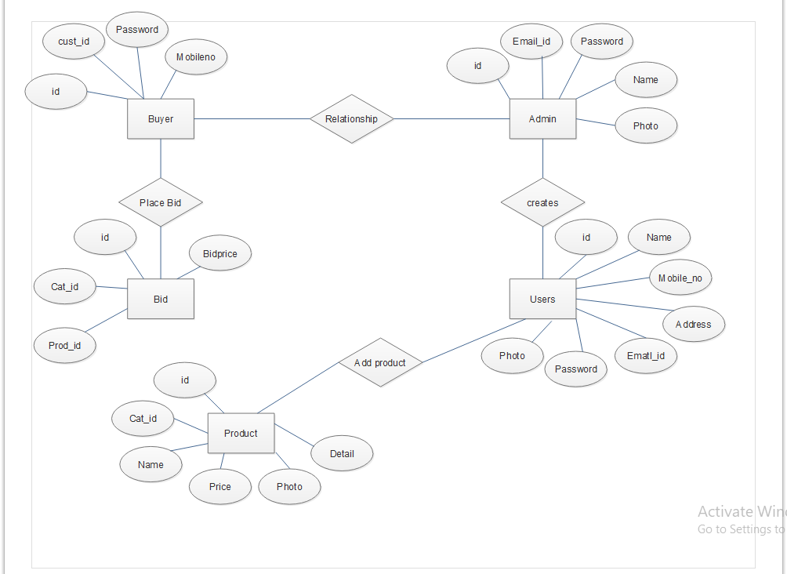

**4.2 BEHAVIORAL MODELING**

**4.2.1 Data Flow Modeling**

**4.2.1.1 Context Level Diagram (Level 0)**

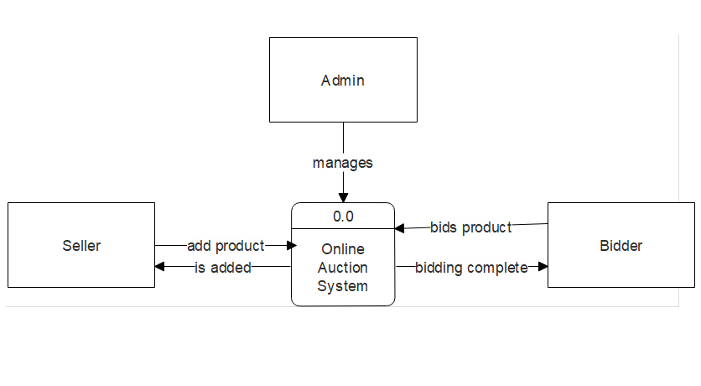

**4.2.1.2 DFD Level 1**

**Seller**

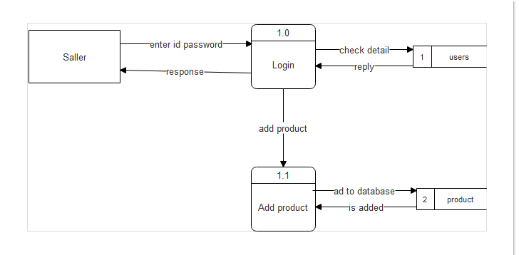

**Customer**

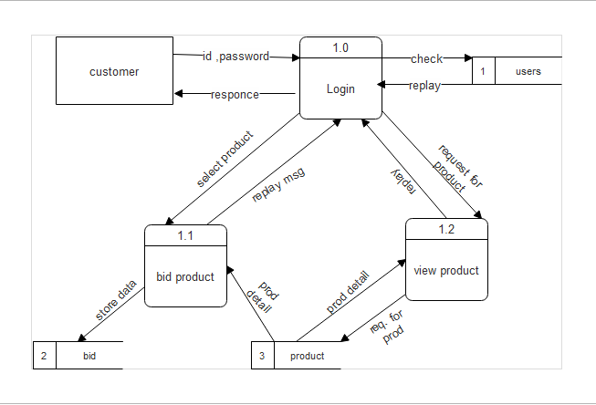

**Admin**

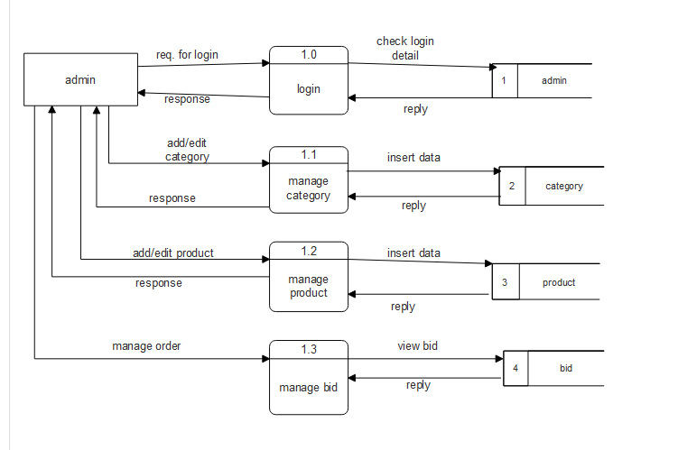

**4.2.1.3 DFD Level 2**

**Customer**

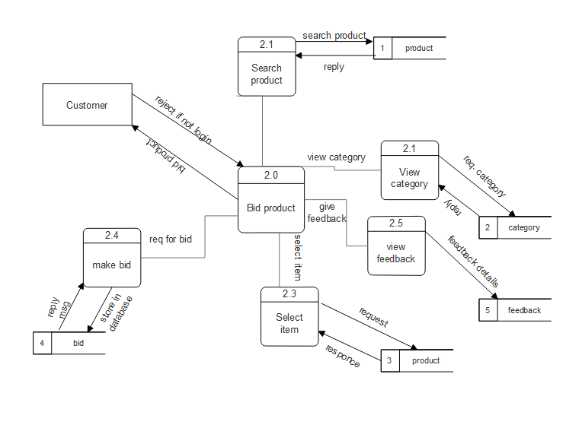

**Seller**

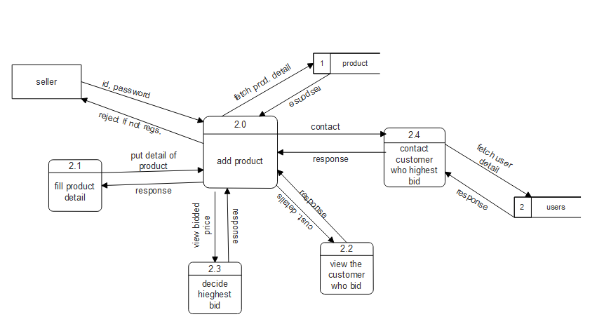

**Admin**

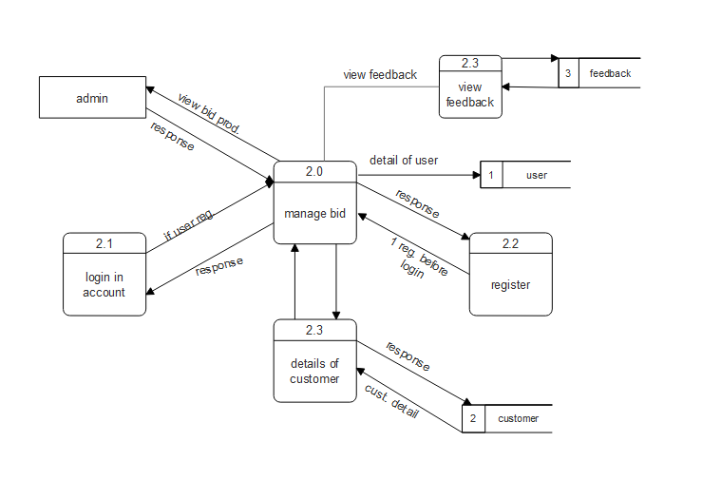

**CHAPTER NO: 5**

**CODING AND TESTING**

* 1. **Coding and Testing**
  2. Sample Code
  3. Test Cases with Sample Inputs and Outputs
  4. **Sample code**

<?php

session_start();

if(!isset($_SESSION["cust_id"])){

header("location: index.php");

}

?>

<html>

<head>

<title>Let's Bid</title>

<!-- for-mobile-apps -->

<meta name="viewport" content="width=device-width, initial-scale=1">

<meta http-equiv="Content-Type" content="text/html; charset=utf-8" />

<meta name="keywords" content="Best Store Responsive web template, Bootstrap Web Templates, Flat Web Templates, Android Compatible web template,

Smartphone Compatible web template, free webdesigns for Nokia, Samsung, LG, SonyEricsson, Motorola web design" />

<script type="application/x-javascript"> addEventListener("load", function() { setTimeout(hideURLbar, 0); }, false);

function hideURLbar(){ window.scrollTo(0,1); } </script>

<!-- //for-mobile-apps -->

<link href="css/bootstrap.css" rel="stylesheet" type="text/css" media="all" />

<link href="css/style.css" rel="stylesheet" type="text/css" media="all" />

<!-- js -->

<script src="js/jquery.min.js"></script>

<!-- //js -->

<!-- cart -->

<script src="js/simpleCart.min.js"> </script>

<!-- cart -->

<link rel="stylesheet" type="text/css" href="css/jquery-ui.css">

<!-- for bootstrap working -->

<script type="text/javascript" src="js/bootstrap-3.1.1.min.js"></script>

<!-- //for bootstrap working -->

<link href='//fonts.googleapis.com/css?family=Open+Sans:400,300,300italic,400italic,600,600italic,700,700italic,800,800italic' rel='stylesheet' type='text/css'>

<link href='//fonts.googleapis.com/css?family=Lato:400,100,100italic,300,300italic,400italic,700,700italic,900,900italic' rel='stylesheet' type='text/css'>

<!-- animation-effect -->

<link href="css/animate.min.css" rel="stylesheet">

<script src="js/wow.min.js"></script>

<script>

<?php

include "footer.php";

?>

</body>

</html>

* 1. **Test cases with simple inputs and outputs**

|  |  |  |  |  |  |
| --- | --- | --- | --- | --- | --- |
| **Test case No.** | **Test data** | **Expected result** | **Actual result** | **Result** | **Test type** |
| 1. | Check admin, user login, password for user id is wrong then not able to login. | Login will be failed | Login denied | Pass | Unit testing |
| 2. | Check if admin, user login, password or user id both is right. | Login will be pass | Login success | Pass | Unit testing |
| 3. | Admin can view user detail | View user detail | View successfully | Pass | Data base testing |
| 4. | Admin can delete users | Delete users | Delete  successfully | Pass | Data base testing |
| 5. | Logout from account and login page will be displayed | Admin is logout | Successfully logout | Pass | Unit testing |
| 6 | Search product | User find related product | Find product successfully | pass | Unit testing |
| 7 | Bid product if user is login | User bid product | Bidding is complete successfully | pass | Unit testing |
| 8 | Bid product even not logon | User would not able to bid product | Bidding process is denied | pass | Unit testing |
| 9 | User can place the product if is the login | User place his/her product for bidding | Adding of product can successful | Pass | Unit testing |
| 10 | User can not place (for selling) the  Product if is not login | User would not able to place the product for selling | Adding product process is denied | Pass | Unit testing |

**CHAPTER NO: 6**

**SYSTEM SCREENSCHOTS**

6.1 Screenshots of the User Interface for all users

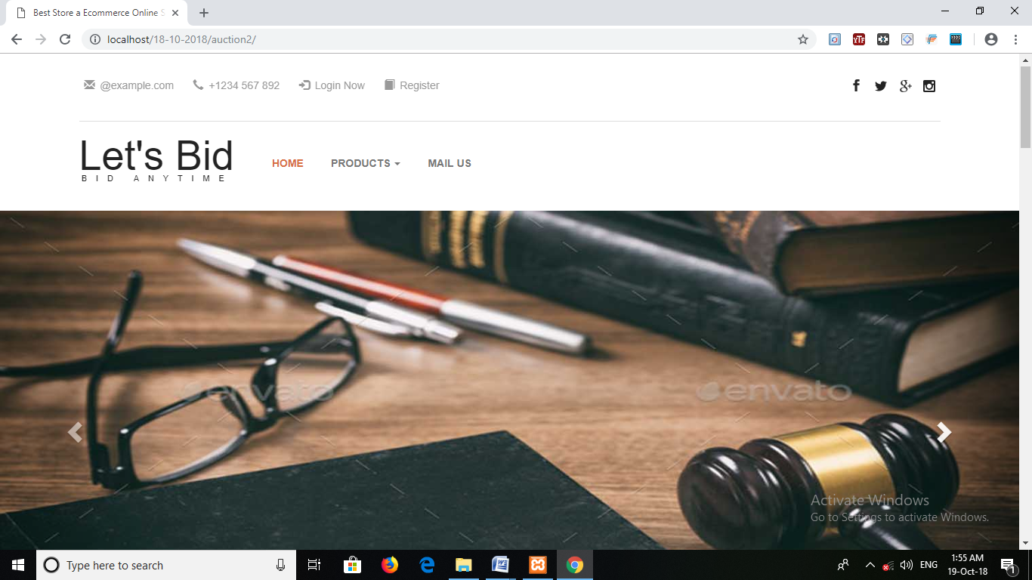

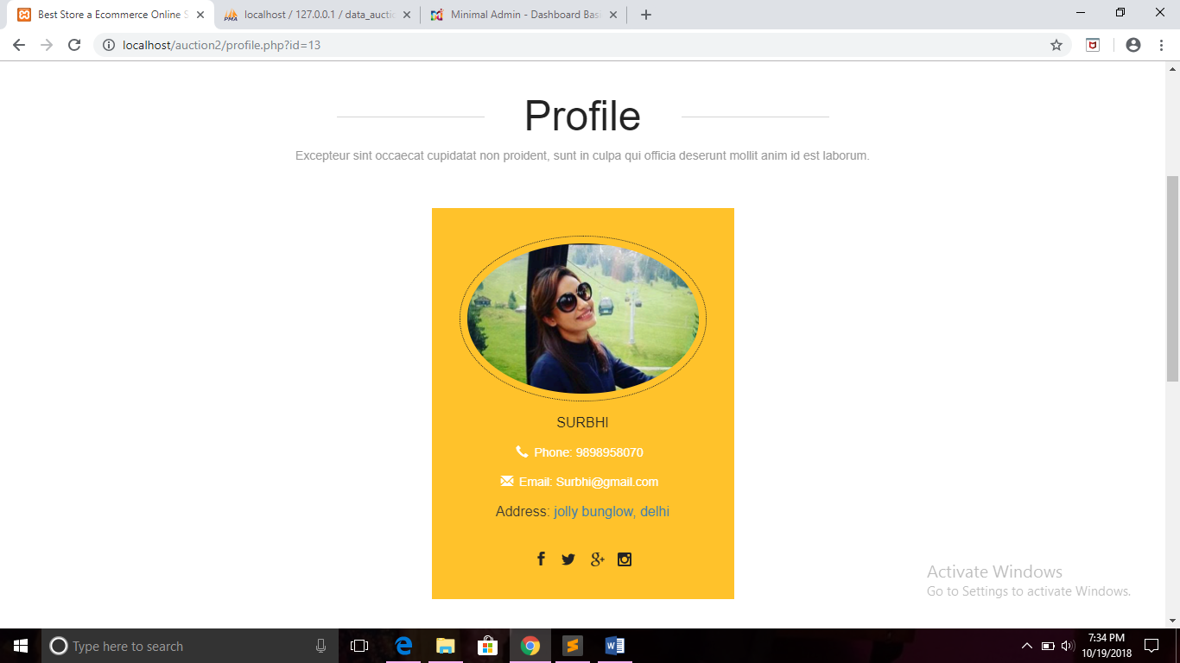

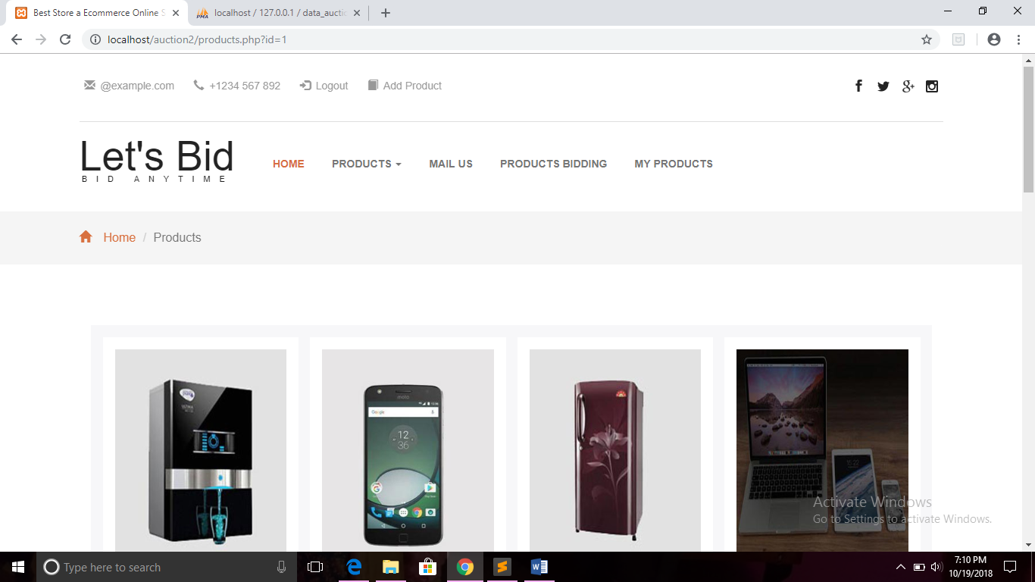

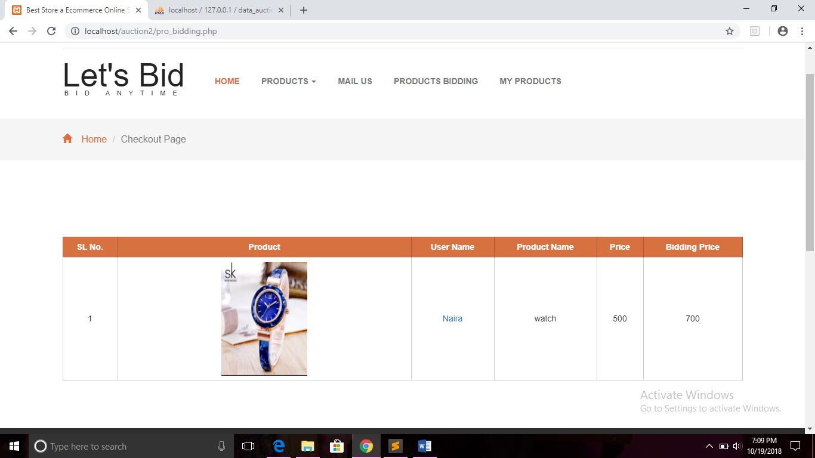

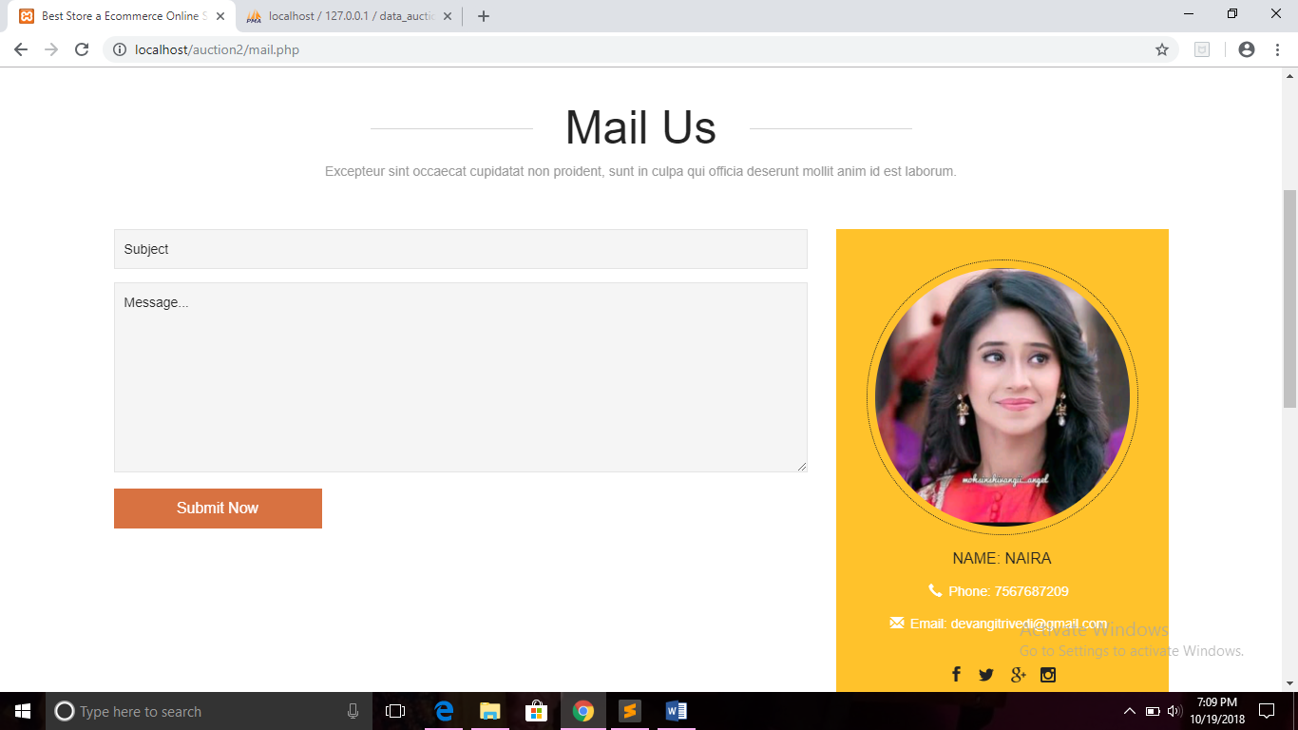

**CHAPTER NO: 7**

**FUTURE ENHANCEMENTS (IF ANY)**

7.1 Future Enhancement

7.1 Future Enhancement

* In this project, we have decided only four static categories like

1. Electronics
2. Jewellery
3. Watches
4. Cars

* In future you can add category of user’s wish that user wants to put in auction.