Software Requirements Specification (SRS)
Project: Mini Project Management Software
Team: Team 14
Version: 1.0
Authors: Srinidhi P (PES1UG24AM407), Sakshi P Shetty (PES1UG24AM395), Sanjana V Shastry (PES1UG24AM916)
Date: 28-09-2026
Status: Draft for review

Revision history
Version | Date | Author | Change summary | Approval
1.0 | 28-09-2026 | Team 14 | Initial SRS with use-case diagrams

Approvals
Role | Name | Signature / Email | Date
Course Coordinator
Team Members

Table of Contents
1. Introduction
2. Overall description
3. External interface requirements
4. System features (detailed)
5. Non-functional requirements (detailed)
5.1 Security
6. Quality attributes & Acceptance tests
7. System models and diagrams
8. Requirements Traceability Matrix (RTM)

1. Introduction

1.1 Purpose
This document is the Software Requirements Specification (SRS) for a mini version of project management software. It defines the functional and non-functional requirements, external interfaces, security requirements and verification criteria for a system in which users can define a project, create tasks, allocate tasks to different team members and track progress.

1.2 Scope
The system is a web-based application used by small teams to plan and monitor work. It covers user registration and login, project creation and membership, task creation, task allocation to team members, task status updates, progress dashboards and reports, and basic administration. It excludes time tracking, billing, Gantt-chart scheduling, third-party integrations, file storage and native mobile applications.

1.3 Audience
Developers, testers, the course instructor and evaluators, and the team members who maintain the software.

1.4 Definitions, acronyms and abbreviations
Term | Meaning
SRS | Software Requirements Specification
PM | Project Manager: the user who creates and manages a project
Team Member | A user who is assigned tasks in a project
Task | A unit of work with title, description, priority, due date, assignee and status
RBAC | Role-Based Access Control
UI / API | User Interface / Application Programming Interface
TLS / HTTPS | Transport Layer Security / HTTP over TLS
CSV | Comma-Separated Values file format
RPO | Recovery Point Objective (maximum tolerable data loss)
RTM | Requirements Traceability Matrix

2. Overall description

2.1 Product perspective
The product is a self-contained, browser-based system with a presentation layer, an application layer that enforces business rules and access control, and a relational database that stores users, projects, tasks, assignments, comments and activity logs. It does not depend on any external system.

2.2 Major product functions
- Register, log in and manage sessions with role-based access
- Create, edit and archive projects; manage project members
- Create, edit, delete and comment on tasks with priority and due dates
- Allocate and reassign tasks to project members
- Update task status and track progress through a dashboard
- Highlight overdue tasks, filter/search tasks and export progress reports
- Administer user accounts and view an activity log

2.3 User roles and characteristics
- Project Manager: plans the work; creates projects and tasks, allocates tasks and monitors progress. Needs a clear overview and quick actions.
- Team Member: executes assigned tasks; needs a simple list of "my tasks" and one-click status updates. No technical training assumed.
- Administrator: maintains user accounts and reviews the activity log.

2.4 Operating environment
Server-side application with a relational database, accessed through current versions of Chrome, Firefox and Edge over a secure network connection. The specific implementation technologies are chosen at design time and are not constrained by this SRS.

2.5 Constraints
- The project must be completed within the academic semester by a team of four students.
- A relational database must be used for persistent data.
- Only open-source or freely available tools and libraries may be used.
- All communication must use HTTPS.

2.6 Assumptions and dependencies
- Users have a modern browser and network access.
- Users register with a valid, unique email address.
- A task is assigned to one member at a time.
- A project has one owning Project Manager, who is the user who created it.

3. External interface requirements

3.1 User interfaces
A responsive web UI with a consistent menu: Dashboard, Projects, My Tasks, Reports and (for Administrators) Users and Activity Log. Forms show clear validation messages; task status is shown with colour and text labels so it is not conveyed by colour alone. Task boards or lists must be usable with keyboard navigation.

3.2 Hardware interfaces
No special hardware is required. The system runs on a standard server and is accessed from desktops, laptops, tablets or phones with a web browser.

3.3 Software interfaces
- Relational database management system for persistent storage (users, projects, tasks, assignments, comments, logs).
- Internal REST/HTTP API between the UI and the application layer, using JSON over HTTPS.
- CSV export interface used by the report feature.

3.4 Communications
- TLS 1.2 or higher enforced for all client–server traffic.
- Session identifiers sent only in secure, HTTP-only cookies or equivalent secure headers.

4. System features (detailed)
Each requirement below includes acceptance criteria and a reference test case. Functional requirement IDs follow MPMS-F-###.

4.1 User management and authentication
Description: Register users, authenticate them and restrict what each role can do.
Req ID | Requirement (shall...) | Type | Priority | Source / Stakeholder | Acceptance criteria / Test case ref | Comments / Dependencies
MPMS-F-001 | The system shall allow a new user to register with name, unique email and password. | Functional | High | All users | AC-F-001: Valid details create an account; duplicate email is rejected with a message. Test: TC-Auth-01 | Email format validated
MPMS-F-002 | The system shall authenticate users by email and password and start a secure session. | Functional | High | All users | AC-F-002: Correct credentials open the dashboard; wrong credentials show a generic error. Test: TC-Auth-02 | Depends on F-001
MPMS-F-003 | The system shall temporarily lock an account after 5 consecutive failed logins. | Functional | Medium | Security | AC-F-003: 6th attempt is blocked for 15 minutes and the event is logged. Test: TC-Auth-03 | Lock duration configurable
MPMS-F-004 | The system shall enforce role-based access with roles Administrator, Project Manager and Team Member. | Functional | High | Security / Admin | AC-F-004: A Team Member cannot create projects or allocate tasks; access is denied with a message. Test: TC-Auth-04 | Applies to every feature
MPMS-F-005 | The system shall end a session on logout or after 30 minutes of inactivity. | Functional | Medium | Security | AC-F-005: Idle session redirects to login and protected pages are inaccessible. Test: TC-Auth-05

4.2 Project management
Description: Define projects and control who belongs to them.
Req ID | Requirement (shall...) | Type | Priority | Source / Stakeholder | Acceptance criteria / Test case ref | Comments / Dependencies
MPMS-F-010 | The system shall allow a Project Manager to create a project with name, description, start date and end date. | Functional | High | Project Manager | AC-F-010: Project saved and shown in the project list; end date must not precede start date. Test: TC-Prj-01 | Core feature
MPMS-F-011 | The system shall allow the Project Manager to edit project details. | Functional | Medium | Project Manager | AC-F-011: Edited values persist and appear on reload. Test: TC-Prj-02
MPMS-F-012 | The system shall allow the Project Manager to archive a completed project without deleting its data. | Functional | Low | Project Manager | AC-F-012: Archived project is hidden from active list but retrievable. Test: TC-Prj-03
MPMS-F-013 | The system shall allow the Project Manager to add or remove registered users as project members. | Functional | High | Project Manager | AC-F-013: Added members can see the project; removed members lose access. Test: TC-Prj-04 | Depends on F-001
MPMS-F-014 | The system shall list only the projects a user owns or is a member of. | Functional | High | All users | AC-F-014: Users never see projects they do not belong to. Test: TC-Prj-05 | Access control

4.3 Task management
Description: Create and maintain tasks inside a project.
Req ID | Requirement (shall...) | Type | Priority | Source / Stakeholder | Acceptance criteria / Test case ref | Comments / Dependencies
MPMS-F-020 | The system shall allow a Project Manager to create a task within a project with title, description, priority and due date. | Functional | High | Project Manager | AC-F-020: Task appears in the project task list with status "To Do". Test: TC-Tsk-01 | Core feature
MPMS-F-021 | The system shall allow a Project Manager to edit a task's details. | Functional | Medium | Project Manager | AC-F-021: Changes are saved and recorded in the activity log. Test: TC-Tsk-02
MPMS-F-022 | The system shall allow a Project Manager to delete a task after confirmation. | Functional | Medium | Project Manager | AC-F-022: Task is removed only after the user confirms. Test: TC-Tsk-03
MPMS-F-023 | The system shall allow users to add comments to a task visible to all project members. | Functional | Low | Team Member | AC-F-023: Comment shows author name and timestamp. Test: TC-Tsk-04

4.4 Task allocation
Description: Assign tasks to team members and let members see their work.
Req ID | Requirement (shall...) | Type | Priority | Source / Stakeholder | Acceptance criteria / Test case ref | Comments / Dependencies
MPMS-F-030 | The system shall allow a Project Manager to assign a task to one project member. | Functional | High | Project Manager | AC-F-030: Only members of that project are selectable; assignee is shown on the task. Test: TC-All-01 | Depends on F-013, F-020
MPMS-F-031 | The system shall allow a Project Manager to reassign a task to a different member. | Functional | Medium | Project Manager | AC-F-031: Previous assignee loses the task from their list; change is logged. Test: TC-All-02
MPMS-F-032 | The system shall show each Team Member a list of tasks assigned to them, sorted by due date. | Functional | High | Team Member | AC-F-032: "My Tasks" lists only the user's own tasks in due-date order. Test: TC-All-03

4.5 Progress tracking and reporting
Description: Track task status and summarise progress for the Project Manager.
Req ID | Requirement (shall...) | Type | Priority | Source / Stakeholder | Acceptance criteria / Test case ref | Comments / Dependencies
MPMS-F-040 | The system shall allow an assignee to update task status among To Do, In Progress, In Review and Done. | Functional | High | Team Member | AC-F-040: Status change is saved immediately and reflected on the dashboard. Test: TC-Prg-01 | Core feature
MPMS-F-041 | The system shall display for each project the percentage of tasks completed and task counts per status. | Functional | High | Project Manager | AC-F-041: With 4 of 10 tasks Done, dashboard shows 40%. Test: TC-Prg-02 | Depends on F-040
MPMS-F-042 | The system shall highlight tasks whose due date has passed and are not Done as overdue. | Functional | Medium | Project Manager | AC-F-042: Overdue tasks are flagged visibly on lists and the dashboard. Test: TC-Prg-03
MPMS-F-043 | The system shall allow tasks to be filtered by status, assignee, priority and due date, and searched by title. | Functional | Medium | All users | AC-F-043: Result list contains only matching tasks. Test: TC-Prg-04
MPMS-F-044 | The system shall generate a project progress report that can be downloaded as CSV. | Functional | Low | Project Manager | AC-F-044: File contains all tasks with assignee, status and due date. Test: TC-Prg-05 | Depends on F-041

4.6 Administration
Description: Maintain user accounts and keep an audit trail.
Req ID | Requirement (shall...) | Type | Priority | Source / Stakeholder | Acceptance criteria / Test case ref | Comments / Dependencies
MPMS-F-050 | The system shall allow an Administrator to view, deactivate and reactivate user accounts. | Functional | Medium | Administrator | AC-F-050: Deactivated users cannot log in. Test: TC-Adm-01
MPMS-F-051 | The system shall maintain an activity log of project, task and assignment changes with user and timestamp. | Functional | Medium | Administrator | AC-F-051: Every create/edit/delete/assign action appears in the log. Test: TC-Adm-02 | Supports audit

5. Non-functional requirements (detailed)
NFRs below are measurable and tied to test plans. IDs follow MPMS-NF-###.
Req ID | Requirement | Category | Priority | Acceptance criteria / Measurement
MPMS-NF-001 | Common pages and actions (login, project list, task update) shall respond within 2 seconds for 95% of requests with up to 50 concurrent users. | Performance | High | 95th percentile ≤ 2 s in load test. Test: TC-Perf-01
MPMS-NF-002 | The system shall be available at least 99% of the time during working hours (excluding planned maintenance). | Reliability | Medium | Uptime report ≥ 99% over the test month. Test: TC-Rel-01
MPMS-NF-003 | A first-time user shall be able to create a project and assign a task within 10 minutes without training. | Usability | High | 5 of 5 test users complete the scenario in ≤ 10 min. Test: TC-UX-01
MPMS-NF-004 | The web interface shall work on the latest versions of Chrome, Firefox and Edge and adapt to screen widths from 360 px to 1920 px. | Portability / Compatibility | Medium | Layout verified on 3 browsers and 3 screen sizes. Test: TC-Cmp-01
MPMS-NF-005 | The system shall back up its database daily and support restoration with no more than 24 hours of data loss. | Reliability / Recoverability | Medium | Restore from backup succeeds in test. RPO ≤ 24 h. Test: TC-Rel-02
MPMS-NF-006 | The code shall be modular with separate layers for UI, business logic and data access, and each module shall have documented unit tests. | Maintainability | Medium | Code review confirms layering; unit-test coverage ≥ 60%. Test: TC-Mnt-01

5.1 Security

5.1.1 Security objectives
- SO-1 Confidentiality: only authenticated and authorised users can view a project's data; users cannot see projects they do not belong to.
- SO-2 Integrity: project, task and assignment data can be changed only by users whose role permits it, and every change is traceable.
- SO-3 Availability and accountability: the system resists account abuse (e.g., repeated login attempts) and keeps a reliable log of who did what and when.

5.1.2 Security requirements
Req ID | Requirement (shall...) | Type | Priority | Acceptance criteria / Test case ref
PRJ-SR-001 | TLS 1.2+ mandatory for all network connections (HTTPS only). | Security | High | HTTP requests are redirected to HTTPS; TLS scan shows no older protocol. Test: TC-Sec-01
PRJ-SR-002 | Passwords shall be stored only as salted hashes (e.g., bcrypt/Argon2), never in plaintext. | Security | High | DB inspection shows only hashes. Test: TC-Sec-02
PRJ-SR-003 | Every request shall be authorised server-side against the user's role and project membership. | Security | High | Direct URL/API access to another project's data returns 403. Test: TC-Sec-03
PRJ-SR-004 | All user input shall be validated and parameterised to prevent SQL injection and XSS. | Security | High | Injection test payloads are rejected or escaped. Test: TC-Sec-04
PRJ-SR-005 | Session tokens shall be random, expire after 30 min of inactivity and be invalidated on logout. | Security | Medium | Reused token after logout is rejected. Test: TC-Sec-05
PRJ-SR-006 | Security-relevant events (login failures, role changes, deletions) shall be logged with timestamp and user. | Security | Medium | Log entries present for each event type. Test: TC-Sec-06
PRJ-SR-007 | Passwords shall be at least 8 characters and include letters and digits. | Security | Medium | Weaker passwords are rejected at registration. Test: TC-Sec-07

6. Quality attributes & Acceptance tests
- Exit criteria for acceptance: all high-priority functional requirements are implemented and verified, no critical NFR or security test fails, and the RTM shows all test cases passed.
- Acceptance test suites: Authentication, Project management, Task management, Task allocation, Progress tracking, Administration, Performance, Security, and Usability/Compatibility.
- Quality attributes targeted: usability, performance, reliability, security, portability and maintainability (see Section 5).

7. System models and diagrams

7.1 UML Use-Case diagrams
Diagram 1 shows how the Project Manager and Team Member create and manage projects and tasks. Diagram 2 shows progress tracking by Project Manager and Team Member, and administration by the Administrator.
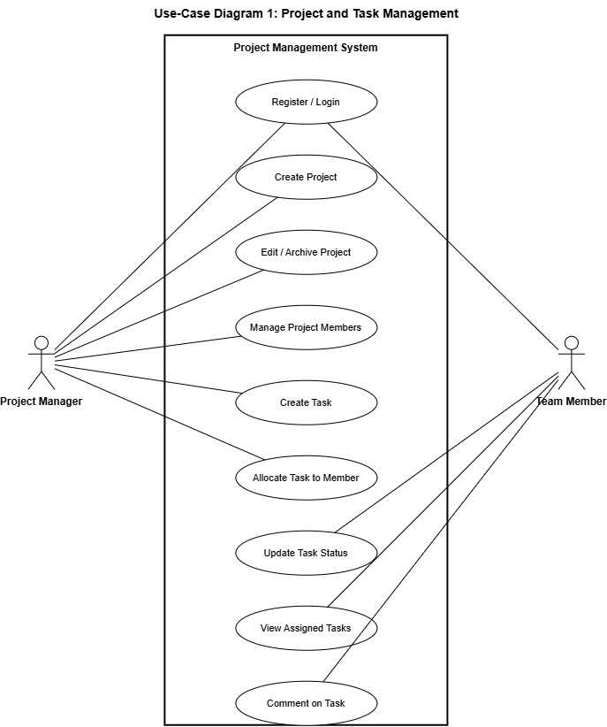
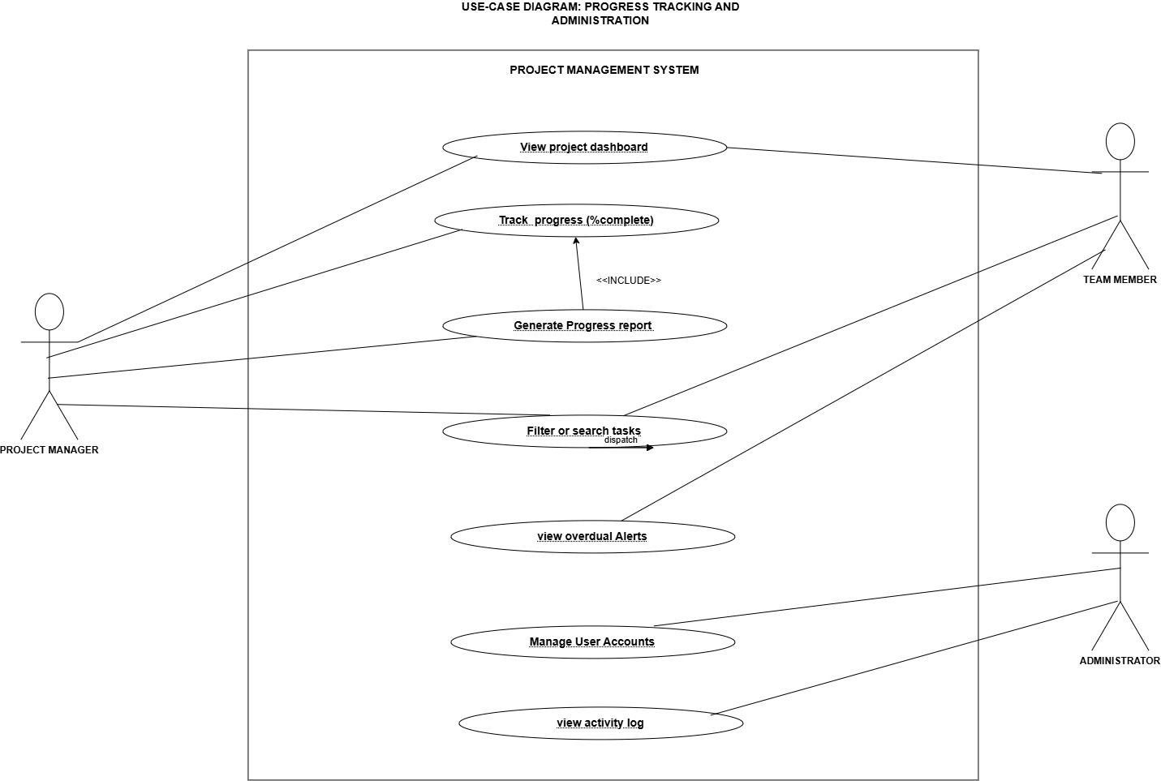

8. Requirements Traceability Matrix (RTM)
Status codes: N = Not started, P = In progress, A = Accepted / verified.
Req ID | Requirement short | Section ref / Design Spec | Module | Test case(s) | Status (N/P/A) | Comments
MPMS-F-001 | User registration | 4.1 / DS-Auth-01 | AuthModule | TC-Auth-01 | N
MPMS-F-002 | User login | 4.1 / DS-Auth-02 | AuthModule | TC-Auth-02 | N
MPMS-F-003 | Account lockout | 4.1 / DS-Auth-03 | AuthModule | TC-Auth-03 | N
MPMS-F-004 | Role-based access | 4.1 / DS-Auth-04 | AuthModule | TC-Auth-04 | N
MPMS-F-005 | Logout / session timeout | 4.1 / DS-Auth-05 | AuthModule | TC-Auth-05 | N
MPMS-F-010 | Create project | 4.2 / DS-Prj-01 | ProjectModule | TC-Prj-01 | N
MPMS-F-011 | Edit project | 4.2 / DS-Prj-02 | ProjectModule | TC-Prj-02 | N
MPMS-F-012 | Archive project | 4.2 / DS-Prj-03 | ProjectModule | TC-Prj-03 | N
MPMS-F-013 | Manage project members | 4.2 / DS-Prj-04 | ProjectModule | TC-Prj-04 | N
MPMS-F-014 | View project list | 4.2 / DS-Prj-05 | ProjectModule | TC-Prj-05 | N
MPMS-F-020 | Create task | 4.3 / DS-Tsk-01 | TaskModule | TC-Tsk-01 | N
MPMS-F-021 | Edit task | 4.3 / DS-Tsk-02 | TaskModule | TC-Tsk-02 | N
MPMS-F-022 | Delete task | 4.3 / DS-Tsk-03 | TaskModule | TC-Tsk-03 | N
MPMS-F-023 | Task comments | 4.3 / DS-Tsk-04 | TaskModule | TC-Tsk-04 | N
MPMS-F-030 | Allocate task | 4.4 / DS-All-01 | AssignmentModule | TC-All-01 | N
MPMS-F-031 | Reassign task | 4.4 / DS-All-02 | AssignmentModule | TC-All-02 | N
MPMS-F-032 | View assigned tasks | 4.4 / DS-All-03 | AssignmentModule | TC-All-03 | N
MPMS-F-040 | Update task status | 4.5 / DS-Prg-01 | ProgressModule | TC-Prg-01 | N
MPMS-F-041 | Project progress dashboard | 4.5 / DS-Prg-02 | ProgressModule | TC-Prg-02 | N
MPMS-F-042 | Overdue highlighting | 4.5 / DS-Prg-03 | ProgressModule | TC-Prg-03 | N
MPMS-F-043 | Filter / search tasks | 4.5 / DS-Prg-04 | ProgressModule | TC-Prg-04 | N
MPMS-F-044 | Progress report | 4.5 / DS-Prg-05 | ReportModule | TC-Prg-05 | N
MPMS-F-050 | Manage user accounts | 4.6 / DS-Adm-01 | AdminModule | TC-Adm-01 | N
MPMS-F-051 | Activity log | 4.6 / DS-Adm-02 | AdminModule | TC-Adm-02 | N
MPMS-NF-001 | Response time | 5 / DS-Perf-01 | Performance | TC-Perf-01 | N
MPMS-NF-002 | Availability | 5 / DS-Rel-01 | Reliability | TC-Rel-01 | N
MPMS-NF-003 | Ease of use | 5 / DS-UX-01 | UI | TC-UX-01 | N
MPMS-NF-004 | Browser compatibility | 5 / DS-Cmp-01 | UI | TC-Cmp-01 | N
MPMS-NF-005 | Backup & recovery | 5 / DS-Rel-02 | Database | TC-Rel-02 | N
MPMS-NF-006 | Maintainability | 5 / DS-Mnt-01 | All modules | TC-Mnt-01 | N
PRJ-SR-001 | TLS for all traffic | 5.1 / DS-Sec-01 | AuthModule / Deployment | TC-Sec-01 | N
PRJ-SR-002 | Password hashing | 5.1 / DS-Sec-02 | AuthModule | TC-Sec-02 | N
PRJ-SR-003 | Server-side authorisation | 5.1 / DS-Sec-03 | AuthModule | TC-Sec-03 | N
PRJ-SR-004 | Input validation | 5.1 / DS-Sec-04 | All modules | TC-Sec-04 | N
PRJ-SR-005 | Session security | 5.1 / DS-Sec-05 | AuthModule | TC-Sec-05 | N
PRJ-SR-006 | Security event logging | 5.1 / DS-Sec-06 | AdminModule | TC-Sec-06 | N
PRJ-SR-007 | Password policy | 5.1 / DS-Sec-07 | AuthModule | TC-Sec-07 | N

