Software Architecture & Design (SAD)
Project: Mini Project Management Software (MPMS)
Team: Team 14
Version: 2.0 (as built, end of Sprint 2)
Authors: Srinidhi P (PES1UG24AM407), Sakshi P Shetty (PES1UG24AM395), Sanjana V Shastry (PES1UG24AM916)
Date: 30-10-2026
Status: Final - describes the implemented system
Repository: github.com/nidhi832/TEAM_NO_14

Revision History

Version | Date | Author | Change Summary
1.0 | Sep 2026 | Team 14 | Initial architecture and design
2.0 | 30-10-2026 | Team 14 | Updated to the as-built system: final stack, component, class and sequence diagrams, endpoints, security design, risks found by testing and their fixes

Approvals

Role | Name | Signature/Date
Course Coordinator
Team Members | Srinidhi P, Sakshi P Shetty, Sanjana V Shastry | 30-10-2026

Table of Contents
1. Introduction
2. Document Overview
3. Architecture
3.1 Goals & Constraints
3.2 Stakeholders & Concerns
3.3 Component (UML) Diagram
3.4 Component Descriptions
3.5 Chosen Architecture Pattern and Rationale
3.6 Technology Stack & Data Stores
3.7 Risks & Mitigations
3.8 Traceability to Requirements
3.9 Security Architecture
4. Design
4.1 Design Overview
4.2 UML Sequence Diagrams
4.3 API Design
4.4 Error Handling, Logging & Monitoring
4.5 UX Design
4.6 Open Issues & Next Steps
5. Appendices

1. Introduction

1.1 Purpose
This document specifies the architecture and design of the Mini Project Management Software (MPMS): how the system is structured, why it is structured that way, and how its main flows, interfaces and security controls work. It is the design counterpart of SRS v2.0.

1.2 Scope
Covers the whole web application: authentication and sessions, projects and members, tasks, comments and allocation, progress dashboard, search and CSV reports, administration and activity log, plus the operational scripts (load test, uptime monitor, database backup, coverage report).

1.3 Audience
Developers, testers, the course instructor and evaluators, and team members who maintain the software.

1.4 Definitions
Term | Meaning
Flask / Blueprint | Python web framework / a group of related routes (one per module)
ORM | Object-Relational Mapper (SQLAlchemy): Python classes mapped to database tables
RBAC | Role-Based Access Control (Admin, PM, Team Member) plus project membership checks
ADR | Architecture Decision Record
STRIDE | Threat model: Spoofing, Tampering, Repudiation, Information disclosure, Denial of service, Elevation of privilege
WAL | Write-Ahead Logging mode in SQLite: readers do not block writers
scrypt | Slow, salted password-hashing algorithm used to store passwords
TLS / HSTS | Transport Layer Security / HTTP Strict Transport Security header
p95 | 95th percentile response time

2. Document Overview

2.1 How to use this document
Section 3 describes the architecture: goals, stakeholders, component and class diagrams, the chosen pattern with Architecture Decision Records, the technology stack, risks, traceability and the security architecture (STRIDE). Section 4 describes the detailed design: two sequence diagrams, the HTTP interface of the main components, error handling, logging and monitoring, UX design, and open issues.

2.2 Related Documents
- SRS v2.0 - SRS_Mini_Project_Management_Software (requirements and RTM)
- Test cases - docs/testing/test-cases.md (STP)
- Performance report - docs/testing/performance-report.md (BL-29)
- Availability and uptime report - docs/testing/availability.md, uptime-report.md (BL-30)
- Backup and restore guide - docs/testing/database-backup.md (BL-33)
- Coverage report - docs/testing/coverage-report.md (BL-34)
- Database schema notes - docs/database-schema.md

3. Architecture

3.1 Goals & Constraints
- Goals: secure by default (RBAC on every request, hashed passwords, revocable sessions); simple to run and demo (one command: python run.py); maintainable (strict layers, 136 automated tests, 97.7% coverage); responsive (p95 under 2 s for 50 concurrent users); available at least 99% in working hours.
- Constraints: 3 students, 2 one-week sprints; open-source tools only; relational database required; HTTPS in production; every change through a GitHub pull request with CI (flake8 + pytest).

3.2 Stakeholders & Concerns
Stakeholder | Main concerns | Addressed by
Project Manager | Quick overview of progress, easy task allocation | Dashboard, project page with task table, CSV report
Team Member | Simple list of own work, one-click status update | My Tasks (sorted by due date), status dropdown
Administrator | Control of accounts, audit trail | Admin users page, activity log with security filter
Developers / maintainers | Modularity, testability, clear rules | Layered structure, services free of HTTP code, architecture tests
Instructor / evaluators | Traceability to SRS, evidence of quality | RTM, test reports in docs/testing, CI history

3.3 Component (UML) Diagram
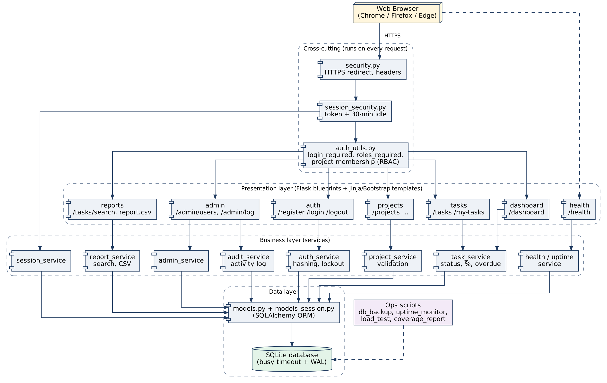
Figure 1 - Component diagram: requests pass the cross-cutting checks, then a route (UI layer), a service (business layer) and the ORM (data layer)

UML Class Diagram (data model)
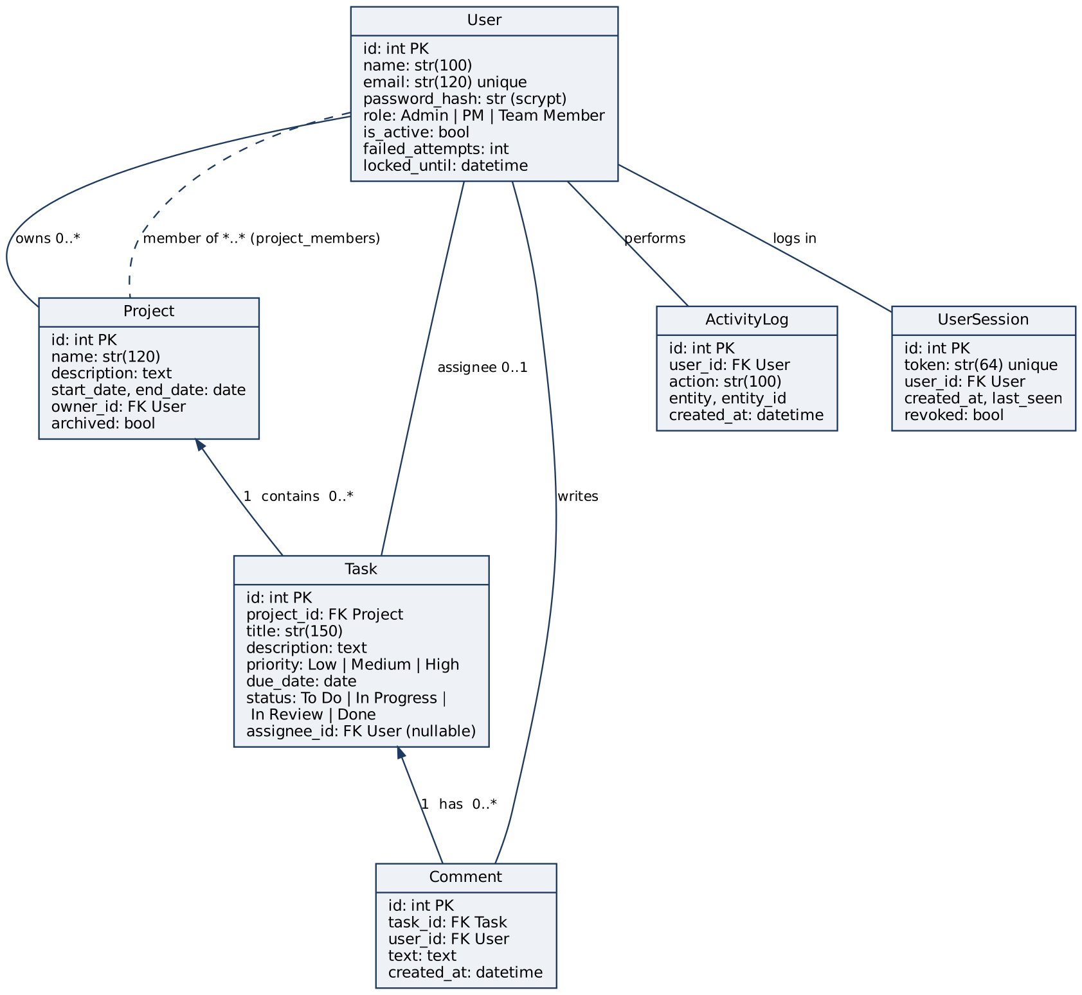
Figure 2 - Class diagram of the persistent entities (SQLAlchemy models); project_members is the many-to-many link table

3.4 Component Descriptions
Component | Files | Responsibility
Web UI | app/templates/*.html | Server-rendered Jinja2 pages styled with Bootstrap; forms for every action
Auth routes | routes/auth.py | Register (role PM / Team Member), login with lockout, logout
Project routes | routes/projects.py | List own projects, create, edit, archive / restore, add / remove members
Task routes | routes/tasks.py | Create, view, edit, delete (confirm page), comment, assign / reassign, status, My Tasks
Dashboard | routes/dashboard.py | % complete, counts per status and overdue count per visible project
Reports | routes/reports.py, services/report_service.py | Task search and filters; CSV progress report
Admin | routes/admin.py, services/admin_service.py | List users, deactivate / reactivate, change role; activity log page
Health | routes/health.py, services/health_service.py, uptime_service.py | GET /health (app + database check); uptime statistics
Access control | auth_utils.py | Loads the current user; login_required, roles_required; visible_projects, can_manage_project, get_project_or_403
Session security | session_security.py, services/session_service.py, models_session.py | Random server-side token per login, 30-min idle timeout, revocation on logout
Transport security | security.py | Optional HTTPS redirect, HSTS and secure cookies (FORCE_HTTPS=1); nosniff header
Business services | services/auth_service, project_service, task_service, audit_service | Hashing, password policy, lockout; input validation; progress maths and overdue rule; activity logging
Data layer | models.py, extensions.py, db_tuning.py | SQLAlchemy models; SQLite busy timeout + WAL
Ops scripts | scripts/*.py, create_admin.py, init_db.py | Load test, uptime monitor, backup / restore, coverage report, first admin, database creation

3.5 Chosen Architecture Pattern and Rationale
Layered (3-tier) monolith following the Model-View-Controller idea: templates are the View, Flask route functions are thin Controllers, services hold the business rules and models hold the data. Rules enforced and tested by tests/test_architecture.py: routes call services, services call models, no SQL inside routes, and services contain no HTTP code.
Rejected alternatives: microservices (too much deployment and network complexity for a 3-person, 2-week project with one small database); a single-page app with a separate JSON API (doubles the work - two codebases, CORS, token handling - with no benefit for a server-rendered form workflow).

Architecture Decision Records
ADR | Decision | Reason | Consequence
ADR-1 | Python 3.11 + Flask monolith with blueprints | One language for app, tests and scripts; small and easy to learn; CI already Python | Single process; scale by running more workers behind a proxy
ADR-2 | SQLite through SQLAlchemy ORM | Relational DB required; zero setup; ORM gives parameterised queries | One writer at a time - mitigated with busy timeout + WAL (ADR-6); move to PostgreSQL for larger teams
ADR-3 | Server-rendered Jinja2 + Bootstrap 5 | Forms and tables fit the workflow; templates auto-escape output (XSS) | Full page reloads; no offline use
ADR-4 | scrypt password hashes (werkzeug) | Salted, deliberately slow - meets PRJ-SR-002 | ~0.1 s CPU per login; slowest action in the load test, accepted
ADR-5 | Server-side session token table in addition to the signed cookie | A signed cookie alone stays valid after logout; the table allows revocation and idle timeout | One extra lookup per request; last_seen written at most once a minute
ADR-6 | SQLite busy timeout 15 s + WAL journal mode | Load test with 50 users produced "database is locked" HTTP 500 errors | 0 errors after the fix; burst p95 1.97 s

3.6 Technology Stack & Data Stores
Layer | Technology
Language / runtime | Python 3.11+ (tested on 3.12 and 3.13)
Web framework | Flask 3 (blueprints, sessions, Jinja2 templates), Werkzeug
Data access | Flask-SQLAlchemy 3.1 / SQLAlchemy 2 ORM
Data store | SQLite file (instance/mpms.db), WAL mode; tables: users, projects, project_members, tasks, comments, activity_logs, user_sessions
UI | HTML5, Bootstrap 5, Bootstrap Icons
Testing & quality | pytest, pytest-cov (coverage gate 60%), flake8
CI / collaboration | GitHub Actions on every pull request and push to main; GitHub Projects board with sprints and story points
Production (recommended) | gunicorn or waitress behind a reverse proxy (e.g. Nginx) that terminates TLS 1.2+

3.7 Risks & Mitigations
Risk | Impact | Mitigation (status)
Many users saving at once lock the SQLite database | HTTP 500 errors | Busy timeout + WAL (done, verified by load test); PostgreSQL if usage grows
Burst of simultaneous logins is CPU-heavy (scrypt) | Slow logins at peak | Accepted for security; measured p95 1.97 s at 50 simultaneous users; more workers in production
Server crash or restart | Downtime | GET /health + uptime monitor; run under a process manager that restarts on failure
Data loss (disk failure, mistake) | Lost projects and tasks | Daily backup with verified restore, RPO <= 24 h (BL-33)
Flask development server used in production | Dropped connections under load | Use gunicorn / waitress for deployment
Secret key committed in code (dev default) | Session cookies could be forged | Set SECRET_KEY from an environment variable in production (open issue 4.6)

3.8 Traceability to Requirements
Requirement | Component(s)
MPMS-F-001..006 (authentication, roles) | Auth routes, auth_service, Access control, Session security
MPMS-F-010..014 (projects) | Project routes, project_service, auth_utils.visible_projects
MPMS-F-020..023 (tasks) | Task routes, project_service / task_service validation
MPMS-F-030..032 (allocation) | Task routes, task_service.due_sort_key
MPMS-F-040..044 (progress, reports) | Task routes, Dashboard, Reports, task_service, report_service
MPMS-F-050..052 (administration) | Admin routes, admin_service, audit_service
MPMS-NF-001 / 002 / 005 / 006 | db_tuning + session_service / Health + uptime_service / db_backup.py / layered structure + tests
PRJ-SR-001..007 | security.py, auth_service, auth_utils, validation in services, session_security, audit_service

3.9 Security Architecture
Threat modelling with STRIDE. Every request passes three checks before reaching a route: transport security (security.py), session token validity (session_security.py) and role / membership checks (auth_utils.py).
Threat (STRIDE) | Example | Control in MPMS
Spoofing | Guessing passwords, reusing a stolen cookie | scrypt hashes, password policy, lockout after 5 failures for 15 min, generic login error, server-side session tokens revoked on logout, 30-min idle timeout
Tampering | Editing another project's task via a crafted URL / form | Server-side checks on every route (get_project_or_403, can_manage_project, assignee check for status); input validation; ORM parameters
Repudiation | "I didn't delete that task" | Activity log with user and timestamp for create / edit / delete / assign / role changes / logins
Information disclosure | Seeing other projects, reading traffic | visible_projects filter, 403 on direct access, HTTPS + HSTS in production, no internal details in /health or error pages
Denial of service | Login flood, database lock | Lockout limits guessing; busy timeout + WAL; health monitoring
Elevation of privilege | Registering as Admin, Team Member creating projects | Admin not selectable at registration; roles_required on PM / Admin routes; admins cannot change their own role or status

4. Design

4.1 Design Overview
Each feature is split across the three layers: a route function reads the form, checks access with auth_utils, calls a service, and renders a template or redirects; the service validates input and applies business rules; the model persists the data. Changes are written to the activity log through log_event / audit_service. Shared rules - the overdue rule, due-date sorting and % complete - live in task_service, so the dashboard, project page, My Tasks, search and CSV report all agree.

4.2 UML Sequence Diagrams

Sequence 1 - Login, session check and logout (MPMS-F-002, F-003, F-005, PRJ-SR-005)
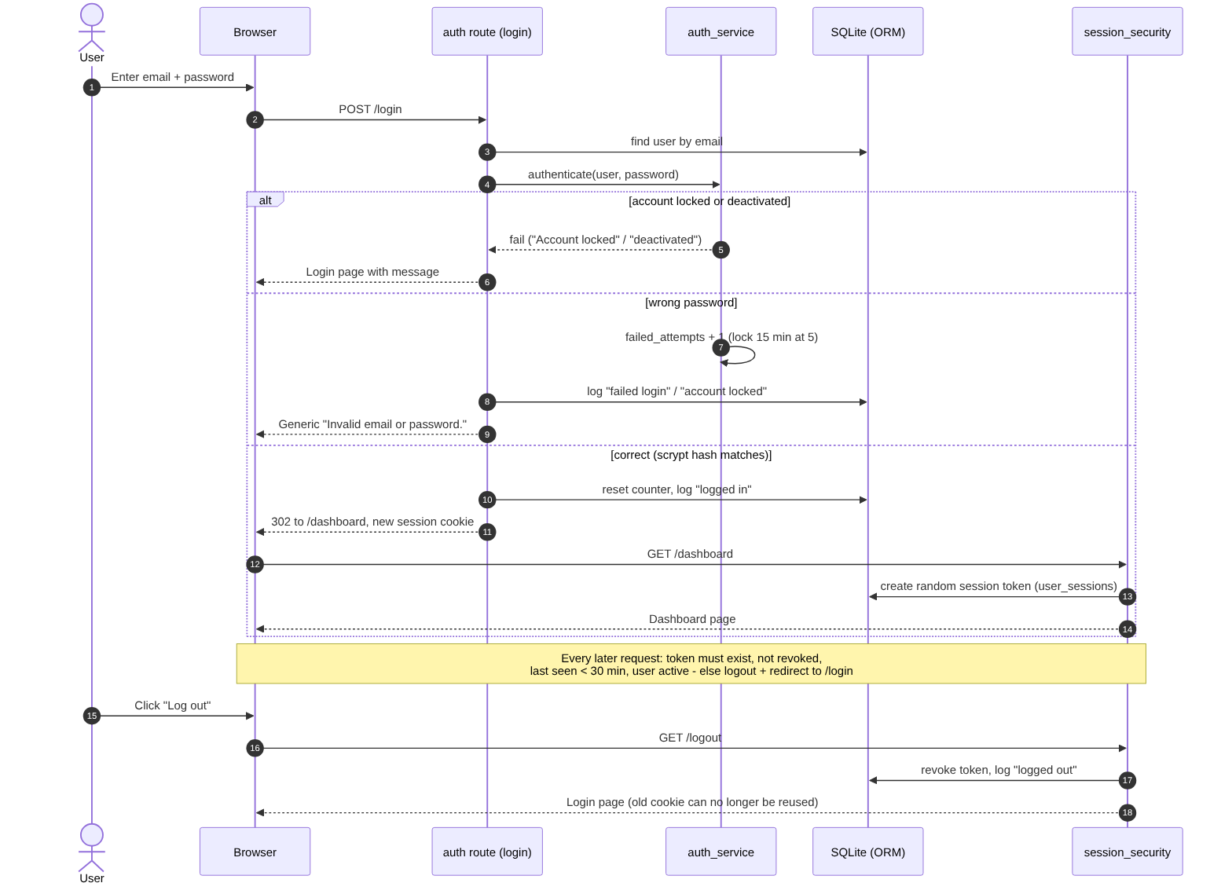
Figure 3 - Login with lockout, server-side session token and logout

Sequence 2 - PM creates and assigns a task (MPMS-F-020, F-030, F-004, PRJ-SR-003/004)
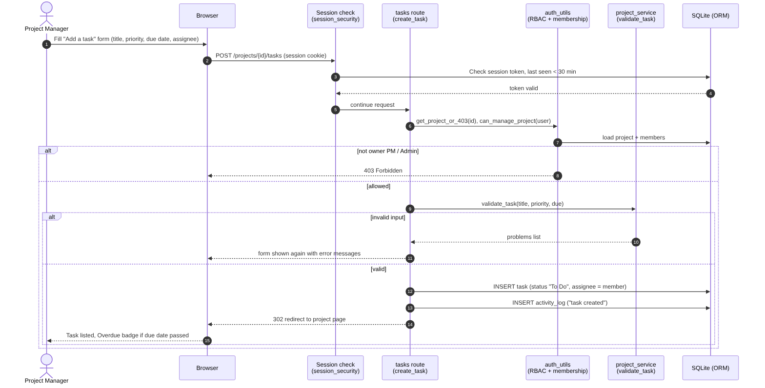
Figure 4 - Creating a task: session check, authorisation, validation, save and activity log

4.3 API Design
MPMS exposes an HTTP interface of HTML pages and form posts (no separate JSON API). All routes except /login, /register and /health require a valid session. Full endpoint list:
Component | Endpoints
Auth | GET/POST /register, GET/POST /login, GET /logout
Projects | GET /projects, GET /projects/archived, GET/POST /projects/new, GET /projects/{id}, GET/POST /projects/{id}/edit, POST /projects/{id}/archive, POST /projects/{id}/unarchive, POST /projects/{id}/members, POST /projects/{id}/members/{uid}/remove
Tasks | POST /projects/{id}/tasks, GET /tasks/{id}, GET/POST /tasks/{id}/edit, GET/POST /tasks/{id}/delete, POST /tasks/{id}/comments, POST /tasks/{id}/assign, POST /tasks/{id}/status, GET /my-tasks
Dashboard / Reports | GET /dashboard, GET /tasks/search, GET /projects/{id}/report.csv
Admin | GET /admin/users, POST /admin/users/{id}/deactivate, POST /admin/users/{id}/reactivate, POST /admin/users/{id}/role, GET /admin/log
Health | GET /health

Interface 1 - Tasks component: create a task
Item | Definition
Endpoint | /projects/{project_id}/tasks
Method | POST (form-encoded)
Request | {title (1-150 chars, required), description, priority: Low | Medium | High, due_date: YYYY-MM-DD (optional), assignee_id (must be a project member, optional)}
Response | 302 redirect to /projects/{project_id}; task created with status "To Do"; activity log entry "task created"
Errors | 302 to /login (no / expired session); 403 not the owning PM or Admin; 404 project not found; validation error message shown on the project page

Interface 2 - Reports component: CSV progress report
Item | Definition
Endpoint | /projects/{project_id}/report.csv
Method | GET
Request | Path parameter project_id; session cookie of the owning PM or an Admin
Response | 200 text/csv, Content-Disposition: attachment; columns: Task ID, Title, Assignee, Status, Priority, Due date, Overdue; final row: Summary (Done of total, %). Cells starting with = + - @ are prefixed with ' to stop spreadsheet formula injection
Errors | 302 to /login; 403 not owner or Admin (or not a member); 404 project not found

Interface 3 - Health component (used by monitoring)
Item | Definition
Endpoint | /health
Method | GET (no login)
Response | 200 {"status": "ok", "database": "ok"}
Errors | 503 {"status": "error"} when the database query fails; no internal details are returned

4.4 Error Handling, Logging & Monitoring
- User-facing errors: clear flash messages for validation problems; generic "Invalid email or password." for any login failure; 403 / 404 for access and missing records; no stack traces shown when debug is off.
- Activity log (activity_logs table): project created / edited / archived / restored, member added / removed, task created / edited / deleted / assigned / reassigned, comment added, task status changes, registrations and logins. Viewable by Admins at /admin/log.
- Security events: failed logins, lockouts, logouts, session timeouts, role changes, account deactivation / reactivation and deletions; "Security events only" filter on the log page.
- No sensitive data in logs: passwords and session tokens are never written to the log.
- Monitoring: GET /health checks the app and database; scripts/uptime_monitor.py records each check and produces the availability report; scripts/load_test.py measures p50 / p95 / max response times.
- Quality gates: GitHub Actions runs flake8 and pytest with the coverage gate on every pull request.

4.5 UX Design
- Consistent top navigation: Dashboard, Projects, My Tasks, Find tasks, Admin (Admins only), with the user's name and role and a Log out button.
- Responsive Bootstrap layout designed for 360-1920 px widths (redesigned in Sprint 2, BL-32).
- Status shown with colour and text; overdue tasks shown with a red row and an "Overdue" badge; progress bar with % complete.
- Forms keep the user's input after a validation error and show the message next to it; destructive actions (delete task, archive project, remove member) ask for confirmation.
- Accessible markup: form fields have visible labels (aria-labels on the search filters); all controls are standard links, buttons and selects, so they work with the keyboard.

4.6 Open Issues & Next Steps
- CSRF protection: forms do not yet carry CSRF tokens; add Flask-WTF CSRFProtect.
- Secret key: read SECRET_KEY from an environment variable instead of the development default.
- Production server: deploy with gunicorn / waitress behind Nginx with TLS 1.2+; enable FORCE_HTTPS=1.
- Usability test: run the 5-user test (MPMS-NF-003, BL-31) and record a cross-browser check (MPMS-NF-004).
- Scale-up: move from SQLite to PostgreSQL if many teams use one server.
- Future features: email notifications for assignments and due dates, task attachments, Gantt / calendar view.

5. Appendices
5.1 Glossary: see Section 1.4 (Flask, ORM, RBAC, ADR, STRIDE, WAL, scrypt, TLS, HSTS, p95).
5.2 References: ISO/IEC/IEEE 42010 (architecture description); OWASP Top 10 and OWASP Authentication / Session Management Cheat Sheets; Flask and SQLAlchemy documentation; SQLite documentation (WAL, busy_timeout).
5.3 Tools: Graphviz (component and class diagrams), Mermaid (sequence diagrams), GitHub Projects and Actions, pytest / pytest-cov, flake8, VS Code.

