Practical 1

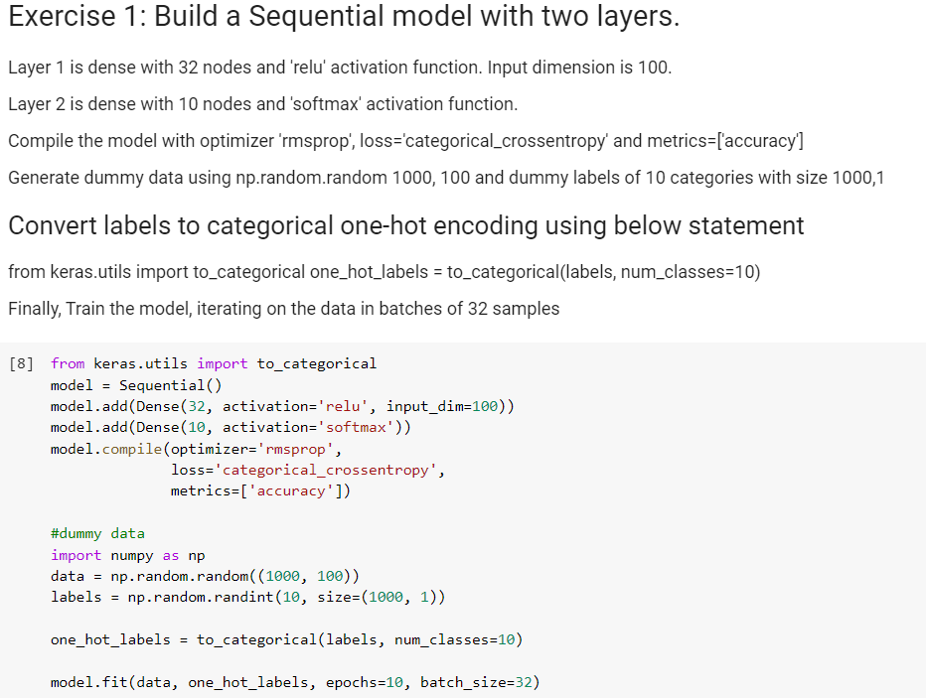Exercise 1:

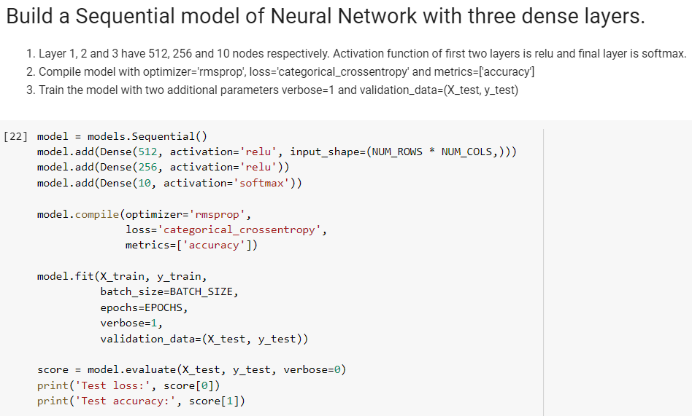Exercise 2:

The test loss is 0.09599477498645365 and test accuracy is 0.9821.

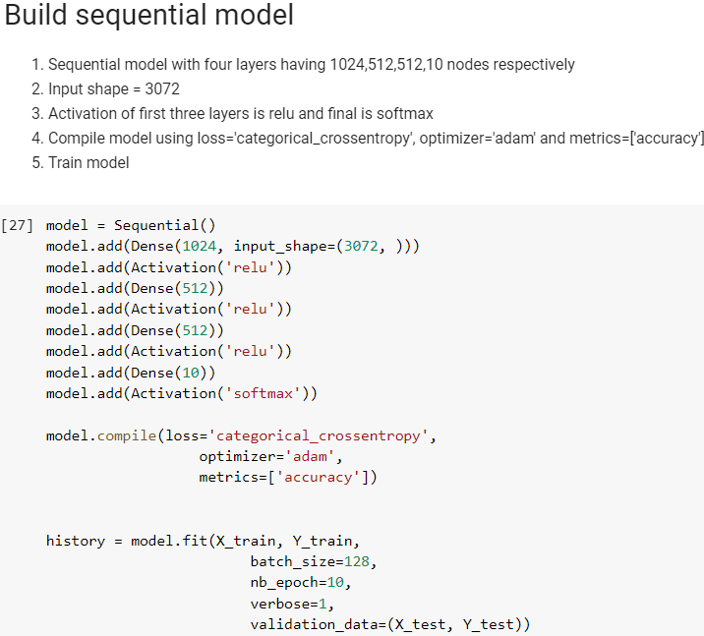Exercise 3: