AI Usage DISCLOSURE FORM

1. Team Details
Team Name: ____Hustle___________
Project / Product Name: ____SGTE(Smart Guided Troubleshooting Engine________________
Organization / Institution (if any): ___MS Ramaiah Institute of Technology(MSRIT)_______________
Submission Date: _______30/09/2026________________

2. AI Usage Declaration
Did your team use any Artificial Intelligence (AI) in developing this project? Yes / No
__________Yes_____________________

3. Purpose of AI Usage ( Brief Details)
Idea generation / brainstorming _ Used AI to brainstorm project ideas, features and approaches for the troubleshooting engine._________________
Code generation or assistance ______ Used AI for coding assistance, implementation suggestions and code improvement.__________
UI / UX design ____ Used AI to generate ideas for the user interface, layout and presentation of troubleshooting results.____________
Content creation ___ Used AI to draft project descriptions, documentation, presentation content and demo script._____________
Data analysis ___Not used____________
Testing / debugging ________ Used AI to identify bugs, suggest fixes and improve test cases and edge-case handling.______
Other _______ Used AI for documentation, technical explanations and project presentation preparation._________________

4. Feature Origin Classification ( Please add/delete based on the number of the feature)
1. Feature Name ____ Natural Language Query Understanding________________
2. Self-Generated/AI-Generated/Both ____Both_______________
3. Description ( include AI tools/platform Used, prompt used , Output Summary, Modification) ______ AI tools/platform used: ChatGPT and LLM-assisted development.
Prompt used: Prompts were used to design and refine approaches for understanding natural-language device complaints, query enrichment, symptom interpretation and structured troubleshooting intent.
Output Summary: AI assisted suggestions were used to develop approaches for converting user complaints into structured information for troubleshooting.
Modification: The team implemented, reviewed, tested and modified the generated approaches to fit the SGTE architecture and project requirements.________________________________________________

1. Feature Name ____ Troubleshooting Recommendation / Structured Guidance________________
2. Self-Generated/AI-Generated/Both ____Both_______________
3. Description (include AI tools/platform Used, prompt used , Output Summary, Modification) ___________ AI tools/platform used: ChatGPT and LLM-assisted development.
Prompt used: Prompts were used to explore methods for converting device complaints into structured troubleshooting actions and step-by-step guidance.
Output Summary: AI-assisted suggestions helped in designing the structure of troubleshooting responses.
Modification: The team adapted the suggestions to the SGTE response format, validation logic, retrieval pipeline, and application requirements.___________________________________________

1. Feature Name ____ Hybrid Retrieval and Knowledge Retrieval________________
2. Self-Generated/AI-Generated/Both ____Both_______________
3. Description (include AI tools/platform Used, prompt used , Output Summary, Modification) ___________ AI tools/platform used: ChatGPT for development assistance and debugging.
Prompt used: Prompts were used to discuss retrieval approaches, including semantic and lexical retrieval, ranking, and relevance handling.
Output Summary: AI-assisted suggestions helped in exploring and refining retrieval and ranking strategies.
Modification: The team implemented and tested the selected approach within the SGTE backend and adjusted it based on project requirements and test results.

1. Feature Name ____Semantic Caching________________
2. Self-Generated/AI-Generated/Both ____Both_______________
3. Description (include AI tools/platform Used, prompt used , Output Summary, Modification) ___________ AI tools/platform used: ChatGPT for implementation assistance, debugging, and design discussion.
Prompt used: Prompts were used to explore semantic caching, cache matching, and reuse of previously generated troubleshooting plans.
Output Summary: AI-assisted suggestions helped refine the caching approach.
Modification: The team implemented the caching mechanism, integrated it with the SGTE pipeline, and tested its behavior.

1. Feature Name ____Guided Navigation / Deep-Link Mapping________________
2. Self-Generated/AI-Generated/Both ____Both_______________
3. Description (include AI tools/platform Used, prompt used , Output Summary, Modification) ___________ AI tools/platform used: ChatGPT for implementation assistance and debugging.
Prompt used: Prompts were used to explore mapping troubleshooting actions to relevant device settings and navigation destinations.
Output Summary: AI-assisted suggestions helped structure the navigation mapping approach.
Modification: The team integrated the approach with the project's deep-link catalogue and validation logic.

1. Feature Name ____Web Interface
2. Self-Generated/AI-Generated/Both ____Both_______________
3. Description (include AI tools/platform Used, prompt used , Output Summary, Modification) ___________ AI tools/platform used: ChatGPT for UI/UX ideation and development assistance.
Prompt used: Prompts were used to suggest layouts and improve the presentation of troubleshooting results.
Output Summary: AI-assisted suggestions were used for interface and presentation ideas.
Modification: The team implemented and customized the interface using React/Vite according to the project requirements.

1. Feature Name ____Testing, Validation and Debugging________________
2. Self-Generated/AI-Generated/Both ____Both_______________
3. Description (include AI tools/platform Used, prompt used , Output Summary, Modification) __________AI tools/platform used: ChatGPT for debugging assistance and test-case discussion.
Prompt used: Prompts were used to investigate errors, improve test coverage, and reason about edge cases.
Output Summary: AI-assisted suggestions helped identify possible issues and testing approaches.
Modification: The team independently verified the suggested changes through automated tests and modified implementations where required.

1. Feature Name ____Project Documentation and Presentation________________
2. Self-Generated/AI-Generated/Both ____Both_______________
3. Description (include AI tools/platform Used, prompt used , Output Summary, Modification) ___________ AI tools/platform used: ChatGPT.
Prompt used: Prompts were used to help structure the project documentation, presentation content, demo narration, and explanations of the system.
Output Summary: AI generated draft explanations and presentation content.
Modification: The team reviewed, edited, and adapted the content to accurately represent the implemented SGTE prototype.

5. Ethical & Compliance Confirmation
AI usage complies with guidelines and policies. Yes
No proprietary or copyrighted data misused. I Agree

6. Declaration & Sign-Off
Name of Team Representative: Nidhi C A
Role: Team Leader
Signature:
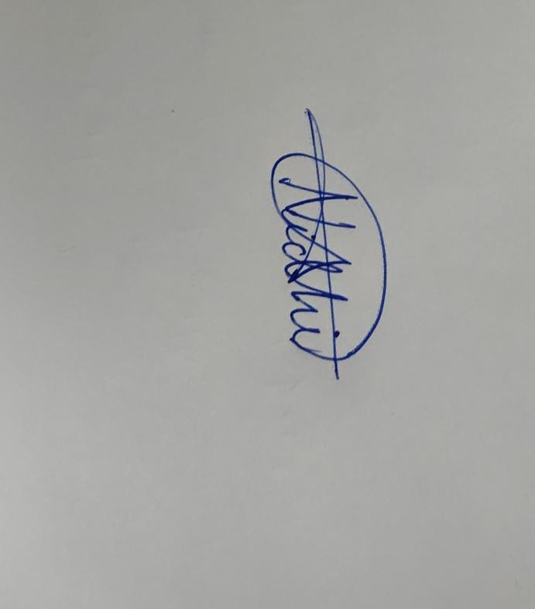
Date: 30/09/2026

