India Semiconductor Growth Predictor

End-to-End Data Science Project Report

Submitted by: Nidhi Chougule
Programme: MSc Data Science
Date: 21 October 2026
GitHub: github.com/nidhichougule/india-semiconductor-growth-predictor

Table of Contents
- 1. Project Overview
- 2. Data Sources and Provenance
- 3. Dataset Structure and Audit Findings
- 4. Preprocessing and Data Pipeline
- 5. Exploratory Data Analysis
- 6. Machine Learning Models
- 7. Market Growth Scenario Analysis
- 8. Interactive Dashboard
- 9. Test Suite
- 10. Limitations and Future Work
- 11. Conclusions
- 12. References

1. Project Overview
The India Semiconductor Growth Predictor is a full end-to-end data science project that analyses India's semiconductor manufacturing ecosystem under the Semicon India Programme (India Semiconductor Mission — ISM). The project ingests official government data from the Press Information Bureau (PIB), performs rigorous data auditing and preprocessing, carries out exploratory data analysis, applies machine learning methods, builds parametric market-growth scenarios, and presents all findings through an interactive Streamlit web dashboard.
The project was motivated by India's ambitious goal to become a global semiconductor hub by 2030, backed by Rs. 2,03,500 crore in programme outlay under the Semicon India Programme. As of May 2026, 12 projects have received ISM cabinet approval with a combined committed capital expenditure of Rs. 1,60,365 crore across seven Indian states.

Key Project Metrics at a Glance
Metric | Value
ISM-approved projects | 12
Committed capex (known) | Rs. 1,60,365 crore
States covered | 7
Facility type categories | 6
Quarterly data points (for ML) | 6 (too sparse — documented)
ML model used | Gradient Boosting Regressor
Evaluation method | Leave-One-Out Cross-Validation (n=10)
Test suite | 68 unit tests — 100% pass rate
Dashboard pages | 5 (Streamlit)

2. Data Sources and Provenance
All data used in this project comes from official Government of India sources. No fabricated, interpolated, or third-party-estimated data is present in the raw files. Two CSV files form the primary dataset:
File | Source | Rows | Description
india_approved_semiconductor_  projects_government.csv | PIB / ISM cabinet approvals  (PRID 2247814, 2258116) | 12 | All ISM-approved projects with investment, capacity, state, facility type, approval period
india_semiconductor_projects_  and_hubs_2026_government_sources.csv | PIB (PRID 2247814, 2253549,  2258119, 2261509) | 13 | Enriched version: 12 ISM + 1 SPECS-funded facility (Sahasra Semiconductors)

Market scenario inputs (parametric assumptions, not raw data files):
Parameter | Value | Source
India semiconductor demand CAGR | 19% | NITI Aayog ISM Roadmap (2022)
Market size 2030 consensus | USD 90–108 billion | NITI Aayog / UBS / IESA
IESA/IBEF 2030 target | USD 103.4 billion | IESA / IBEF Sector Report 2024
Base market size (FY2023) | USD 44 billion | IESA estimate
Programme outlay (Phase 1+2) | Rs. 2,03,500 crore | MeitY / ISM

Licence: Government of India Open Data Licence (GODL) v1.0 — free to use with attribution. Full provenance documented in data/raw/data_source_manifest.md and data/processed/PROVENANCE.md.

3. Dataset Structure and Audit Findings
A comprehensive data audit was conducted (tests/audit_data.py) before any preprocessing. Key findings are summarised below.

3.1 File 1 — Column Structure
Column | dtype | Missing | Unique | Notes
project_id | int64 | 0 | 12 | Sequential ID
company | object | 0 | 12 | Full legal name
project_location | object | 0 | 8 | City / district
state | object | 0 | 6 | Indian state
facility_type | object | 0 | 9 | Raw type string
technology_or_product | object | 0 | 12 | —
investment_crore | float64 | 2 | 11 | NaN for CML & SSPL
capacity | object | 0 | 12 | —
approval_period | object | 0 | 6 | Month-year string
status | object | 0 | 3 | Current status
source_url | object | 0 | 2 | PIB URL
hub_cluster | object | 0 | 8 | Geographic cluster

Duplicate rows: 0. Parse warnings: 0 (all approval_period values parsed cleanly).

3.2 File 2 — Additional Columns
File 2 has 14 columns (13 rows = 12 ISM + 1 SPECS). Additional columns: classification, government_programme, official_source_date, official_source_url, hub_relevance. The official_source_date column holds the PIB data-collection date (e.g. 01-Apr-2026), NOT the project approval date, and is never used as such.

3.3 Investment Completeness
Status | Count | Projects | Amount (Rs. crore)
Known investment | 10 / 12 | All except CML and SSPL | 1,60,365
Missing investment | 2 / 12 | Crystal Matrix Limited (CML), Suchi Semicon Pvt. Ltd. (SSPL) | Not disclosed

Missing values are preserved as NaN — never imputed or filled. All investment figures are committed/approved capital expenditure per PIB press releases, not realised disbursements or revenue.

3.4 Cross-File Entity Matching
A transparent, manually reviewed lookup table (ENTITY_MAP in tests/audit_data.py) maps all 12 ISM projects between the two files. No fuzzy or probabilistic matching was used. Key name differences documented: TEPL vs. TSAT (same Tata group, different subsidiaries), HCL-Foxconn JV vs. Vama Sundari Investments / Foxconn India, CG Semi vs. CG Power Ltd, and a row-ordering difference for SiCSem and 3D Glass Solutions between files.

4. Preprocessing and Data Pipeline
The preprocessing pipeline (src/preprocessing.py) produces four clean output files in data/processed/ without modifying any raw CSV. Raw files are treated as read-only.

4.1 Transformations Applied
Transformation | Details
Column normalisation | snake_case, whitespace stripped
Date parsing | approval_period (e.g. 'June 2023') -> approval_date (2023-06-01). Always 1st of the month. No intra-month precision claimed.
Quarter derivation | approval_quarter_label (e.g. 2023Q2) from approval_date
Fiscal year derivation | India FY (Apr-Mar): month >= 4 -> FY = year+1
Facility type normalisation | 9 raw strings -> 6 canonical categories via lookup map
is_investment_known flag | Boolean; exactly mirrors investment_crore.notna()
data_classification column | Always 'ISM Approved' for projects_clean.csv
NaN preservation | investment_crore NaN for CML and SSPL — never filled

4.2 Output Files
File | Rows | Cols | Description
projects_clean.csv | 12 | 18 | All ISM projects, cleaned and annotated
statetype_analysis.csv | 9 | 6 | State x facility-type investment aggregation
quarterly_investment.csv | 6 | 5 | Quarterly series with NaN and completeness flags
non_ism_projects.csv | 1 | 14 | Sahasra Semiconductors (SPECS) — excluded from ISM aggregates

4.3 Quarterly Investment Table
Quarter | Projects | Investment (Rs. cr) | Cumulative (Rs. cr) | Complete?
2023Q2 | 1 | 22,516 | 22,516 | Yes
2024Q1 | 3 | 126,230 | 148,746 | Yes
2024Q3 | 1 | 3,307 | 152,053 | Yes
2025Q2 | 1 | 3,706 | 155,759 | Yes
2025Q3 | 4 | 4,606 | 160,365 | Yes
2026Q2 | 2 | NaN | NaN | No (NaN)

The cumulative investment becomes NaN once an incomplete quarter (2026Q2) is reached, ensuring no false precision in reported totals.

5. Exploratory Data Analysis
Seven EDA charts were generated (src/eda.py) using real project data. Key findings are presented below with accompanying charts.

5.1 Investment by State
Gujarat dominates ISM investment, hosting the three largest projects by capex: Tata Electronics TEPL (Rs. 91,526 cr), Micron Technology (Rs. 22,516 cr), and TSAT/Morigaon (Rs. 27,120 cr — Assam). The top three states by investment are Gujarat, Assam, and Gujarat again (for CG Power and Kaynes).
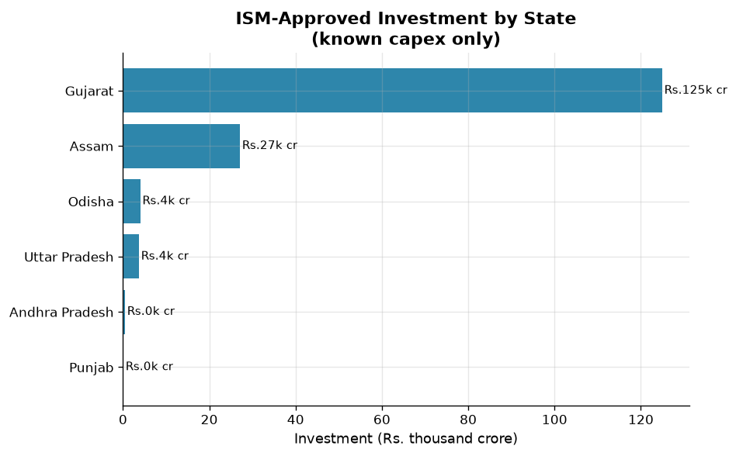
Figure 1: ISM-Approved Investment by State (Rs. crore, known capex only)

5.2 Investment by Facility Type
Semiconductor Fabs account for the dominant share (~57%) of total committed investment, driven entirely by TEPL's Rs. 91,526 crore fab project. ATMP/OSAT is the most common facility type by project count (5 of 12 projects).
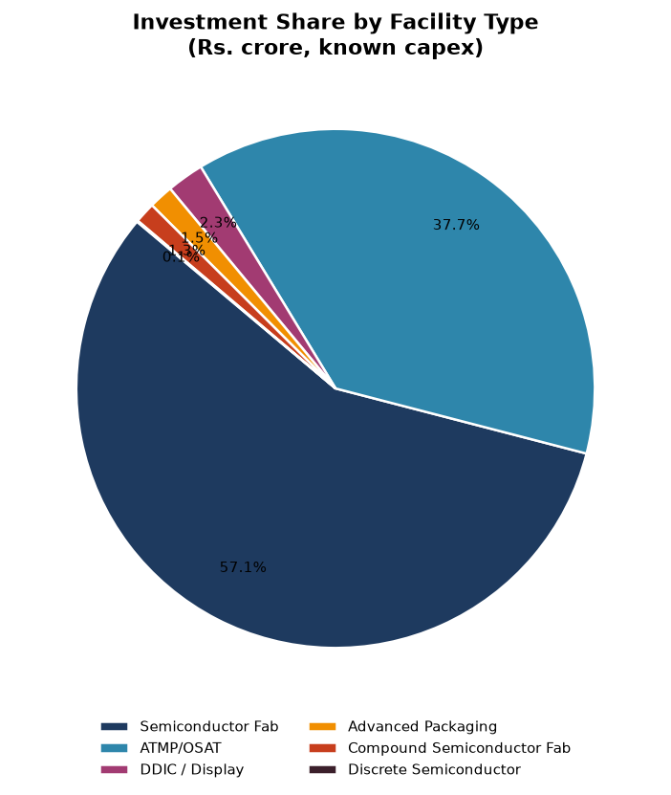
Figure 2: Investment Share by Facility Type

5.3 Quarterly Approvals Timeline
Approvals were clustered in two waves: February 2024 (3 projects, Rs. 1,26,230 cr) and August 2025 (4 projects, Rs. 4,606 cr). Seven of 13 quarters had no approvals — these are observed zero-approval quarters, not data gaps.
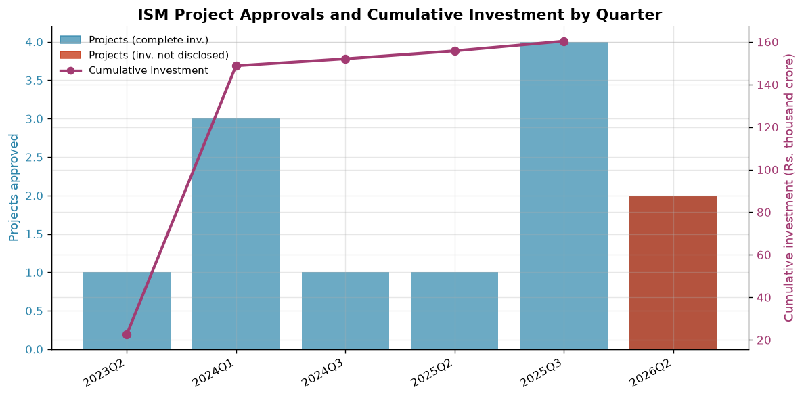
Figure 3: ISM Project Approvals and Cumulative Investment by Quarter

5.4 State and Facility Distribution
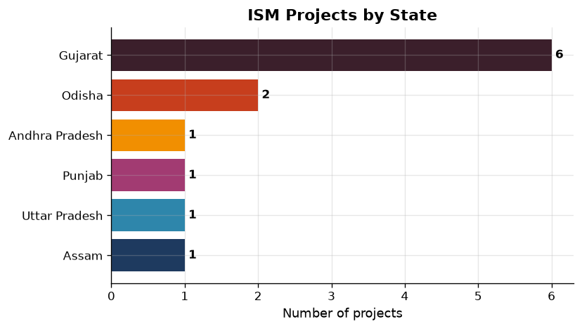
Figure 4: Number of ISM Projects by State

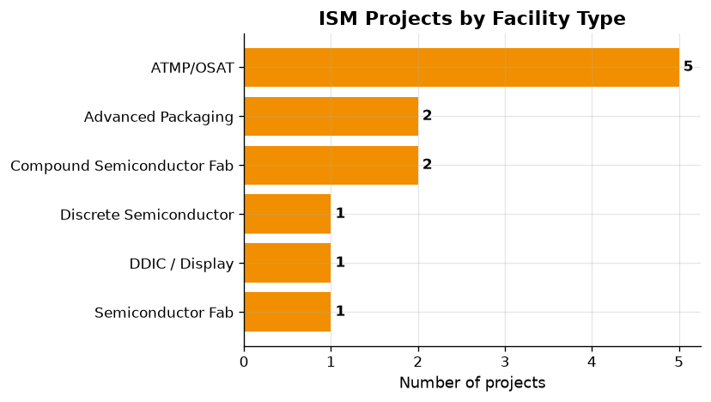
Figure 5: Number of Projects by Canonical Facility Type

5.5 Investment Heat Map
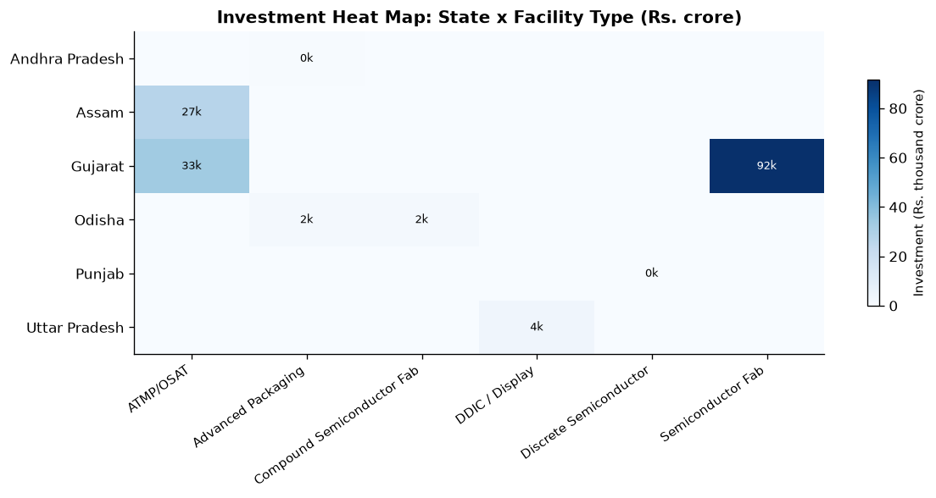
Figure 6: Investment Heat Map — State x Facility Type

6. Machine Learning Models
Two modelling approaches were applied, reflecting the honest constraints of the dataset.

6.1 Investment Prediction Model
A supervised regression model was trained to predict investment_crore from facility type, state, and fiscal year. Three models were evaluated: Random Forest, Gradient Boosting, and Ridge Regression. Leave-One-Out Cross-Validation (LOO-CV) was used because the training set has only n=10 samples — the only honest evaluation strategy for this size.

Model Comparison (LOO-CV, n=10)
Model | LOO-MAE (Rs. crore) | LOO-R² | Selected
Random Forest | 16,670 | -0.071
Gradient Boosting | 13,832 | 0.073 | Best
Ridge Regression | 17,286 | -0.039

The Gradient Boosting model was selected with LOO-MAE of Rs. 13,832 crore and LOO-R² of 0.073. The low R² is expected given only 10 training samples with high variance in investment values (range: Rs. 117 cr to Rs. 91,526 cr).
Feature importances: Facility type canonical (90.2%) >> Fiscal year (8.3%) >> State (1.5%). This aligns with domain knowledge — semiconductor fabs require orders of magnitude more capital than ATMP/OSAT facilities.
IMPORTANT: This model is illustrative only. n=10 is far below the sample sizes required for reliable ML. Results must not be used for investment decisions.

6.2 Time-Series Forecasting — Not Feasible
The quarterly ISM approval series yields only 6 non-empty quarters over a 13-quarter span (54% gap rate). Standard time-series methods (ARIMA, SARIMA, Exponential Smoothing, LSTM) require 20–50+ observations. No synthetic data was manufactured.
Method | Typical Min. Observations | Feasible with ISM data?
ARIMA / SARIMA | 30–50 | No (6 points)
Holt-Winters Exp. Smoothing | 20–30 | No (6 points)
LSTM / GRU (deep learning) | 100+ | No (6 points)
Linear regression | ~20 | No (6 points, high variance)

Recommended alternative: DGCI&S/DGFT HS-8542 monthly trade data (Electronic Integrated Circuits) from tradestat.commerce.gov.in — provides ~180 monthly observations from FY2010 and is suitable for ARIMA.

7. Market Growth Scenario Analysis
Three parametric market growth scenarios were constructed using published CAGR inputs from NITI Aayog and IESA. These are clearly labelled as scenario projections, not ML predictions.
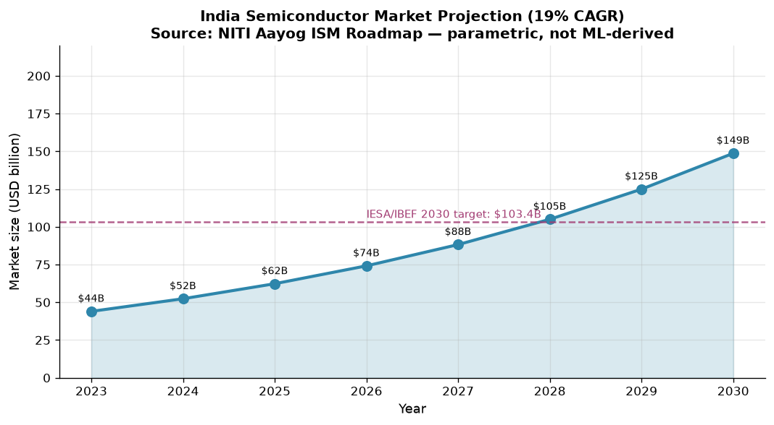
Figure 7: India Semiconductor Market Projection (Parametric — 19% CAGR base case)

Scenario | CAGR | 2025 (USD B) | 2027 (USD B) | 2030 (USD B)
Conservative | 15% | $59.9B | $79.2B | $103.6B
Base (NITI Aayog) | 19% | $62.5B | $88.5B | $148.7B
Optimistic | 22% | $65.6B | $97.6B | $188.6B

Base: NITI Aayog ISM Roadmap; IESA/IBEF 2030 target: USD 103.4 billion (dashed line in chart).

8. Interactive Dashboard
An interactive Streamlit web dashboard (app.py) was built with five pages, allowing users to explore all project data and models interactively.
Page | Contents
Overview | KPI cards (projects, capex, states, facility types), investment by state bar chart, facility-type pie chart, quarterly timeline (dual-axis), project count bar, status pie. State and facility-type filters.
Market Scenarios | Parametric CAGR projection with adjustable sliders (base market size, CAGR %, end year). Scenario comparison table.
ML Model | LOO-CV comparison table, feature importances bar chart, live investment prediction tool (select state / facility / FY).
Raw Data | Browse all processed tables (projects, quarterly, state-agg). CSV download button.
About | Data sources, methodology notes, limitations, GitHub link.

Run command:
streamlit run app.py
Then open http://localhost:8501 in a browser.

9. Test Suite
A comprehensive pytest test suite (tests/test_preprocessing.py) contains 68 unit tests across 10 test classes. All tests passed (0 failures). Tests use small inline fixtures and never modify raw data.
Test Class | Tests | Coverage Area
TestApprovalDateParsing | 10 | All 6 approval periods parse to 1st of month; bad formats raise ValueError; PIB collection date not used
TestMissingInvestment | 5 | NaN preserved for CML/SSPL; is_investment_known flag; known sum = Rs. 1,60,365 cr
TestDuplicateHandling | 4 | Zero exact duplicates in both files; unique project IDs
TestUnitConsistency | 6 | investment_crore is float64; INVESTMENT_UNIT/NOTE constants; all known values positive
TestFacilityTypeMapping | 15 | All 13 raw-to-canonical mappings; unknown types pass through unchanged
TestQuarterlyAggregation | 6 | 6 quarterly rows; 2026Q2 investment_complete=False; NaN propagation in cumulative
TestRawDataPreservation | 5 | 12 rows File 1; 13 rows File 2; raw df not mutated by preprocessing
TestNonISMSeparation | 4 | Sahasra excluded from projects_clean; appears in non_ism extract
TestFiscalYear | 10 | Apr-Mar boundary; all 6 approval months mapped correctly
TestColumnCompleteness | 3 | All required columns present in projects_clean and quarterly_investment

Run:
pytest tests/test_preprocessing.py -v

10. Limitations and Future Work

10.1 Current Limitations
Limitation | Details | Mitigation Applied
Very small dataset | n=12 (10 with investment) | LOO-CV; illustrative-only label
Missing investment for 2 projects | CML, SSPL — not disclosed in PIB | NaN preserved; investment_complete flag
Month-only approval dates | No exact day known | First-of-month convention; documented
Quarterly series too sparse | 6 non-empty quarters — ARIMA not viable | No forecasting; documented in ml_feasibility_note.md
Single-currency assumption | All capex in INR; no USD conversion | Stated clearly in provenance
No realisation tracking | Committed capex ≠ disbursed | Documented in INVESTMENT_NOTE constant

10.2 Future Work
1. Collect DGCI&S/DGFT HS-8542 monthly trade statistics (~180 monthly observations) to enable ARIMA time-series forecasting of semiconductor import/export trends.
2. Add state-level policy and incentive data to enrich the investment prediction model.
3. Integrate real-time PIB RSS feeds for automatic new-project detection.
4. Deploy the Streamlit dashboard to Streamlit Community Cloud for public access.
5. Extend to Phase 3 ISM approvals as they become available.

11. Conclusions
This project delivers a complete, data-integrity-first end-to-end analysis of India's ISM semiconductor programme. Key conclusions:
1. India has approved Rs. 1,60,365 crore in semiconductor capex across 12 projects in 7 states since June 2023 — an unprecedented pace of semiconductor investment for the country.
2. Gujarat is the dominant hub (6 of 12 projects; largest by investment), followed by Odisha and Andhra Pradesh. ATMP/OSAT is the most common facility type; Semiconductor Fab commands the largest capex share (~57%).
3. The quarterly approval series is too sparse (6 data points, 54% gap rate) for any meaningful ML time-series forecasting. This limitation is honestly documented rather than worked around with synthetic data.
4. A Gradient Boosting investment predictor (LOO-MAE: Rs. 13,832 cr) was built as an illustrative model. Facility type accounts for 90.2% of feature importance, consistent with domain knowledge that fabs cost vastly more than ATMP facilities.
5. Parametric market scenarios using NITI Aayog's 19% CAGR project India's semiconductor market reaching USD 148.7 billion by 2030 under the base case — broadly consistent with the IESA/IBEF consensus target of USD 103.4 billion.

12. References
- [1] Press Information Bureau (PIB), Government of India. ISM Cabinet Approvals. PRID 2247814, 2253549, 2258116, 2258119, 2261509. https://pib.gov.in
- [2] NITI Aayog. India Semiconductor Mission (ISM) Roadmap. New Delhi, 2022. https://niti.gov.in
- [3] India Electronics & Semiconductor Association (IESA) / IBEF. India Semiconductor Industry Report. 2024. https://ibef.org
- [4] Ministry of Electronics & IT (MeitY). Semicon India Programme. https://ism.gov.in
- [5] DGCI&S / DGFT. HS-8542 Monthly Trade Statistics. https://tradestat.commerce.gov.in
- [6] Government of India. Open Data Licence (GODL) v1.0. https://data.gov.in/government-open-data-license-india

— End of Report —

