**CS5100 - Weather Predictor User Manual**

**Team Information**: Neethu Prasad

Nidhi Gupta

**Description:**

Predict the occurrences of various weather phenomenon like Rain, Fog, Snow, Thunderstorm using a decision tree classifier implemented using C4.5 algorithm suggested by Quinlan

1. **Files**

The following files are included with the submission

**External Library**

Weka.jar - External library for J48 classifier.

**Java Files**

DecisionTree.java - main file.

Evaluation.java - computes the accuracy of given result.

GainRatio.java - Computes the gain ratio of given feature, threshold value and left and right subset data at threshold position.

GrowTree.java - creates a decision tree by recursively selecting the feature with best gain ratio.

J48Decision.java - trains and classifies test data using Weka J48 implementation.

PostTreePruning.java - prunes the inital decision tree if the pruned tree gives better accuracy.

SelectFeature.java - calls GainRatio.java to get the maximum gain ratio for given feature and returns a feature with maximum gain ratio.

ValidateWithPruning.java -classifies the given test and random data with the help of C4.5 decision tree.

Feature.java - data structure for storing a feature name value pair.

Node.java - data structure for a node in the decision tree.

WeatherData.java - data structure for storing input data instance.

**Input file(s)**

Inputs to C4.5 algorithm

WeatherDataTest.csv - stores 2015 weather data from weatherundergrounds.com

WeatherDataTrain.csv - stores 2014 weather data from weatherundergrounds.com

randomData.csv - stores random data to be classified

Input to J48 (same train and test data in arff format)

classnameTest.arff stores 2015 weather data and classnameTrain.arff stores 2014 weather data.

fogTest.arff, fogTrain.arff, snowTest.arff, snowTrain.arff, rainTest.arff, rainTrain.arff, thunderTest.arff, thunderTrain.arff

**Output file(s)**

Output.txt stores the classification result for randomData.csv

**2. Software and Hardware Requirements**

|  |  |
| --- | --- |
| IDE | Eclipse Mars Release (4.5.0) |
| JRE | JavaSE-1.8 |
| External library | weka.jar |
| Processor | Intel(R)Core(™)I5-5200U CPU@2.20GHz |
| RAM | 8GB |
| OS | 64 bit Windows 10 |

**3.Software Installation Instructions**

1. Weka.jar -        installation instruction and jar file are available at

<http://www.cs.waikato.ac.nz/ml/weka/downloading.html>.

We have also included weka.jar in our zip file

      Make sure to use a stable version.

b)   JRE -               can be downloaded from <http://www.oracle.com/technetwork/>

                              java/javase/downloads/jre8-downloads-2133155.html

c)   Eclipse IDE -  Latest Eclipse IDE could be downloaded from

                                    https://eclipse.org/downloads/

**4. Setting Up the Environment**

Download the project folder from **https://drive.google.com/drive/folders/0B9m5qbswJ6giYlNFc0UtX2FUNkE**

Extract the source folder (Weather-Predictor that contains the source Java and input files) from the zipped folder we just downloaded and save it to a convenient location on computer.

**Steps to execute the Weather Predictor Project from Eclipse**

1. After opening Eclipse IDE, go to **Imports** in **File** Menu and select **Existing projects into Workspace** inside **General folder**

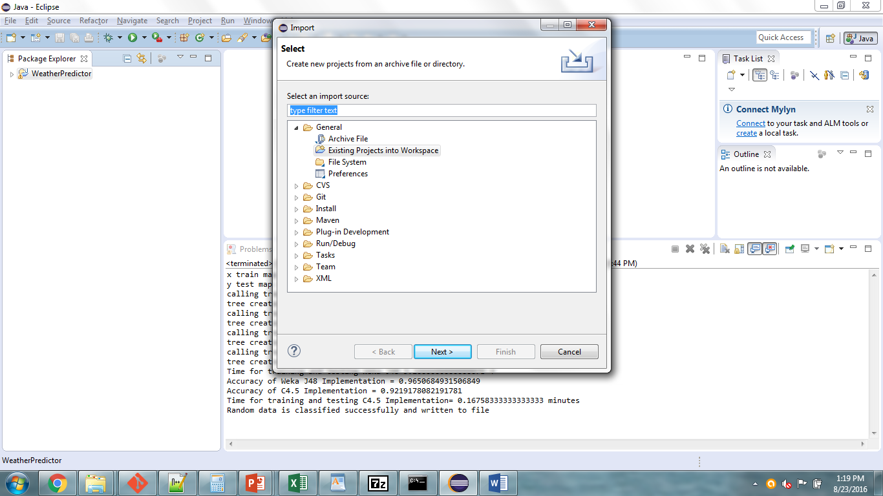

1. **Import Dialog box** is displayed. Select the **root directory** and browse to the folder **WeatherPredictor** we just extracted.

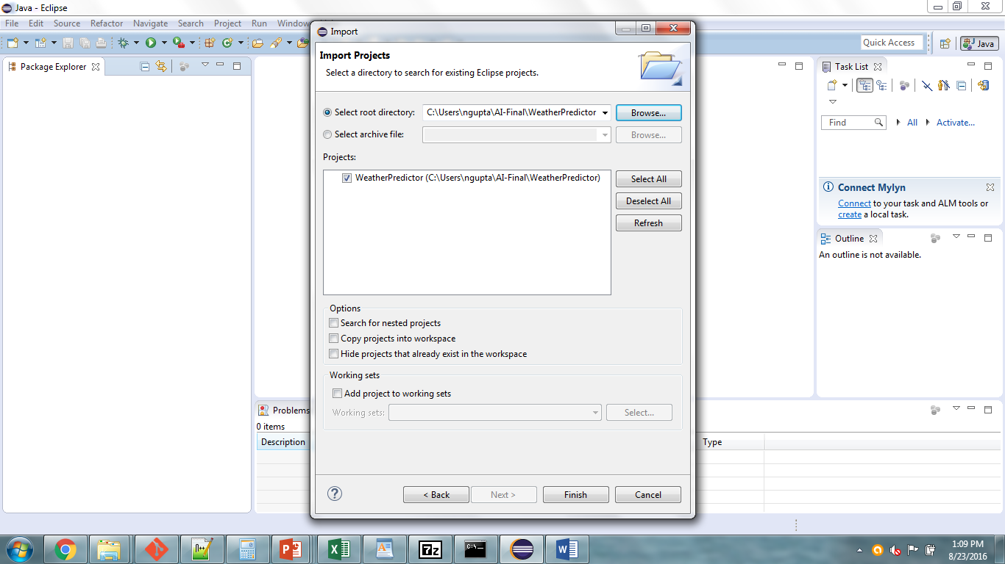

Click on **Finish**

1. Right click the **WeatherPredictor** Project that gets created on **Package** **Explorer** and select properties and select Java Build Path -> Libraries -> Add External JARs -> weka.jar

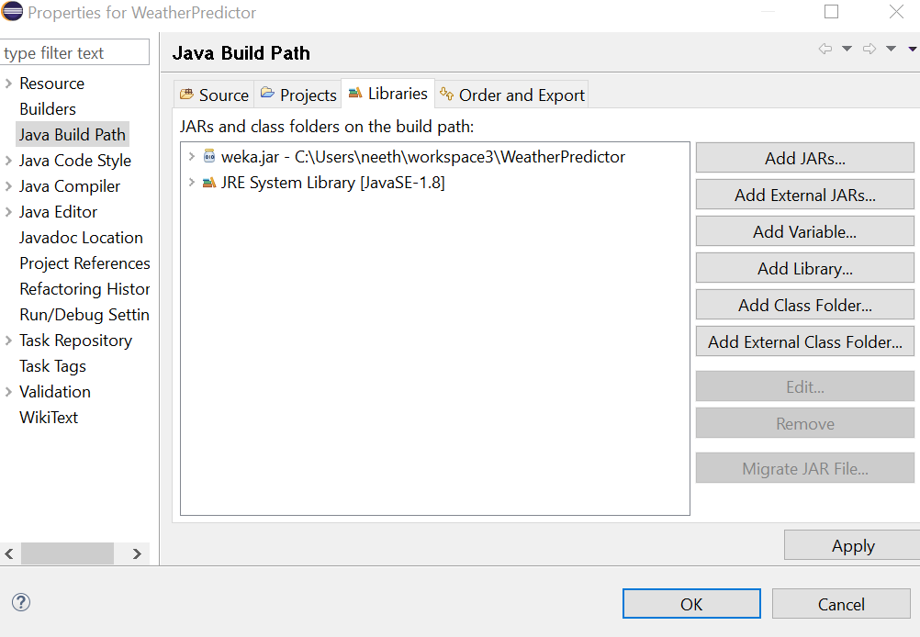

1. Select the **WeatherPredictor** Project that gets created on **Package** **Explorer** and click on **Run**.

Select **Java ->Run Configurations**

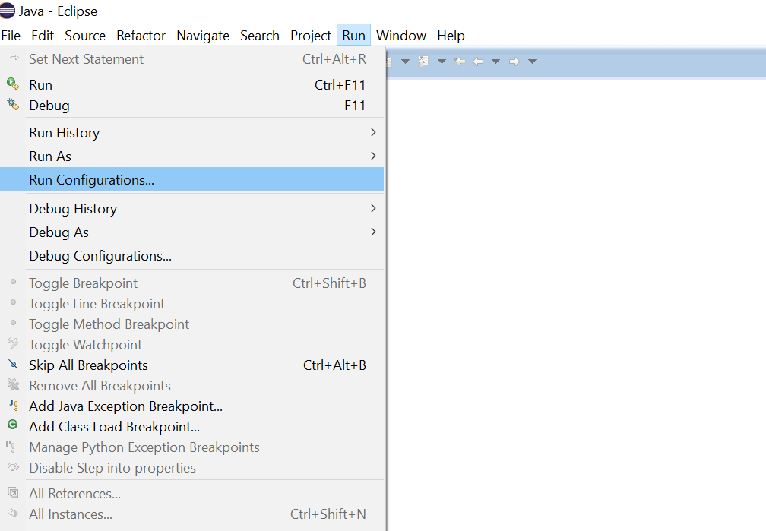

1. Select **Java Application** from left pane

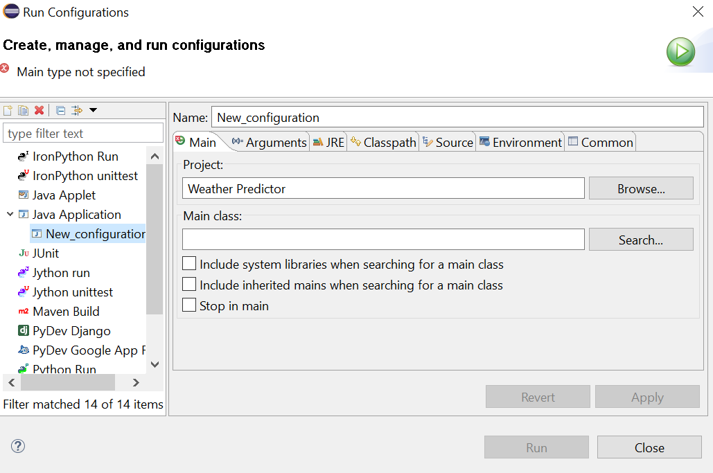

1. Click on search button beside Main class. A dialog box appears, now select **DecisionTree-main** from the drop down menu, as this Java file holds the main method of our application.

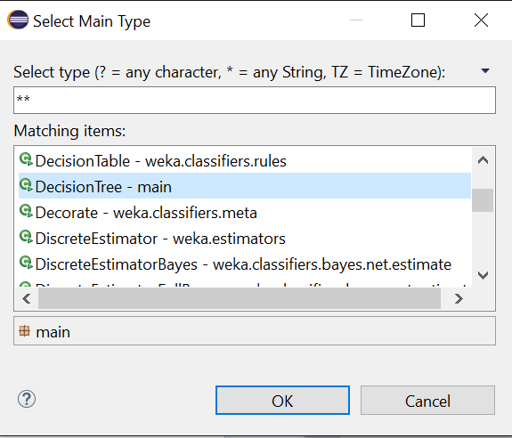

Hit **Ok** to proceed

1. Click on **Arguments** tab and input the file names in the following order

WeatherDataTrain.csv

WeatherDataTest.csv

randomData.csv

output.txt

Click on **Apply**

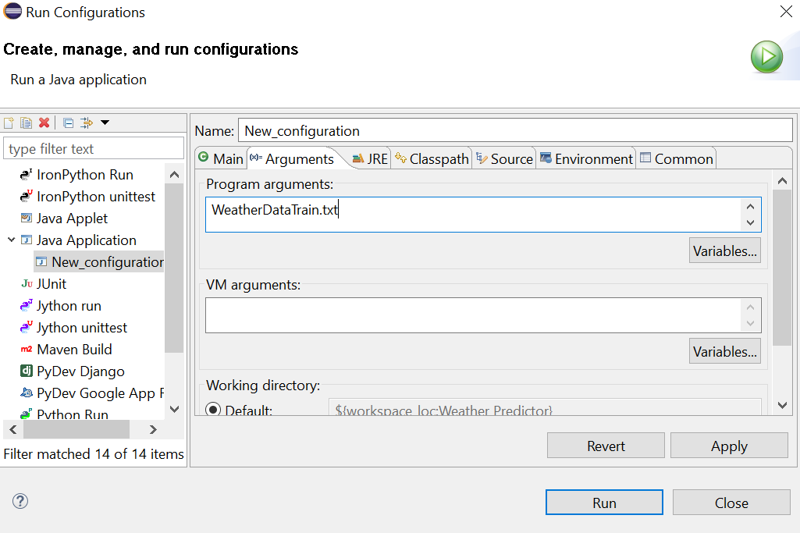

1. Click on **Run**. The Java project is then executed and prints the output (performance parameters like Execution time, Prediction accuracy) on console. Additionally, an output.txt file gets created inside the java project that predicts the weather phenomenon for random data sent as input to the program