TABLE OF CONTENTS
- Introduction
- Objectives
- About ECIL and NUCON
- PLC Fundamentals
- NUCON PLC Architecture
- PLC Communication Modules
- PLC System Configurations
- PLC Programming
- SCADA System
- Python-Based NUCON I/O Simulator
- Learning Outcomes

1. Introduction
Industrial automation has become an essential part of modern manufacturing and process industries. Automation systems improve productivity, accuracy, reliability, and safety while minimizing human intervention.
During my one-month internship at Electronics Corporation of India Limited (ECIL), I received practical training in NUCON PLC and SCADA systems. The internship provided exposure to both hardware and software used for real-time monitoring and control.
Apart from theoretical learning, I also developed a Python-based GUI application to simulate the configuration of NUCON PLC I/O modules, which enhanced my understanding of PLC architecture and industrial software development.

2. Objectives
The objectives of the internship were:
- To study PLC architecture.
- To learn PLC programming using ECLOGIC10.
- To study SCADA systems.
- To understand standalone, redundant, and distributed PLC systems.
- To develop a software application for PLC I/O configuration.

3. About ECIL and NUCON PLC
Electronics Corporation of India Limited (ECIL) is a Government of India enterprise specializing in electronics, nuclear instrumentation, industrial automation, defence electronics, and communication systems.
The R&D-II division develops industrial automation products including:
- Programmable Logic Controllers (PLC)
- SCADA Systems
- Remote I/O Systems
- Communication Modules
NUCON PLC is widely used in:
- Power Plants
- Oil & Gas Industries
- Chemical Plants
- Electrical Substations
- Manufacturing Industries

4. PLC Fundamentals
A Programmable Logic Controller (PLC) is a rugged industrial computer designed for controlling industrial machines and automated processes.
The PLC continuously performs the following operations:
- Reads input signals from devices.
- Executes the process logic.
- Updates outputs to devices.
Major PLC components include:
- Power Supply (PS)
- CPU
- Inter PLC Module.
- Network Module
- Remote I/O Module
- I/O Modules
The PLC communicates with SCADA systems through industrial communication protocols such as MODBUS TCP/IP.

5. NUCON PLC Architecture
The NUCON PLC follows a modular architecture where different functional modules are connected through a backplane.
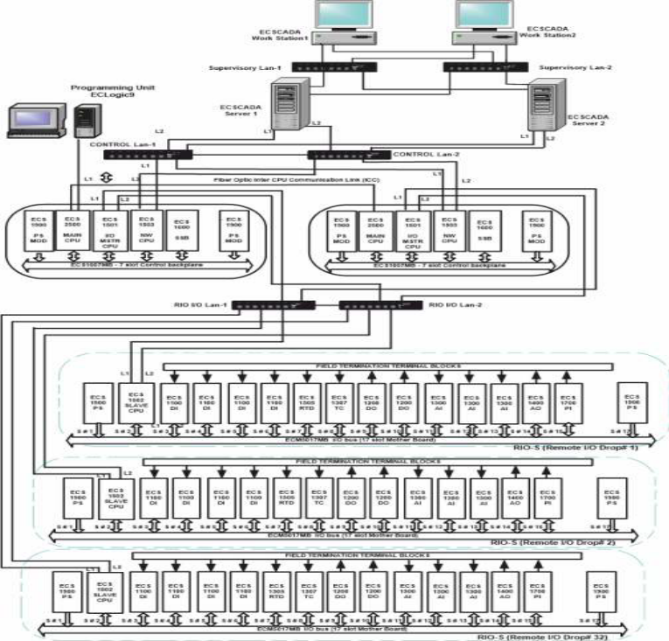
The architecture consists of:
- Power Supply (PS)
- CPU
- RIOM
- NETM
- IPLC
- SSB
- Various I/O Modules
7-Slot Controller
Used for compact industrial applications.
17-Slot Controller
Supports a larger number of I/O modules for medium and large automation systems.
Multiple Node Architecture
Several PLC nodes can be interconnected to build distributed automation systems.

I/O Modules
Different I/O boards supported by NUCON include:
- Digital Input (DI)
- Digital Output (DO)
- Analog Input (AI)
- Analog Output (AO)
Digital I/O module contains 32 channels for interfacing with field devices.
Analog I/O module contains 16 channels for interfacing with field devices.

6. PLC Communication Modules
During the internship, several communication modules were studied.
NETM (Network Module)
- Connects PLC through Ethernet.
- Enables communication with SCADA.
- Supports MODBUS TCP/IP protocol.
RIOM (Remote I/O Master)
- Communicates with remote I/O racks through UDP Protocol.
IPLC (Inter PLC Communication)
- Enables communication between PLCs.
- Supports Unicast communication.
- Supports Multicast communication.
SSB (Secure System Board)
- Provides secure communication.
- Provides secure application download.
SCM ( Serial Communication Module)
The Serial communication module supports RS-232/RS-485/RS-422 modes and supports MODBUS serial protocol to communication with external devices which supports MODBUS serial protocol.

7. PLC System Configurations
Standalone System

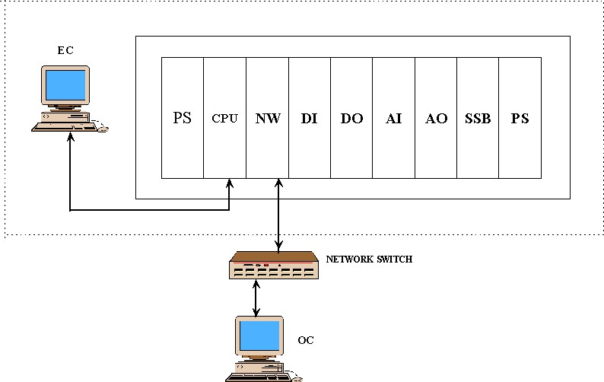

A single PLC independently controls all field devices.
Advantages:
- Simple configuration
- Low cost
- Suitable for small industries

Extended System
A extended master module communicates with multiple slave racks to increase I/O capacity.
Advantages:
- Increased scalability
- More I/O support
- Flexible expansion

Redundant System
Two PLC controllers are installed:
- Active Controller
- Standby Controller
The standby controller automatically takes over if the active controller fails.
Advantages:
- High availability
- Increased reliability
- Continuous plant operation

8. PLC Programming
The internship introduced ECLOGIC10 Programming Software, which is based on CODESYS V3.5 SP16.
The following IEC 61131-3 programming languages were studied:
Function Block Diagram (FBD)
Graphical programming using interconnected function blocks.
Ladder Diagram (LD)
Graphical representation similar to electrical relay circuits.
Structured Text (ST)
High-level programming language similar to Pascal.
Sequential Function Chart (SFC)
Used to design sequential industrial processes.
The CODESYS software allows:
- Logic programming
- Program download to PLC
- Online monitoring
- Online change to PLC
- Forcing I/O

9. SCADA System
SCADA stands for Supervisory Control and Data Acquisition.
SCADA systems are used to:
- Monitor industrial plants
- Acquire process data
- Control field devices
- Display graphical process screens
- Generate alarms
- Maintain historical data
During the internship, it was observed that SCADA communicates with NUCON PLCs through the NETM communication module.
Applications include:
- Process Automation
- Oil & Gas Automation
- Electrical Automation
- Water Treatment Plants
- Manufacturing Industries

10. Python-Based NUCON I/O Simulator
To reinforce the concepts learned during the internship, I developed a Python-based GUI application that simulates the configuration of NUCON PLC I/O modules. The application was developed using the Tkinter library and follows an object-oriented approach with modular data structures for nodes, slots, and I/O modules.
The simulator replicates the workflow of configuring a PLC rack in software and provides a user-friendly interface for experimenting with different module configurations.
Key Features
- Interactive GUI development using Python Tkinter.
- Creation and management of multiple PLC nodes.
- Simulation of 14-slot I/O racks.
- Configuration support for:
  - Digital Input (DI)
  - Digital Output (DO)
  - Analog Input (AI)
  - Analog Output (AO)
- Dedicated configuration windows for each module type.
- Configuration of 32 channels per module.
- Module parameters including:
  - Fail-safe configuration
  - Fail-safe value
  - Watchdog (WDT) timeout
  - Voltage range
  - Current range
  - Process Low and Process High values
- Node copy and delete functionality.
Technologies Used
- Python 3
- Tkinter
- ttk
- Object-Oriented Programming (OOP)
This project enhanced my understanding of PLC architecture and demonstrated how industrial software tools can simplify hardware configuration and testing.

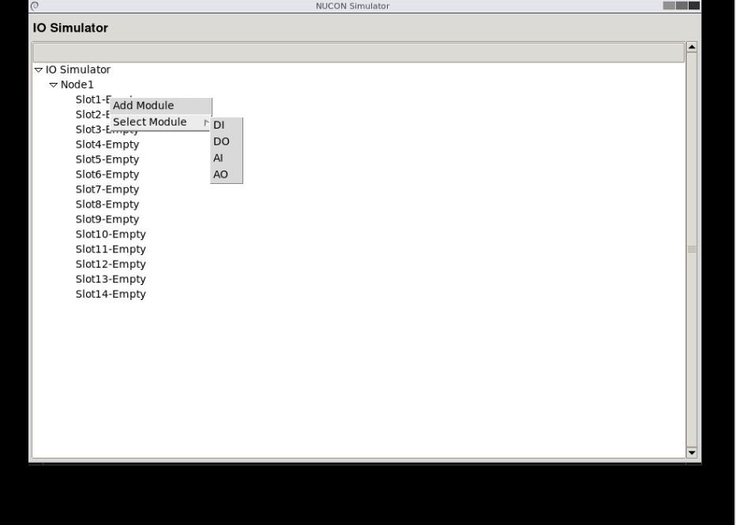
Home Layout

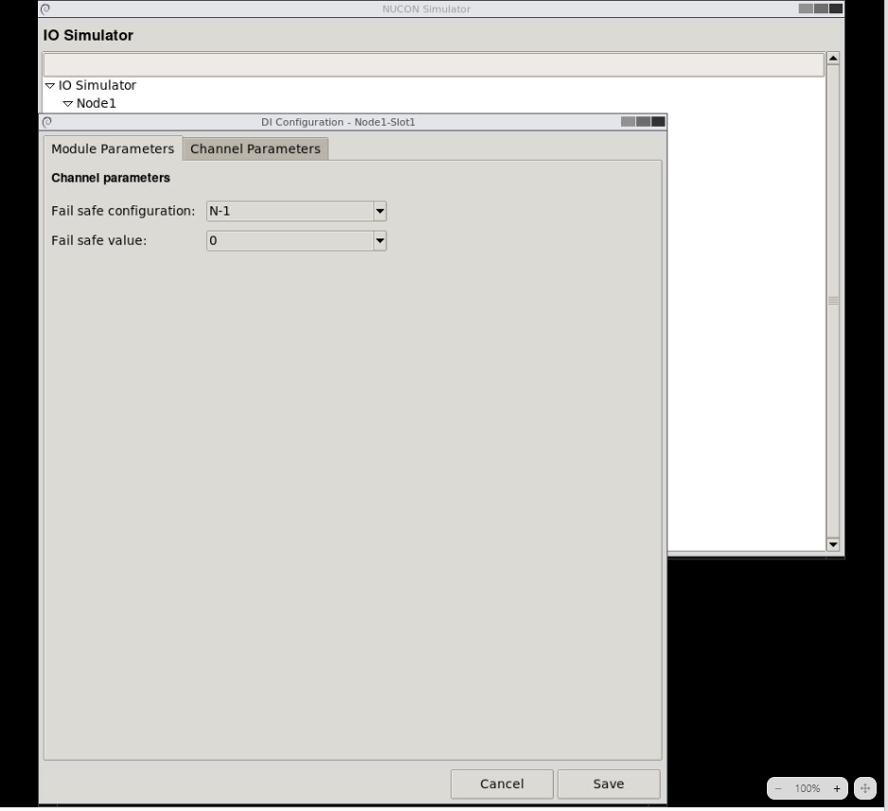
DI Module Parameters

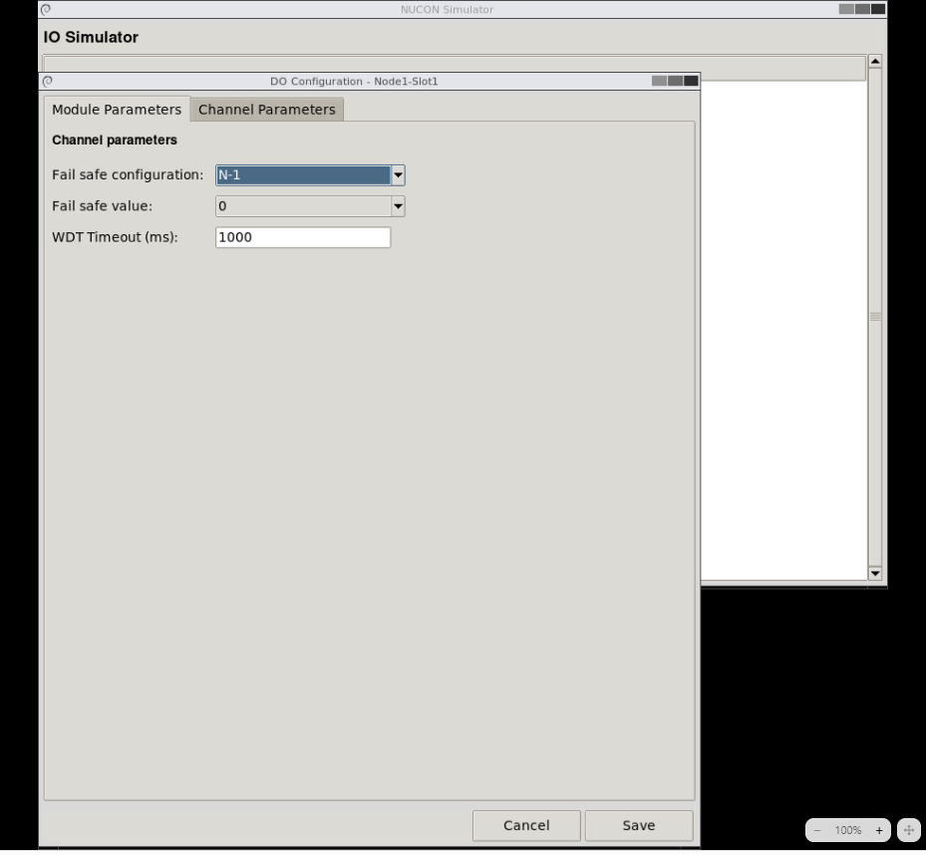
DO Module Parameters

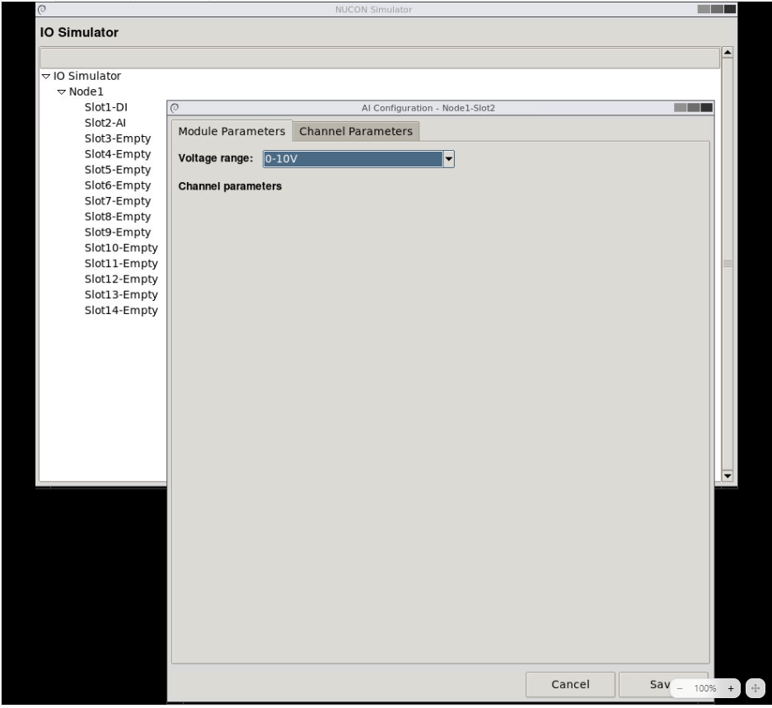
AI Module Parameters
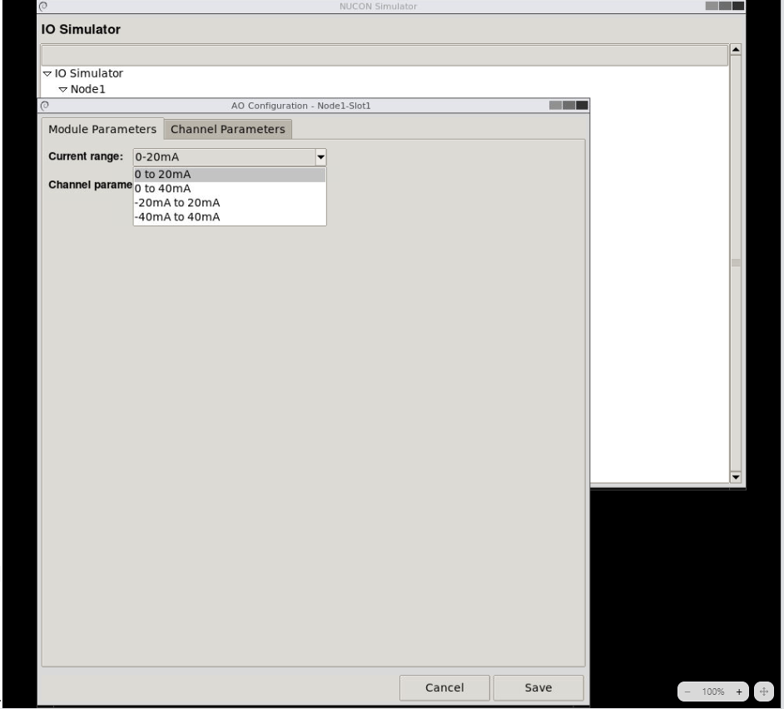
AO Module Parameters

11. Learning Outcomes
At the end of the internship, I gained knowledge of:
- Industrial automation systems such as PLC’s.
- PLC architecture.
- PLC communication modules.
- SCADA systems.
- Distributed industrial automation.
- Standalone and redundant PLC architectures.
- Python GUI development using Tkinter.
- Object-Oriented Programming for software.
- PLC I/O simulation and configuration management.
The internship helped bridge the gap between classroom learning and industrial applications while strengthening both my software development and automation engineering skills.

