RETAIL SALES DATA ENGINEERING
PROJECT DOCUMENTATION
ABC Retail Solutions — End-to-End Data Pipeline
Assessment: Data Engineering Pipeline
Technologies: Python · MySQL · Power BI

June 2026

Executive Summary
This document presents the complete end-to-end data engineering solution developed for ABC Retail Solutions. The project involved ingesting, profiling, cleaning, transforming, and modelling retail transaction data from two source systems into an analytics-ready star schema for Power BI reporting.

Total Records Processed | Data Quality Issues Resolved | Tables in Star Schema | Validation Checks Passed
8,494 | 12 Issue Types | 6 Tables | 10 / 10

Key Achievements
- Successfully ingested and merged 4,243 + 4,251 = 8,494 raw retail transactions from two source systems
- Resolved all data quality issues including 800+ missing prices, duplicate transaction IDs, category inconsistencies, and PII exposure
- Implemented business-aware transaction flagging: Normal Transaction, Successful Return, Failed Return, Invalid Transaction
- Built a clean 5-dimension star schema in MySQL with 100% referential integrity
- Power BI model connected with all relationships verified and correctly configured

Architecture & Data Flow

Solution Architecture Overview
The solution follows a layered data engineering architecture with five distinct stages: ingestion, processing, storage, modelling, and visualisation.

LAYER 1 — DATA SOURCES
retail_data1.xlsx (4,243 records) | retail_data2.xlsx (4,251 records) | product_details.xlsx (10 records)
↓ Python pandas — pd.read_excel() — Data Ingestion
LAYER 2 — PYTHON DATA PROCESSING (Jupyter Notebook)
Data Profiling → Category & Product Standardisation → Date Conversion → Duplicate Resolution
PII Masking → Price Recovery → Transaction Flagging → Revenue & Return Calculation → Validation
↓ df.to_csv() — Export curated dataset
LAYER 3 — CURATED DATASET
retail_curated.csv — Cleaned, validated, enriched retail transactions ready for SQL loading
↓ MySQL LOAD — staging_sales → dimension tables → fact_sales
LAYER 4 — SQL STAR SCHEMA (MySQL — retail_sales_analytics)
fact_sales (Central Fact Table) | staging_sales (Staging)
dim_product | dim_city | dim_payment | dim_channel | dim_date
↓ Power BI Desktop — MySQL Connector/NET — Import Mode
LAYER 5 — POWER BI DASHBOARD
Revenue Analysis | Product Performance | Category Trends | City & Regional Insights | Channel Analysis

Data Sources & Ingestion

Source Datasets
Three datasets were provided as Excel files for this assessment:

Dataset | Records | Role | Description
retail_data1.xlsx | 4,243 | Transaction Source 1 | Raw retail transactions from system 1 with intentional quality issues
retail_data2.xlsx | 4,251 | Transaction Source 2 | Raw retail transactions from system 2 — same schema, same issues
product_details.xlsx | 10 | Product Dimension | Master reference: product_id, product_name, category, standard price

Ingestion Approach
Data was ingested locally using Python (pandas) in a Jupyter Notebook environment. The ingestion process covered:
- Reading Excel files using pd.read_excel() with appropriate dtype handling
- Concatenating both transaction datasets with pd.concat() — a source_system column was added before merging to preserve origin tracking
- Loading the product dimension table separately for use as a validation and enrichment reference
- Initial row count validation after ingestion to confirm all records loaded correctly

Ingestion Validation
retail_data1: 4,243 rows loaded — PASSED
retail_data2: 4,251 rows loaded — PASSED
product_details: 10 rows loaded — PASSED
Combined dataset: 8,494 rows before deduplication — PASSED

Data Profiling & Quality Findings

Profiling Summary
A comprehensive data profiling exercise was conducted on the combined raw dataset before any cleaning. The following issues were identified:

# | Issue Category | Scope | Detail
1 | Missing Prices | ~800+ records | price column null — required for revenue calculation
2 | Duplicate Transaction IDs | Multiple records | Same transaction_id appearing twice (one failed, one successful)
3 | Category Inconsistencies | All records | ELEC / electronics / Electronics — 12+ variants across 4 categories
4 | Product Name Inconsistencies | All records | PHONE / phone / Phone — multiple case/format variants per product
5 | Date Data Type Error | All records | transaction_date stored as object/string instead of datetime
6 | Negative Quantities | Subset of records | quantity < 0 — investigated as potential returns
7 | Zero Quantities | Subset of records | quantity = 0 — no sale, no return — identified as invalid transactions
8 | PII Exposure | All records | Customer email and phone number fields present in raw data — unmasked
9 | Missing Time Dimensions | All records | year, month, month_name, year_month fields absent — needed for BI
10 | No Source Tracking | All records | No field to distinguish retail_data1 vs retail_data2 origin after merge

Category Inconsistency Detail
Raw Variants Found | Standardised Value | Mapping Rule
ELEC, electronics, Electronics | Electronics | Upper/lower/mixed case and abbreviation mapping
CLOTH, clothing, Clothing | Clothing | Upper/lower/mixed case and abbreviation mapping
FURN, furniture, Furniture | Furniture | Upper/lower/mixed case and abbreviation mapping
HOME, home appliances, Home Appliances | Home Appliances | Upper/lower/mixed case and abbreviation mapping

Data Cleaning & Transformation

1. Category Standardisation
A Python dictionary-based mapping was applied using str.map() or str.replace() to convert all raw category variants to the four canonical values. A validation check confirmed only four distinct values remained post-cleaning.

2. Product Name Standardisation
Product names were standardised by joining the transactions table with the product dimension table on product_id and replacing the transaction product_name with the master product_name from the dimension table. This ensured a single, consistent naming convention.

3. Date Type Conversion & Time Enrichment
transaction_date was converted from object dtype to datetime using pd.to_datetime(). Four additional time dimension columns were extracted to support Power BI time-intelligence:
- year — extracted using .dt.year
- month — extracted using .dt.month
- month_name — extracted using .dt.strftime('%B')
- year_month — formatted as YYYY-MM using .dt.strftime('%Y-%m')

4. Missing Price Recovery
Approximately 800+ records had null values in the price column. The product_details dimension table contained standard prices for all 10 products. A left join on product_id was used to populate missing prices with the master price from the dimension table.
Price Recovery Result
Records with missing price before recovery: ~800+
Records successfully recovered using product dimension join: 100%
Records with missing price after recovery: 0
Validation: df['price'].isnull().sum() == 0 — PASSED

5. Quantity Investigation & Business Logic
Rather than blindly removing or replacing anomalous quantity values, a thorough investigation was conducted to understand the business meaning of each case.

Negative Quantities — Return Classification
Negative quantity records were cross-referenced against payment_status. The analysis revealed that the majority of negative quantity records had a 'successful' payment status, indicating product returns rather than data errors. A transaction_flag was assigned accordingly:
Condition | Business Meaning | Flag Assigned
quantity < 0 AND payment_status = 'successful' | Product return processed | Successful Return
quantity < 0 AND payment_status = 'failed' | Return attempt failed | Failed Return
quantity > 0 | Normal sale | Normal Transaction
quantity = 0 | No business event | Invalid Transaction

Zero Quantities — Invalid Transaction Removal
Zero quantity records were manually examined. They exhibited mixed payment statuses and represented no business event — no units sold and no units returned. These were classified as Invalid Transactions and removed from the final curated dataset.

6. Duplicate Transaction Resolution
Duplicate transaction IDs were investigated and found to follow a consistent pattern: each duplicated transaction_id had exactly one failed record and one successful record, representing a payment retry scenario. The business rule applied was to retain the successful outcome and discard the failed attempt. The same logic was applied to return transactions — where both a Failed Return and Successful Return existed for the same transaction_id, the Failed Return was discarded.

7. PII Masking
Customer Personally Identifiable Information was protected in compliance with data privacy best practices:
Field | Action Taken | Result
customer_name | Removed from curated dataset | Field excluded from retail_curated.csv
email | Masked — partial obfuscation | Stored as email_masked (e.g. jo***@gmail.com)
phone | Masked — partial obfuscation | Stored as phone_masked (e.g. +91 98***5678)

8. Revenue & Return Calculation
A deliberate design decision was made to track revenue and returns as separate columns rather than storing returns as negative revenue. This provides cleaner reporting and allows Net Revenue to be calculated independently.
Metric | Formula | Applied To
Revenue | Price × Quantity × (1 − Discount) | Normal Transaction only
Return Value | Price × ABS(Quantity) × (1 − Discount) | Successful Return only
Net Revenue | Revenue − Return Value | Calculated at reporting layer in Power BI / SQL

SQL Data Model — Star Schema

Schema Design Principles
A star schema was chosen as the optimal structure for analytical workloads. The central fact table captures all measurable business events (sales, returns) while five dimension tables provide the descriptive context for slicing and filtering data in Power BI. This design minimises join complexity, maximises query performance, and aligns with Power BI best practices.
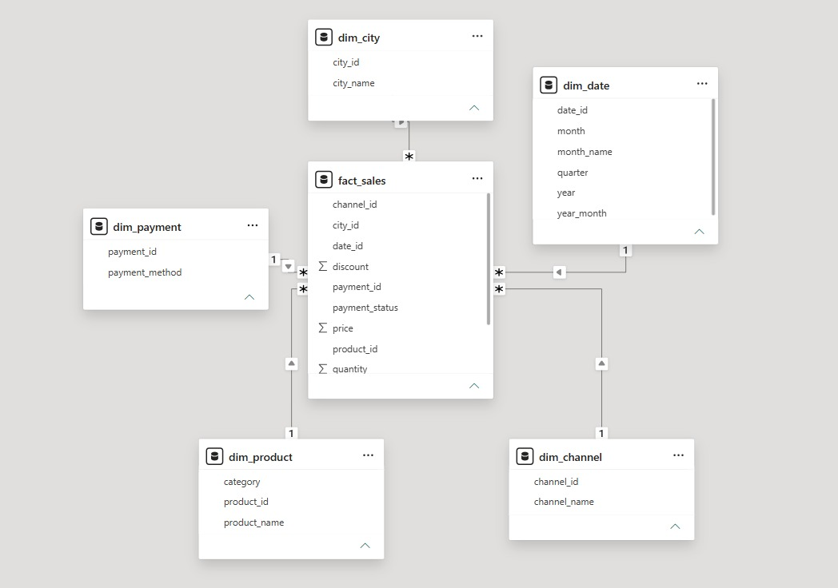

Schema Overview
Table | Type | Primary Key | Business Purpose
fact_sales | Fact | transaction_id | Central table — all sales and return transactions with measures
staging_sales | Staging | — | Intermediate load table — raw curated data before dimension population
dim_product | Dimension | product_id | Product master — product_id, product_name, category
dim_city | Dimension | city_id (auto) | City/location dimension — city_id, city_name
dim_payment | Dimension | payment_id (auto) | Payment method dimension — payment_id, payment_method
dim_channel | Dimension | channel_id (auto) | Sales channel dimension — channel_id, channel_name (online/offline)
dim_date | Dimension | date_id (auto) | Date dimension — date_id, year, month, month_name, year_month, quarter

Relationships & Cardinality
All relationships follow the standard star schema pattern — a single foreign key in fact_sales links to the primary key of each dimension table. Cardinality is Many-to-One (fact to dimension) in all cases.
Fact Column (FK) | Dimension Column (PK) | Cardinality | Filter Direction
fact_sales.product_id | dim_product.product_id | Many → One | Single
fact_sales.city_id | dim_city.city_id | Many → One | Single
fact_sales.payment_id | dim_payment.payment_id | Many → One | Single
fact_sales.channel_id | dim_channel.channel_id | Many → One | Single
fact_sales.date_id | dim_date.date_id | Many → One | Single

Power BI Model Verification
All 5 relationships confirmed in Power BI Model View — screenshot provided.
Filter direction: Single (Dimension → Fact) for all relationships.
Cross-filter behaviour tested — category, city, date, and channel slicers all propagate correctly to fact_sales.
No inactive relationships or ambiguous paths detected.

Fact Table — Key Columns
Column | Data Type | Description
transaction_id | VARCHAR(50) PK | Unique identifier for each sales transaction
product_id | VARCHAR(50) FK | Links to dim_product
city_id | INT FK | Links to dim_city
payment_id | INT FK | Links to dim_payment
channel_id | INT FK | Links to dim_channel
date_id | INT FK | Links to dim_date
quantity | INT | Units sold (positive) or returned (negative — before flagging)
price | DECIMAL(10,2) | Unit price — recovered from product dimension if originally missing
discount | DECIMAL(10,2) | Discount rate applied to the transaction
revenue | DECIMAL(10,2) | Calculated revenue — Normal Transactions only
return_value | DECIMAL(10,2) | Calculated return value — Successful Returns only
payment_status | VARCHAR(50) | Final payment outcome after duplicate resolution

Assumptions & Business Decisions
All assumptions were documented during the analysis phase to ensure transparency and reproducibility of the pipeline decisions.

# | Area | Assumption | Justification
1 | Negative Quantities | quantity < 0 records represent product returns, not data errors | Majority had successful payment status — consistent with return processing
2 | Zero Quantities | quantity = 0 records are invalid and should be excluded | No business value — zero units means no sale and no return occurred
3 | Duplicate Transaction IDs | Duplicates represent payment retries — retain successful outcome | Each duplicate pair contained exactly one failed and one successful record
4 | Missing Prices | Standard product price from dimension table is the correct fallback | Product dimension is the master reference — prices are standardised
5 | Revenue Design | Returns tracked separately, not as negative revenue | Cleaner reporting — Net Revenue = Revenue minus Return Value in BI layer
6 | PII Protection | Masking is sufficient — full removal not required for email/phone | Masked fields retain analytical usefulness (domain analysis) while hiding PII
7 | Date Dimension | Quarter derived as CEIL(month/3) | Standard quarter calculation — Q1=1, Q2=2, Q3=3, Q4=4
8 | Source Tracking | source_system column added before concat to preserve dataset origin | Required for data lineage, debugging, and source-level reporting

Data Validation Report

Final Validation Checklist
A comprehensive set of validation checks was executed on the final curated dataset before loading into MySQL. All checks passed.

# | Validation Check | Method | Result
1 | No missing values in key columns | df.isnull().sum() — all critical fields | PASSED ✓
2 | No duplicate rows | df.duplicated().sum() == 0 | PASSED ✓
3 | No duplicate transaction IDs | df['transaction_id'].duplicated().sum() == 0 | PASSED ✓
4 | Category values standardised | df['category'].unique() — only 4 values | PASSED ✓
5 | Product names standardised | Cross-check against product_details | PASSED ✓
6 | Revenue calculation correct | Spot check: price × qty × (1−disc) | PASSED ✓
7 | Return value calculation correct | Spot check: price × ABS(qty) × (1−disc) | PASSED ✓
8 | Date column is datetime type | df['transaction_date'].dtype == datetime64 | PASSED ✓
9 | All product_ids in dimension | Left join check — no unmatched product IDs | PASSED ✓
10 | PII fields masked or removed | email_masked, phone_masked format validation | PASSED ✓

Overall Validation Result
10 / 10 validation checks PASSED
0 critical issues remaining in curated dataset
Dataset confirmed ready for SQL loading and Power BI reporting

Business KPIs & DAX Measures

Core KPIs
The following KPIs are supported by the star schema and can be implemented as DAX measures in Power BI:

KPI | DAX Measure | Business Use
Total Revenue | SUM(fact_sales[revenue]) | Overall gross revenue from normal transactions
Total Return Value | SUM(fact_sales[return_value]) | Total value of successful product returns
Net Revenue | [Total Revenue] - [Total Return Value] | Revenue after accounting for returns
Avg Order Value | DIVIDE([Total Revenue], DISTINCTCOUNT(fact_sales[transaction_id])) | Average value per transaction
Return Rate % | DIVIDE([Total Return Value], [Total Revenue], 0) | Proportion of revenue returned
Total Units Sold | SUM(fact_sales[quantity]) | Total quantity of items sold
Revenue by Category | Uses dim_product[category] as slicer | Category-level revenue breakdown
Revenue by City | Uses dim_city[city_name] as slicer | Geographic revenue distribution
Online vs Offline Revenue | Uses dim_channel[channel_name] as slicer | Channel performance comparison
Revenue by Month/Quarter | Uses dim_date[year_month] / [quarter] | Time-series revenue trending

Conclusion and Recommendations

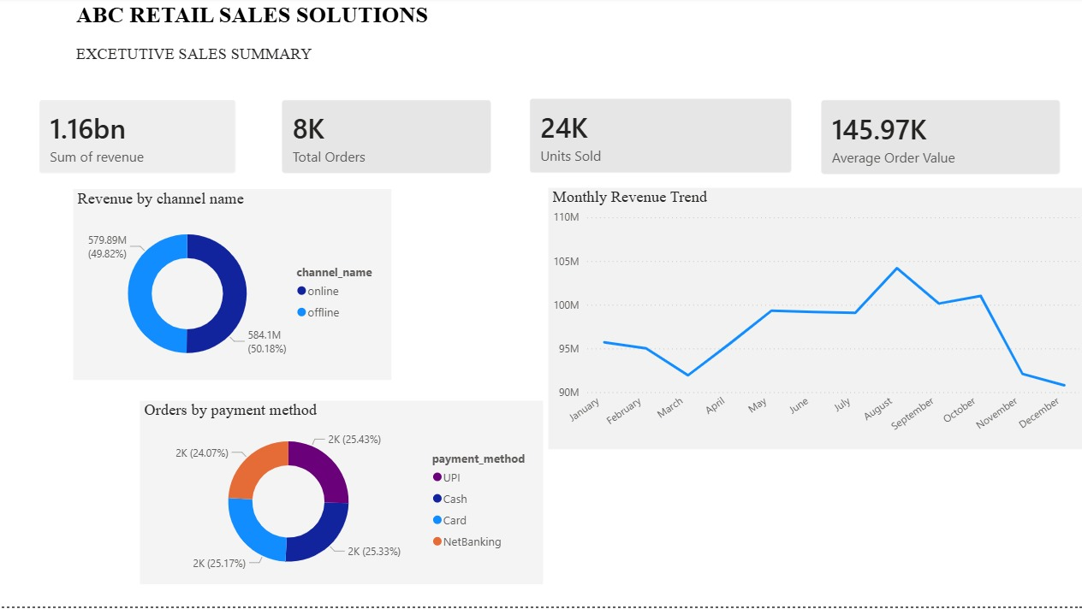

Dashboard 1: Executive Sales Summary

Key Insights
- The business generated approximately 1.16 Billion in revenue from 8K orders and 24K units sold.
- Revenue is evenly distributed across Online (50.18%) and Offline (49.82%) channels, indicating a strong omnichannel presence.
- UPI emerged as the most preferred payment method, reflecting increasing digital payment adoption.
- Monthly revenue remained stable throughout the year, peaking in August and declining slightly during November–December.

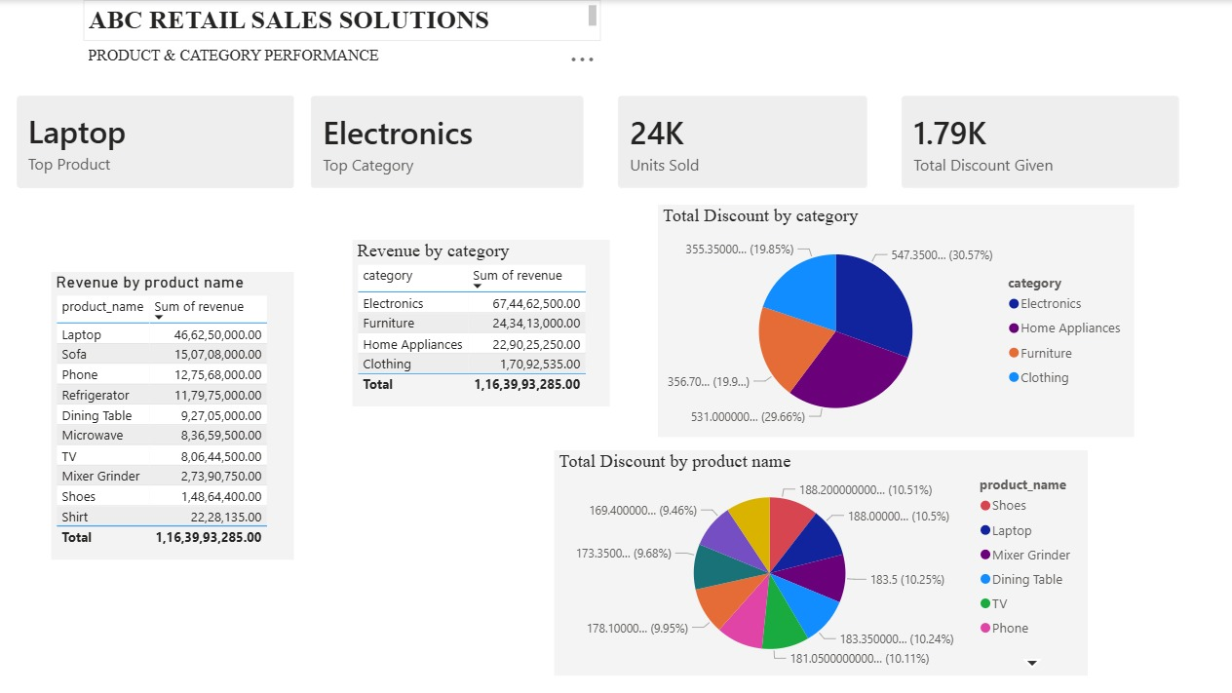

Dashboard 2: Product & Category Performance

Key Insights
- Laptop is the highest revenue-generating product in the portfolio.
- Electronics is the top-performing category, contributing approximately 58% of total revenue.
- Revenue is concentrated among a small number of products, highlighting the importance of key product lines.
- Discount allocation is relatively balanced across categories, with no category showing excessive discount dependency.

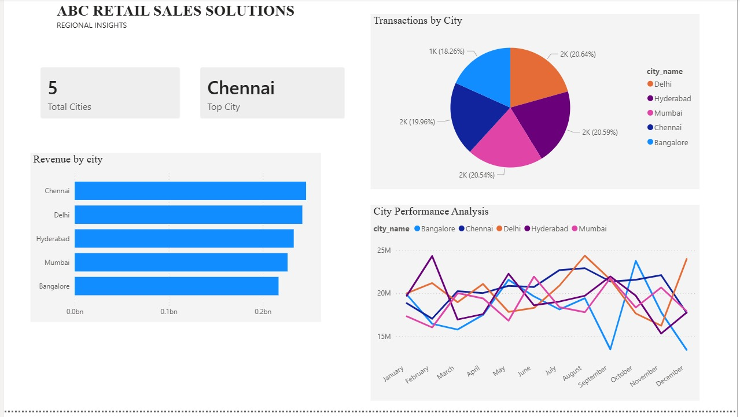

Dashboard 3: Regional Insights

Key Insights
- Chennai is the highest revenue-generating city.
- Revenue contribution is relatively balanced across all five cities, reducing geographic concentration risk.
- City-level revenue trends indicate varying seasonal demand patterns across regions.
- The diversified regional presence supports stable business performance and growth opportunities.

Final Conclusion
This project successfully developed an end-to-end retail analytics solution using Python, MySQL, and Power BI. Raw transactional data was cleaned, validated, modeled using a star schema, and transformed into interactive dashboards that support business decision-making. The analysis identified Electronics as the primary revenue driver, Laptop as the top-performing product, Chennai as the leading market, and UPI as the preferred payment method. Overall, the solution provides actionable insights that can support revenue growth, operational efficiency, and strategic planning.

Key Recommendations
- Strengthen the Electronics category through inventory optimization and targeted promotions.
- Improve Clothing category performance through focused marketing and product expansion.
- Launch seasonal campaigns during November–December to address year-end revenue declines.
- Leverage the balanced online-offline channel mix through omnichannel initiatives.
- Optimize discount strategies using category-level performance analysis.
- Replicate successful sales strategies from Chennai across other cities.
- Encourage digital payments through UPI-focused incentives and loyalty programs.

