

Concept Document

Grocery Scanner App



February 14, 2020

Smart Mobile

Nidhi Sharma, Edgaras Spiridonovas

Table of Contents

Problem 2

Solution 2

Sustainable Development Goals 2

Brainstorm sessions 2

Mind map: 3

Personas: 4

Ideas 5

# Problem

Nowadays it is highly important to check the ingredients of a product before you would purchase it. Furthermore, stock in grocery shops may contain a lot of preservatives that might be harmful for a customer’s health.

# Solution

This app will provide the user with the opportunity to scan the barcode or label of a product and check whether it is made using sustainable practices. An application like this would be helpful for health-conscious consumers and people trying to stay in shape since they seek greener options.

# Sustainable Development Goals

This application will help in solving goal #3, Good Health and Well Being.

# Brainstorm sessions

Two different brainstorm methods were used, mind mapping and personas, and through using these we came up with ideas and our target audience.

## Mind map:

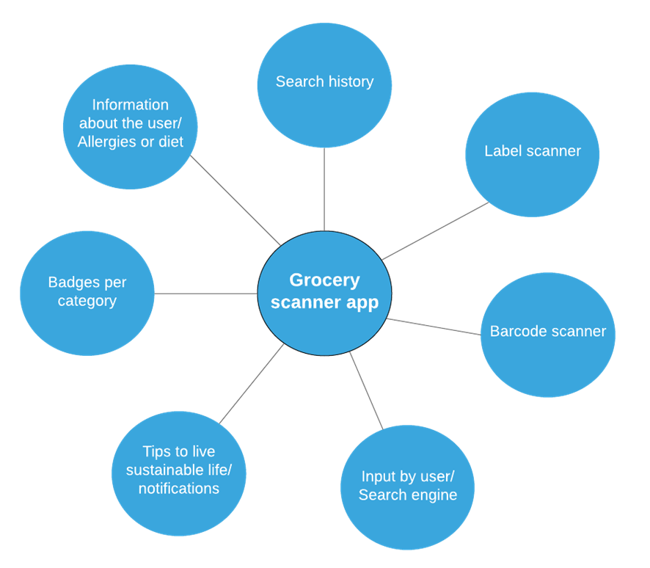

## A screenshot of a social media post Description automatically generatedPersonas:

# A screenshot of a cell phone Description automatically generatedIdeas

* The application will have the option to open camera and process the barcode or brand/label of the product. Having received necessary data, the app will display the related details.
* There are examples available on the internet about PWA software used to read barcodes, labels – make use of the hardware of a mobile device - camera.