|  |  |  |
| --- | --- | --- |
|  |  |  |
| Name: Nidhi Sharma, Edgaras Spiridonovas  Class: SM42  Student No: 3233006, 3633055 |  |  |

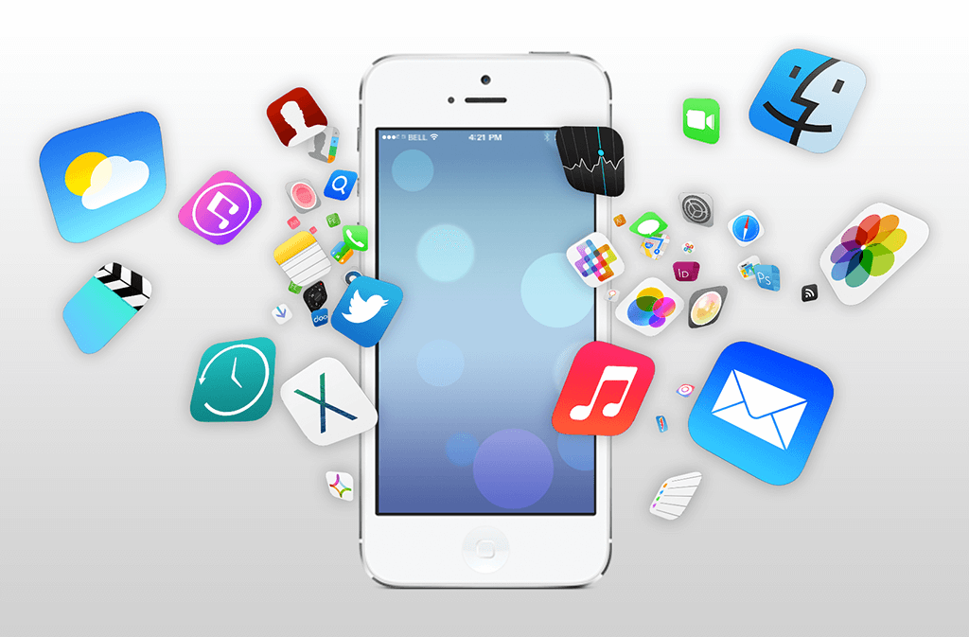

**Smart Mobile**

**Design Document**

TABLE OF CONTENTS

Version History 2

Product Definition 2

Personas 3

Scenarios 4

Use Cases 5

Prototype 9

Testing 10

Prototype (After testing) 13

# 

# 

# **Version History**

|  |  |  |  |
| --- | --- | --- | --- |
| Version | Date | Changes | Author |
| 0.1 | 12/03/2020 | Initial version | Duo |
| 0.2 | 20/03/2020 | Added sketches, wrote product definition and some use cases | Duo |
| 0.3 | 11/04/2020 | Added survey testing results and screenshots of prototype | Nidhi |
| 0.4 | 19/04/2020 | Added observation testing results and screenshots of prototype after testing | Nidhi |

# **Product Definition**

* **Current situation**

Nowadays a lot of people want to eat healthy and are trying to avoid things they are allergic to. However, they don’t put in the time to research on what they should eat to be healthy or check if they are allergic to a particular ingredient in the products they buy at the stores. This can be considered harmful to health and people will continue eating unhealthily.

Our application helps a user to quickly get information of a product they would like to buy and see if its healthy enough, if it fits in their diet plans or if it contains something, they are allergic to. This app will provide the user with the opportunity to scan the barcode or label of a product and check whether it is made using sustainable practices. An application like this would be helpful for health-conscious consumers and people trying to stay in shape since they seek greener options.

# **Personas**

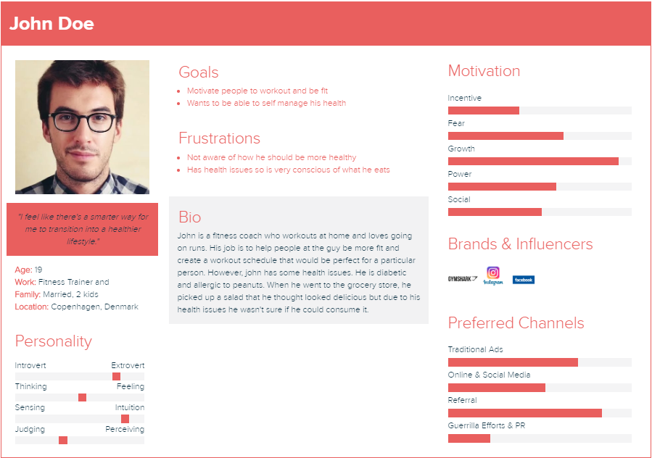

# **Scenarios**

**Backstory**

Laura is studying Psychology at IU in Indiana. She is serious about her studies, so she spends a lot of time studying for her classes. Laura is also invested in maintaining an active and healthy lifestyle. She believes eating well is the key. Due to the shortage of time she ends up shopping unhealthy food which isn’t good for her diet. She would like the opportunity to see whether the products she buys at the grocery are healthy enough of her.

**Everyday Scenario:**

After finishing her lectures Laura visits grocery store to buy missing products or to grab something delicious on the way home like smoothie try something new. She prefers to eat healthy therefore she uses a grocery app to scan products she wants to purchase in order to help her if it would be healthy enough for her. After she finishes shopping, she is happy because she realized everything, she bought was health enough and what she likes to eat.

**Worst Scenario:**

Laura forgot to buy lunch after university. During lunch break she doesn’t have time to reach the store she usually shops at. There is a new store opened with new products near her university. She goes there to get her lunch but, the store had strange meals to sell, so she used the grocery app to scan the barcode. However, the barcode wasn’t recognized, and the option to add it manually didn’t work for her due to some technical issues. Finally, she didn’t end up buying anything from the store because she was scared to eat something unhealthy or not in her diet.

**Ideal Scenario:**

Laura decided to buy meal during her lunch break. During lunch break she goes to a new store. There are a lot of new products and a lot of new meals that looks tasty and healthy and it updates every couple day with new meals. She uses grocery app to scan barcode and find out which one of new meals are healthy for her. The app recognized the food and display how healthy it is. Laura eats her healthy meal and goes to classes happy.

**Golden Plate Scenario:**

After university Laura goes to store to get some products for lunch and buy something to eat for dinner. Laura meets her friend Jessica that is also doing shopping. However, Jessica doesn’t have the grocery app and she is not sure how healthy her products are. So, Laura helps her with purchasing healthy products using the app and tells her the website where she can get app for herself.

# **Use Cases**

**Sample Use Case Brief**

Use Case Name: Scan Product

Actors:

* Application User (User)

Use Case Description: After the user scans the selected product. The user will be provided with information about the product and if it contains allergens in user allergens list.

**Formal Use Case Example**

Use Case Name: Get information about product

Actors:

* Logged in User (Have recent scan history, selected allergens)
* System (shows information to user)

Triggers:

* The user scan barcode of product that user want information about.
* The user input barcode of product that user want information about.

Preconditions:

* User has selected the allergens in allergens list.

Post-conditions:

* The user will be informed if product is healthy by icon near product picture.
* The user will be provided with information about the product.
* The product will be placed in recent history.

Normal Flow:

1. The user will click “Scan” button.
2. The system will turn on camera for product scan.
3. The user will scan barcode of product by using camera.
4. The system will detect barcode.
5. The system will show product title, brand, image, short description, national data, if its healthy or not and if contains allergens selected in allergens list.
6. The system adds scanned item to recent history.
7. The user will exit the system

Alternate Flows:

2A1: The product was not found, or user want to use search by title.

1. The user will input product title(name) in search box.
2. The system will show all products with title that includes inputted title(name).
3. The user selects product.
4. The use case continues at step 5.

2B1: The System don’t find any products

1. The use case continues at step A1 or step B1.

6A1: The user will continue scanning products.

1. The use case continues at step 1.

**Sketches**

Home screen and history page

My list and user’s details page

Product Information page

**Prototype**

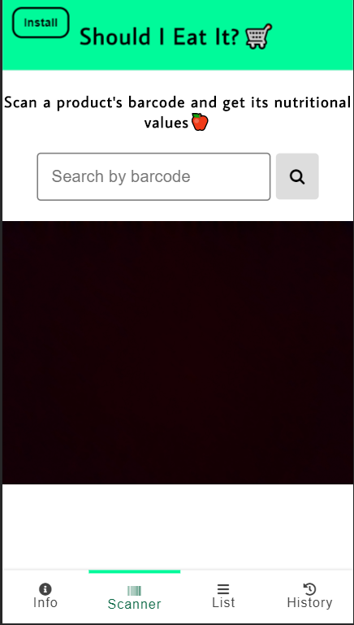

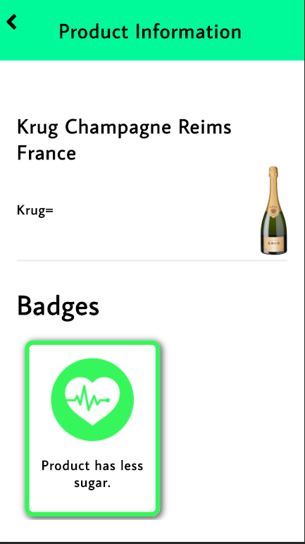

**Testing**

For the user testing, my partner and I decided to use two different forms of testing. I conducted a survey while he did observations with different users. The goal of the survey was to see if users would use such an application in order to live a healthier lifestyle, while the goal of the observations was to see if users can perform certain tasks on our application and not have a hard time using it.

**Survey Results:**

**Observation Results:**

Video 1 - <https://www.dropbox.com/s/510vnv3s9etw7bv/2020-04-18%2020-12-11.mkv?dl=0>

Video 2 – <https://www.dropbox.com/s/6wmmspfqeav65h2/2020-04-18%2022-55-43.mkv?dl=0>

Video 3 - <https://www.dropbox.com/s/akt3maqo9r2uln2/2020-04-20%2001-11-47%20Amin.mkv?dl=0>

Video 4 - <https://www.dropbox.com/s/5ibzqrk48m7z9cd/2020-04-21%2011-16-02Success2%21.mkv?dl=0>

**Summary of Findings:**

|  |  |  |
| --- | --- | --- |
| Issue | Severity | Feedback |
| The information page contained too much information and no user wants to read everything.  The order of the sections was not the same as the list page, so it was noticeable. | Low | Reduce the information and only keep the important text so the user understands how everything works in the application. Change the order of the sections. |
| The scanner page was confusing to the user because the information was not clear enough. | Medium | Put a button on the scanning page one to refer to the list page so user can choose its options. |
| The user did not get the concept of the list page because according to him/her it didn’t show any information of the product. | High | Instead of a list page, replace it with badges list page and put a button incase user wants to read more information.  In the info page, put a button to set up the badges by selecting the options. |
| The user did not understand how to get from the product information page to the badges page | Medium | In the product information page if no badges were selected, then display a button asking would you like to set up the badges. Made some minor changes to the design of the application. |

**What went well:**

Even though it was not clear enough what to do the users still managed to perform their tasks and could see the information for each of the products. Furthermore, the surveys were also very successful as we received very constructive feedback which helped us to improve the prototype.

**Other things we learned:**

We learned that our design of the application could have been improved more. As of right now our application has a very minimalistic view, but some users would like it to be more visually appealing.

# **Prototype (After testing)**

­­­