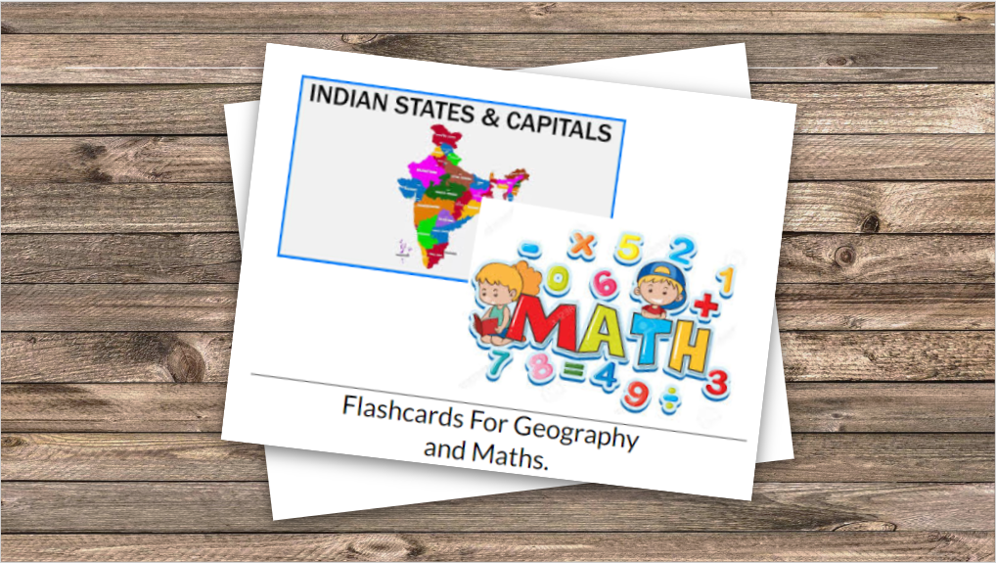

Flashcard App

Python tkinter Mini-Project

Yash Mehta-1811024

Nidhi Nair-1811028

# BACKGROUND

Millions of kids use mobile devices or Laptops or PCs for games and entertainment every day. Though children rarely buy apps themselves, this audience represents a vast market segment and has a high profit potential for developers and business.

Technological progress is ongoing, and the days when a child received all his/her information from books and TV are long gone. Nowadays, kids have grown up in the era of social networks and mobile/desktop apps, and they are used to absorbing content from those.

Educational apps are especially relevant for pre-schoolers or secondary section, for example. These are products focused on teaching reading and arithmetic.

## Scope of the Project

The project has been focused on teaching children the basic geography and arithmetic with the review of current existing techniques. The objectives of this project are:

* Only Python(Tkinter) application is to be developed for the purpose mentioned above.
* Seek feedback on performance and UI.
* Maintain the system and fix the bugs and upgrade up to ONE month after commissioning.
* Procurement of hardware for using the system is **OUT OF SCOPE** of this project.

# GENERAL OVERVIEW OF PROJECT UNDERTAKEN

Flashcard app is a Python app whose purpose is to help children learn and identify all the states and respective capitals cities of India and perform basic addition and subtraction on numerals ranging from 1-10, with widgets quiz to help along the way. It is completely ad-free and open source.

PROJECT DESIGN

System design /Architecture diagram/ and UML diagrams related to activities of the project It should provide detailed understanding of the topic.

**INTRODUCTION**

In this App, the task of the user is to choose between the  two modules i.e. Geography or Math. If the user chooses the Math module, two options will be available i.e. Addition and Subtraction. Random flashcards ranging from 1-10 will be displayed randomly to perform the arithmetic operation.

If the user chooses Geography. A random state of India will be displayed on the screen and the user has to guess the correct answer and type it down, if wrong an error message will be displayed. Also apart from this the user has to attempt a small multiple choice answer quiz in which the state will be displayed and multiple capital city names will be given as options. The user has to identify the state and then choose its respective capital city.

**PROBLEM DEFINITION**

Design a Desktop Application using Python Tkinter to help children understand the basic Geography of our country India, and also perform basic Mathematics.

The main purpose is that the children can identify and name all the states of India as well as the capital cities of the respective states. It is then followed by a small quiz for better understanding and learning. The app includes basic addition and subtraction of numerics for the children to learn Mathematics.

BLOCK DIAGRAM FUNCTIONALITIES

GEOGRAPHY MODULE:

STATES OF INDIA:

One by one any of the states of India will be shown on the screen like a Flashcard, the person has to identify the State and type his/her answer in the empty box given below.

CAPITAL CITIES OF RESPECTIVE STATES:

To identify the capitals, any state’s flash card will be displayed followed with multiple choice answers (various capitals). The correct answer has to be chosen by the person.

MATH MODULE:

Random number flash cards will be shown on the screen to perform addition and subtraction. The person has to type his answer in the empty box given below.

REQUIRED SOFTWARE MODULES

* **OS:** We will use this Python Module to read our training directories and file names.
* **Tkinter:** tkFileDialogue is a module with open and save dialogue functions.
* **PIL:** ImageTk module contains support to create and modify Tkinter BitmapImage and PhotoImage objects from PIL image.
* **PIL:** Image module provides a class with the same name which is used to represent PIL image. The module also provides a number of factory functions, including functions to load images from files, and to create new images.
* **PhotoShop:** To create Flashcards for numeric and states.

(No hardware modules required for this app)

FUNCTIONS IMPLEMENTED

* **def math_random():** This function is used to display random flashcards corresponding to random numerals from 0-10, for performing basic arithmetic operations.
* **def answer_add():** The verification of the answer given by the user is done in this function. Failing to write a value in the box and clicking on “Answer” button would display an error message.
* **def answer_sub():** This has same function as answer_add.
* **def add():** This function constructs the window and designs the layout of “addition” block. All the images are loaded in this function and displayed on the screen. The random number is also generated in this function.
* **def sub():** This function has same task as that of add( ).
* **def random_states():** Here from the list “our_states” the image of state corresponding to the random number generated is loaded onto the screen.
* **def state_capital_answer():** This function verifies the correctness of the answer given by the user of states’ capital.
* **def state_answer():** This function verifies the correctness of the answer given by the user of states’ capital.Failing to write a value in the box and clicking on “Answer” button would display an error message.
* **def states():** This function is actual layout of the states block. All the frames are created inside this function.
* **def state_capitals():** Here from dictionary “our_states_capitals”, the 3 random options of values i.e. capitals are generated and the answer is also generated by using while loop. And after each turn the values are shuffled to display the state.
* **def hide_all_frames( ):** This function destroy all the previous widgets and helps to load new ones. To loop through the numerous widgets a method called “.winfo_children()” is used.

SCREENSHOTS OF THE PROJECT:

**(Main window)**

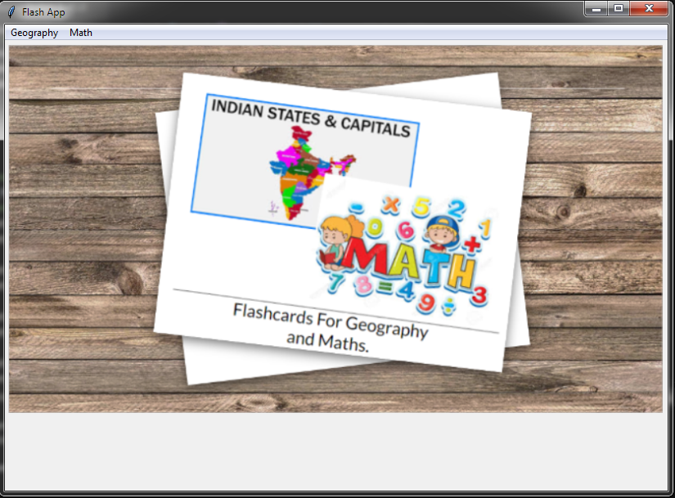

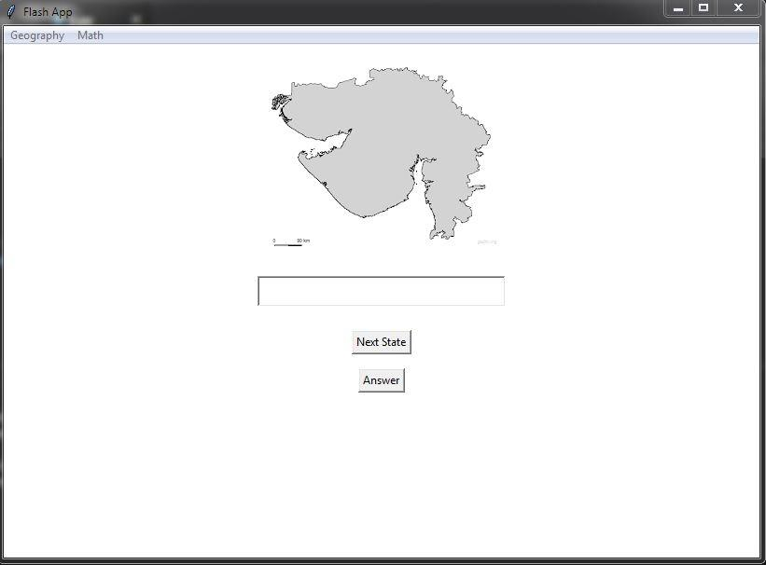

(States module)

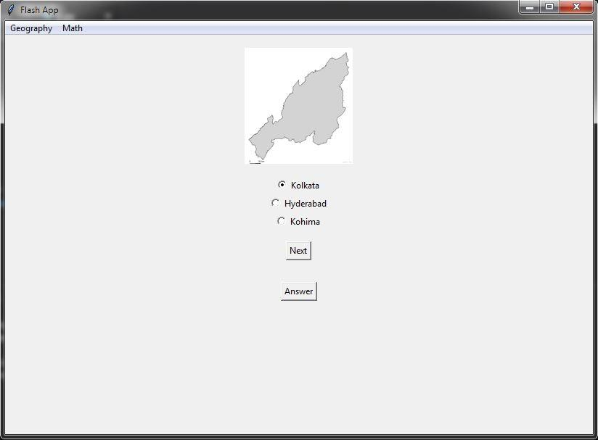

(States_capitals module)

(pop up when user does not type the answer and clicks answer button)

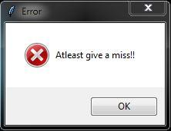

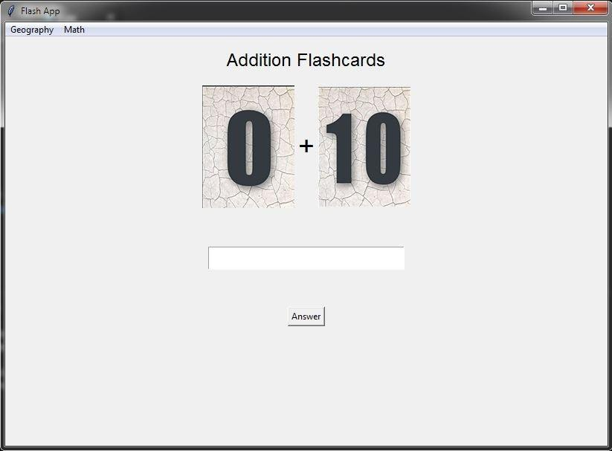

Addition Module

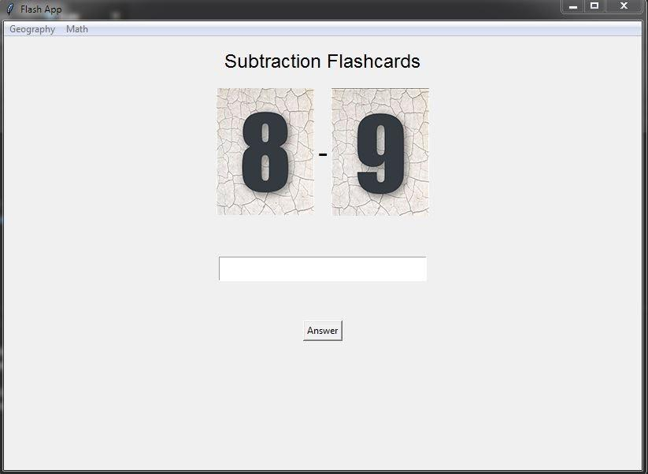

Subtraction Module

(pop up when the user does not type an answer and clicks on the answer button)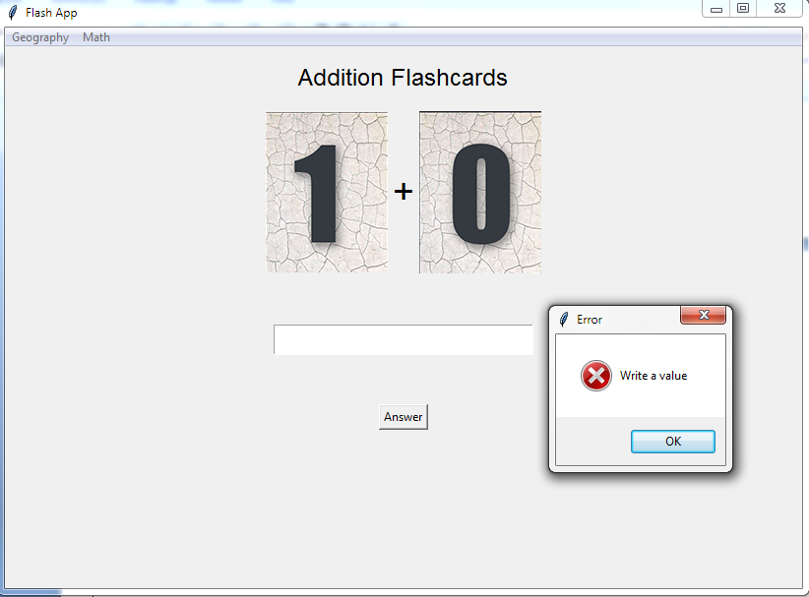

CONCLUSION

Using Python Tkinter we learned to design a basic desktop app for the children to help them solve easy addition and subtraction on numerals ranging from 1-10 and identify states and capital cities of India.This will help the children built a strong foundation for mathematics as well geography.

FUTURE WORKS

We have planned on adding more modules in the application such as :

**Maths:**

* Multiplication.
* Division.

**Geography:**

* Identify Countries and their respective Flags.
* Grouping Countries according to their respective Continents.
* Identify Capitals of the Country.

REFERENCES

* Geeks for Geeks.
* Wikipedia.
* Photoshop.
* Python.org.