
Analysis of Restaurants in London, England
25.12.2019
─
Nidhi Jha
Capstone Project

1.Introduction

1.1 Background
London is the capital and the largest city of England and the United Kingdom.London is considered to be one of the world's most important global cities and has been termed the world's most powerful, most desirable,most influential, most visited, most expensive, innovative, sustainable, most investment friendly, and most popular for work city in the world.
London exerts a considerable impact upon the arts, commerce, education, entertainment, fashion, finance, healthcare, media, professional services, research and development, tourism and transportation.
British cuisine encompasses the cooking styles, traditions and recipes associated with England. It has distinctive attributes of its own, but also shares much of Americans, China, and India touches.
1.2 Problem
Analysing the distribution of restaurants in London is the main aim of this project. Which types of restaurants are where? Where the restaurants of a particular type are located? These are the questions we’ll be focusing on.
1.3 Interest
The people of London are the targeted audience. The residents of London, the tourists, and the businessmen. The people interested in opening a restaurant in an area are probably gonna be interest as well

2.Data acquisition and cleaning
2.1 Data sources
The main sources of this project were:
- Wikipedia: To obtain the list of neighborhoods and boroughs in London
(https://en.wikipedia.org/wiki/List_of_areas_of_London)
- Citypopulation: To obtain the population of the boroughs
(https://www.citypopulation.de/en/uk/greaterlondon/)
- FourSquare: To obtain the location, venues of the different restaurants in a borough.

2.2 Data Cleaning

First, I scraped the Wikipedia page for the neighborhoods, boroughs, and postal. Then, scraped the Citypopulation page to obtain the populations from the different boroughs.
Second, I had to clean the borough list from Wikipedia to match the borough list from the Citypopulation page.
Third, I found the locations of the various neighborhoods of London and mapped them.

Figure 1. Map representing all the neighborhoods of London

3. Methodology
3.1 Analysis of Boroughs
The first thing we need to know when we’re opening a restaurant is where to open it? I approach this question by finding the five most populated boroughs in London.

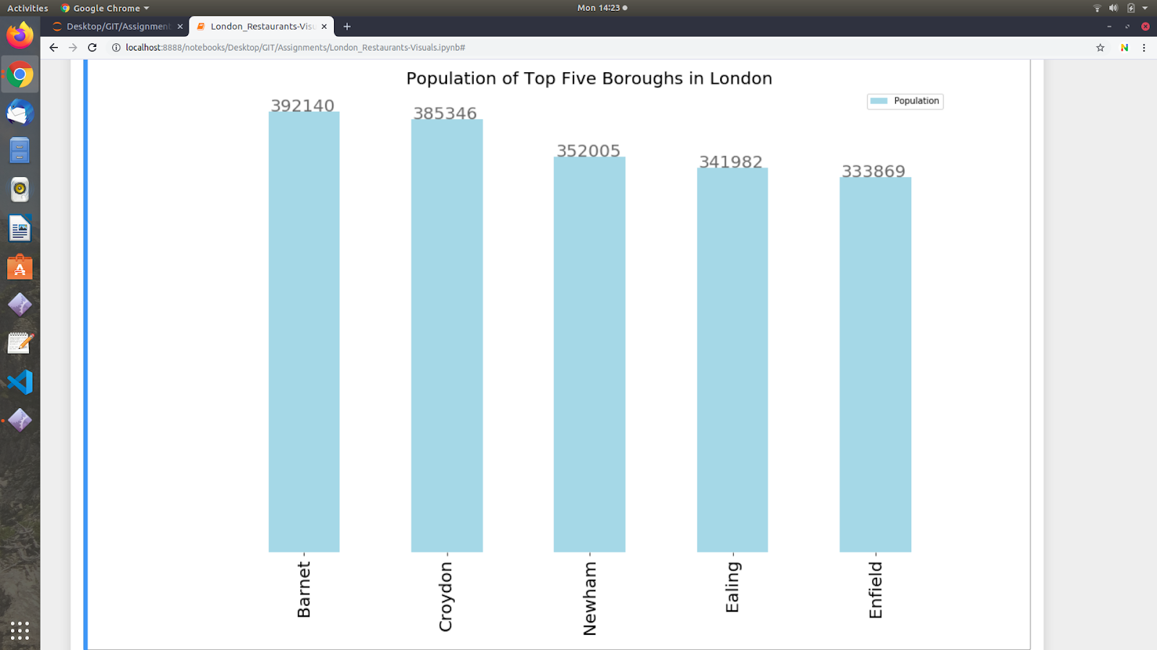
Figure 2. Population of Top Five Boroughs

3.2 FourSquare
After finding the five most populated boroughs, we use the FourSquare API to find the restaurants in the boroughs. We use the food category id f FourSquare to find the restaurants.

3.3 Tabulating and finding the frequency of the different venues
After tabulating the data of the different boroughs we find the frequency of each kind of restaurant. We find the frequency and tabulate it.
We merge all the tables and find the total no. of each kind of restaurant in each of the top 5 boroughs.
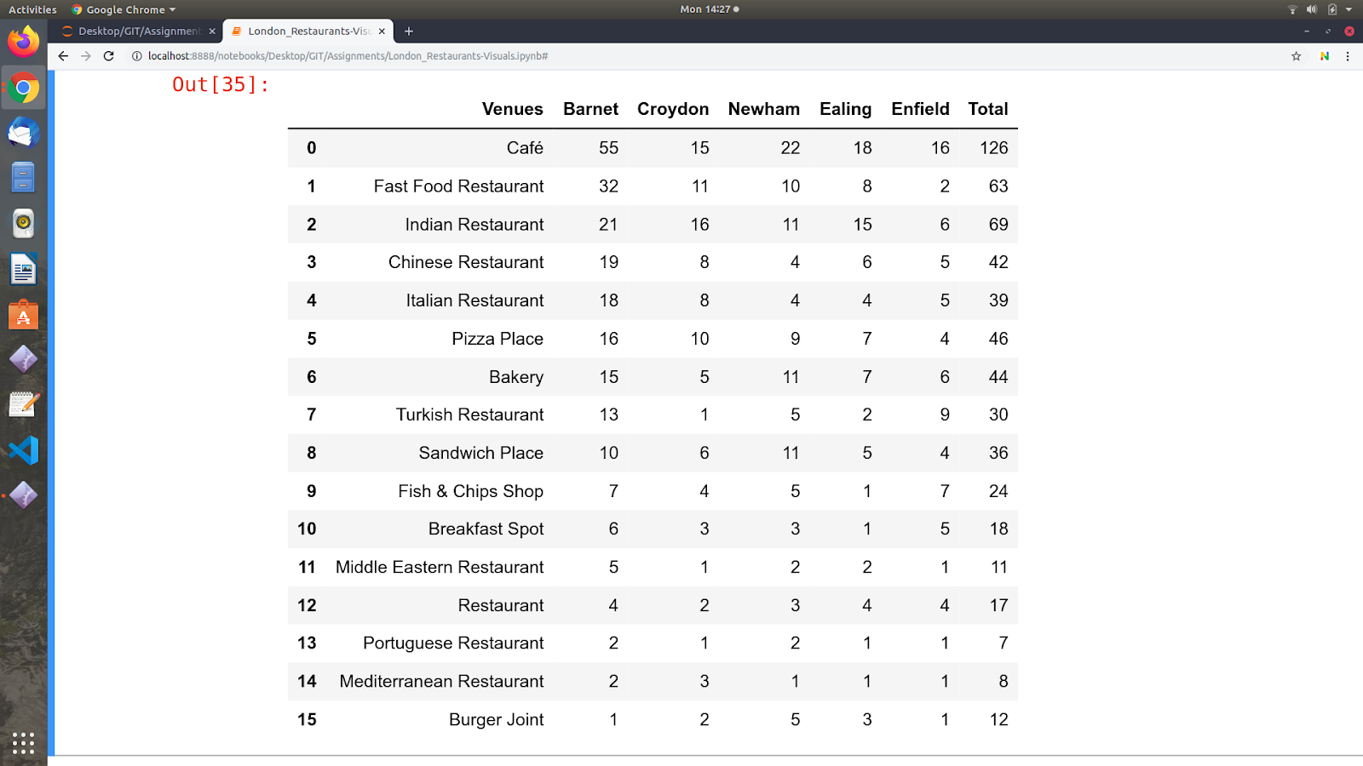
Figure 3. Table of the different venue categories of the top five boroughs

3.4 Finding where to open what
After we have gathered the data for the various boroughs and select the type of restaurant we want to open we must decide where to open it. I approach this by selecting the the borough containing the least no. of these type of restaurants.
The restaurant I have selected for this project is ‘Indian Restaurants’ . I find the neighborhoods in which the Indian Restaurants are open, these are the neighborhoods I do not want to open in, to avoid competition.
I find the mean of the latitudes and longitudes of the neighborhoods in which the Indian Restaurants are open in, this assures that I am still around the poplatution interested in this cuisine. Then I find the neighborhoods within the radius of 5km from the mean location, excluding the ones already containing Indian Restaurants.
That’s it, we have found populated areas with less competition to open our restaurant.

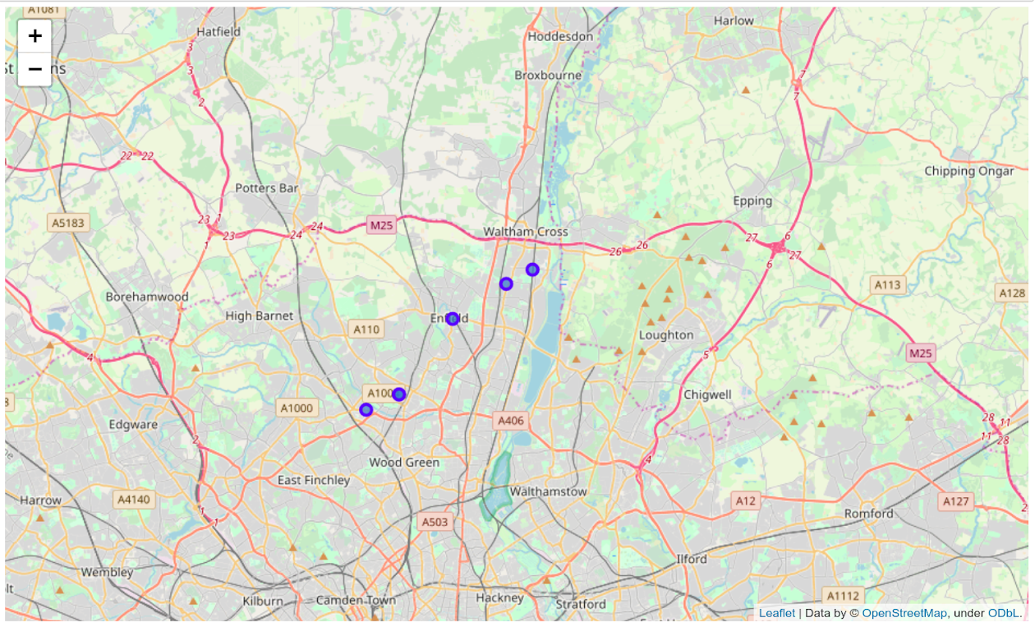
Figure 4. Places in Enfield having an Indian Restaurant
4. Results
As you can see now we obtain locations of the neighborhoods with the potential of being areas to open an Indian Restaurant. There are nine such neighborhoods to be found and they are mapped below:

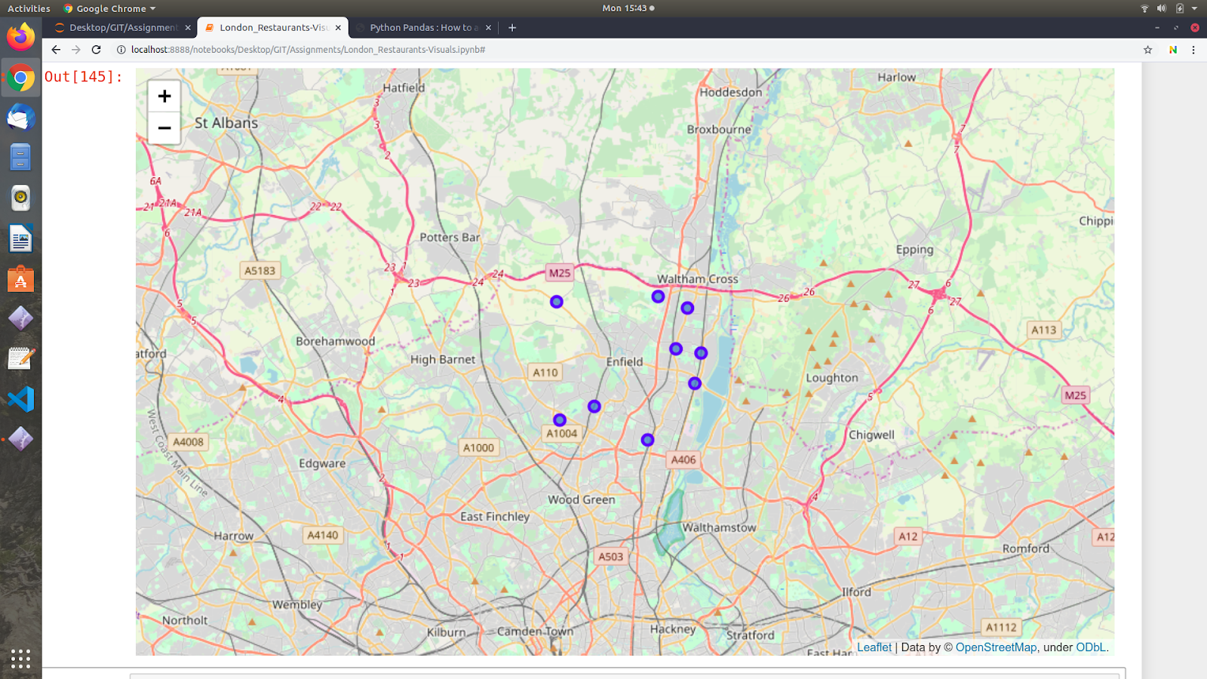Figure 5. Places to open an Indian Restaurant in Enfield

5. Discussion
London is a cultural city, not only by its people but now I’ve learnt by its cuisine as well. It has more than 15 different kinds of restaurants in the inner city alone. The competition is tough, and where to open the restaurant is the main question for a businessman. Though I have come up with a solution it can be improved. Doing a more detailed study of the layout of the restaurants and finding the hotspots around the city of the same. Doing this along with machine learning techniques would further improve my results.

6. Conclusion
I have been able to find potential places from a list of over 500 neighborhoods for opening a restaurant. Thus making it easier for restaurant owners all over to open shops in London. Making people’s lives easier and improving their livelihood.

