Thapal Signature Flow Complete UIX and Interaction Master
Final design handoff for Claude and the engineering team
Approved visual concept: Signature Flow, Concept 06
Owner: KK
Document version: UIX standalone V4 alignment draft — 9 November 2026
Design approval: KK rated the direction 10/10. This is approval of the design direction, not of production code or financial accuracy.
Use and source note: This is the standalone UIX and design-flow authority for the Thapal development team. It carries forward KK’s approved Signature Flow Concept 06 and all 111 numbered screens. The full THAPAL V4 Final 1 was reported as shared with Claude but was not available as an attached or accessible source in this document-generation session. This document therefore aligns with the available V3/V3.1 and known V4 decisions; Claude must run and report a line-by-line V4 parity comparison before treating it as exhaustive against V4. No UIX implementation, merge, database change or publication is authorised by this document.
Visual truth: Ten images below are direct screenshots of the independently hosted Signature Flow prototype. They are the approved design-direction references for the particular screens/states displayed; they do not represent 111 completed visual designs. Remaining screens must be proposed in the same design language and individually reviewed by KK. An earlier iPad capture was inaccurate and is deliberately excluded. Brand placeholders in captures (thapal. and T.) must be replaced by the approved capitalised Thapal identity and the actual Option 02 vector once supplied.

1. Executive directive
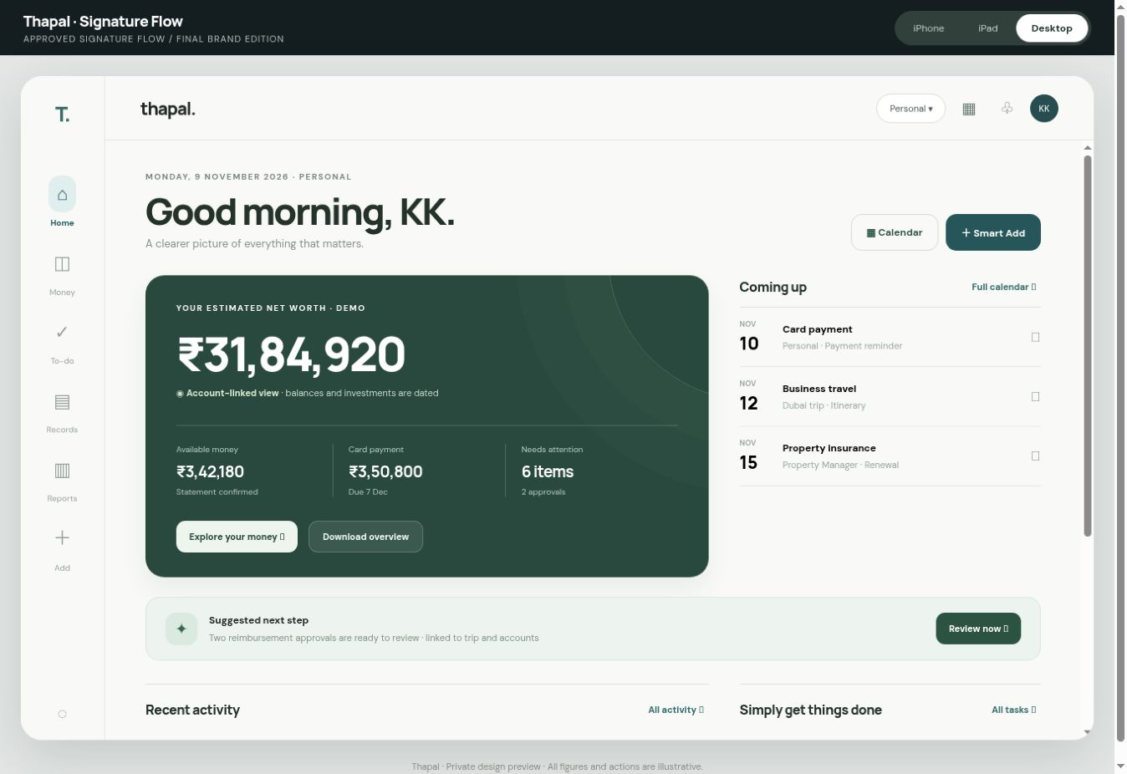
Figure 1 — Desktop Home, approved Signature Flow prototype
Figure 1 — Desktop Home, approved Signature Flow prototype. Exact capture from the separate Signature Flow prototype, with demonstration values. It is a visual reference, not proof that the production workflow is functioning.
Reproduce the approved Signature Flow appearance and the natural Flow interaction model faithfully, then implement the full Thapal system underneath it. This document is the UIX contract, navigation specification, interaction map, and test plan. It is not permission to alter production data or deploy a release. Do not redesign the accepted look; do not substitute a generic dashboard, card grid, accounting ERP, or another theme. Show working previews at iPhone, iPad, and desktop sizes throughout development. No functionality is accepted because it merely looks clickable.
Design source of truth: private interactive concept https://ledgerline-signature-flow.alertcabin20.chatgpt.site (legacy preview URL, now displaying Thapal). The concept is a design study with illustrative figures and local-only actions. ledgerline.biz is the existing live product under its prior name; do not overwrite it, replace its data, alter its authentication, or publish new code without explicit approval. Obtain read access to the current codebase and inspect existing components before changing anything. Preserve the existing Statement Desk and confirmed accounting rules.
Non-negotiable outcome: an exceptionally polished, approachable financial companion usable by a person who is not an accountant, while still preserving correct source-linked books, permissions, explanations, exports, and an audit trail. The app should feel calm, intelligent, responsive and quietly premium. The visual language is Apple-inspired, never an imitation of Apple’s protected assets.

2. Authority and traceability
The following are distinct and must not be conflated:
- Approved visual direction: Signature Flow, 10/10 preference.
- Observed prototype behavior: navigation, selected module screens, illustrative Smart Add steps, tabs, search suggestions, device preview toggles.
- Required production behavior: the detailed implementation specification below; this is a target, not a claim about completed code.
- Unresolved implementation decisions: final vector artwork production and licensing, fonts licensing, live feeds, regional statutory templates, external integration credentials, production release approval and device verification. The name Thapal and minimalist Option 02 logo direction are selected.
Capture screenshots and interaction recordings of the reference at desktop, iPad and iPhone; freeze them in the design QA baseline. Record the exact source commit, deployment, browser and date in each comparison. Do not treat demo numbers, fictional dates, account suffixes or examples as real records.

3. Visual system and tokens

3.1 Identity
The Signature Flow visual identity combines the restrained editorial quality of Signature Edition with Flow’s reassuring hierarchy, guided next action, universal search and direct navigation. The final approved product name is Thapal—always capital T, lowercase hapal, without a trailing full stop in the wordmark. The chosen logo direction is Option 02: a minimal single-stroke capital T symbol paired with a clean, contemporary Thapal wordmark. Use deep forest ink, restrained typography, exact optical alignment, and excellent readability from a small app icon to a desktop header. No stacked-paper motif, interwoven symbol, ornamental frame, decorative ligature, complex emblem, gradient or shadow. The symbol’s final vector curves, kerning, clear-space and small-size optical compensation require design QA before release. Apply this consistently to the sign-in screen, navigation, app icon, document titles, reports, notification sender, mobile app name, metadata, onboarding and help content. This is a design and naming decision, not a verified trademark or domain clearance. No heavy gradients, ornamental illustrations, glowing cards, neon finance colors or noisy colored glyphs.

3.1.1 Final logo production contract
- Approved direction: Option 02, minimalist T plus modern sans-serif Thapal. Do not reopen creative directions without KK’s instruction.
- Capitalization: always Thapal in UI, reports, email subject lines, notifications, document footers, metadata, app store copy and legal-facing product references. Never thapal, THAPAL, Thapal. or T. as the full name. The standalone app-icon symbol may be a simple T.
- Master artwork: deliver original editable SVG/vector outlines and editable text-layout source, with dark-on-light, light-on-dark, monochrome and icon-only exports. Verify exact spelling, licensed typeface and legibility at 16, 24, 32, 48 and 128 px.
- Placement: the symbol may appear in the rail/app icon; the wordmark appears in the top bar and sign-in screen. Keep baseline, cap height, clear space and sizes consistent across devices. Do not invent a tagline.
- Acceptance: compare the final artwork in the real Signature Flow header at iPhone, iPad and desktop widths, plus splash/sign-in, notification icon and reports. No clipping or visual overpowering of the content. Any non-trivial logo refinements require KK review before production.

3.2 Reference palette
The prototype CSS contains these reference values. These are starting tokens to be normalized and tested, not a claim that every screen already uses them perfectly.
Token | Reference | Application
Ink | #222923 | Primary text and icon strokes
Muted | #778178 | Support text and secondary labels
Soft | #F5F5F0 | Quiet secondary surfaces
Line | #E7E8E1 | Hairlines and row separation
Deep | #223B35 | Premium primary actions and emphasis
Mint | #D3E8DC | Rare positive or contextual accents
Copper | #AD7756 | Restrained warm brand detail
App canvas | #FBFBF8 | Main content background
Preview surround | #E7E9E5 | Prototype frame only; not the actual mobile app chrome

3.3 Design rules
- Use a systematic 4-point spacing grid: 4, 8, 12, 16, 20, 24, 32, 40, 48 and 64. Default desktop page inset 32–40 px, tablet 24–32 px, iPhone 16–20 px, adapted for safe areas.
- Large editorial welcome heading, restrained uppercase overline, one prominent financial number, supporting metrics, thin separators, mostly flat rows and selective soft surfaces.
- Set font family by a confirmed licensed web-safe/system stack. Prototype uses Manrope in places; document the chosen production families and loading fallbacks. Use tabular numerals for money; align currency and decimal precision consistently. Support Tamil and Hindi fallback glyphs where enabled.
- Define text roles: hero 36–44 px desktop / 28–34 px phone, page title 26–32 / 24–28, section title 17–20, body 14–16, support 12–14, overline 10–12. These are design targets; tune against reference captures and accessibility zoom.
- Minimum ordinary touch target 44 × 44 CSS px, visible keyboard focus, contrast at least WCAG AA for normal text, semantic controls, reduced-motion support, readable 200% zoom and dynamic text sizing.
- Icons must be one coherent outline family in consistent 20/24 px optical boxes with accessible labels. Replace placeholder Unicode symbols in production with licensed, consistent vector icons. The specific user-facing meaning must never rely on color alone.
- Use restrained 160–240 ms motion for direct manipulations and 240–320 ms for panels. No unnecessary animation; honor prefers-reduced-motion.
- Avoid giant nested cards. Use typography, space, subtle lines and occasional muted backgrounds to establish hierarchy. Avoid decorative boxes around every number.
- Maintain logical visual rhythm: back controls, title, description, filters, content, secondary links, bottom safe-area spacing. Keep actions in the same relative place across similar modules.

4. Device-specific composition
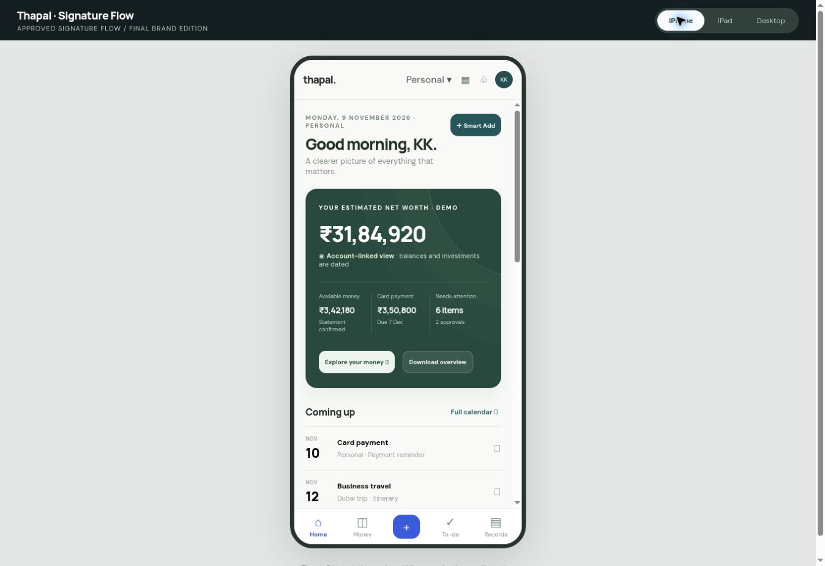
Figure 2 — iPhone-mode Home, actual prototype simulation
Figure 2 — iPhone-mode Home, actual prototype simulation. Exact capture from the separate Signature Flow prototype, with demonstration values. It is a visual reference, not proof that the production workflow is functioning.
Dimension | iPhone | iPad | Desktop
Primary navigation | Persistent 5-item bottom navigation: Home, Money, Add, To-do, Records; Reports and deeper modules reached by search, contextual links and More/Records index | Adaptive sidebar or split navigation; selected detail remains visible beside list | Slim persistent left rail, visible context/header and wide content pane
Primary action | Center Add remains immediately available, outside keyboard overlap | Add button in header/rail and contextual actions | Add in rail/header and contextual content
Content | One meaningful column; no horizontal scroll; safe-area insets | Two columns where valuable, three only when legible | Two-column editorial Home and contextual panels; maximum readable widths
Home hierarchy | Greeting, net-worth headline, next action, metric stack, upcoming, activity, quick links | Greeting + net worth across width; next step beside activity/calendar | Signature wealth summary, Coming up, single priority and quiet lists
Lists | Full-width tap rows, large hit targets, detail pushed full-screen | List/detail split, persistent selection | Spacious list/detail or content panel
Smart Add | Full-height sheet with camera/files, sticky next action, accessible dismissal | Modal/split sheet showing original and extracted data | Wide original-vs-intelligent-fields canvas
Search | Full-screen command search, keyboard opens only after user taps search | Overlay/palette, result grouping | Command palette with keyboard shortcut and contextual quick results
On iPhone test compact and large widths including 320, 375, 390, 430 CSS px and landscape; real physical iPhone Safari must be tested. On iPad test 768, 820, 1024, 1180 widths, portrait/landscape and Split View. On desktop test 1280, 1440, 1728 and narrow resizable windows. Breakpoints are implementation details; content usability is the acceptance criterion. Do not simply scale down a desktop mockup.

5. Navigation architecture

5.1 Global navigation
Primary destinations: Home, Money, To-do, Records, Reports. Global utilities: Smart Add, Calendar, Notifications, Search, Workspace switcher, Profile/Settings, Help. On iPhone Reports may sit under Records/More but must remain reachable within two clear taps from Home. A user can search by person, merchant, amount, document, trip, company, asset, property or report. Show results grouped by domain, with source and workspace labels.
Back behavior: every module and detail has a predictable Back control that returns to the prior location with scroll/filter preserved. Breadcrumbs on desktop/iPad are compact and accurate to the real navigation path; do not show Home > detail when the user actually came from Reports. Browser back/forward and deep links must work. Closing a modal returns focus to its opening control and must not erase unsaved work silently.
Workspace switcher: Personal, Family, Company, Trust, plus configured organizations. Always display the active workspace and permissions. Changing it refreshes all relevant data; never leak data across workspaces. Optionally allow a combined authorized personal overview but label entity ownership for every value. A user with multiple companies can select individual company, entity group or approved consolidated view.

5.2 Canonical route map
Top route | Children and deep links
/home | Next action, Money overview, calendar item, activity detail, Smart Add, universal search
/money | Accounts, bank account, credit card, transfers, payments, loans, cash, investments, net worth, reconciliation
/tasks | Inbox, Smart Review, approvals, missing sources, reconciliation exceptions, reminders, review history
/records | DocuRepo, Statement Desk, expenses, transactions, Travel, Reimbursements, Assets, Property, Investments, entities/projects
/reports | Catalogue, builder, filters, previews, export jobs, download history and evidence packs
/calendar | Month/agenda, item detail, source record, reminders, linked external calendar
/notifications | Activity, grouped alerts, actions, preferences
/add | Smart Add → Intelligent Canvas → source confirmation → Statement Desk authoritative intake → linked result
/search | Global results → authorized record/detail/command
/settings | Profile, workspaces, organizations, bank/payment methods, integrations, roles, security, accessibility, language, exports
Every child route needs loading, empty, populated, error, unauthorized, stale data, offline, unsaved draft, and success states where applicable. For every deep link, breadcrumbs and return target must be correct.

6. Complete screen inventory and contracts
Each numbered screen below is required. Claude must produce a screen-by-screen implementation checklist, not merely create the five navigation tabs. Individual subpages may share reusable templates but must still have purposeful fields, states and actions. Every displayed figure links to its authoritative source, has a valuation/as-of date where needed and does not imply false accuracy.
Total coverage: 111 explicitly identified screens or functional subpages across 11 areas. This is a traceability inventory, not a proposal to clutter the navigation with 111 menu entries. Claude must map each ID to a route or purposeful modal/panel, a reusable layout archetype, an authoritative data source, the allowed actions, empty/error/review states, a responsive screenshot and its end-to-end tests. Every ID must be marked Implemented, Partial, Missing, Blocked or Not applicable with evidence; none may be silently omitted.
Area | Screen IDs | Count | Main visual / interaction pattern
Onboarding and access | A01–A06 | 6 | Calm step-based setup; original vs extracted documents; progress and recovery
Home and universal | B01–B08 | 8 | Editorial Home, global search, calendar, notifications, workspace context
Money and accounts | C01–C12 | 12 | Account-first index/detail, transaction evidence, money and liabilities
Inbox and Statement Desk | D01–D10 | 10 | Attention queue, source-vs-parsed comparison, match and exception review
Expenses and Smart Add | E01–E11 | 11 | Full source-visible Intelligent Canvas and draft-to-confirmation journey
DocuRepo and organizations | F01–F09 | 9 | Document viewer, relationship panel, entity master and projects
Travel and reimbursements | G01–G11 | 11 | Trip tabs, itinerary versus finance status, claim and settlement
Investments | H01–H08 | 8 | Holdings lists, dated prices, tax lots, net-worth composition
Assets and property | I01–I10 | 10 | Registers, property detail, ownership and valuation paths
Reports and statutory | J01–J14 | 14 | Scope builder, preview, background export, professional close
Settings and trust | K01–K12 | 12 | Plain-language settings, integration health, scoped roles and recovery
Total | A01–K12 | 111 | Each screen receives desktop, iPad and iPhone acceptance evidence

A. Onboarding and access
A01 Welcome and Sign in. Clean brand mark, Google sign-in, secure session states, terms/privacy links, account recovery; no intrusive marketing. A02 Workspace setup. Select personal, family, organization or trust; add organization by uploading registration documents; extracted values previewed and confirmed with cited document fields. A03 Invite and access. Owner, member, preparer, reviewer, verified accountant, auditor read-only; invitation, expiration, revocation, grants and role explanation. A04 Setup progress. Import sources, confirm account ownership, choose accounting period, unfinished setup recovery. A05 Opening balances. Source-backed schedules, validation and unresolved opening differences. A06 Welcome tour. Short optional, skippable, never blocks core work.

B. Home and universal tools
B01 Home: Signature header and personalized greeting; estimated net worth with as-of label; cash, investments, cards, pending counts; priority/next best action; upcoming events; recent transactions; quiet shortcuts to Statement Desk, Travel, Records and Reports. B02 Global search: category-grouped results, recent records, natural-language query and direct routes; keyboard activation intentional. B03 Calendar month and agenda: due dates, premiums, subscriptions, trips, document expiry, approvals, tax deadlines, loan EMIs and property events; each event opens its linked source. B04 Calendar item: details, owner, source, reminder schedule, recurrence, snooze and external calendar sync status. B05 Notifications center: grouped actionable notices, severity, unread/read, mark all, snooze, thresholds and destination. B06 Notification preferences: per type/channel/workspace and quiet hours. B07 Workspace selector: account/entity boundary, accessible switch and confirmation of unsaved work. B08 Global command/help: Find anything, voice-to-text with transcription review, context help and shortcut discovery.

C. Money, accounts and financial operations
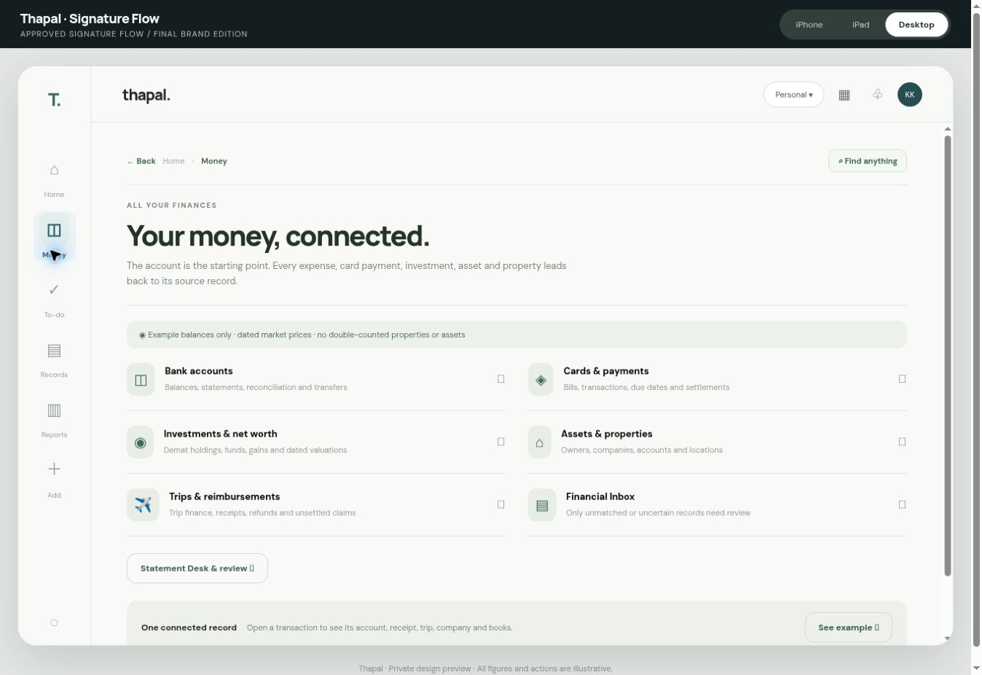
Figure 3 — Money hub and account entry points
Figure 3 — Money hub and account entry points. Exact capture from the separate Signature Flow prototype, with demonstration values. It is a visual reference, not proof that the production workflow is functioning.
C01 Money overview: separate verified cash, cards, receivables/payables, loans, investments, assets and liabilities; net-worth calculation must avoid double counting. C02 Bank account index and C03 Bank account detail: masked identifiers, institution, account owner, source freshness, running balances, statement history, transaction list, reconciliation state and account reports. C04 Credit card index and C05 Card detail: statement cycle, posted vs pending, due date, minimum/total due, linked payments, unmatched items and installment details. C06 Transaction detail: source line, attachments, original amount/currency, classification, entity, merchant, linked invoice, trip/property/asset, audit history, split and reviewer decision. C07 Transfer and card payment review: from/to accounts, third-party distinction, duplicate protection, linked debit/credit, reversals and reconciliation; no fake expense on card payment. C08 Loans and EMIs: lender, liability, schedule, principal/interest breakdown, collateral, upcoming due and statements. C09 Cash and wallet accounts: opening balance, movements and reconciliation. C10 Net worth: dated composition, group/entity boundaries, pricing freshness and transparent inclusions/exclusions. C11 Recurring payment manager: detection, confirmation, future cash requirements, reminders and cancellations. C12 Account settings: owner/company mapping, permissions, sync, historical import, currency and export.

D. Financial Inbox and Statement Desk
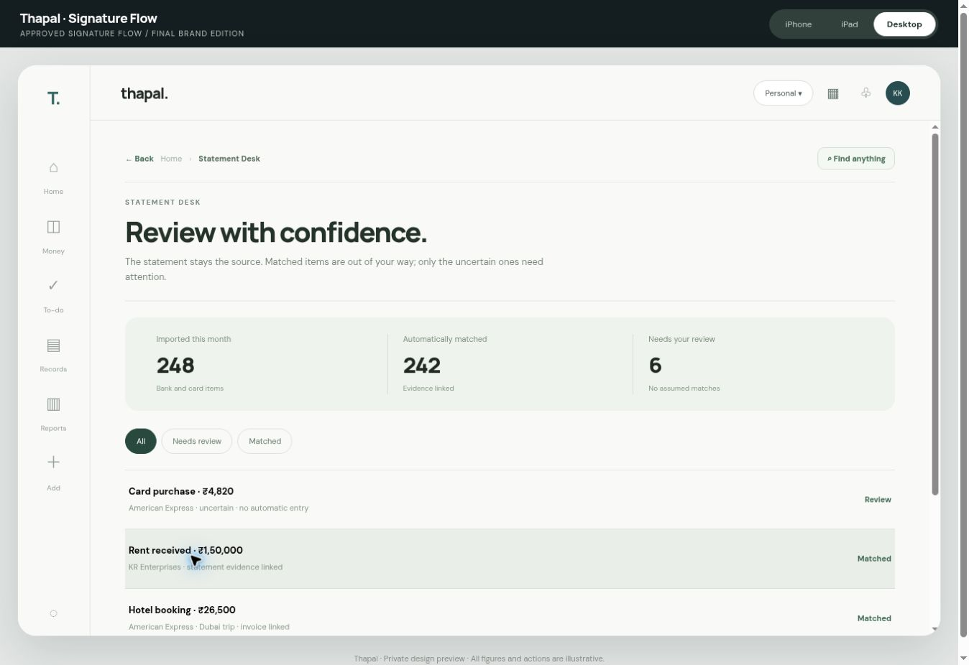
Figure 4 — Statement Desk review entrance
Figure 4 — Statement Desk review entrance. Exact capture from the separate Signature Flow prototype, with demonstration values. It is a visual reference, not proof that the production workflow is functioning.
D01 Financial Inbox overview: grouped pending action by workspace, account, entity and importance, not an unbounded raw import list. D02 Smart Review: review queues with bulk select and select all within explicit scope; confidence and source reasons, safe approve/reject/undo. D03 Statement Desk intake: preserve the existing authoritative statement-centric entry model. Upload PDF/CSV/XLSX/image statement, choose/create account, detect source period, show extracted lines and balances, deduplicate, then stage. D04 Statement comparison: original document visibly beside parsed lines; opening/closing balance proof, chronology, running totals, missing lines, currency and duplicates. D05 Match suggestions: possible invoice/bill/receipt/transfer matches, confidence and reason, no reuse of a single invoice for duplicate debits, no forced match of partial payments. D06 Account reconciliation: opening + credits – debits = closing, differences, bank fees/interest, source gap and independent check. D07 Transfers and Card Payments queue: precise two-sided linking and third-party exceptions. D08 Review history: who changed what, before/after, evidence, time and undoability. D09 Background job progress: imports survive navigation/reload; resumable, retryable and cancellable where safe; never pretend work completed. D10 Exception resolution: missing statement, suspicious duplicate, unclear merchant, partial payment, unmatched invoice, unauthorized import and conflicting owner.

E. Expenses and intelligent intake
E01 Universal Expense entry: Smart Add or optional accessible quick correction, not an accountant-heavy form; voice, photo, upload, email-forward and share sheet when supported. E02 Smart Add source selection: choose file/camera/voice/drag-and-drop, batch indicator, supported formats, clear privacy notice. E03 Intelligent Canvas extraction: original source permanently visible, suggested vendor, amount, date, taxes, currency, payment account, category, entity, project/trip/property/asset, reimbursement and confidence. E04 Canvas exception/duplicate review: side-by-side evidence and candidate links; edit, split, defer, assign, reject, clear reason; user can inspect source field crop. E05 Canvas confirmation: explicit proposed changes, destination and effects; user approves only safe authorized actions. E06 Draft and processing history: where the file went, job status, corrections, failures, duplicate handling, and undo. E07 Expense list: fast search, filters, bulk category, grouped activity and download. E08 Expense detail: original evidence and all accounting links. E09 Income/receipt detail: bank source, payer, invoice and tax status. E10 Merchant/category rules: suggestion review, history, merge preview and undo. E11 Splits and multi-currency: allocation by amount/percentage, precision, exchange source/date and stale exchange flag.

F. Documents and organizations
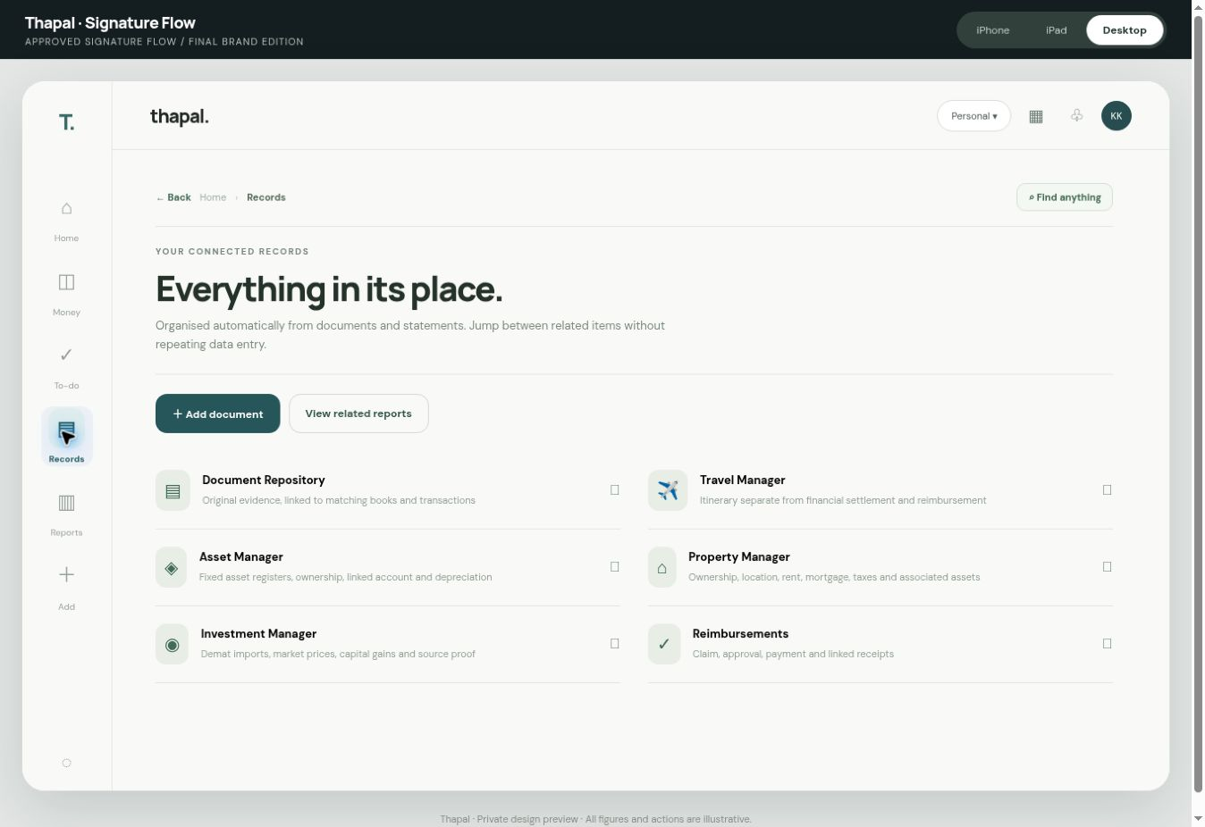
Figure 5 — Records, the repository entry point
Figure 5 — Records, the repository entry point. Exact capture from the separate Signature Flow prototype, with demonstration values. It is a visual reference, not proof that the production workflow is functioning.
F01 DocuRepo index: folder-free search plus filters by entity, record type, date, ownership and expiry. F02 Document viewer: PDF/image/spreadsheet preview, extracted text, source metadata, versions, access, linked records and immutable original. F03 Document relationship view: one source to accounts, expenses, trips, assets, property, accounting entries, report and audit trail. F04 Document requests: missing evidence request, assignee, due date and permission. F05 Documents lifecycle: replacement, superseding, retention, deletion permission and audit. F06 Company/entity index: group relationships, legal identity, tax registration, owners and mapping. F07 Company profile: document extraction, legal names, period, bank accounts, staff roles, statutory status and contacts. F08 Projects/activities: linked expenses, budget, reimbursement and detailed statement. F09 Contact/merchant directory: deduplicated and ownership scoped.

G. Travel and reimbursements
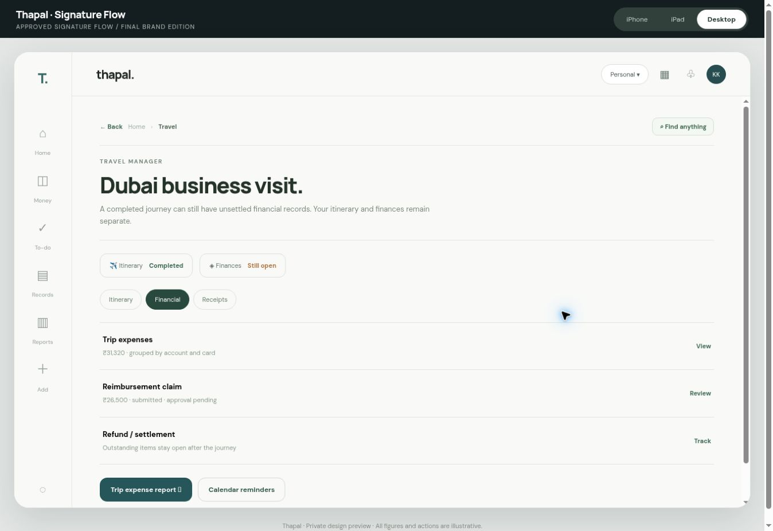
Figure 6 — Travel workspace
Figure 6 — Travel workspace. Exact capture from the separate Signature Flow prototype, with demonstration values. It is a visual reference, not proof that the production workflow is functioning.
G01 Travel Manager index: trips grouped by upcoming, active, completed, with independent financial status. G02 Trip overview: destination, dates, purpose, travelers, owning workspace, itinerary status and financial settlement status. G03 Itinerary: flights, accommodation, transport, meetings, documents, schedule and calendar. G04 Trip budget: planned vs committed vs spent, by currency/entity/account; compact, never double count credit card payment. G05 Trip expenses: source-linked payments, allocations and account/card filters. G06 Travel receipts: original invoices and booking proof. G07 Reimbursement claim: original expense reference, policy, claimant, submitted/approved/paid status. G08 Approval and payment: who can approve, separation of duties, bank settlement and partial payment. G09 Refund and trip closing: track cancellations, refunds, open card settlements and outstanding claims independently of completed itinerary. G10 Trip report and evidence: detailed expenditure statement, traveler/role, company, account, dates, currency, settlement and PDFs/CSV/XLSX. G11 Trip collaborator settings: roles, privacy, approvals and change log.

H. Investments and net worth
H01 Portfolio overview: holdings by demat/provider, asset class and owner. H02 Import statements: ICICI Direct and other supported brokers, equities, mutual funds, gold, distributions, corporate actions and opening holdings. H03 Holding detail: units, cost lots, transactions, market price/as-of, income, realized/unrealized gain, evidence and stale-data badge. H04 Valuation history: authoritative, licensed/available feed, provider provenance and last update; never invent ‘live’ when delayed/stale. H05 Capital gains and corporate actions: splits, bonuses, dividends, transfers and tax lots. H06 Manual market-rate fallback: explicit manual source and stale indicator. H07 Net worth reconciliation: bank + investments + property/asset ownership + liabilities with consolidation adjustments and no duplicate asset book-value/market-value inclusion. H08 Portfolio reports: positions, holdings, flows, realized gains and source pack.

I. Assets and property
I01 Asset register: entity, classification, code, acquisition date, cost, funding account, location, custodian and status. I02 Asset detail: invoices, ownership, depreciation method/life, accumulated depreciation, impairment, maintenance, transfers and disposal. I03 Asset import review: Excel/PDF register extraction, duplicate detection and approval. I04 Depreciation working: books vs tax methods, dates, reversals and change history. I05 Asset disposal/transfer: gain/loss, buyer, sale evidence, account settlement and no silent deletes. I06 Property index: owner, property, group, rental/operating status. I07 Property detail: deed, acquisition/funding, valuation date, linked loan, rent receipts, tenants, occupancy, insurance, tax and maintenance. I08 Property cash flow: rent, expenses, dues, loan and account reconciliation. I09 Property calendar: renewal, tenancy, tax, insurance and compliance. I10 Asset/property relationship: associated equipment mapped to buildings without double counting the property plus component assets.

J. Reports, tax and statutory work
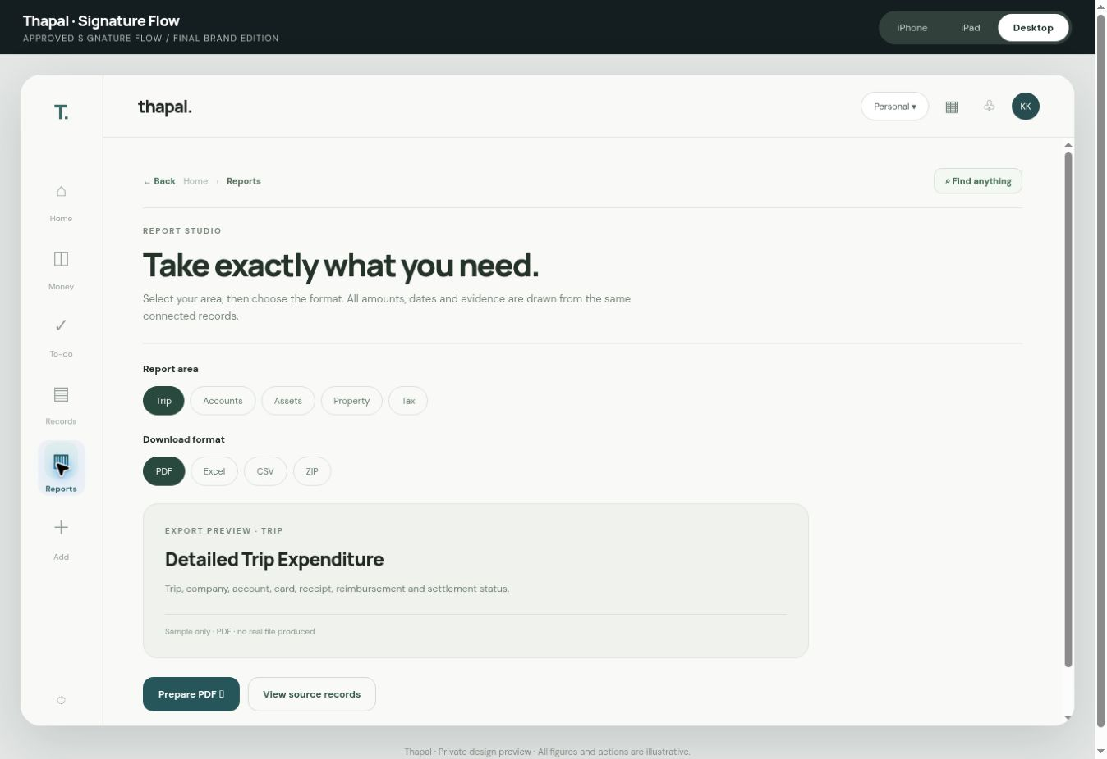
Figure 7 — Reports entry point
Figure 7 — Reports entry point. Exact capture from the separate Signature Flow prototype, with demonstration values. It is a visual reference, not proof that the production workflow is functioning.
J01 Report studio: discover via global search, entity/account/trip/property/period selectors and saved configurations. J02 Report preview: clear scope, totals, source links, provisional badges and validation status. J03 Export dialog: PDF/XLSX/CSV/ZIP, date range, currency, entity, included evidence and redaction. J04 Export jobs and history: background generation, retry, completed download integrity/hash, access and expiry. J05 Personal reports: cash flow, spending, income, budget, debts, recurring, net worth, investments and tax prep. J06 Business books: general ledger, trial balance, balance sheet, P&L, cash flow, journal, vouchers and period close. J07 Account reports: statements, reconciliation, credit card and outstanding. J08 Expenses/projects/travel: detailed expenditure, budget variance, reimbursement settlement and evidence. J09 Assets/property/investments: registers, depreciation, rental statements, gains, holdings, valuations and source packs. J10 Tax working center: statutory calendar, classification, drafts, source-linked schedules, professional review and sign-off. J11 India-specific reporting templates: GST, TDS/TCS, income tax and Companies Act as applicable to each entity, period and currently verified rules. J12 Malaysia/multi-jurisdiction scope: activate only for entities with applicable profiles; rules and formats must be verified separately. J13 Period close and audit readiness: reconcile, unresolved exceptions, opening schedules, accruals/prepayments, reversals, lock/unlock permissions and evidence pack. J14 Regulatory monitor: provenance, effective date, change log and professional-approval gates. Never auto-file or claim regulatory conformity without a verified template and approval.

K. Settings, integrations and trust
K01 Settings home: clear categories, account/workspace context. K02 Accounts and payment methods: linked account management, import permissions and mapping. K03 Organization and ownership: company group, personal/family/trust, relationships, accounting period and currency. K04 Roles and accountant grants: invitation, identity recheck, scoped access, expiry, revoke and full log. K05 Integrations: bank feeds, demat, document storage, email, calendars, notifications, WhatsApp/share sheet where permitted, with connection health and graceful fallback. K06 Import and automation rules: explain/approve merchant classifications, recurrence and matching thresholds. K07 Accessibility and language: font sizing, contrast, reduced motion, language and voice entry. K08 Security: Google sign-in, sessions, MFA where supported, revocation and activity. K09 Data and recovery: export, backups, restore drills, deleted-document recovery, retention and legal holds. K10 Release/version information: environment, build, service health and known limitations. K11 Support/help: plain-English glossary, context help, error reporting and guided recovery. K12 Privacy and consent: sensitive document handling, scopes, audit history and deletion policy.

7. Core cross-module data connections
Source / event | Authoritative destination | Linked surfaces | Guardrails
Bank/card statement line | Statement Desk, account ledger | Money, Inbox, transaction, reconciliation, Reports | Independent balance proof, dedupe, no invented match
Receipt / bill / invoice | DocuRepo original + staged expense/invoice | Intelligent Canvas, account, trip, project, asset/property, tax, reports | Source immutable, edits versioned, no unapproved posting
Card payment / internal transfer | Linked debit and credit across accounts | Card dues, Money, reconciliation, cash flow | No double count as spending; third-party distinction
Travel booking | Trip itinerary record | Calendar, Docs, trip expense only when payable/posted | Itinerary completion ≠ financial settlement
Reimbursement | Claim linked to exact incurred expense | Approval, payable, bank settlement, report | No duplicate expense; role checks
Demat statement / market price | Investment lots and valuation service | Investments, net worth, gains, reports | Dated prices, provenance, stale flag
Company documents | Entity master + DocuRepo | Settings, accounts, tax, reports, permissions | Extract + confirm; entity boundary enforced
Asset/property acquisition | Fixed asset/property ledger + source | Money, loans, depreciation, locations, net worth | Ownership, valuation basis, consolidation safeguards
Reminder/deadline | Calendar event with source ID | Home, Notifications, account/trip/property/tax | Deep link, recurrence, timezone, notification choice
Period close | Ledger snapshot + linked evidence | Reports, auditor, reconciliation, recovery | Approval, lock, audit trail, restore test
All records require stable IDs, entity and workspace ID, owner/permissions, source document IDs, account IDs when applicable, timestamps, status, version and actor. Preserve transaction-level provenance across imports and corrections. Build one canonical financial calculation layer; never calculate Home, report and detail totals separately. Use idempotency keys for imports, payment matching, exports and background jobs.

8. Complete interaction flows

Flow 1 — First-time setup with document extraction
Sign in → select/create workspace → upload company registration / identity and bank sources → OCR and extraction → show originals alongside suggested fields → user confirms or corrects → create organization and account mappings → import opening schedules → run validation → show Setup complete only when authoritative records meet requirements → Home with source freshness. No compulsory manual retyping where a document contains a reliable value; always allow safe correction and exceptions.

Flow 2 — Daily financial review
Home priority → To-do → Financial Inbox → Statement Desk → select account and period → compare original lines with parsed transactions → see matched/unmatched → inspect possible duplicates and partial payments → approve a valid match or leave unresolved → account reconciliation → updated Money totals → Review History. A duplicate bank debit cannot reuse an invoice; a short payment remains partially outstanding; unmatched charges stay exceptions.

Flow 3 — Smart Add and Intelligent Canvas
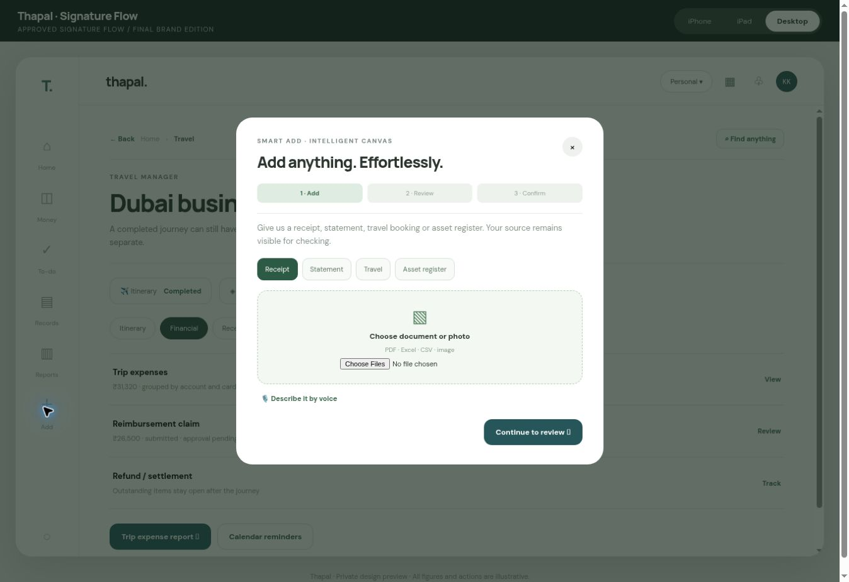
Figure 8 — Add source
Figure 8 — Add source. Exact capture from the separate Signature Flow prototype, with demonstration values. It is a visual reference, not proof that the production workflow is functioning.
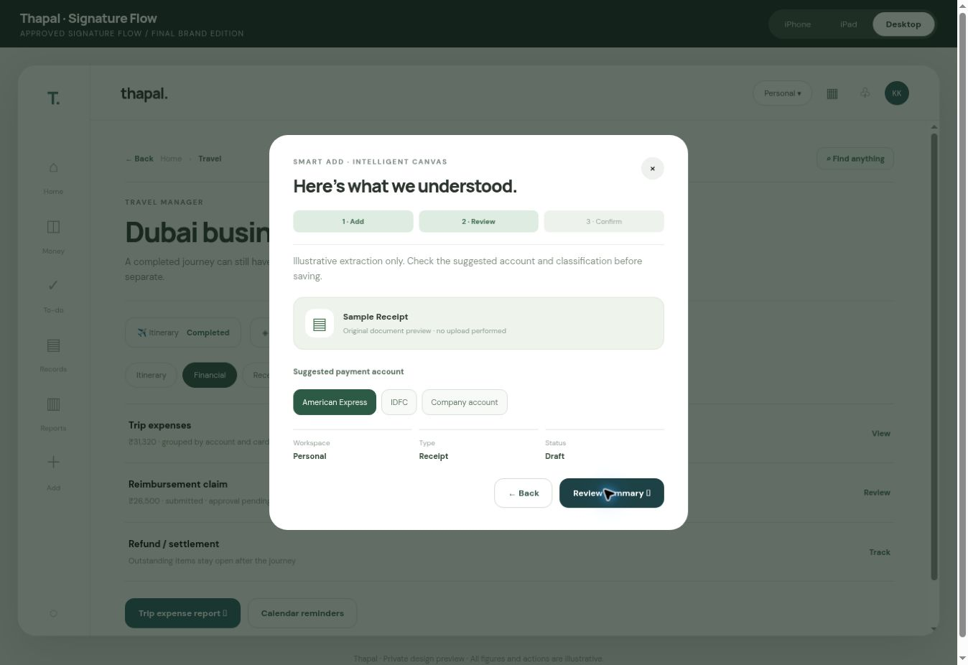
Figure 9 — Review source
Figure 9 — Review source. Exact capture from the separate Signature Flow prototype, with demonstration values. It is a visual reference, not proof that the production workflow is functioning.
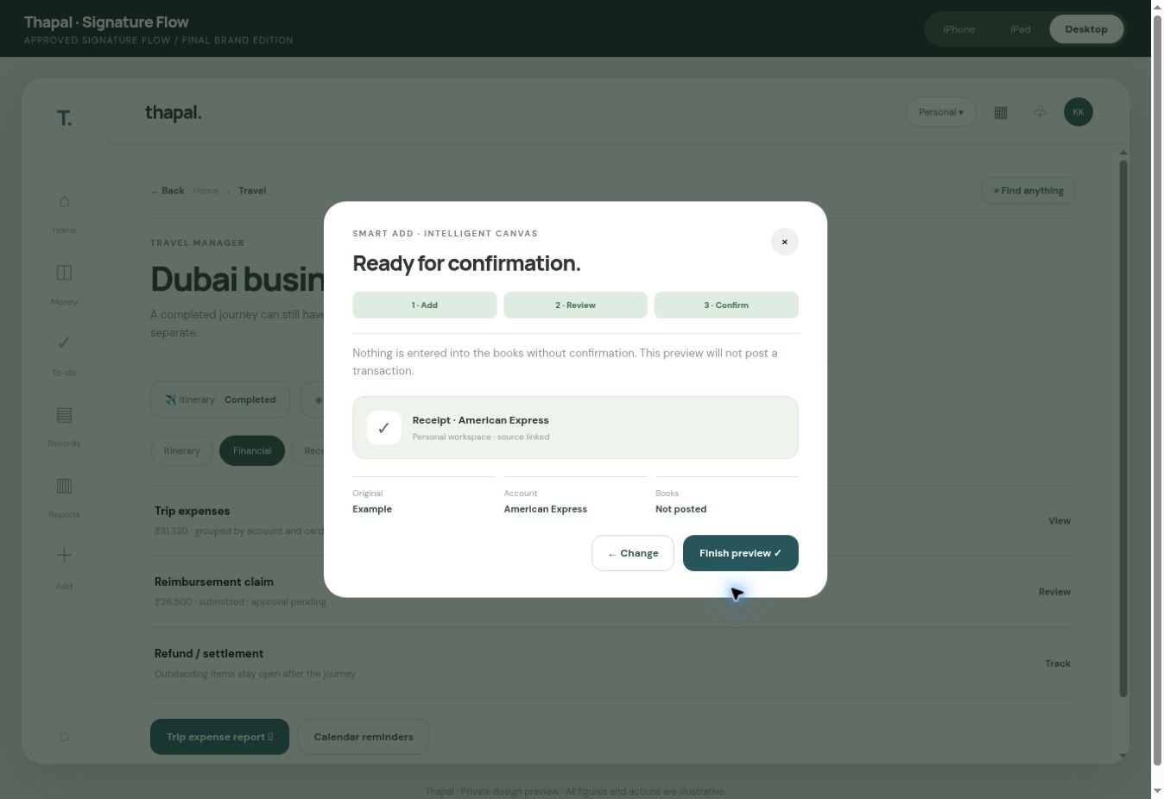
Figure 10 — Confirm proposed action
Figure 10 — Confirm proposed action. Exact capture from the separate Signature Flow prototype, with demonstration values. It is a visual reference, not proof that the production workflow is functioning.
Any module Add button → choose source (camera, Files, share sheet, voice, drag-drop) → local preview and upload/progress → document classification → extracted fields with clickable source evidence → account/entity/trip/project suggestions → duplicate and currency checks → user correction or defer → explicit confirmation with effect (draft, link, post only if authorized) → authoritative Statement Desk intake if it contains statement lines → source-linked receipt/expense and review history → return to originating context. If OCR uncertain, never fake a field. If offline, queue visibly and reconcile after connection. A long upload remains recoverable after navigation. Record canceled/rejected drafts without contaminating books.

Flow 4 — Travel lifecycle
Records → Travel → new trip from booking → itinerary/calendar → estimated budget → link receipts and card/bank lines → allocate to company/project → submit reimbursement → approve/pay claim → await refund/card settlement → detailed expenditure report and evidence ZIP → mark finance complete independently. Trip completion must never silently close pending refunds or claims.

Flow 5 — Assets, property and net worth
Upload purchase deed/invoice/register → extract owner, location, acquisition amount and account → reconcile payment and depreciation rules → attach asset to property if relevant → valuation with date/source → net-worth inclusion review → report. If a piece of equipment is embedded in property value, the consolidation rule must prevent counting both market/property value and the same component separately.

Flow 6 — Investment import and valuation
Upload demat statement → parse holdings and tax lots → reconcile opening/closing quantity and cash transactions → source-linked portfolio → refresh permitted market data with timestamp → stale/unavailable badge when necessary → net-worth summary and report. Never say ‘live’ merely because a prior close is displayed.

Flow 7 — Reports and period close
Enter Report Studio from source module or global menu → choose entity, account, date and format → preview scope and unresolved items → request export → background job progress → download and integrity verification → optionally include evidence pack → accountant reviews tax/period-close schedules → controlled sign-off/lock. An export failure keeps the job retryable; no fake success toast.

Flow 8 — Calendar and notifications
Account/trip/property/recurring payment creates due event → Home Coming up and Calendar show event → user taps date or notification → direct destination and relevant record → snooze/reschedule with permission → sync external calendar if authorized → clear sync status. Notification tap must not lead to a generic unrelated page.

Flow 9 — Permissions, recovery and continuity
Owner grants scoped accountant role → recipient verifies identity → sees authorized workspace and record only → action creates audit entry → owner revokes → access ceases across tabs and downloads. Interrupted upload/reconciliation/export resumes safely without duplication. Backups and restore are tested in isolated environment before release.

9. Screen-level states and writing tone
For all screens build skeleton loading, successful loading, empty state with next useful action, partial/stale data, offline, permission denied, recoverable error, irrecoverable failure, and saved draft when relevant. Use plain-English labels: “Needs your review”, “Matched to statement”, “Couldn’t read this line”, “Choose an account”, “Saved as a draft”. Keep technical accounting vocabulary behind accessible explanation; do not hide professional detail from accountants. Never use “100% accurate”, “guaranteed”, “all done”, or “live” unless evidence supports it.
Money formatting: Indian digit grouping for INR; local currency symbol, ISO code when ambiguity exists; negatives, zero and refunds visually clear; never truncate important decimals. Distinguish balances, dues, available cash, investments, asset values, liabilities, cash flow and net worth. Use consistent success/warning/error treatments with text and icons. Every source-derived displayed value needs an as-of/source state.

10. Acceptance testing matrix
These are mandatory release tests, not proof they already passed. Each test must have an ID, device/browser, steps, expected result, actual result, screenshot/video, build, owner and resolution. No severity 1 or 2 defects at approval. Test on production-like anonymized seed fixtures; no live financial changes.
ID | Journey / quality gate | Required result
UX01 | Visual comparison on every screen | Typography, spacing, alignment, icon family, colors and hierarchy match approved baseline within documented tolerance
UX02 | iPhone narrow/large and real Safari | No clipping, horizontal scrolling, keyboard overlap or obstructed actions; safe area and dynamic type correct
UX03 | iPad portrait, landscape and Split View | Purposeful split layout, no desktop squeeze, controlled overflow
UX04 | Desktop keyboard navigation | Full focus order, visible focus, Enter/Escape, browser back, deep links and screen-reader labels
UX05 | Reduced motion / contrast / 200% zoom | Usable without motion, readable, no hidden controls
NAV01 | Every primary and secondary route | Correct entry, destination, breadcrumbs, Back and preserved filters/scroll
NAV02 | Global search | Finds modules and records without cross-workspace leakage; handles zero results and stale data
NAV03 | Workspace switching | Correct data scope, totals refresh and unsaved-work warning
ADD01 | Single receipt through Smart Add | Preview, extraction, correction, account/entity linking, source preservation, confirmation and correct final state
ADD02 | Batch PDF, photo, CSV and XLSX | Formats classified, individual failures recoverable, duplicates caught
ADD03 | Cancel, close, Escape and resume | No orphan modal, data loss or accidental posting; opening control regains focus
ADD04 | Voice-to-text and correction | Consent, transcript preview, correction, appropriate fallbacks and no false recording claim
STM01 | Independent bank statement balance proof | Printed opening, credits, debits and closing reconcile without circular use of invoice data
STM02 | Duplicate debit and partial payment | Duplicate invoice match blocked; outstanding invoice balance maintained
STM03 | Missing bank fee/unmatched invoice | Both shown as unresolved exceptions, never invented
STM04 | Long-running import, reload and retry | Job persists and resumes without duplicate postings
FIN01 | Transfer and credit card settlement | Both account sides linked, no new spending counted for card payment
FIN02 | Net worth with properties and assets | No component duplication; valuation source/date visible
TRV01 | Completed itinerary, open finance | Reimbursement/refund/card balance remains open until settled
TRV02 | Trip reporting | Accounts, currencies, expenses, receipts and claims reconcile to source
INV01 | Demat upload and corporate actions | Holdings/units/cost lots reconcile; stale market data disclosed
RPT01 | PDF/XLSX/CSV/ZIP reports | Correct scope, formatting, totals, evidence and byte-integrity; jobs retry safely
TAX01 | Regulatory template and close | Current rule source, review status, professional approval and period lock enforced
SEC01 | Cross-workspace/role permissions | No unauthorized data/API/export access; revoked access terminates
SEC02 | Recovery and backup restore drill | Verifiable recovery with audit trail and no duplicate financial events
PERF01 | Home, Money, Inbox and Expenses | Target meaningful ready state ≤2 s in agreed network/device test profile
PERF02 | Statement Desk | Target meaningful ready state ≤2.5 s; long tasks explicitly backgrounded
REL01 | Preview vs intended release | Exact commit, tests, migration plan, rollback and deployment parity recorded

10.1 Prototype audit evidence and limits
Observed/checked in a previous interactive prototype QA pass: Home and Money navigation, non-Home Back/Find-anything control, Smart Add step 1 → step 2 → account selection (IDFC) → step 3, not-posted confirmation wording, and closing Smart Add. A close-control issue was found and repaired, then dismissal was retested. JavaScript syntax check passed on the acceptance overlay. This covers selected illustrative behaviors only. It is not a full iPhone-device test, accessibility audit, API test, real OCR test, export verification, bank reconciliation test or production security audit.
Static-source audit observations: source uses an inherited single-page prototype with screens overridden by several JS layers, placeholder Unicode icons, hard-coded sample totals/dates, demo notice() dialogs for certain actions and local-only file selection. Several modules use generic detail layouts. The production rebuild must consolidate overrides into clear components and real routes while preserving its appearance. Notable potential concerns to verify: a report action’s interpolated template text, modal dismissal and focus restoration beyond the specific close test, file-name rendering sanitization, semantic keyboard controls, actual responsive behavior on hardware and correct route history. Do not certify these as passed without fresh tests.

11. Engineering implementation instructions for Claude
- Audit before editing. Inventory routes/components/schema/services; compare to this matrix and earlier Thapal requirements, marking Done / Partial / Missing / Blocked with evidence. Identify user-modified code and preserve it. Do not replace Statement Desk, accounting history or permissions just to make the UI easier.
- Create the design system. Freeze tokens, typography, icons, common page header, sidebar, bottom nav, breadcrumbs, empty/loading/error states and modals. Use a component library that does not alter visual identity. Screenshot comparisons precede broader rollout.
- Implement all inventory pages. Build them in connected vertical slices: shell + Home → accounts/Statement Desk → Smart Add → travel/reimbursements → investments/assets/property → reports/close → settings/security. Reuse elements but do not leave blank placeholder screens.
- Bind authoritative records. Use stable entity/account/source IDs, server-side authorization and one calculation layer. Keep demo/mock fixtures in preview only. Every write records provenance and approval status.
- Separate safe automation from consequential approval. Automate extraction and suggestions; require explicit authorized confirmation for uncertain financial decisions, professional sign-off and statutory filing.
- Test every journey at each slice. Unit, integration, accessibility, visual regression and end-to-end tests must use seeded fixtures with adversarial cases. Maintain a defect log and screen-by-screen coverage report.
- Protect the current release. Development and QA in preview/staging. Database migrations reversible and backed up. Publish only after explicit KK approval with exact commit, release notes, screenshots, test evidence and rollback.

11.1 Required Claude output after each implementation cycle
- Screens built, changed and not touched; exact routes and preview link.
- Difference from the Signature Flow baseline with before/after iPhone, iPad and desktop captures.
- User journeys executed, counts of passing/failing tests and raw evidence paths.
- Source records connected, authorization checks and any synthetic/mock data still visible.
- Bugs fixed, known limitations, migration impact and rollback route.
- Current status by all screen IDs A01 through K12, plus blockers and next iteration.
- A clear separation between ‘implemented’, ‘automated test passed’, ‘physically device-tested’, ‘compliance reviewed’, and ‘approved for production’.

12. Approval and release gate
KK’s 10/10 is the approved aesthetic target. Production approval requires all critical journeys, all mandatory pages, iPhone experience, security and accounting correctness to be verified. Collect visual acceptance on actual iPhone, iPad and desktop; demonstrate Smart Add with real yet safe sample documents; demonstrate independent reconciliation, reports and roles; verify release parity. If any screen is absent or any figure unreliable, mark it not ready. Do not infer success from a passing unit-test count or a beautiful preview.
Final handoff instruction to Claude: “Build Thapal to this exact Signature Flow UIX specification, preserving the established live application’s source of truth. First return a screen/route/feature gap audit and a phased preview implementation plan; then implement and prove each journey. Do not deploy to production or touch live records without explicit approval. Never present mock interactions as completed functionality. Treat visual excellence, iPhone usability, provenance, auditability, accessibility, data correctness and recoverability as simultaneous acceptance conditions.”

13. Universal interaction anatomy for every page
The same page anatomy applies across the 111 screen IDs, with density adapted to device and role:
- Context: active legal entity or Personal/Family/Group context, page title, succinct explanation, provenance/as-of date.
- Orientation: Back returns to the precise originating page, selected tab, scroll position and filters. Deep links and browser Back work. Breadcrumbs appear when useful on larger screens; a simple labelled Back suffices on iPhone.
- Primary action: one meaningful next step; supporting actions live in a consistent action menu. Dangerous actions use an explicit confirmation and show financial consequences.
- Content: flat, readable rows, meaningful group headers, no stacked generic cards; labels understandable to a non-accountant.
- Source relationship: amounts open details; details open their source document and accounting entry where authorised; report values open the filtered underlying records.
- State: skeleton/loading, populated, empty with help, stale/partial, permission denied, offline, save pending, recoverable failure, blocked, completed and history. Do not show a success state before durable confirmation.
- Accessibility: logical focus, visible keyboard selection, announced live changes, 44px targets, 200% zoom, plain-language errors, reduced motion and language-aware rendering.

Shared components and exact behaviour
Component | Entry and response | Required edge cases
Workspace switcher | Personal, own family shares, companies, trusts, configured group; current scope visible at all times | Warn of unsaved draft; clear stale data, cache and search on switch; never leak former scope
Universal Search | User taps icon or uses shortcut; group permitted results by account, transaction, document, trip, person, property and report | Do not auto-open keyboard on unrelated screens; permission and empty results; query retained on Back
Calendar | Home icon opens month/agenda; event opens exact originating module record, not a dead generic event | Overdue, recurrence, multiple owners, all-day/time-zone, snooze, privacy of ICS titles
Notifications | Group by entity, due date and consequence; tap goes to source with a contextual action | Failed delivery, deduplication, read/unread sync, revoke, quiet hours
Global Add | One reusable camera/files/drag/drop/voice/share/email entry, all feeding Statement Desk | Batch, multi-page join, multi-document split, background resume, unsupported file, malware, duplicate
Intelligent Canvas | Original beside extracted data on wide screens, switchable source/data on phone | Field confidence, source crop, mixed currencies, edit/defer, offline, conflicting owner, cancel
List/detail | Select row; preserve filter and scroll; detail opens split pane on iPad/desktop and full page on iPhone | Very long values, multi-select/select-all scope, sorting, empty/error, responsive overflow
Safe action menu | View, edit draft, replace, split, link, duplicate check, share, export, cancel, delete where allowed | Posted history never erased; correction uses reversal; undo reason and audit log
Money amount | Tap opens account, event, posting, evidence, reconciliation, linked modules | Source date, stale estimated/confirmed status, negative/refund, exchange-rate precision
Export | Format, scope, source/evidence options, preview, durable progress and verified download | Retry, permission expiry, large file, checksum, redaction and data period

14. Module-to-module navigation and data relationship map
Each arrow represents both a useful navigation path and a record relationship, not an invitation to duplicate financial postings.
Starting view | Navigate to | What carries across | Return behaviour
Home net worth | Money → Net worth → Holding/account/property | Active scope and valuation-as-of | Back to Home at same scroll
Home next action | To-do → specific unresolved record | Workspace, task ID, account, priority | Return to same To-do selection
Bank transaction | Statement Desk → Source → Match → Expense/Invoice | Transaction ID, amount, account, confidence | Back to original bank row
Card payment | Card → transfer pair → bank account | Both debit/credit IDs; one settlement effect | Retain both accounts and cycle
Expense | Paying card/account → trip/project → company → reimbursement | One expense ID with separate payer and beneficiary | Breadcrumb and action panel
Company profile | Accounts → Books → GST/Tax → documents → reports | Legal-entity ID and accounting period | Company context remains fixed
Trip | Itinerary → receipts → budget → claims → settlement → Trip Pack | Permanent trip ID; separate itinerary/finance states | Trip active tab preserved
Property | Title → tenant/lease → rent bank row → loan → asset → report | Permanent property ID and owner | Return to selected property
Asset | Invoice → payment → depreciation → maintenance → disposal | Permanent asset ID, location, funder | Return to exact register filter
Investment | CAS/broker source → lot → bank flow → valuation → gains/tax | Owner, holding ID, tax lots, market data date | Return to owner portfolio
Tax report | Draft → figure → book posting → original source → review | Entity, period, rules version, proposed status | Back to exact line in draft
Calendar event | Original loan/trip/tax/property/insurance item | Source ID, owner, due date | Return to calendar date
Notification | Exact due/review item | Notification and originating source IDs | Back to notification list
Document | Every linked record and reported figure | Immutable source ID/version | Back to document and prior filters

A critical accounting distinction
The UI must label financial statuses honestly: Estimated, Source confirmed, Reconciled, Reviewed, Filed, Paid and Locked are different. No report or screen may state that an alert-driven bank balance is confirmed, that a tax draft is filed, or that a credit-card settlement is an expense. Consolidated group totals must identify owner and elimination rules. Permanent readable IDs use the individual company or personal accounting scope, not merely the current login owner, as reaffirmed in the reported V4 decision DN-P2-IDS.

15. Detailed interaction journeys and alternate paths

Journey A — First ten minutes
Sign-in → choose Personal/company/trust/family account → Add registration or statement → file preview → extraction suggestions → resolve only unknown owner/account/period → setup progress → first Money view → To-do for missing evidence. A returning user resumes from the exact unfinished step. No manual company-registration form should be the default; show extracted official fields with their original source beside them. An account without validated opening balance must remain provisional.

Journey B — Daily money review
Home → Coming up/Needs attention → To-do grouped by owner and risk → transaction or source → explanation and candidate match → approve, split, reject or defer → independent statement reconciliation → Money totals and reports refresh. A duplicate debit cannot consume the same bill twice. A partial payment leaves the open amount. Every review action supports history and safe undo where permitted.

Journey C — Smart Add from every screen
Tap Add in Home, an expense, a trip or an asset → source choice → immediate original preview → durable upload job → read and classify → Intelligent Canvas with source evidence and account/owner/trip suggestions → duplicate and tax checks → correct/confirm/defer → visible outcome in its original module and the corresponding To-do/Books/Records links. Cancel does not post. Re-upload of same original cannot create a second financial event. Batch files stay separately traceable while a multi-page single document remains one record.

Journey D — Travel and reimbursement
Forward booking → create Trip ID and calendar → itinerary → budget → card/bank-linked expenses → payer versus beneficiary entity → claim and independent approver → partial bank settlement → refund waiting → separate finance and travel status → PDF/Excel/CSV/ZIP Trip Pack. Show claimant, approving entity and bank evidence; do not close money merely because the journey ended.

Journey E — Investment and net worth
Upload CAS/demat → broker and owner matching → lot movements and corporate actions → bank cash flows → source-dated closing/NAV prices → realised/unrealised gain → liabilities and group elimination → net-worth view → tax and holding reports. If a provider fails, display Stale/Unavailable and last successful date; never invent live valuations. The iPhone view must show the same essential evidence one level at a time.

Journey F — Property, assets and projects
Upload deed/invoice/contractor bill → owner, permanent property/asset/project ID → bank funding, loan and evidence → project cost head/CWIP if applicable → location and maintenance → depreciation and tax treatment → rentals/insurance/tenant if applicable → valuation and reports. Asset and property must not double count building fixtures. Deletion of posted assets or holdings becomes controlled disposal/reversal, never silent destruction.

Journey G — Business books and compliance
Upload invoice/bill or raise a sales invoice → customer/vendor → entity-specific accounting → GST/TDS rule and evidence → bank receipt/payment → reconciliation → journal and reports → compliance working → professional review → export/file through approved method → acknowledgement and payment evidence. Distinguish preparing, reviewing, filing and paying; opening a report line must show the underlying calculation and original document.

Journey H — Family and professional access
Switch to another adult’s family scope only when shared → invitation/role scope → identity verification → access granted with expiry → view and propose within the grant → owner approve where needed → revoke immediately → audit history. A user cannot see another person’s private records simply because they are family, manager or finance staff. Lost access while a page is open must terminate searches, exports and detail access correctly.

Journey I — Offline, failure and recovery
Document added offline → visible queue → network restored → idempotent resume → duplicate check → original preserved → success with source reference. OCR failure shows why and allows retry/manual upload; notification failure does not affect accounting; export failure preserves job ID; provider prices become stale; restored files/entries keep permanent IDs and never re-post. The user can always find unfinished items in To-do or processing history.

16. Additional V4 functional areas that need UIX placements
These are not extra primary navigation tabs. They belong within the 111 parent screens and may contain legitimate child pages, drawers or reusable details. Claude must expand the screen register if a separate route is required rather than hiding an untracked screen.
V4 functional area | Parent UIX destination | Required child interaction
Company secretary and governance | Records → Entity; Reports → Compliance | Registers, meetings, resolutions, filing task, evidence, CA/CS approval
Trusts and 80G | Records → Trust; Reports → Tax | Donations, donor identity, receipts, registers and verified forms
Sales invoices and payables | Money and Records → Transactions; Reports | Create/preview/send, credit notes, ageing, payment evidence, tax links
Payroll import | Records → Company; Money → Payables | Salary register upload, fields and exception review, statutory liabilities
Insurance | Records → Policies; Calendar | Policy detail, nominee, premiums, renewal, claims, no inflated net worth
Forex and LRS | Money → Currencies; Reports → Tax | Wallet/card, remittance, FX rate, tax credit, stale source
Estate readiness | Records → Personal | Nominees, document inventory, restricted sharing and emergency access
Construction and projects | Records → Projects | Cost head, certified bills, line-item evidence, CWIP and variance
Email intake | Add → Integrations; Records → Intake history | Forwarding addresses, consent, connected status and failed import
Notices and appeals | To-do and Records → Compliance | Notice, owner, due date, response draft, submissions and evidence
AIS/Form 26AS | Reports → Personal Tax | Government statement comparison, unmatched amounts, draft review
Ask Thapal | Search / Help | Source-grounded answer, scope label, report jump, “I can’t verify”
Monthly Money Letter | Home / Reports / Notifications | Period summary with dated figures and one-click source links
Automation quality | Settings → Automation; To-do | Accuracy by field, issuer, format, exceptions and no-touch rate
Money Map | Money | Grouped map on wide displays, one-level drilldown on iPhone, accessible list alternative
Completion and Health Centre | To-do / Settings / Reports | What is current, provisional, missing, overdue, blocked and verified

17. Responsive device-specific screen contracts
iPhone. Bottom navigation: Home, Money, central deep-green Add, To-do, Records. Reports within two taps via Records or global search. One column; fixed safe-area bottom actions; search keyboard only on user action; details full-screen with contextual Back. Smart Add is a full-height sheet with camera/files and persistent Continue. Source inspection must not hide extracted fields permanently; a source/data toggle or step navigation is acceptable if faithful to approved concept.
iPad. Adaptive sidebar and split view with list/detail persistence. No enlarged phone-only interface. Support portrait, landscape and Split View. Source PDF/image stays alongside extracted fields where space allows. Calendar, investment holdings, Travel and Money Map use real tablet density. No iPad layout counts as approved until a correct prototype capture and physical test are available.
Desktop. Narrow rail and wide content; Home’s net worth and Coming up relationship follows Figure 1. Source/data Canvas side by side, global command search, right detail panes, report builder, bulk review and keyboard shortcuts. Respect narrow browser windows, 200% zoom and no horizontal overflow of financial totals.

18. Screen acceptance and visual review protocol
For each ID A01–K12, produce an audit row with: route; entry source; title; purpose; screen design screenshot at iPhone/iPad/desktop; active workspace; data contract; action and secondary menus; destination links; all relevant states; permission/role; keyboard/screen-reader evidence; unit/integration/end-to-end test; exact V4 requirement IDs; visual approval by KK; version/commit. Eight fully built screens in Claude’s earlier code audit are not assumed visually approved. Remaining partial/missing screens remain open even when a generic component renders them.
Visual review must include a side-by-side actual capture versus the corresponding approved prototype image where one exists. Check brand, font, button hue, grid and baseline, icons, title size, whitespace, safe areas, scrolling, overlay positioning, focus restoration, motion, dark/low-light and high-contrast modes if offered. For screens without approved captures, generate a candidate in the same system, label it proposed, and ask KK to approve. Do not use conceptual diagrams as evidence of exact UIX appearance.
Functional review must follow actual user actions, including permission denial, failed provider, duplicate import, split payment, refund, partial claim, empty onboarding, stale market feed and 20,000-row batch if relevant. Log defects by severity and screen ID. A 10/10 user design rating does not mean production release approval.

19. Claude execution and delivery contract
- Read this UIX master alongside THAPAL V4 Final 1 and report every difference, missing V4 module, newly required route and approval conflict. Do not silently substitute this document for V4.
- Map all 111 screen IDs to current route/component and mark Implemented, Partial, Missing, Blocked with code, screenshot and test proof. Compare with existing Gate 1 evidence.
- Freeze the Signature Flow component library, token system, brand and navigation shell before mass page rollout. Preserve and reuse functioning business logic; do not redesign financial calculations in UI files.
- Implement vertical slices in an isolated branch/preview: shell; Home/Search/Calendar/To-do; Money/Statement Desk; Smart Add/Canvas; Records/DocuRepo; Travel/Claims; Investments; Assets/Property/Projects; Reports/Compliance; Settings/Access.
- Each slice must show all three device compositions, role variations, empty/stale/error states, complete back/forward paths, exact source links and no duplicate financial effects.
- Produce a screenshot contact sheet, route/interaction graph, automated and manually tested journeys, screenshot diffs, accessibility findings and a list of visual decisions needed from KK after each slice.
- Do not merge, publish, migrate financial data, grant roles or change live DNS without separate explicit KK approval. Physical iPhone/iPad checks and hosted integration verification are distinct release gates.
Approval statement: Signature Flow visual direction is approved. Individual unshown pages, final Option 02 SVG, actual mobile/tablet rendering, accounting integrity and production deployment are not automatically approved.

Appendix A — Design reference pages presently demonstrated
Direct prototype surfaces: Home, Money, To-do, Records, Reports/Report Studio, Calendar, Notifications, Account, Transaction, Statement Desk, Travel Manager, Assets, Property, Investments, Documents, Reimbursements, Smart Add/Intelligent Canvas, workspace selection and command search. The term ‘surface’ is intentional: several are illustrative templates, not the complete child pages enumerated above.
Prototype design features to preserve: editorial greeting, estimated net worth with dated/provenance note, compact supporting metrics, priority panel, Coming up linked events, recent activity, direct search, persistent navigation, fluid source-linked rows, restrained color, connected-record language, workflow tabs (Statement Desk, Travel and Reports), account/workspace awareness, and three-step Smart Add preview.

Appendix B — Definitions
UIX: visual interface, screen hierarchy, navigation, interaction, feedback and accessibility together. Statement Desk: authoritative bank/card statement intake and review entry point. DocuRepo: original evidence and document relationship store. Intelligent Canvas: source-visible extraction, matching, exception handling and confirmation workspace. Financial Inbox: attention management and exception review; not a second independent source of transactions. As-of: the date/time and provider/source of a balance, rate or valuation. Authoritative close: approved ledger and evidence state for a period, not merely a downloaded PDF.

16. Authentication Sign In and Secure Access
Approved direction: use the light, minimal Signature Flow presentation, forest-green primary actions and approved Option 02 Thapal logo. This section expands A01 and K08 and supplements, rather than replaces, all earlier screens and workflow requirements. These are proposed implementation specifications; no production authentication changes are authorised by this document.

16.1 Visual contract
Use a warm off-white surface, deep forest text, restrained dividers, generous breathing room and the existing Signature Flow typography tokens. Avoid gradients, marketing illustrations and oversized cards.
Show the approved Thapal symbol and exact wordmark, a concise welcome heading, email/password fields, visible password toggle, Forgot password link, primary Sign in button and Google sign-in alternative.
Only show biometric or device unlock when previously enrolled on this trusted device. Never imply that Face ID, fingerprint or MPIN recovers account ownership.
Provide accessible input labels, validation immediately adjacent to the affected control, visible focus, keyboard and screen-reader semantics, password-manager support and responsive safe-area handling.
Do not invent a mandatory tagline; concise supporting text may be reviewed before release. Design each state at iPhone, iPad portrait/landscape and desktop breakpoints.

16.2 Screen register
ID | Screen | Required behaviour
A01 | Welcome and sign in | Brand, email, password, Google, recovery, terms and privacy.
A01.1 | Google sign in | Provider redirect or native flow, errors, account linking safeguards.
A01.2 | Email and password | Validation, reveal/hide, submit, loading and invalid credentials.
A01.3 | Forgot password | Neutral confirmation response, throttling and secure recovery request.
A01.4 | Email verification | Expiring single-use link/code, resend and invalid/expired states.
A01.5 | Biometric enrolment | Explicit opt-in after authenticated session, revoke control.
A01.6 | Biometric unlock | Native device prompt, cancel, lockout and fallback.
A01.7 | MPIN setup and unlock | Device-bound unlock only, retry limits and reauthentication.
A01.8 | Locked or expired session | Opaque overlay, explanation, fresh sign-in and sign-out.
A01.9 | New device verification | Step-up check and trusted-device management.
A01.10 | Workspace selection | Only authorised scopes, search and safe switching.
A01.11 | Sessions and devices | View and revoke current/other sessions with audit history.

16.3 End to end navigation
New user: Welcome → verified identity → enrolment/onboarding → authorised workspace → setup progress → Home. Never create duplicate identity on provider switching.
Returning user: Open app → valid session? If trusted and lock enabled, biometric/MPIN unlock; otherwise sign in → restore authorised workspace and safe destination.
Account recovery: Forgot password → generic acknowledgment → single-use expiring email recovery → credential update → invalidate appropriate sessions → sign in.
Session timeout: Redact underlying app and notifications → lock overlay → password/biometric where policy allows → return to prior route after fresh permission check.
Workspace switch: Check unsaved changes → list only permitted personal/family/company/trust scopes → switch → refetch every query/cache under new scope → navigate.
Privileged action: Role/permission check → recent-authentication check → step-up if required → explicit confirmation → execute → audit entry.

16.4 Lock screen correction from current iPhone capture
On locked screens, hide the Home, Money, To-do and Records navigation, workspace name, user avatar, pending expense counts, reminders and any cached financial data. Do not leave interactive or focusable controls behind the overlay.
Use the same logo and visual tokens as sign-in. Show one primary unlock path when available, with clearly secondary Use account password, Get a code by email where policy permits, and Sign out.
Distinguish an app unlock from account recovery. Email code must be validated server-side; MPIN must not reset credentials or bypass step-up controls.
Avoid confusing copy such as claiming a sign-in method is available before verifying the account actually supports it. Error and recovery states must be readable in simple language.

16.5 Security and data boundaries
Preserve existing provider configuration, identities, role grants, audit records and historic accounting data. Inspect current implementation first; migration requires explicit approval and rollback plan.
Enforce sessions, MFA where supported, rate limits, credential verification, CSRF/session protections and revocation on the server. Never treat UI hiding as access control.
Prevent account enumeration in reset or verification messaging. Use expiring single-use tokens and secure storage; never persist raw passwords, PINs or reusable biometric secrets in application storage.
Keep personal and each legal entity isolated in server queries, caches, exports, notifications and deep links. A reauthenticated session never automatically grants access to a revoked workspace.
Protect sign-in routes from open redirects. Invalidate stale privileged pages and recheck roles after login, account switch and session refresh.
Record login, failed attempts, enrolment, security setting changes, device revocation, role grants and sensitive access with appropriate retention and privacy safeguards.

16.6 Device and accessibility matrix
iPhone and Android: Single-column thumb-friendly form, native biometric sheet, keyboard avoidance and safe areas.
iPad: Centred width-limited form in portrait and landscape; hardware keyboard navigation.
Desktop: Centred authentication layout, password manager support, keyboard focus and accessible errors.
All devices: Large touch targets, clear disabled/loading states, reduced motion, contrast, localisation and screen-reader labels.

16.7 Independent acceptance and preview evidence
Capture and review every screen state at iPhone, iPad and desktop dimensions against approved Signature Flow typography, spacing, logo and palette.
Test Google login, email/password, account linking, reset, expired codes, resend limits, offline states, refresh and browser back/forward, sign-out and session expiration.
Verify device lock, biometric decline and lockout, MPIN fallback, new device, revoked user, changed role, expired invitation and cross-workspace deep links.
Test no financial information appears while locked; all underlying controls are inert and inaccessible to keyboard and assistive technology.
Run security, accessibility and cross-entity isolation tests independently. Record screen evidence and unresolved differences; obtain KK design sign-off before implementation merge or release.

