Create a folder and open it on VS code

Run the below commands on VS code terminal -

Download Nodejs -

node.js - https://nodejs.org/en/download/

Download Ganache -

https://trufflesuite.com/ganache/ (do not close ganache)

Download Truffle -

npm install -g truffle

truffle version

install "solidity" extension on VS

"Tailwind CSS Intellisense"

truffle init (after this command, you will see folders like contracts, migrations, test getting created

(In contracts add Bank.sol)

(if truffle init does not work, use truffle console)

On Ganache -

-> Quickstart -> Contracts -> Link Truffle Projects

Add truffle-config.js file -> Save and restart

On VS code -

truffle console

compile (it should create a folder “build” with Bank.json file)

(On Ganache, after compiling “Bank” contract would be seen

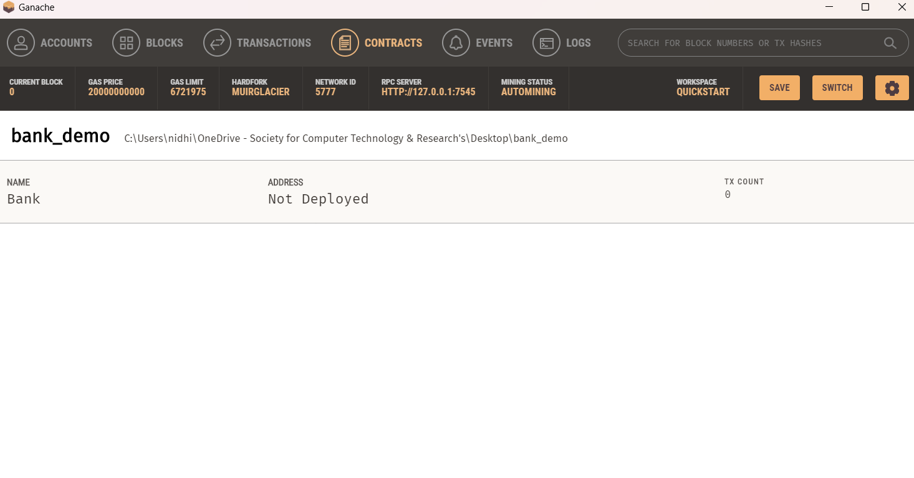

Now add js file in migrations

truffle migrate --reset

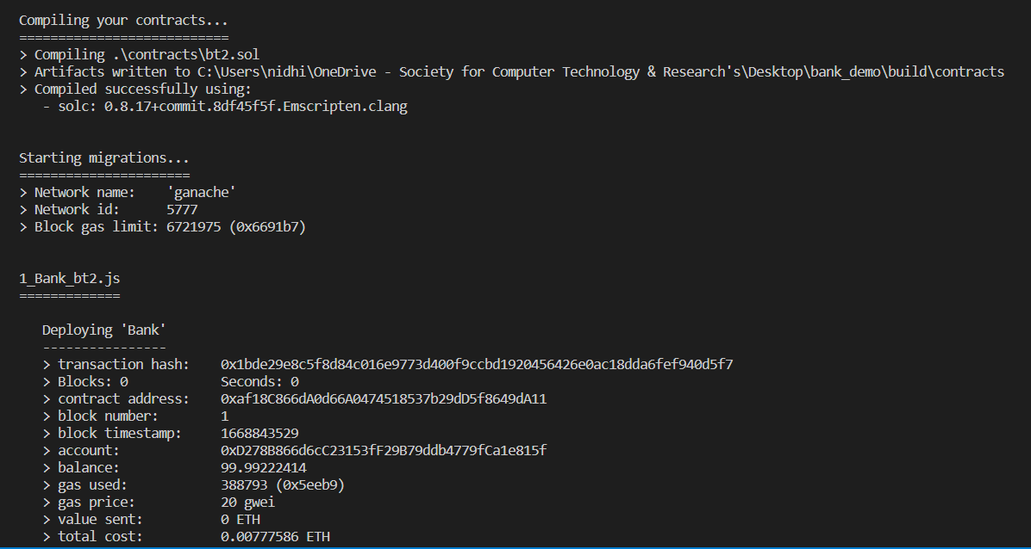

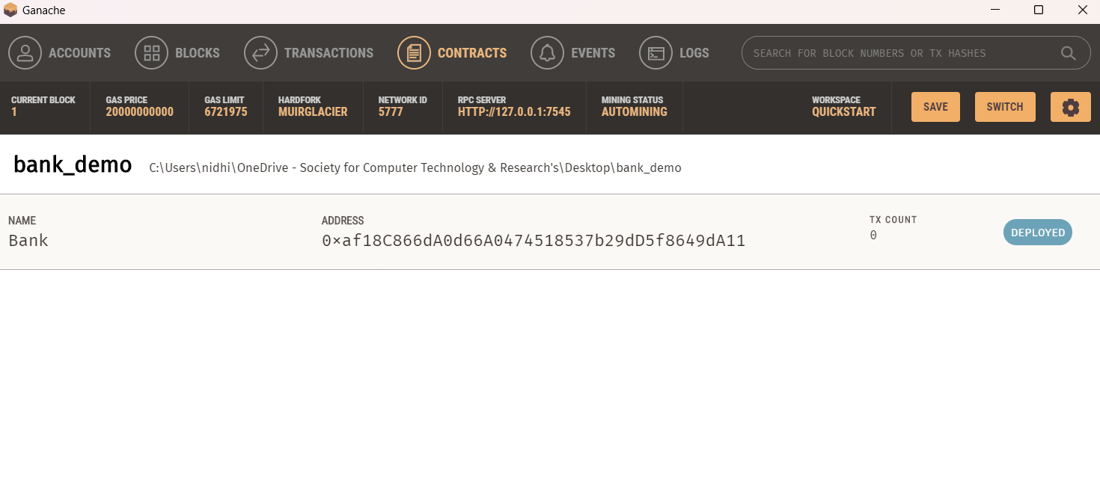

Using Remix extension -

npm i -g ganache-cli

ganache-cli