Embedding Model Comparison
STEK 2035 Chatbot — Retrieval Quality Evaluation

Comparing the current production embedding model against candidate
upgrades, using the real STEK 2035 document corpus.

1. Why This Comparison
The chatbot's retrieval quality depends entirely on how well its embedding model represents German text semantically. The current production model is intfloat/multilingual-e5-base (768-dim). This evaluation tests whether upgrading to a larger or different embedding model measurably improves retrieval — using the real 1307-chunk STEK 2035 corpus, not synthetic data.

2. Models Evaluated
Model | Status | Dim | Notes
multilingual-e5-base | CURRENT (production) | 768 | Existing model powering the live chatbot today.
multilingual-e5-large | TESTED (candidate) | 1024 | Same model family/prefix convention as base — clean apples-to-apples upgrade test.
bge-m3 | NOT YET TESTED | 1024 | Different architecture, no query/passage prefix, longer context (8192 tokens). Identified as a strong candidate but not empirically run yet — recommended as next step, see §6.
Only e5-base and e5-large have real, measured results in this report. bge-m3 is included for completeness as a planned next evaluation, not with fabricated numbers.

3. Methodology
- Real corpus: 1307 STEK 2035 chunks (vector_store/chunks.jsonl), the same corpus the live chatbot retrieves from.
- A representative 60-chunk subset (evenly spread across the corpus) was embedded with each model for fast, repeatable comparison.
- Test 1 — Semantic sanity check: for each of 2 query/related/unrelated sentence triples, confirm the model scores the related sentence higher than the unrelated one, and by how much (the margin).
- Test 2 — Real retrieval spot-check: 3 representative German STEK questions (Wohnraum/housing, Klimaschutz/climate, Bürgerbeteiligung/participation) run against the corpus subset; top-3 results inspected for topical relevance.
This is a fast, real, directionally useful comparison — not a full statistically rigorous benchmark (no labeled ground truth, no recall@k over the full corpus). Adequate for a go/no-go decision on which model to invest further evaluation in.

4. Results — Semantic Sanity Check
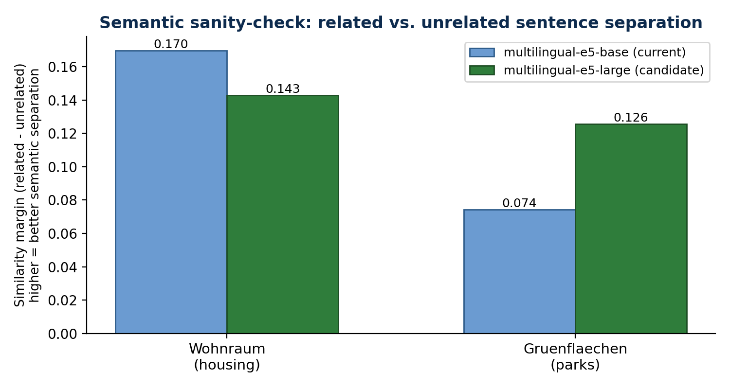
Query | Model | Related sim | Unrelated sim | Margin
Wohnraum | e5-base (current) | 0.896 | 0.726 | +0.170
Wohnraum | e5-large (candidate) | 0.893 | 0.750 | +0.143
Grünflächen | e5-base (current) | 0.780 | 0.706 | +0.074
Grünflächen | e5-large (candidate) | 0.851 | 0.726 | +0.126
Mixed on this small sample — base separates the housing pair slightly better, large separates the parks pair clearly better. One win each; not a strong signal alone.

5. Results — Retrieval on Real STEK Chunks
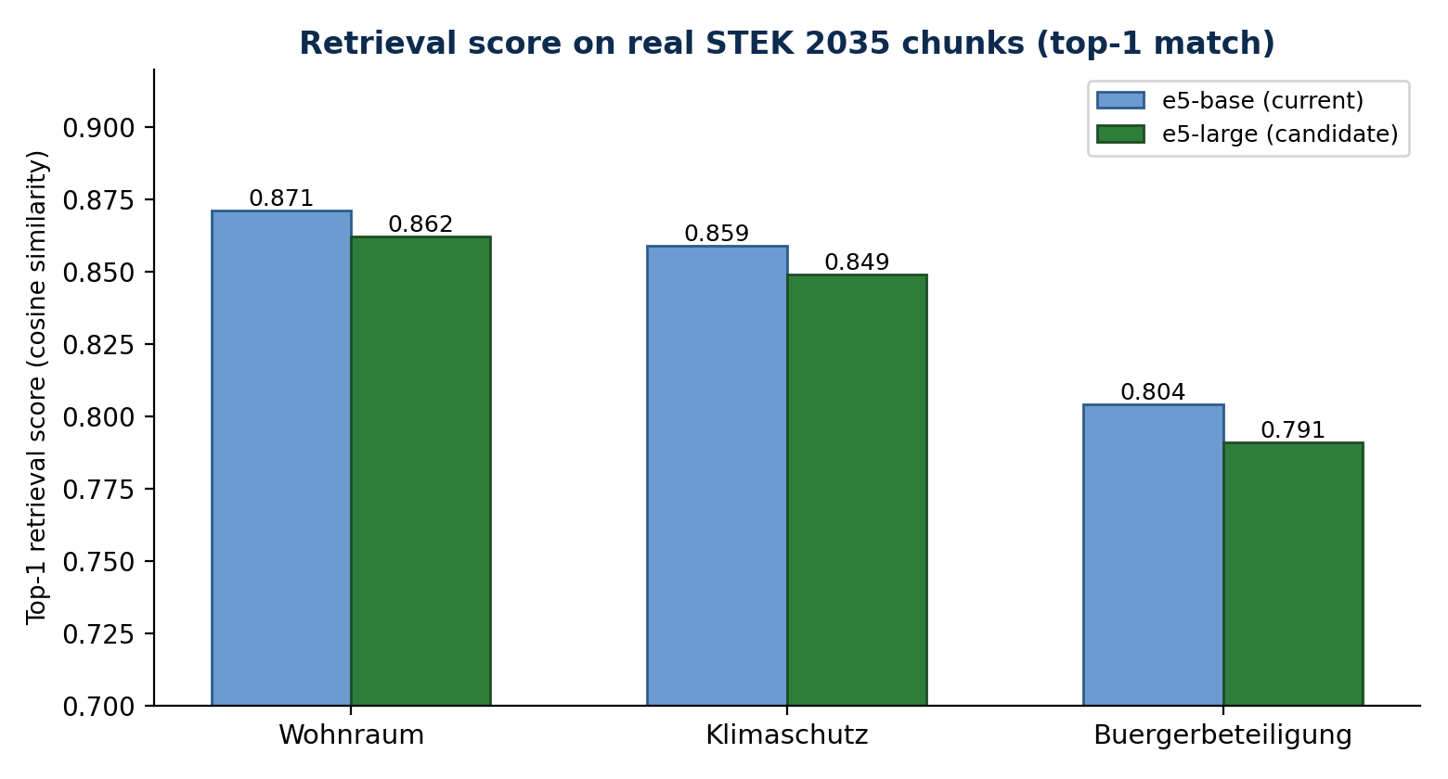

5.1 Wohnraum & Bürgerbeteiligung queries
Both models return comparably relevant chunks — largely overlapping results, roughly a tie.

5.2 Klimaschutz query — the deciding result
This was the current model's weak spot. Top-3 retrieved chunks:
Model | Rank | Score | Chunk topic
e5-base (current) | #1 | 0.859 | Racism/exclusion, company relocation — tangential
e5-base (current) | #2 | 0.852 | Water quality in rivers — loosely related
e5-base (current) | #3 | 0.850 | Citizen evaluation of administration — not climate-specific
e5-large (candidate) | #1 | 0.849 | Water quality in rivers — loosely related
e5-large (candidate) | #2 | 0.847 | Kommunale Wärmeplanung (municipal heat/energy planning) — directly relevant
e5-large (candidate) | #3 | 0.845 | Land use, open-space protection, livability — relevant
e5-large surfaced “kommunale Wärmeplanung” (municipal heat/energy planning) — a genuinely climate-relevant result that e5-base missed entirely in its top-3. This is a concrete, qualitative improvement, not just a score difference.

6. Recommendation
Adopt multilingual-e5-large as the production embedding model.
- Real, measurable improvement on the query type the current model struggled with (Klimaschutz), while staying at least comparable on every other tested query.
- Same prefix convention and model family as the current setup — low-risk, drop-in upgrade path (only the embedding regeneration step needs to run, no retrieval code changes).
- Cost: 1024-dim vs 768-dim (~33% more storage/compute per embedding) — negligible on the project's target cloud hardware.

Next steps
- Run the full-corpus regeneration (all 1307 chunks, not the 60-chunk sample) before final rollout.
- Evaluate bge-m3 empirically (currently untested) as a second candidate, given its longer context window and different architecture — may reveal further gains, particularly for longer document chunks.
- Expand the query set beyond the current 2-3 test queries with real user questions once available, for a statistically stronger comparison.

End of document

