CSIS 4495 - 002 Applied Research Project

Midterm Report

**Finance Tracker Web Application for Budget Management**

Video link- [W25_4495_S2_NidhiN_Midterm_Recording](https://collegedouglas-my.sharepoint.com/:v:/g/personal/nidhin_student_douglascollege_ca/EWIySk4UZqBHmIpZ1KGwS9MBcihxh7krSTVTZRnZtFQhDw?nav=eyJyZWZlcnJhbEluZm8iOnsicmVmZXJyYWxBcHAiOiJPbmVEcml2ZUZvckJ1c2luZXNzIiwicmVmZXJyYWxBcHBQbGF0Zm9ybSI6IldlYiIsInJlZmVycmFsTW9kZSI6InZpZXciLCJyZWZlcnJhbFZpZXciOiJNeUZpbGVzTGlua0NvcHkifX0&e=KSoq8A)

Nidhi Nidhi, 300378175

CSIS 4495-002

Instructor: Padmapriya Arasanipalai Kandhadai

Date: February 20, 2025

Douglas College

**Table of Contents**

1. [Introduction](https://cac-word-edit.officeapps.live.com/we/wordeditorframe.aspx?ui=en-US&rs=en-US&wopisrc=https%3A%2F%2Fcollegedouglas-my.sharepoint.com%2Fpersonal%2Fnidhin_student_douglascollege_ca%2F_vti_bin%2Fwopi.ashx%2Ffiles%2F2ae2905f19dd43f6b2b96d122912c49c&wdnewandopenct=1740101947007&wdorigin=OFFICECOM-WEB.START.NEW&wdprevioussessionsrc=HarmonyWeb&wdprevioussession=9e7e81a1-0726-413e-9d88-db52e36631db&wdenableroaming=1&wdfr=1&mscc=1&wdodb=1&hid=317384A1-9092-8000-19B4-BC6B6C50D55D.0&uih=sharepointcom&wdlcid=en-US&jsapi=1&jsapiver=v2&corrid=574c3bd3-ca28-78fa-0765-9ebe0c2e69b3&usid=574c3bd3-ca28-78fa-0765-9ebe0c2e69b3&newsession=1&sftc=1&uihit=docaspx&muv=1&cac=1&sams=1&mtf=1&sfp=1&sdp=1&hch=1&hwfh=1&dchat=1&sc=%7B%22pmo%22%3A%22https%3A%2F%2Fcollegedouglas-my.sharepoint.com%22%2C%22pmshare%22%3Atrue%7D&ctp=LeastProtected&rct=Normal&wdhostclicktime=1740101947785&csc=1&instantedit=1&wopicomplete=1&wdredirectionreason=Unified_SingleFlush#introduction)
   1. [Domain and Background](https://cac-word-edit.officeapps.live.com/we/wordeditorframe.aspx?ui=en-US&rs=en-US&wopisrc=https%3A%2F%2Fcollegedouglas-my.sharepoint.com%2Fpersonal%2Fnidhin_student_douglascollege_ca%2F_vti_bin%2Fwopi.ashx%2Ffiles%2F2ae2905f19dd43f6b2b96d122912c49c&wdnewandopenct=1740101947007&wdorigin=OFFICECOM-WEB.START.NEW&wdprevioussessionsrc=HarmonyWeb&wdprevioussession=9e7e81a1-0726-413e-9d88-db52e36631db&wdenableroaming=1&wdfr=1&mscc=1&wdodb=1&hid=317384A1-9092-8000-19B4-BC6B6C50D55D.0&uih=sharepointcom&wdlcid=en-US&jsapi=1&jsapiver=v2&corrid=574c3bd3-ca28-78fa-0765-9ebe0c2e69b3&usid=574c3bd3-ca28-78fa-0765-9ebe0c2e69b3&newsession=1&sftc=1&uihit=docaspx&muv=1&cac=1&sams=1&mtf=1&sfp=1&sdp=1&hch=1&hwfh=1&dchat=1&sc=%7B%22pmo%22%3A%22https%3A%2F%2Fcollegedouglas-my.sharepoint.com%22%2C%22pmshare%22%3Atrue%7D&ctp=LeastProtected&rct=Normal&wdhostclicktime=1740101947785&csc=1&instantedit=1&wopicomplete=1&wdredirectionreason=Unified_SingleFlush#domain-and-background)
   2. [Problem Statement](https://cac-word-edit.officeapps.live.com/we/wordeditorframe.aspx?ui=en-US&rs=en-US&wopisrc=https%3A%2F%2Fcollegedouglas-my.sharepoint.com%2Fpersonal%2Fnidhin_student_douglascollege_ca%2F_vti_bin%2Fwopi.ashx%2Ffiles%2F2ae2905f19dd43f6b2b96d122912c49c&wdnewandopenct=1740101947007&wdorigin=OFFICECOM-WEB.START.NEW&wdprevioussessionsrc=HarmonyWeb&wdprevioussession=9e7e81a1-0726-413e-9d88-db52e36631db&wdenableroaming=1&wdfr=1&mscc=1&wdodb=1&hid=317384A1-9092-8000-19B4-BC6B6C50D55D.0&uih=sharepointcom&wdlcid=en-US&jsapi=1&jsapiver=v2&corrid=574c3bd3-ca28-78fa-0765-9ebe0c2e69b3&usid=574c3bd3-ca28-78fa-0765-9ebe0c2e69b3&newsession=1&sftc=1&uihit=docaspx&muv=1&cac=1&sams=1&mtf=1&sfp=1&sdp=1&hch=1&hwfh=1&dchat=1&sc=%7B%22pmo%22%3A%22https%3A%2F%2Fcollegedouglas-my.sharepoint.com%22%2C%22pmshare%22%3Atrue%7D&ctp=LeastProtected&rct=Normal&wdhostclicktime=1740101947785&csc=1&instantedit=1&wopicomplete=1&wdredirectionreason=Unified_SingleFlush#problem-statement)
   3. [Literature Review](https://cac-word-edit.officeapps.live.com/we/wordeditorframe.aspx?ui=en-US&rs=en-US&wopisrc=https%3A%2F%2Fcollegedouglas-my.sharepoint.com%2Fpersonal%2Fnidhin_student_douglascollege_ca%2F_vti_bin%2Fwopi.ashx%2Ffiles%2F2ae2905f19dd43f6b2b96d122912c49c&wdnewandopenct=1740101947007&wdorigin=OFFICECOM-WEB.START.NEW&wdprevioussessionsrc=HarmonyWeb&wdprevioussession=9e7e81a1-0726-413e-9d88-db52e36631db&wdenableroaming=1&wdfr=1&mscc=1&wdodb=1&hid=317384A1-9092-8000-19B4-BC6B6C50D55D.0&uih=sharepointcom&wdlcid=en-US&jsapi=1&jsapiver=v2&corrid=574c3bd3-ca28-78fa-0765-9ebe0c2e69b3&usid=574c3bd3-ca28-78fa-0765-9ebe0c2e69b3&newsession=1&sftc=1&uihit=docaspx&muv=1&cac=1&sams=1&mtf=1&sfp=1&sdp=1&hch=1&hwfh=1&dchat=1&sc=%7B%22pmo%22%3A%22https%3A%2F%2Fcollegedouglas-my.sharepoint.com%22%2C%22pmshare%22%3Atrue%7D&ctp=LeastProtected&rct=Normal&wdhostclicktime=1740101947785&csc=1&instantedit=1&wopicomplete=1&wdredirectionreason=Unified_SingleFlush#literature-review)
   4. [Hypotheses and Benefits](https://cac-word-edit.officeapps.live.com/we/wordeditorframe.aspx?ui=en-US&rs=en-US&wopisrc=https%3A%2F%2Fcollegedouglas-my.sharepoint.com%2Fpersonal%2Fnidhin_student_douglascollege_ca%2F_vti_bin%2Fwopi.ashx%2Ffiles%2F2ae2905f19dd43f6b2b96d122912c49c&wdnewandopenct=1740101947007&wdorigin=OFFICECOM-WEB.START.NEW&wdprevioussessionsrc=HarmonyWeb&wdprevioussession=9e7e81a1-0726-413e-9d88-db52e36631db&wdenableroaming=1&wdfr=1&mscc=1&wdodb=1&hid=317384A1-9092-8000-19B4-BC6B6C50D55D.0&uih=sharepointcom&wdlcid=en-US&jsapi=1&jsapiver=v2&corrid=574c3bd3-ca28-78fa-0765-9ebe0c2e69b3&usid=574c3bd3-ca28-78fa-0765-9ebe0c2e69b3&newsession=1&sftc=1&uihit=docaspx&muv=1&cac=1&sams=1&mtf=1&sfp=1&sdp=1&hch=1&hwfh=1&dchat=1&sc=%7B%22pmo%22%3A%22https%3A%2F%2Fcollegedouglas-my.sharepoint.com%22%2C%22pmshare%22%3Atrue%7D&ctp=LeastProtected&rct=Normal&wdhostclicktime=1740101947785&csc=1&instantedit=1&wopicomplete=1&wdredirectionreason=Unified_SingleFlush#hypotheses-and-benefits)
2. [Summary of Initially Proposed Research Project](https://cac-word-edit.officeapps.live.com/we/wordeditorframe.aspx?ui=en-US&rs=en-US&wopisrc=https%3A%2F%2Fcollegedouglas-my.sharepoint.com%2Fpersonal%2Fnidhin_student_douglascollege_ca%2F_vti_bin%2Fwopi.ashx%2Ffiles%2F2ae2905f19dd43f6b2b96d122912c49c&wdnewandopenct=1740101947007&wdorigin=OFFICECOM-WEB.START.NEW&wdprevioussessionsrc=HarmonyWeb&wdprevioussession=9e7e81a1-0726-413e-9d88-db52e36631db&wdenableroaming=1&wdfr=1&mscc=1&wdodb=1&hid=317384A1-9092-8000-19B4-BC6B6C50D55D.0&uih=sharepointcom&wdlcid=en-US&jsapi=1&jsapiver=v2&corrid=574c3bd3-ca28-78fa-0765-9ebe0c2e69b3&usid=574c3bd3-ca28-78fa-0765-9ebe0c2e69b3&newsession=1&sftc=1&uihit=docaspx&muv=1&cac=1&sams=1&mtf=1&sfp=1&sdp=1&hch=1&hwfh=1&dchat=1&sc=%7B%22pmo%22%3A%22https%3A%2F%2Fcollegedouglas-my.sharepoint.com%22%2C%22pmshare%22%3Atrue%7D&ctp=LeastProtected&rct=Normal&wdhostclicktime=1740101947785&csc=1&instantedit=1&wopicomplete=1&wdredirectionreason=Unified_SingleFlush#summary-of-initially-proposed-research-project)
   1. [Research Design and Methodology](https://cac-word-edit.officeapps.live.com/we/wordeditorframe.aspx?ui=en-US&rs=en-US&wopisrc=https%3A%2F%2Fcollegedouglas-my.sharepoint.com%2Fpersonal%2Fnidhin_student_douglascollege_ca%2F_vti_bin%2Fwopi.ashx%2Ffiles%2F2ae2905f19dd43f6b2b96d122912c49c&wdnewandopenct=1740101947007&wdorigin=OFFICECOM-WEB.START.NEW&wdprevioussessionsrc=HarmonyWeb&wdprevioussession=9e7e81a1-0726-413e-9d88-db52e36631db&wdenableroaming=1&wdfr=1&mscc=1&wdodb=1&hid=317384A1-9092-8000-19B4-BC6B6C50D55D.0&uih=sharepointcom&wdlcid=en-US&jsapi=1&jsapiver=v2&corrid=574c3bd3-ca28-78fa-0765-9ebe0c2e69b3&usid=574c3bd3-ca28-78fa-0765-9ebe0c2e69b3&newsession=1&sftc=1&uihit=docaspx&muv=1&cac=1&sams=1&mtf=1&sfp=1&sdp=1&hch=1&hwfh=1&dchat=1&sc=%7B%22pmo%22%3A%22https%3A%2F%2Fcollegedouglas-my.sharepoint.com%22%2C%22pmshare%22%3Atrue%7D&ctp=LeastProtected&rct=Normal&wdhostclicktime=1740101947785&csc=1&instantedit=1&wopicomplete=1&wdredirectionreason=Unified_SingleFlush#research-design-and-methodology)
   2. [Technologies](https://cac-word-edit.officeapps.live.com/we/wordeditorframe.aspx?ui=en-US&rs=en-US&wopisrc=https%3A%2F%2Fcollegedouglas-my.sharepoint.com%2Fpersonal%2Fnidhin_student_douglascollege_ca%2F_vti_bin%2Fwopi.ashx%2Ffiles%2F2ae2905f19dd43f6b2b96d122912c49c&wdnewandopenct=1740101947007&wdorigin=OFFICECOM-WEB.START.NEW&wdprevioussessionsrc=HarmonyWeb&wdprevioussession=9e7e81a1-0726-413e-9d88-db52e36631db&wdenableroaming=1&wdfr=1&mscc=1&wdodb=1&hid=317384A1-9092-8000-19B4-BC6B6C50D55D.0&uih=sharepointcom&wdlcid=en-US&jsapi=1&jsapiver=v2&corrid=574c3bd3-ca28-78fa-0765-9ebe0c2e69b3&usid=574c3bd3-ca28-78fa-0765-9ebe0c2e69b3&newsession=1&sftc=1&uihit=docaspx&muv=1&cac=1&sams=1&mtf=1&sfp=1&sdp=1&hch=1&hwfh=1&dchat=1&sc=%7B%22pmo%22%3A%22https%3A%2F%2Fcollegedouglas-my.sharepoint.com%22%2C%22pmshare%22%3Atrue%7D&ctp=LeastProtected&rct=Normal&wdhostclicktime=1740101947785&csc=1&instantedit=1&wopicomplete=1&wdredirectionreason=Unified_SingleFlush#technologies)
   3. [Expected Results](https://cac-word-edit.officeapps.live.com/we/wordeditorframe.aspx?ui=en-US&rs=en-US&wopisrc=https%3A%2F%2Fcollegedouglas-my.sharepoint.com%2Fpersonal%2Fnidhin_student_douglascollege_ca%2F_vti_bin%2Fwopi.ashx%2Ffiles%2F2ae2905f19dd43f6b2b96d122912c49c&wdnewandopenct=1740101947007&wdorigin=OFFICECOM-WEB.START.NEW&wdprevioussessionsrc=HarmonyWeb&wdprevioussession=9e7e81a1-0726-413e-9d88-db52e36631db&wdenableroaming=1&wdfr=1&mscc=1&wdodb=1&hid=317384A1-9092-8000-19B4-BC6B6C50D55D.0&uih=sharepointcom&wdlcid=en-US&jsapi=1&jsapiver=v2&corrid=574c3bd3-ca28-78fa-0765-9ebe0c2e69b3&usid=574c3bd3-ca28-78fa-0765-9ebe0c2e69b3&newsession=1&sftc=1&uihit=docaspx&muv=1&cac=1&sams=1&mtf=1&sfp=1&sdp=1&hch=1&hwfh=1&dchat=1&sc=%7B%22pmo%22%3A%22https%3A%2F%2Fcollegedouglas-my.sharepoint.com%22%2C%22pmshare%22%3Atrue%7D&ctp=LeastProtected&rct=Normal&wdhostclicktime=1740101947785&csc=1&instantedit=1&wopicomplete=1&wdredirectionreason=Unified_SingleFlush#expected-results)
3. [Changes to the Proposal](https://cac-word-edit.officeapps.live.com/we/wordeditorframe.aspx?ui=en-US&rs=en-US&wopisrc=https%3A%2F%2Fcollegedouglas-my.sharepoint.com%2Fpersonal%2Fnidhin_student_douglascollege_ca%2F_vti_bin%2Fwopi.ashx%2Ffiles%2F2ae2905f19dd43f6b2b96d122912c49c&wdnewandopenct=1740101947007&wdorigin=OFFICECOM-WEB.START.NEW&wdprevioussessionsrc=HarmonyWeb&wdprevioussession=9e7e81a1-0726-413e-9d88-db52e36631db&wdenableroaming=1&wdfr=1&mscc=1&wdodb=1&hid=317384A1-9092-8000-19B4-BC6B6C50D55D.0&uih=sharepointcom&wdlcid=en-US&jsapi=1&jsapiver=v2&corrid=574c3bd3-ca28-78fa-0765-9ebe0c2e69b3&usid=574c3bd3-ca28-78fa-0765-9ebe0c2e69b3&newsession=1&sftc=1&uihit=docaspx&muv=1&cac=1&sams=1&mtf=1&sfp=1&sdp=1&hch=1&hwfh=1&dchat=1&sc=%7B%22pmo%22%3A%22https%3A%2F%2Fcollegedouglas-my.sharepoint.com%22%2C%22pmshare%22%3Atrue%7D&ctp=LeastProtected&rct=Normal&wdhostclicktime=1740101947785&csc=1&instantedit=1&wopicomplete=1&wdredirectionreason=Unified_SingleFlush#changes-to-the-proposal)
   1. [Frontend Framework: Flutter to Bootstrap](https://cac-word-edit.officeapps.live.com/we/wordeditorframe.aspx?ui=en-US&rs=en-US&wopisrc=https%3A%2F%2Fcollegedouglas-my.sharepoint.com%2Fpersonal%2Fnidhin_student_douglascollege_ca%2F_vti_bin%2Fwopi.ashx%2Ffiles%2F2ae2905f19dd43f6b2b96d122912c49c&wdnewandopenct=1740101947007&wdorigin=OFFICECOM-WEB.START.NEW&wdprevioussessionsrc=HarmonyWeb&wdprevioussession=9e7e81a1-0726-413e-9d88-db52e36631db&wdenableroaming=1&wdfr=1&mscc=1&wdodb=1&hid=317384A1-9092-8000-19B4-BC6B6C50D55D.0&uih=sharepointcom&wdlcid=en-US&jsapi=1&jsapiver=v2&corrid=574c3bd3-ca28-78fa-0765-9ebe0c2e69b3&usid=574c3bd3-ca28-78fa-0765-9ebe0c2e69b3&newsession=1&sftc=1&uihit=docaspx&muv=1&cac=1&sams=1&mtf=1&sfp=1&sdp=1&hch=1&hwfh=1&dchat=1&sc=%7B%22pmo%22%3A%22https%3A%2F%2Fcollegedouglas-my.sharepoint.com%22%2C%22pmshare%22%3Atrue%7D&ctp=LeastProtected&rct=Normal&wdhostclicktime=1740101947785&csc=1&instantedit=1&wopicomplete=1&wdredirectionreason=Unified_SingleFlush#frontend-framework-flutter-to-bootstrap)
   2. [Authentication Mechanism](https://cac-word-edit.officeapps.live.com/we/wordeditorframe.aspx?ui=en-US&rs=en-US&wopisrc=https%3A%2F%2Fcollegedouglas-my.sharepoint.com%2Fpersonal%2Fnidhin_student_douglascollege_ca%2F_vti_bin%2Fwopi.ashx%2Ffiles%2F2ae2905f19dd43f6b2b96d122912c49c&wdnewandopenct=1740101947007&wdorigin=OFFICECOM-WEB.START.NEW&wdprevioussessionsrc=HarmonyWeb&wdprevioussession=9e7e81a1-0726-413e-9d88-db52e36631db&wdenableroaming=1&wdfr=1&mscc=1&wdodb=1&hid=317384A1-9092-8000-19B4-BC6B6C50D55D.0&uih=sharepointcom&wdlcid=en-US&jsapi=1&jsapiver=v2&corrid=574c3bd3-ca28-78fa-0765-9ebe0c2e69b3&usid=574c3bd3-ca28-78fa-0765-9ebe0c2e69b3&newsession=1&sftc=1&uihit=docaspx&muv=1&cac=1&sams=1&mtf=1&sfp=1&sdp=1&hch=1&hwfh=1&dchat=1&sc=%7B%22pmo%22%3A%22https%3A%2F%2Fcollegedouglas-my.sharepoint.com%22%2C%22pmshare%22%3Atrue%7D&ctp=LeastProtected&rct=Normal&wdhostclicktime=1740101947785&csc=1&instantedit=1&wopicomplete=1&wdredirectionreason=Unified_SingleFlush#authentication-mechanism)
   3. [Database Structure and Access](https://cac-word-edit.officeapps.live.com/we/wordeditorframe.aspx?ui=en-US&rs=en-US&wopisrc=https%3A%2F%2Fcollegedouglas-my.sharepoint.com%2Fpersonal%2Fnidhin_student_douglascollege_ca%2F_vti_bin%2Fwopi.ashx%2Ffiles%2F2ae2905f19dd43f6b2b96d122912c49c&wdnewandopenct=1740101947007&wdorigin=OFFICECOM-WEB.START.NEW&wdprevioussessionsrc=HarmonyWeb&wdprevioussession=9e7e81a1-0726-413e-9d88-db52e36631db&wdenableroaming=1&wdfr=1&mscc=1&wdodb=1&hid=317384A1-9092-8000-19B4-BC6B6C50D55D.0&uih=sharepointcom&wdlcid=en-US&jsapi=1&jsapiver=v2&corrid=574c3bd3-ca28-78fa-0765-9ebe0c2e69b3&usid=574c3bd3-ca28-78fa-0765-9ebe0c2e69b3&newsession=1&sftc=1&uihit=docaspx&muv=1&cac=1&sams=1&mtf=1&sfp=1&sdp=1&hch=1&hwfh=1&dchat=1&sc=%7B%22pmo%22%3A%22https%3A%2F%2Fcollegedouglas-my.sharepoint.com%22%2C%22pmshare%22%3Atrue%7D&ctp=LeastProtected&rct=Normal&wdhostclicktime=1740101947785&csc=1&instantedit=1&wopicomplete=1&wdredirectionreason=Unified_SingleFlush#database-structure-and-access)
4. [Project Planning and Timeline](https://cac-word-edit.officeapps.live.com/we/wordeditorframe.aspx?ui=en-US&rs=en-US&wopisrc=https%3A%2F%2Fcollegedouglas-my.sharepoint.com%2Fpersonal%2Fnidhin_student_douglascollege_ca%2F_vti_bin%2Fwopi.ashx%2Ffiles%2F2ae2905f19dd43f6b2b96d122912c49c&wdnewandopenct=1740101947007&wdorigin=OFFICECOM-WEB.START.NEW&wdprevioussessionsrc=HarmonyWeb&wdprevioussession=9e7e81a1-0726-413e-9d88-db52e36631db&wdenableroaming=1&wdfr=1&mscc=1&wdodb=1&hid=317384A1-9092-8000-19B4-BC6B6C50D55D.0&uih=sharepointcom&wdlcid=en-US&jsapi=1&jsapiver=v2&corrid=574c3bd3-ca28-78fa-0765-9ebe0c2e69b3&usid=574c3bd3-ca28-78fa-0765-9ebe0c2e69b3&newsession=1&sftc=1&uihit=docaspx&muv=1&cac=1&sams=1&mtf=1&sfp=1&sdp=1&hch=1&hwfh=1&dchat=1&sc=%7B%22pmo%22%3A%22https%3A%2F%2Fcollegedouglas-my.sharepoint.com%22%2C%22pmshare%22%3Atrue%7D&ctp=LeastProtected&rct=Normal&wdhostclicktime=1740101947785&csc=1&instantedit=1&wopicomplete=1&wdredirectionreason=Unified_SingleFlush#project-planning-and-timeline)
   1. [Updated Timeline](https://cac-word-edit.officeapps.live.com/we/wordeditorframe.aspx?ui=en-US&rs=en-US&wopisrc=https%3A%2F%2Fcollegedouglas-my.sharepoint.com%2Fpersonal%2Fnidhin_student_douglascollege_ca%2F_vti_bin%2Fwopi.ashx%2Ffiles%2F2ae2905f19dd43f6b2b96d122912c49c&wdnewandopenct=1740101947007&wdorigin=OFFICECOM-WEB.START.NEW&wdprevioussessionsrc=HarmonyWeb&wdprevioussession=9e7e81a1-0726-413e-9d88-db52e36631db&wdenableroaming=1&wdfr=1&mscc=1&wdodb=1&hid=317384A1-9092-8000-19B4-BC6B6C50D55D.0&uih=sharepointcom&wdlcid=en-US&jsapi=1&jsapiver=v2&corrid=574c3bd3-ca28-78fa-0765-9ebe0c2e69b3&usid=574c3bd3-ca28-78fa-0765-9ebe0c2e69b3&newsession=1&sftc=1&uihit=docaspx&muv=1&cac=1&sams=1&mtf=1&sfp=1&sdp=1&hch=1&hwfh=1&dchat=1&sc=%7B%22pmo%22%3A%22https%3A%2F%2Fcollegedouglas-my.sharepoint.com%22%2C%22pmshare%22%3Atrue%7D&ctp=LeastProtected&rct=Normal&wdhostclicktime=1740101947785&csc=1&instantedit=1&wopicomplete=1&wdredirectionreason=Unified_SingleFlush#updated-timeline)
   2. [Project Management](https://cac-word-edit.officeapps.live.com/we/wordeditorframe.aspx?ui=en-US&rs=en-US&wopisrc=https%3A%2F%2Fcollegedouglas-my.sharepoint.com%2Fpersonal%2Fnidhin_student_douglascollege_ca%2F_vti_bin%2Fwopi.ashx%2Ffiles%2F2ae2905f19dd43f6b2b96d122912c49c&wdnewandopenct=1740101947007&wdorigin=OFFICECOM-WEB.START.NEW&wdprevioussessionsrc=HarmonyWeb&wdprevioussession=9e7e81a1-0726-413e-9d88-db52e36631db&wdenableroaming=1&wdfr=1&mscc=1&wdodb=1&hid=317384A1-9092-8000-19B4-BC6B6C50D55D.0&uih=sharepointcom&wdlcid=en-US&jsapi=1&jsapiver=v2&corrid=574c3bd3-ca28-78fa-0765-9ebe0c2e69b3&usid=574c3bd3-ca28-78fa-0765-9ebe0c2e69b3&newsession=1&sftc=1&uihit=docaspx&muv=1&cac=1&sams=1&mtf=1&sfp=1&sdp=1&hch=1&hwfh=1&dchat=1&sc=%7B%22pmo%22%3A%22https%3A%2F%2Fcollegedouglas-my.sharepoint.com%22%2C%22pmshare%22%3Atrue%7D&ctp=LeastProtected&rct=Normal&wdhostclicktime=1740101947785&csc=1&instantedit=1&wopicomplete=1&wdredirectionreason=Unified_SingleFlush#project-management)
5. [Implemented Features](https://cac-word-edit.officeapps.live.com/we/wordeditorframe.aspx?ui=en-US&rs=en-US&wopisrc=https%3A%2F%2Fcollegedouglas-my.sharepoint.com%2Fpersonal%2Fnidhin_student_douglascollege_ca%2F_vti_bin%2Fwopi.ashx%2Ffiles%2F2ae2905f19dd43f6b2b96d122912c49c&wdnewandopenct=1740101947007&wdorigin=OFFICECOM-WEB.START.NEW&wdprevioussessionsrc=HarmonyWeb&wdprevioussession=9e7e81a1-0726-413e-9d88-db52e36631db&wdenableroaming=1&wdfr=1&mscc=1&wdodb=1&hid=317384A1-9092-8000-19B4-BC6B6C50D55D.0&uih=sharepointcom&wdlcid=en-US&jsapi=1&jsapiver=v2&corrid=574c3bd3-ca28-78fa-0765-9ebe0c2e69b3&usid=574c3bd3-ca28-78fa-0765-9ebe0c2e69b3&newsession=1&sftc=1&uihit=docaspx&muv=1&cac=1&sams=1&mtf=1&sfp=1&sdp=1&hch=1&hwfh=1&dchat=1&sc=%7B%22pmo%22%3A%22https%3A%2F%2Fcollegedouglas-my.sharepoint.com%22%2C%22pmshare%22%3Atrue%7D&ctp=LeastProtected&rct=Normal&wdhostclicktime=1740101947785&csc=1&instantedit=1&wopicomplete=1&wdredirectionreason=Unified_SingleFlush#implemented-features)
   1. [User Authentication System](https://cac-word-edit.officeapps.live.com/we/wordeditorframe.aspx?ui=en-US&rs=en-US&wopisrc=https%3A%2F%2Fcollegedouglas-my.sharepoint.com%2Fpersonal%2Fnidhin_student_douglascollege_ca%2F_vti_bin%2Fwopi.ashx%2Ffiles%2F2ae2905f19dd43f6b2b96d122912c49c&wdnewandopenct=1740101947007&wdorigin=OFFICECOM-WEB.START.NEW&wdprevioussessionsrc=HarmonyWeb&wdprevioussession=9e7e81a1-0726-413e-9d88-db52e36631db&wdenableroaming=1&wdfr=1&mscc=1&wdodb=1&hid=317384A1-9092-8000-19B4-BC6B6C50D55D.0&uih=sharepointcom&wdlcid=en-US&jsapi=1&jsapiver=v2&corrid=574c3bd3-ca28-78fa-0765-9ebe0c2e69b3&usid=574c3bd3-ca28-78fa-0765-9ebe0c2e69b3&newsession=1&sftc=1&uihit=docaspx&muv=1&cac=1&sams=1&mtf=1&sfp=1&sdp=1&hch=1&hwfh=1&dchat=1&sc=%7B%22pmo%22%3A%22https%3A%2F%2Fcollegedouglas-my.sharepoint.com%22%2C%22pmshare%22%3Atrue%7D&ctp=LeastProtected&rct=Normal&wdhostclicktime=1740101947785&csc=1&instantedit=1&wopicomplete=1&wdredirectionreason=Unified_SingleFlush#user-authentication-system)
   2. [Dashboard Design](https://cac-word-edit.officeapps.live.com/we/wordeditorframe.aspx?ui=en-US&rs=en-US&wopisrc=https%3A%2F%2Fcollegedouglas-my.sharepoint.com%2Fpersonal%2Fnidhin_student_douglascollege_ca%2F_vti_bin%2Fwopi.ashx%2Ffiles%2F2ae2905f19dd43f6b2b96d122912c49c&wdnewandopenct=1740101947007&wdorigin=OFFICECOM-WEB.START.NEW&wdprevioussessionsrc=HarmonyWeb&wdprevioussession=9e7e81a1-0726-413e-9d88-db52e36631db&wdenableroaming=1&wdfr=1&mscc=1&wdodb=1&hid=317384A1-9092-8000-19B4-BC6B6C50D55D.0&uih=sharepointcom&wdlcid=en-US&jsapi=1&jsapiver=v2&corrid=574c3bd3-ca28-78fa-0765-9ebe0c2e69b3&usid=574c3bd3-ca28-78fa-0765-9ebe0c2e69b3&newsession=1&sftc=1&uihit=docaspx&muv=1&cac=1&sams=1&mtf=1&sfp=1&sdp=1&hch=1&hwfh=1&dchat=1&sc=%7B%22pmo%22%3A%22https%3A%2F%2Fcollegedouglas-my.sharepoint.com%22%2C%22pmshare%22%3Atrue%7D&ctp=LeastProtected&rct=Normal&wdhostclicktime=1740101947785&csc=1&instantedit=1&wopicomplete=1&wdredirectionreason=Unified_SingleFlush#dashboard-design)
   3. [Expense Visualization](https://cac-word-edit.officeapps.live.com/we/wordeditorframe.aspx?ui=en-US&rs=en-US&wopisrc=https%3A%2F%2Fcollegedouglas-my.sharepoint.com%2Fpersonal%2Fnidhin_student_douglascollege_ca%2F_vti_bin%2Fwopi.ashx%2Ffiles%2F2ae2905f19dd43f6b2b96d122912c49c&wdnewandopenct=1740101947007&wdorigin=OFFICECOM-WEB.START.NEW&wdprevioussessionsrc=HarmonyWeb&wdprevioussession=9e7e81a1-0726-413e-9d88-db52e36631db&wdenableroaming=1&wdfr=1&mscc=1&wdodb=1&hid=317384A1-9092-8000-19B4-BC6B6C50D55D.0&uih=sharepointcom&wdlcid=en-US&jsapi=1&jsapiver=v2&corrid=574c3bd3-ca28-78fa-0765-9ebe0c2e69b3&usid=574c3bd3-ca28-78fa-0765-9ebe0c2e69b3&newsession=1&sftc=1&uihit=docaspx&muv=1&cac=1&sams=1&mtf=1&sfp=1&sdp=1&hch=1&hwfh=1&dchat=1&sc=%7B%22pmo%22%3A%22https%3A%2F%2Fcollegedouglas-my.sharepoint.com%22%2C%22pmshare%22%3Atrue%7D&ctp=LeastProtected&rct=Normal&wdhostclicktime=1740101947785&csc=1&instantedit=1&wopicomplete=1&wdredirectionreason=Unified_SingleFlush#expense-visualization)
6. [Work Date/Hours Log](https://cac-word-edit.officeapps.live.com/we/wordeditorframe.aspx?ui=en-US&rs=en-US&wopisrc=https%3A%2F%2Fcollegedouglas-my.sharepoint.com%2Fpersonal%2Fnidhin_student_douglascollege_ca%2F_vti_bin%2Fwopi.ashx%2Ffiles%2F2ae2905f19dd43f6b2b96d122912c49c&wdnewandopenct=1740101947007&wdorigin=OFFICECOM-WEB.START.NEW&wdprevioussessionsrc=HarmonyWeb&wdprevioussession=9e7e81a1-0726-413e-9d88-db52e36631db&wdenableroaming=1&wdfr=1&mscc=1&wdodb=1&hid=317384A1-9092-8000-19B4-BC6B6C50D55D.0&uih=sharepointcom&wdlcid=en-US&jsapi=1&jsapiver=v2&corrid=574c3bd3-ca28-78fa-0765-9ebe0c2e69b3&usid=574c3bd3-ca28-78fa-0765-9ebe0c2e69b3&newsession=1&sftc=1&uihit=docaspx&muv=1&cac=1&sams=1&mtf=1&sfp=1&sdp=1&hch=1&hwfh=1&dchat=1&sc=%7B%22pmo%22%3A%22https%3A%2F%2Fcollegedouglas-my.sharepoint.com%22%2C%22pmshare%22%3Atrue%7D&ctp=LeastProtected&rct=Normal&wdhostclicktime=1740101947785&csc=1&instantedit=1&wopicomplete=1&wdredirectionreason=Unified_SingleFlush#work-datehours-log)
7. [References](https://cac-word-edit.officeapps.live.com/we/wordeditorframe.aspx?ui=en-US&rs=en-US&wopisrc=https%3A%2F%2Fcollegedouglas-my.sharepoint.com%2Fpersonal%2Fnidhin_student_douglascollege_ca%2F_vti_bin%2Fwopi.ashx%2Ffiles%2F2ae2905f19dd43f6b2b96d122912c49c&wdnewandopenct=1740101947007&wdorigin=OFFICECOM-WEB.START.NEW&wdprevioussessionsrc=HarmonyWeb&wdprevioussession=9e7e81a1-0726-413e-9d88-db52e36631db&wdenableroaming=1&wdfr=1&mscc=1&wdodb=1&hid=317384A1-9092-8000-19B4-BC6B6C50D55D.0&uih=sharepointcom&wdlcid=en-US&jsapi=1&jsapiver=v2&corrid=574c3bd3-ca28-78fa-0765-9ebe0c2e69b3&usid=574c3bd3-ca28-78fa-0765-9ebe0c2e69b3&newsession=1&sftc=1&uihit=docaspx&muv=1&cac=1&sams=1&mtf=1&sfp=1&sdp=1&hch=1&hwfh=1&dchat=1&sc=%7B%22pmo%22%3A%22https%3A%2F%2Fcollegedouglas-my.sharepoint.com%22%2C%22pmshare%22%3Atrue%7D&ctp=LeastProtected&rct=Normal&wdhostclicktime=1740101947785&csc=1&instantedit=1&wopicomplete=1&wdredirectionreason=Unified_SingleFlush#references)

# Introduction

### **Domain and Background**

Personal finance management is critical for individuals to achieve financial stability and carry out their monetary goals. Despite its importance, many individuals struggle with tracking their expenses, creating and adhering to budgets, and making informed financial decisions. This research project focuses on developing a web application that eases expense tracking, budget customization, provides AI assistance for financial decisions, and generates comprehensive PDF reports.

The application aims to bridge the gap between simple expense tracking and actionable financial insights by creating an intuitive platform that not only records financial data but also helps users understand their spending patterns and optimize their budgets.

### **Problem Statement**

The research addresses several key questions related to personal finance management:

1. How can users efficiently track income and expenses while gaining actionable insights to improve their savings?
2. Can AI integration improve personalized budget recommendations based on individual spending patterns?
3. How can financial data visualization enhance users' understanding of their financial habits and encourage better decision-making?

These questions are particularly important in today's economic environment, where financial literacy and efficient budget management are essential skills for individuals across all income levels.

### **Literature Review**

Current personal finance applications in the market primarily focus on basic expense tracking functionality but often lack comprehensive recommendation features. Notable gaps in existing solutions include:

1. **Limited AI Integration**: While some platforms offer basic insights, they typically lack sophisticated AI-driven recommendations tailored to individual financial behaviors.
2. **Static Visualization Tools**: Many existing applications provide basic charts and graphs, but fail to offer interactive visualization tools that can adapt to user-specific inquiries and preferences.
3. **Segregated Functionality**: Users often need multiple applications to cover expense tracking, budgeting, financial forecasting, and report generation, creating a fragmented user experience.

This research aims to address these limitations by developing an integrated solution that combines robust tracking capabilities with intelligent insights and flexible visualization options.

### **Hypotheses and Benefits**

**Primary Hypothesis**: AI-driven financial recommendations will significantly improve user engagement and financial decision-making compared to traditional expense tracking methods.

**Secondary Hypothesis**: Interactive visualization of financial data will lead to better budget adherence and savings rates among users.

**Expected Benefits**:

* Enhanced user experience through intuitive interface design and reduced manual input requirements. For e.g. Input in Natural language
* Improved financial decision-making through personalized AI recommendations
* Better understanding of spending patterns through interactive visualizations
* Long-term improvement in financial planning capabilities for users
* Centralized platform for all personal finance management needs

# Summary of Initially Proposed Research Project

### **Research Design and Methodology**

The original project proposal outlined the development of a full-stack web application using Node.js for the backend, Bootstrap/EJS for the frontend, and MongoDB as the database solution. The application was designed to enable users to:

1. Track income and expenses across various categories
2. Set and manage budgets
3. Visualize financial data through interactive charts
4. Receive AI-powered insights and recommendations
5. Generate PDF reports for offline review

The project adopted an Agile development methodology, featuring iterative development cycles and regular testing. This approach was chosen specifically to accommodate the integration of AI components and allow for adjustments based on user/client feedback during the development process.

### **Technologies**

The initially proposed technology stack included:

* **Operating System**: Windows/Linux (ensuring cross-platform compatibility)
* **Frontend**: Bootstrap 5 with EJS templating for responsive design
* **Backend**: Node.js with Express.js for API development and server-side logic
* **Database**: MongoDB (NoSQL) for flexible expense categorization and data storage
* **AI Tools**: Google's Gemini API for generating expense recommendations and insights

This technology stack was selected for its flexibility, scalability, and suitability for rapid application development.

### **Expected Results**

The project aimed to deliver:

1. A fully functional web application enabling users to track expenses, set budgets, and generate comprehensive reports
2. AI-driven insights to help users make better financial decisions (e.g., "Fuel expenses increased by 20% this month")
3. Interactive visualization tools to help users understand their spending patterns
4. An intuitive user interface accessible across multiple devices

The primary contribution would be empowering users to make data-driven financial decisions through a combination of tracking tools, visualization capabilities, and AI-powered recommendations.

# Changes to the Proposal

Since the initial proposal, several strategic changes have been made to improve the project's implementation and ensure better outcomes. These changes reflect deeper research into technology options and a clearer understanding of user requirements.

### **Frontend Framework: Flutter to Bootstrap**

**Original Plan**: The first consideration included Flutter as a potential front-end framework.

**Current Decision**: Bootstrap with EJS has been confirmed as the front-end solution.

**Justification**:

* Flutter, while excellent for cross-platform mobile development, presents potential challenges for web applications including slower loading times and browser compatibility issues.
* Bootstrap offers mature community support, extensive documentation, and proven performance for responsive web design.
* EJS provides server-side templating that works seamlessly with Node.js, allowing for dynamic content generation without additional client-side frameworks.
* This combination enables faster development cycles and better performance for web-based financial applications.

### **Authentication Mechanism**

**Original Plan**: Use Passport.js for user authentication.

**Current Decision**: Implement a custom authentication system.

**Justification**:

* After reviewing Passport.js documentation, it was determined that the library offers more complexity than required for the project's simple username/password authentication needs.
* A custom authentication system provides better control over the user experience and session management.
* The simplified approach reduces dependencies and potential points of failure while maintaining adequate security for the application's purposes.

### **Database Structure and Access**

**Original Plan**: Use MongoDB with default security settings.

**Current Decision**: Configured MongoDB for broader access with plans to implement proper security measures before production.

**Justification**:

* Initial connection attempts to the MongoDB cluster were unsuccessful due to default security settings that block access from external IP addresses.
* For development purposes, the database has been configured to accept connections from any IP address.
* This approach facilitates easier development and testing across different environments.
* Prior to production deployment, proper security measures will be implemented, including IP whitelisting, encrypted connections, and secure authentication mechanisms.

# Project Planning and Timeline

### **Updated Timeline**

The following timeline outlines the remaining phases of the project from the current point to completion:

|  |  |  |
| --- | --- | --- |
| **Phase** | **Dates** | **Key Deliverables** |
| Midterm Submission | Feb 24, 2025 | Midterm Report, Basic UI, Authentication System |
| Core Functionality | Feb 25 - Mar 7, 2025 | Expense Tracking System, Category Management, Data Storage Implementation |
| Data Visualization | Mar 8 - Mar 14, 2025 | Interactive Charts, Financial Summary Views, Dashboard Enhancements |
| AI Integration | Mar 15 - Mar 28, 2025 | Google Gemini API Integration, Recommendation Engine |
| PDF Reporting | Mar 29 - Apr 3, 2025 | Report Generation, Export Functionality |
| Testing & Refinement | Apr 4 - Apr 10, 2025 | Testing, Bug Fixes, Performance Optimization |
| Final Submission | Apr 11, 2025 | Complete Application, Final Report |

### **Project Management**

As this is a solo project, all responsibilities are managed by a single developer (Nidhi). The development process is being tracked using a Gantt chart to visualize the project timeline and dependencies. Tasks are organized into the following categories:

* Completed
* In Progress
* Testing
* To Do
* Backlog

This approach allows for clear timeline visualization, identification of critical paths, and accurate tracking of project progress against scheduled milestones. The current Gantt chart is shown below, illustrating both completed work and upcoming deliverables:

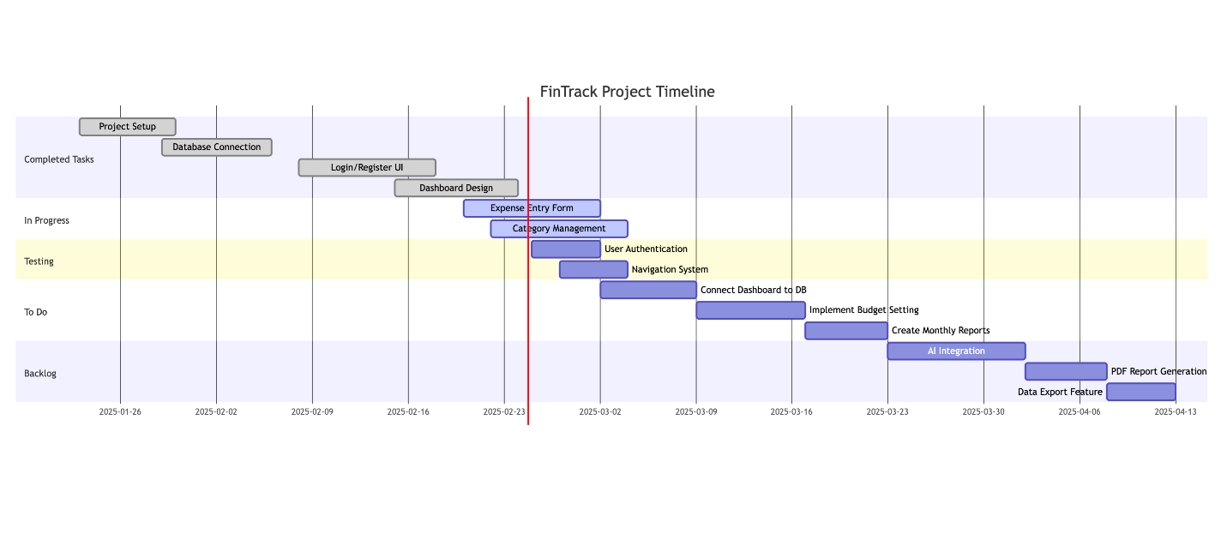**Implemented Features**

As of the midterm report deadline, several key features have been implemented, establishing the foundation for the Finance Tracking application.

### **User Authentication System**

The user authentication system has been implemented with custom authentication mechanisms instead of using Passport.js. This system includes:

1. **User Registration Page**: Allows new users to create accounts with basic profile information.
2. **Login System**: Securely authenticates users and establishes sessions.
3. **Session Management**: Maintains user login state throughout their interaction with the application.

The authentication system differentiates between registered users and visitors, providing appropriate views and access levels based on user status.

**Implementation Screenshots:**

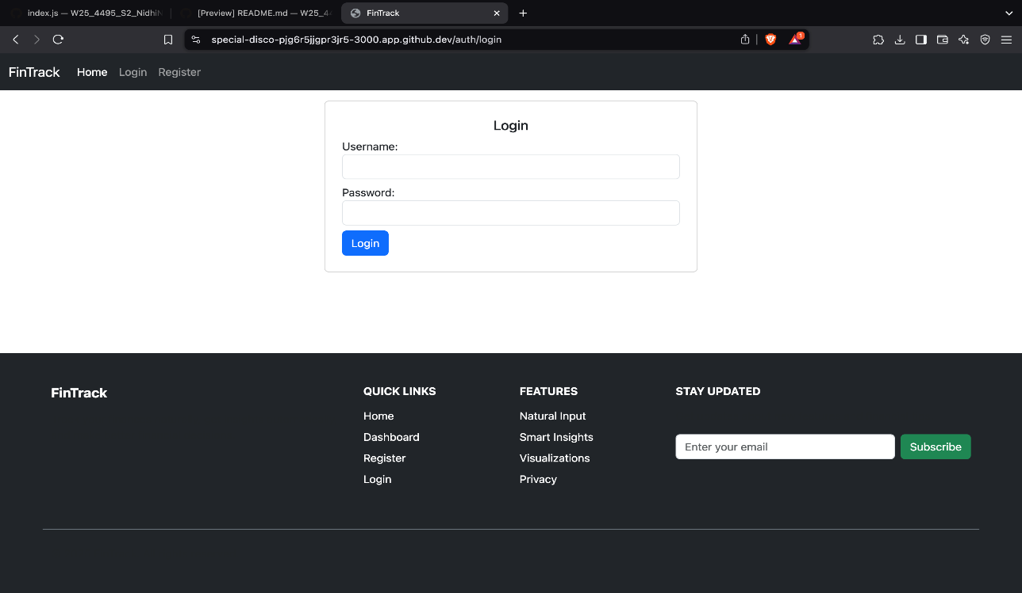

Code Sample (Login Authentication):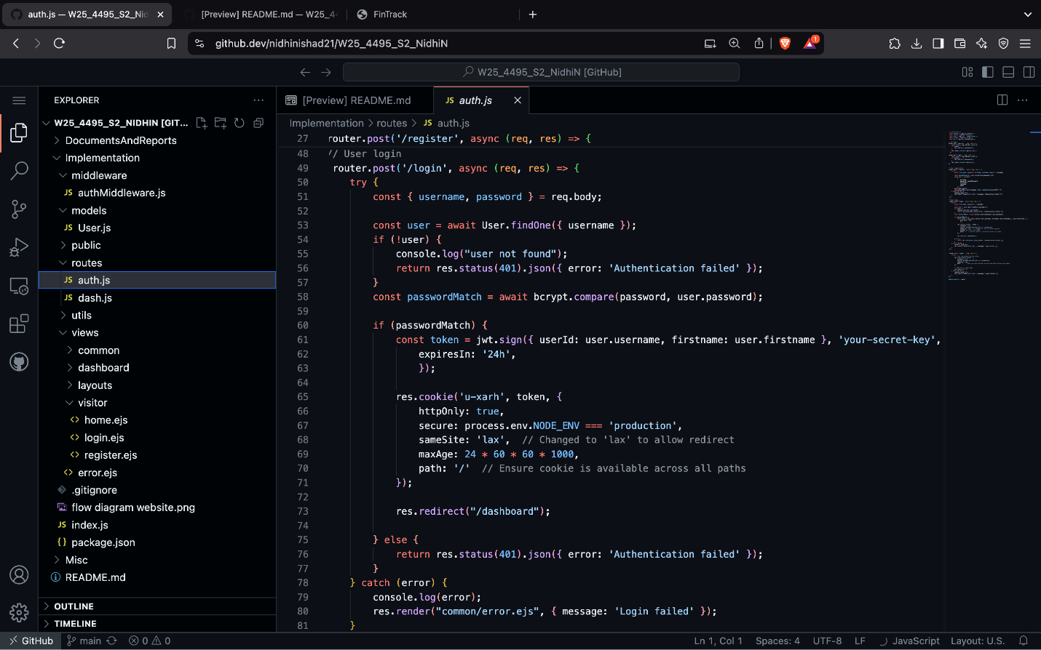Registration Page: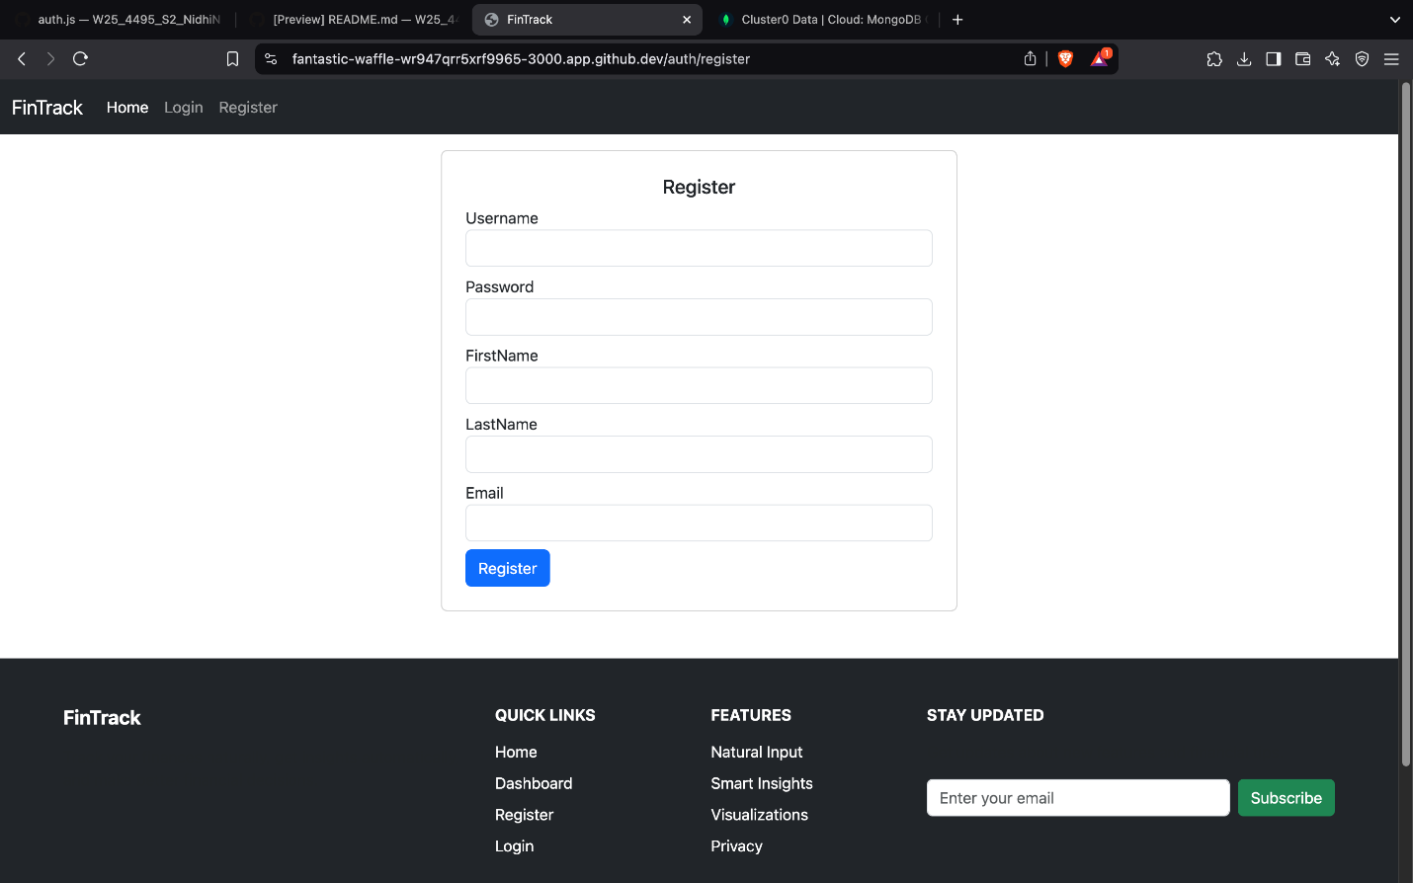

Code sample: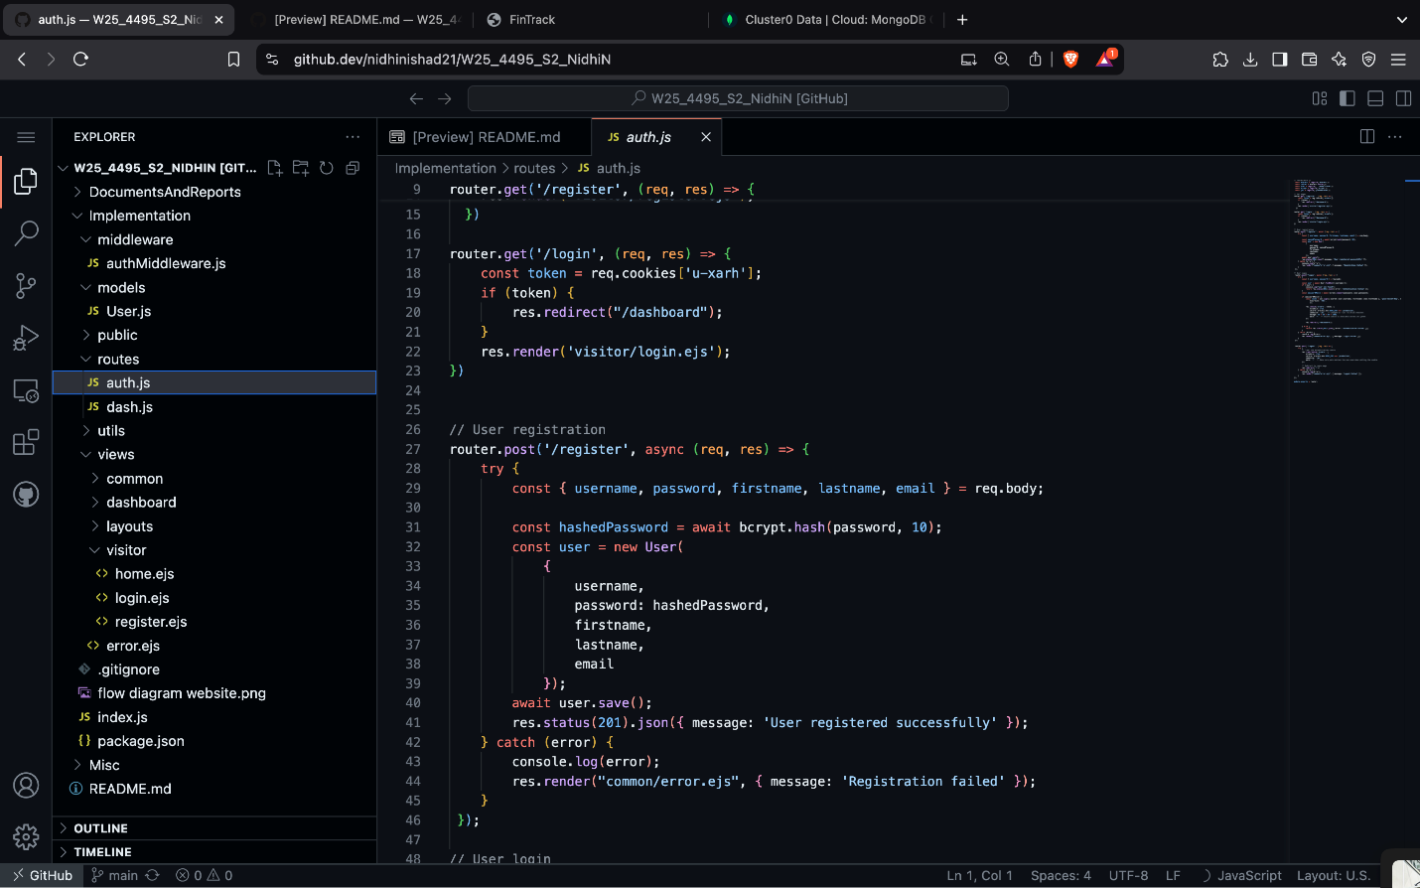

Home Page: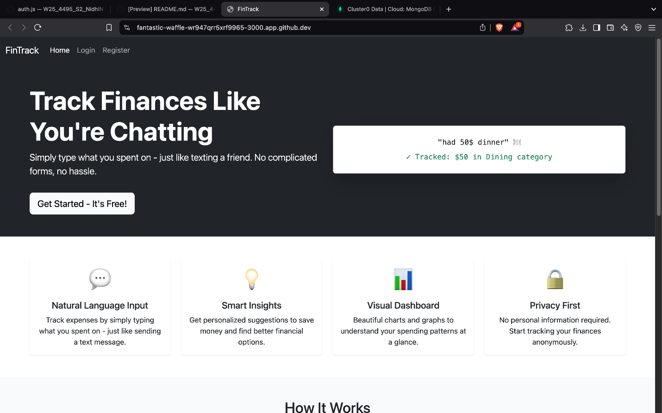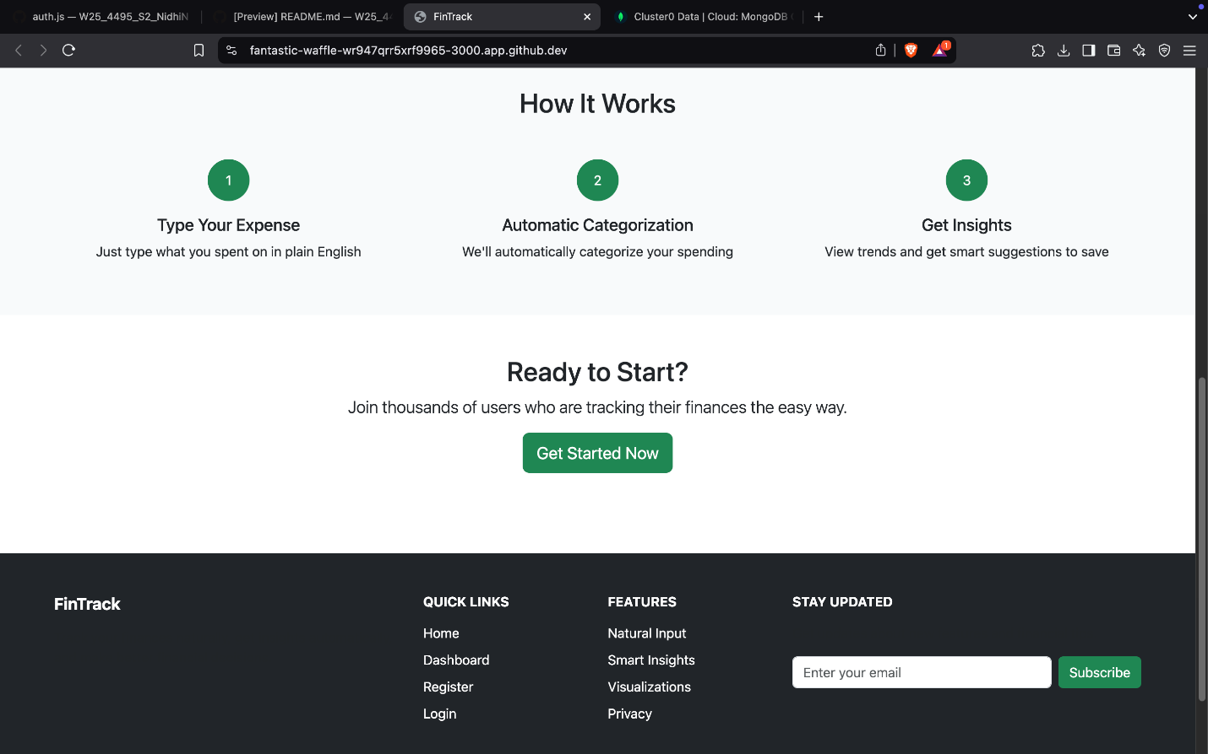Code sample: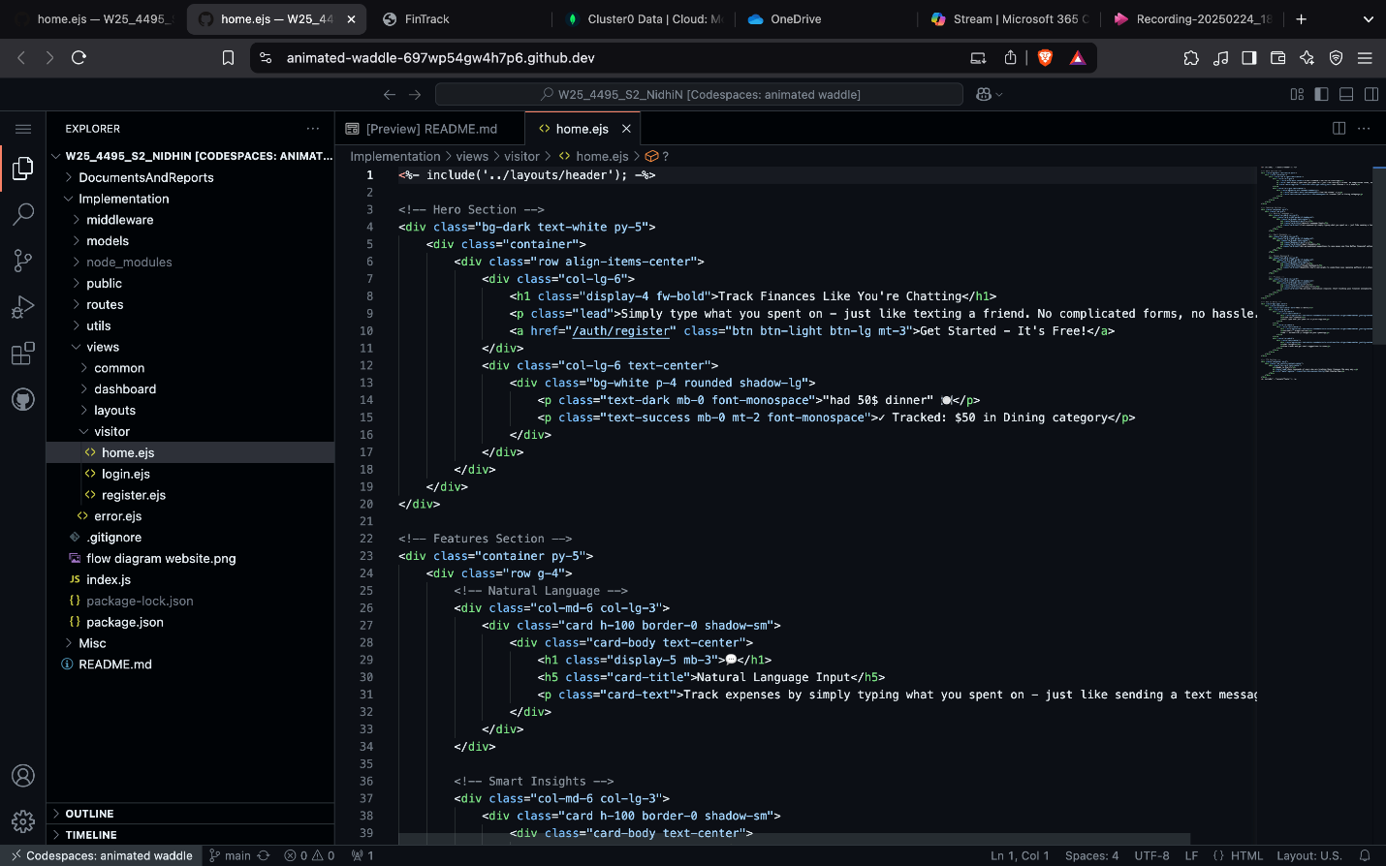

### **Dashboard design**

For logged user:  
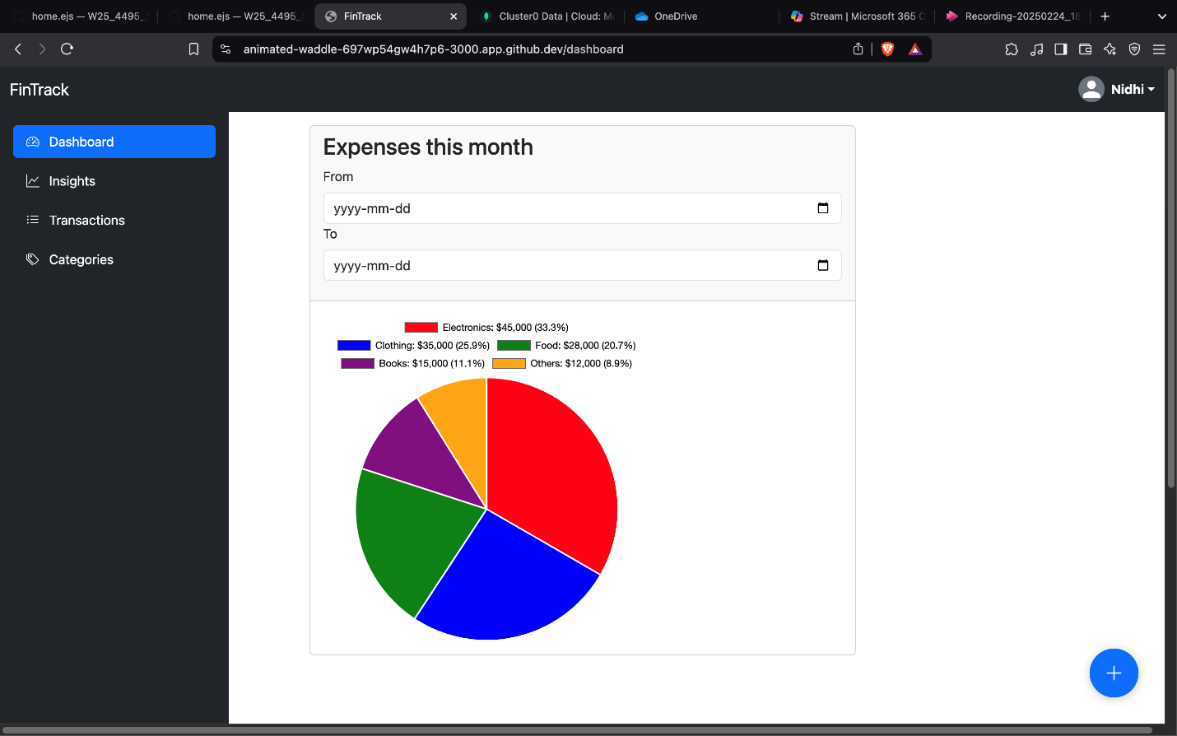

Expense Visualization  
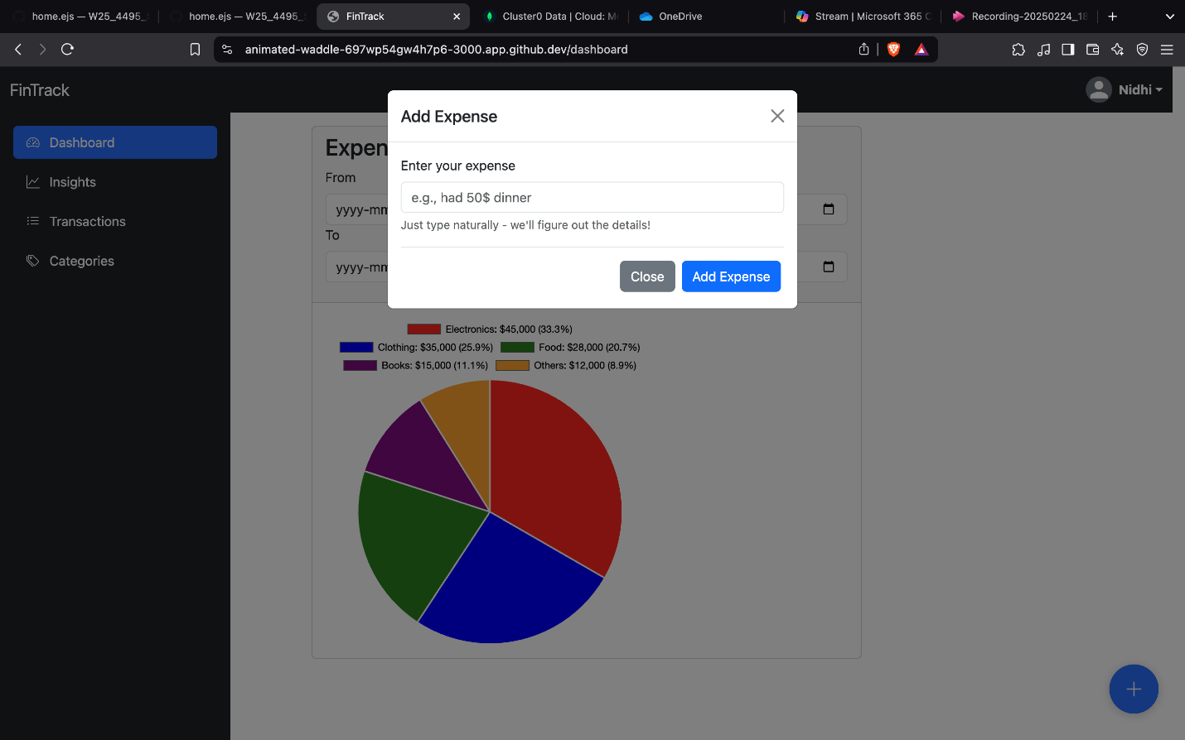

Code sample: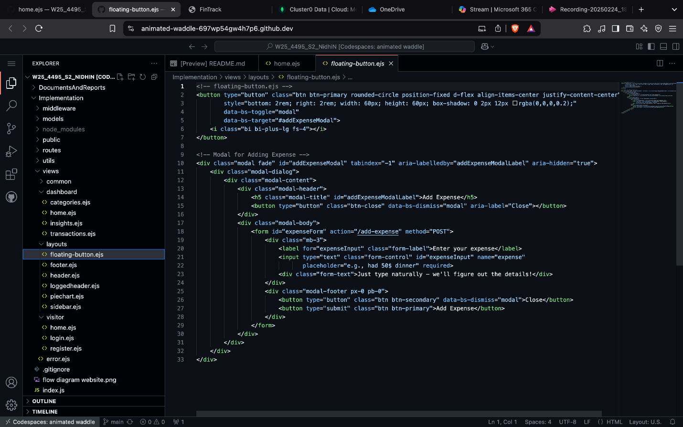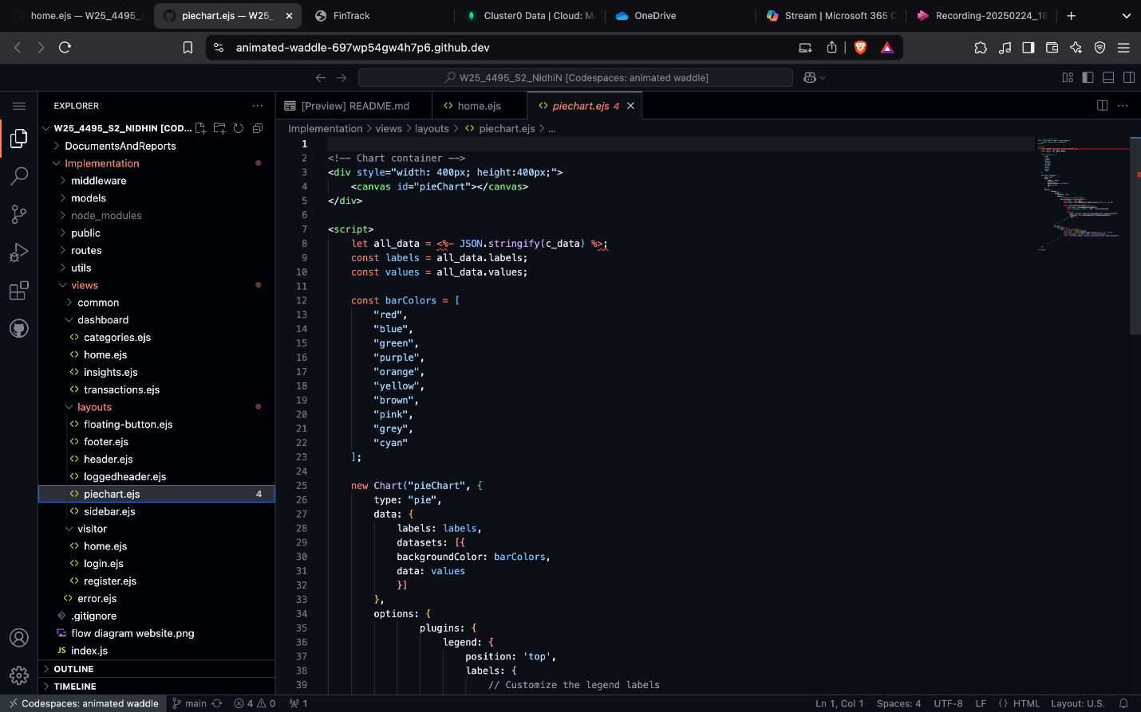

Code sample: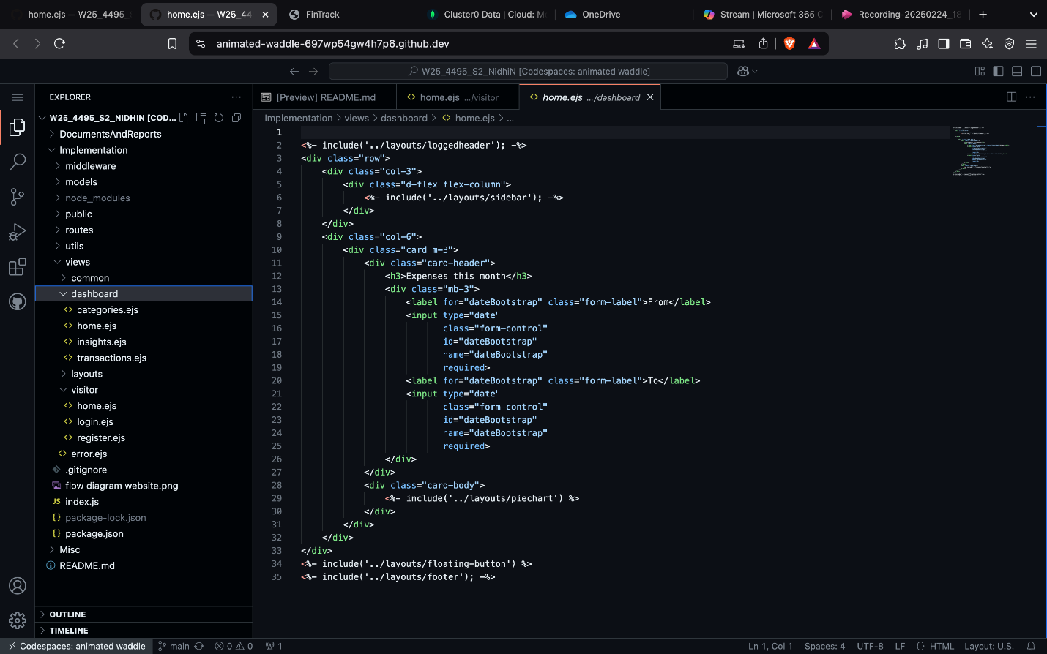

# Work Date/Hours Log

# Closing and References

* MongoDB Documentation. (2023). <https://www.mongodb.com/docs/>
* Node.js Documentation. <https://nodejs.org/>
* Express.js Documentation. <https://expressjs.com/>
* Bootstrap Documentation. <https://getbootstrap.com/>
* EJS Documentation. <https://ejs.co/>
* Chart.js Documentation. <https://www.chartjs.org/docs/latest/>
* Bcrypt Documentation. <https://github.com/kelektiv/node.bcrypt.js/>
* Stack Overflow <https://stackoverflow.com/>
* Passport.js <https://www.passportjs.org/docs/>