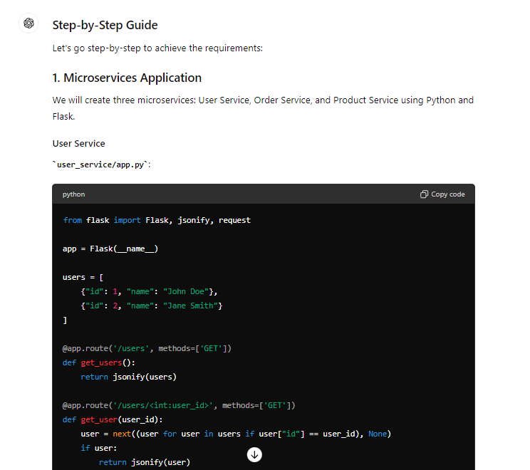

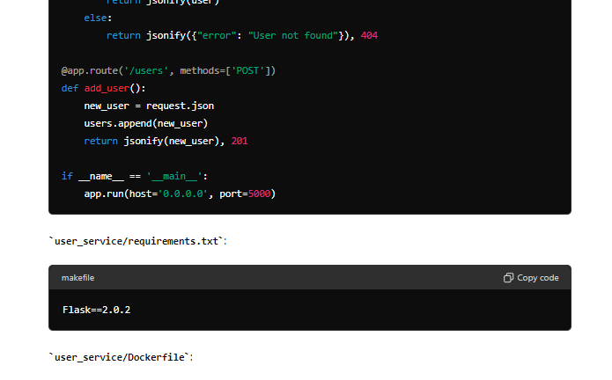

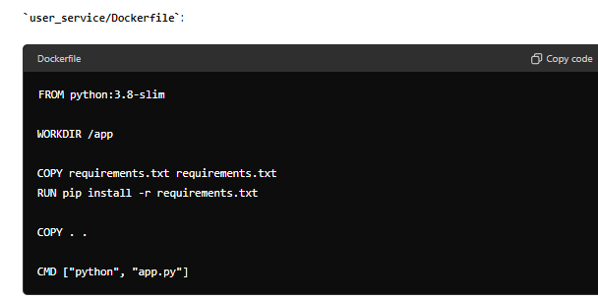

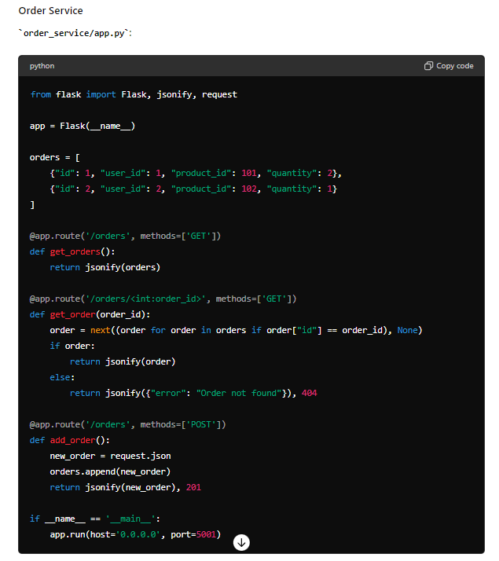

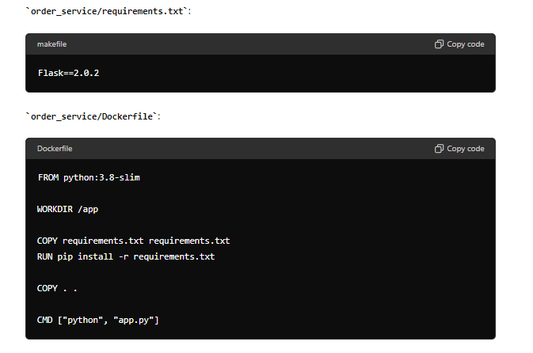

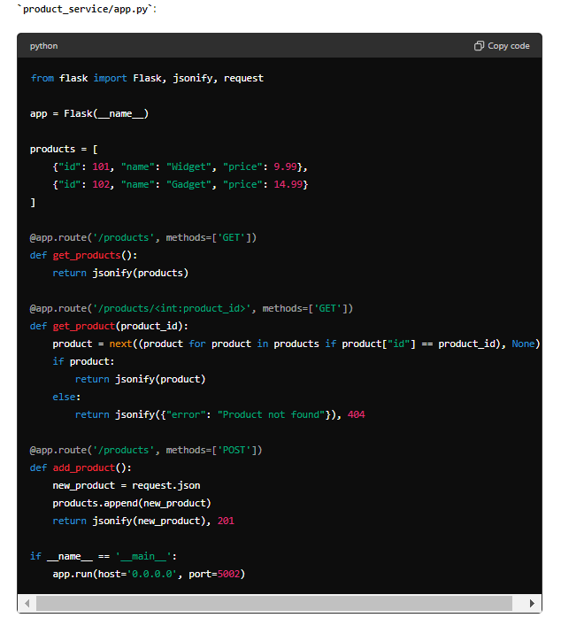

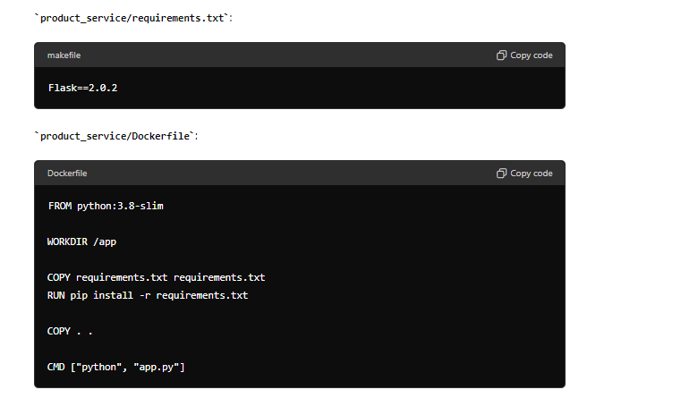

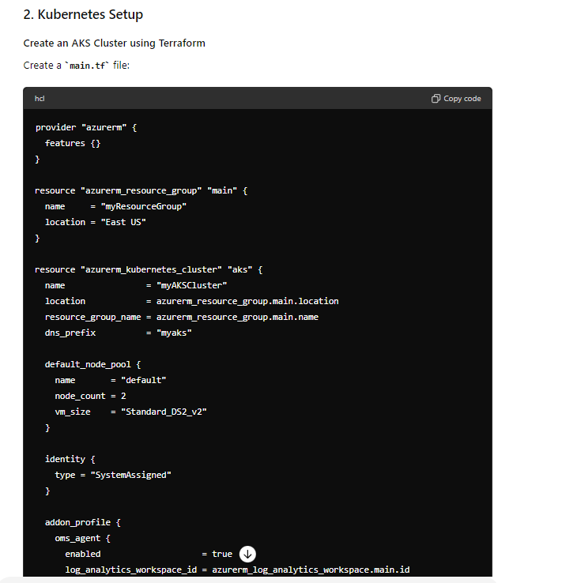

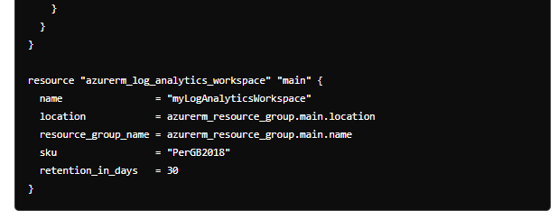

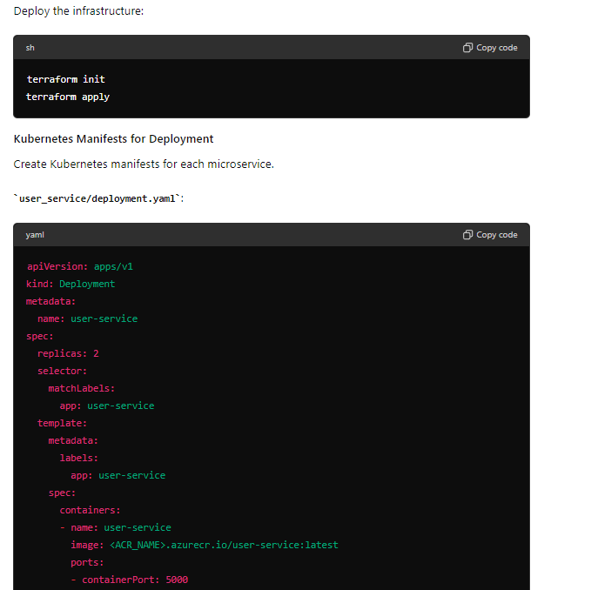

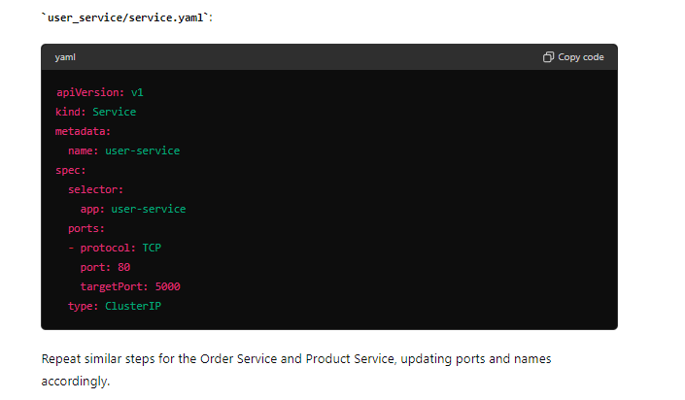

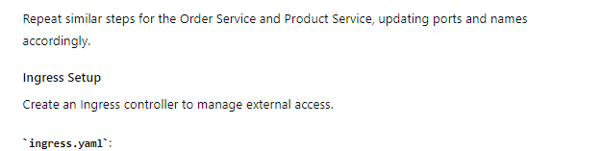

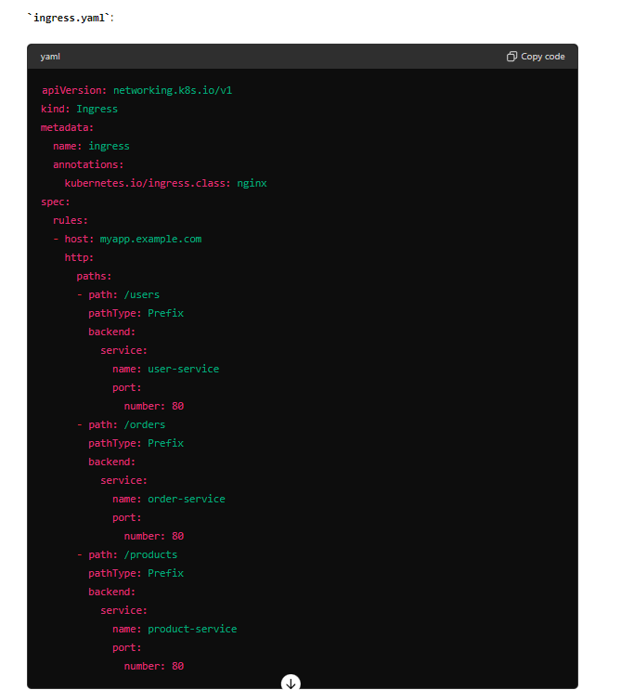

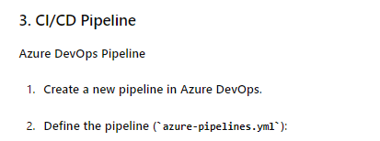

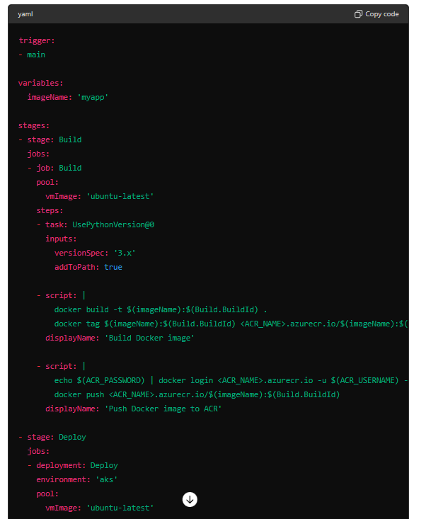

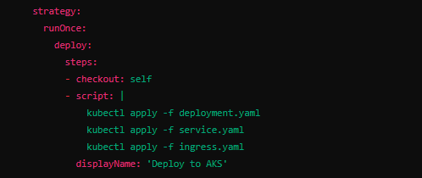

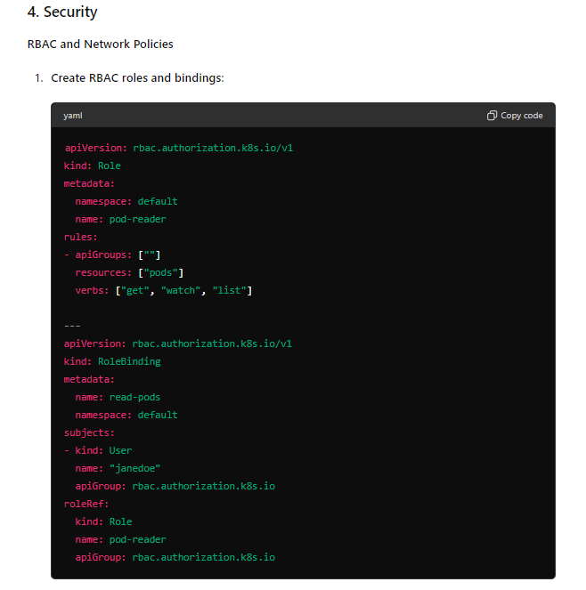

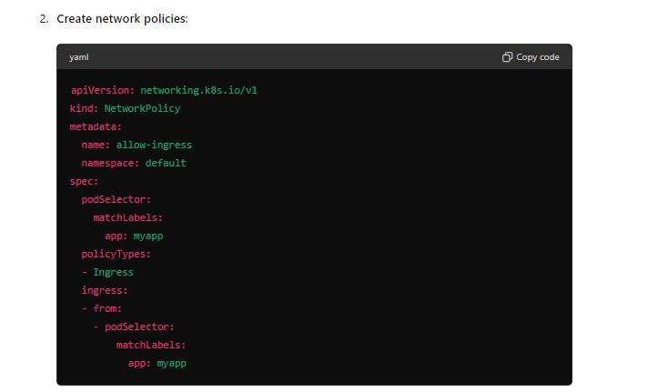

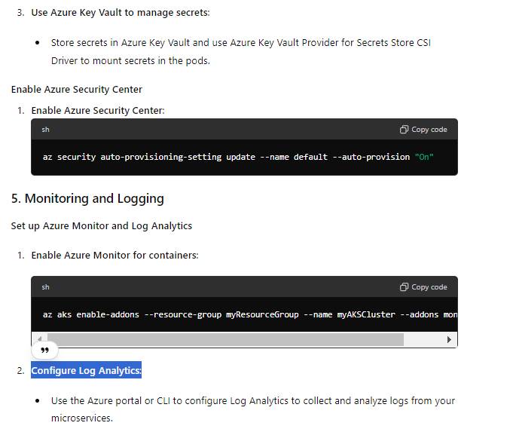

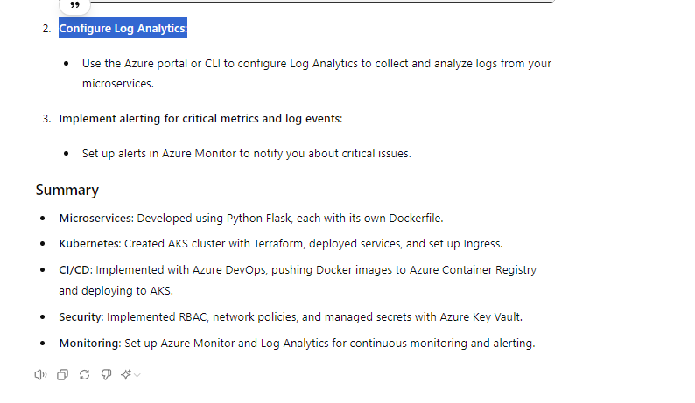

## Table of Contents

1. Microservices Application
   * User Service
   * Order Service
   * Product Service
2. Kubernetes Setup
   * Creating AKS Cluster with Terraform
   * Deploying Microservices
   * Ingress Setup
3. CI/CD Pipeline
4. Security
   * RBAC and Network Policies
   * Azure Key Vault
5. Monitoring and Logging

## 1. Microservices Application

### Overview

We will create three microservices: User Service, Order Service, and Product Service using Python Flask.

### User Service

**user_service/app.py**

user_service/requirements.txt

user_service/Dockerfile

### Order Service

order_service/app.py

Product Service

## . Kubernetes Setup

### Overview

We will set up a Kubernetes cluster on Azure Kubernetes Service (AKS), deploy our microservices, and configure ingress for external access.

### Creating AKS Cluster with Terraform

#### Create Terraform Configuration

Create a main.tf file:

**Deploy the Infrastructure**

1. Initialize Terraform:

sh

Copy code

terraform init

1. Apply the configuration:

sh

Copy code

terraform apply

### Deploying Microservices

#### Create Kubernetes Manifests

Create manifests for each microservice.

**user_service/deployment.yaml**

### Ingress Setup

Create an Ingress controller to manage external access.

**ingress.yaml**

## . CI/CD Pipeline

### Overview

We will set up a CI/CD pipeline in Azure DevOps to automate the build, test, and deployment process.

### Azure DevOps Pipeline

#### Create a New Pipeline

1. Sign in to your Azure DevOps organization and navigate to your project.
2. Go to Pipelines and create a new pipeline.
3. Choose the repository containing your microservices.

#### Define the Pipeline

Create a file named azure-pipelines.yml in your repository:

**IMPORTANT NOTE**

**Replace <ACR_NAME>, <ACR_USERNAME>, and <ACR_PASSWORD> with your Azure Container Registry details.**

## 4. Security

### Overview

We will implement Role-Based Access Control (RBAC) and network policies in the AKS cluster, use Azure Key Vault to manage secrets, and enable Azure Security Center for continuous security assessment.

### RBAC and Network Policies

#### Create RBAC Roles and Bindings

Create a file named rbac.yaml:

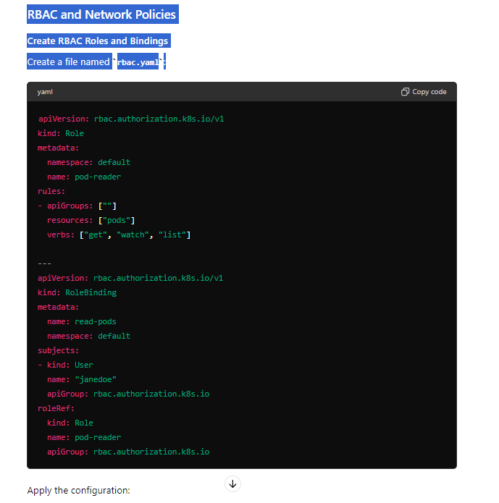

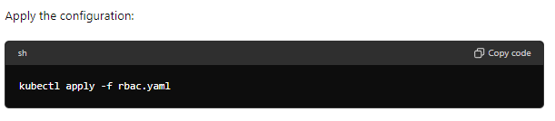

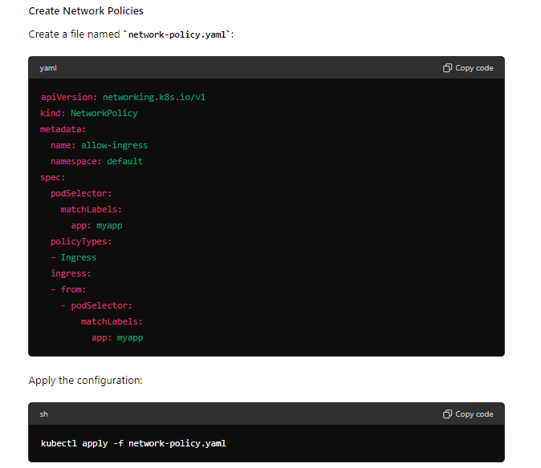

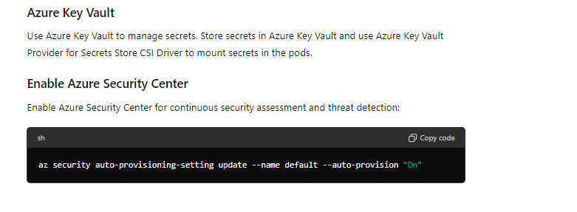

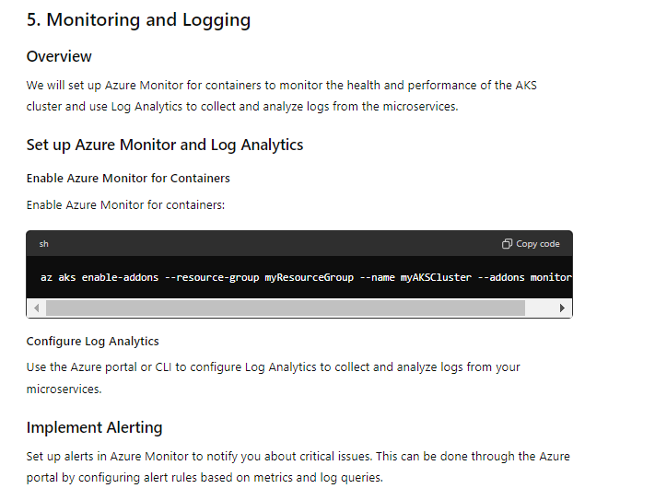

**Explain to interviewer**

When explaining the complete microservices application setup with an interviewer, you should focus on clarity, demonstrating your knowledge, and highlighting your hands-on experience with each step. Here's a structured approach to explaining the entire process:

**Introduction**

1. **Overview**: Start with a high-level overview of what you’ve done:
   * Developed three microservices (User Service, Order Service, Product Service) using Python Flask.
   * Deployed them to an AKS (Azure Kubernetes Service) cluster.
   * Set up a CI/CD pipeline using Azure DevOps.
   * Implemented security measures using RBAC and network policies.
   * Used Azure Key Vault for secrets management.
   * Enabled monitoring and logging using Azure Monitor and Log Analytics.

**1. Microservices Application**

**Explanation**:

* **Development**: "I developed three microservices using Python Flask, each responsible for different aspects of the application. The User Service manages user data, the Order Service handles orders, and the Product Service manages product information."

**Details**:

* **User Service**:
  + Basic CRUD operations for user data.
  + Dockerfile for containerization.
* **Order Service**:
  + CRUD operations for order management.
  + Dockerfile included.
* **Product Service**:
  + Handles CRUD for product data.
  + Containerized with Dockerfile.

**2. Kubernetes Setup**

**Explanation**:

* **AKS Cluster**: "I used Terraform to create an AKS cluster with at least two nodes. Terraform allowed for infrastructure as code, making the setup reproducible and manageable."

**Details**:

* **Terraform Script**:
  + Described how the script provisions the AKS cluster and related resources.
* **Deployment**:
  + Kubernetes manifests for deploying each microservice.
  + Services and Ingress configuration to expose the microservices within the cluster and manage external access.

**3. CI/CD Pipeline**

**Explanation**:

* **Azure DevOps**: "I set up a CI/CD pipeline using Azure DevOps to automate the build, test, and deployment processes. This ensures that any changes in the codebase are automatically built into Docker images, pushed to Azure Container Registry, and deployed to the AKS cluster."

**Details**:

* **Pipeline Configuration**:
  + Build stage: Docker image creation and pushing to ACR.
  + Deploy stage: Kubernetes deployment using the updated images.

**4. Security**

**Explanation**:

* **RBAC and Network Policies**: "To secure the AKS cluster, I implemented RBAC to control access to resources and network policies to manage the traffic between pods."

**Details**:

* **RBAC**:
  + Created roles and role bindings to restrict permissions.
* **Network Policies**:
  + Policies to allow or restrict traffic based on pod labels.
* **Azure Key Vault**:
  + Used for managing sensitive data and secrets.
* **Azure Security Center**:
  + Enabled for continuous security assessment and threat detection.

**5. Monitoring and Logging**

**Explanation**:

* **Azure Monitor**: "To ensure the application's health and performance, I set up Azure Monitor for containers and configured Log Analytics to collect and analyze logs from the microservices."

**Details**:

* **Azure Monitor**:
  + Enabled for the AKS cluster to monitor container performance.
* **Log Analytics**:
  + Configured to aggregate logs from all services.
  + Alerts set up for critical issues based on metrics and logs.

**Conclusion**

1. **Summarize**: "In summary, I developed a complete microservices application with robust deployment, security, and monitoring processes. Each microservice is independently scalable and maintainable, and the entire system is monitored for performance and security."
2. **Discussion**: "I'd be happy to dive deeper into any specific part of this setup or discuss any challenges I faced and how I addressed them."

**Tips for Explaining to an Interviewer**

* **Be Clear and Concise**: Avoid jargon and keep explanations simple unless the interviewer asks for more technical details.
* **Highlight Your Role**: Make it clear what your contributions were, especially if it was a team effort.
* **Use Examples**: Where possible, use examples or anecdotes to illustrate your points.
* **Be Ready for Questions**: Anticipate follow-up questions and be prepared to dive deeper into each area.

This structured approach ensures that you cover all critical aspects of the project while demonstrating your technical skills and understanding of the entire process.

**Expecting issues**

When working on a microservices application deployed on Kubernetes with a CI/CD pipeline, several issues can arise. Here's a list of potential problems and how to troubleshoot them:

**1. Development and Build Issues**

**Issue: Code Errors and Dependencies**

**Symptoms**: Build failures, runtime errors, missing dependencies. **Troubleshooting**:

* **Unit Testing**: Ensure thorough unit tests to catch errors early.
* **Dependency Management**: Use tools like pipenv or requirements.txt for Python dependencies.
* **Error Logs**: Check logs for errors during the build process.

**2. Docker and Container Issues**

**Issue: Docker Build Failures**

**Symptoms**: Errors while building Docker images. **Troubleshooting**:

* **Dockerfile Syntax**: Verify the Dockerfile syntax and commands.
* **Build Context**: Ensure the correct files are included in the build context.
* **Dependencies**: Make sure all dependencies are installed properly in the Dockerfile.

**Issue: Container Startup Failures**

**Symptoms**: Containers crash or fail to start. **Troubleshooting**:

* **Log Inspection**: Check container logs using docker logs <container_id>.
* **Configuration Files**: Verify configuration files are correct and accessible.
* **Health Checks**: Implement and review health checks to diagnose startup issues.

**3. Kubernetes Deployment Issues**

**Issue: Pod Failures**

**Symptoms**: Pods are in CrashLoopBackOff or Error states. **Troubleshooting**:

* **Pod Logs**: Use kubectl logs <pod_name> to check logs.
* **Describe Pod**: Use kubectl describe pod <pod_name> to get detailed information.
* **Resource Limits**: Ensure that resource requests and limits are correctly set.

**Issue: Service Discovery and Networking**

**Symptoms**: Services are not accessible, DNS issues. **Troubleshooting**:

* **Service and Endpoints**: Check services and endpoints using kubectl get svc and kubectl get endpoints.
* **Network Policies**: Verify network policies are correctly configured and not overly restrictive.
* **DNS Resolution**: Use tools like nslookup or dig inside the cluster to test DNS resolution.

**Issue: Ingress Configuration**

**Symptoms**: External access issues, 404 errors. **Troubleshooting**:

* **Ingress Rules**: Verify ingress rules are correctly configured.
* **Ingress Controller**: Ensure the ingress controller is properly deployed and running.
* **Logs**: Check logs of the ingress controller for errors.

**4. CI/CD Pipeline Issues**

**Issue: Pipeline Failures**

**Symptoms**: CI/CD pipeline stages fail. **Troubleshooting**:

* **Pipeline Logs**: Review logs for each pipeline stage.
* **Script Errors**: Check for errors in build and deployment scripts.
* **Environment Variables**: Ensure all necessary environment variables are set.

**Issue: Docker Push Failures**

**Symptoms**: Docker images fail to push to Azure Container Registry (ACR). **Troubleshooting**:

* **Authentication**: Verify ACR login credentials.
* **Image Tags**: Ensure image tags are correctly specified.
* **Network Issues**: Check for network connectivity issues to ACR.

**5. Security Issues**

**Issue: Access Denied Errors**

**Symptoms**: Unauthorized access errors. **Troubleshooting**:

* **RBAC Configuration**: Check RBAC roles and bindings.
* **Secrets Management**: Verify access to secrets stored in Azure Key Vault.
* **Logs**: Review security logs for unauthorized access attempts.

**6. Monitoring and Logging Issues**

**Issue: Lack of Metrics or Logs**

**Symptoms**: Missing or incomplete metrics/logs. **Troubleshooting**:

* **Azure Monitor Configuration**: Verify that Azure Monitor is correctly configured.
* **Log Analytics Workspace**: Ensure logs are being sent to the correct Log Analytics workspace.
* **Agent Deployment**: Check if monitoring agents are deployed and running on all nodes.

**Issue: Alerting Issues**

**Symptoms**: Missing or incorrect alerts. **Troubleshooting**:

* **Alert Rules**: Verify that alert rules are correctly configured.
* **Thresholds**: Ensure alert thresholds are appropriate for your application.
* **Test Alerts**: Manually test alerts to ensure they trigger correctly.

**General Troubleshooting Steps**

1. **Logs and Metrics**: Always start by checking logs and metrics for any anomalies.
2. **Documentation**: Refer to official documentation for any tools or services you are using.
3. **Community and Support**: Use forums, community support channels, and official support if you are stuck.
4. **Rollback**: Have a rollback strategy to revert to the last known good state if a deployment fails.
5. **Incremental Changes**: Make small, incremental changes to identify the exact point of failure.

By anticipating these issues and knowing how to troubleshoot them, you can confidently explain your approach and demonstrate your problem-solving skills to the interviewer.

**Impress interviewer**

o enhance the structure and impress the interviewer while discussing your microservices application setup, consider including the following additional elements:

**1. Architecture Diagram**

* **Overview Diagram**: Provide a high-level architecture diagram that illustrates how the microservices interact with each other, how they communicate within the AKS cluster, and how external users or systems access them through the Ingress controller.
* **Components**: Label each component (microservices, Kubernetes resources, CI/CD pipeline, Azure services) with brief descriptions to provide a visual aid that enhances understanding.

**2. Performance and Scalability Considerations**

* **Scalability**: Discuss how the microservices are designed to scale horizontally within the AKS cluster. Explain strategies such as Kubernetes Horizontal Pod Autoscaler (HPA) based on CPU or custom metrics.
* **Load Testing**: Mention if load testing was performed to validate the application's performance under expected traffic conditions. Share any findings and optimizations made based on these tests.

**3. High Availability and Disaster Recovery**

* **Availability Zones**: If applicable, mention if the AKS cluster spans multiple availability zones for redundancy and high availability.
* **Backup and Restore**: Discuss strategies for data backup (e.g., database backups) and restoration in case of data loss or disaster recovery scenarios.

**4. Compliance and Governance**

* **Compliance**: Highlight any compliance standards (e.g., GDPR, HIPAA) that the application adheres to and how the architecture and security measures support compliance requirements.
* **Governance**: Discuss how RBAC and network policies are enforced to ensure proper governance and security within the AKS cluster.

**5. Infrastructure as Code (IaC)**

* **Terraform**: Explain the advantages of using Terraform for provisioning the AKS cluster and how it supports infrastructure as code principles for repeatability and consistency.
* **Version Control**: Emphasize the use of version control (e.g., Git) for managing infrastructure and deployment configurations alongside application code.

**6. Error Handling and Logging Enhancements**

* **Centralized Logging**: Describe how Log Analytics aggregates logs from all microservices and Kubernetes components, providing a centralized view for troubleshooting and monitoring.
* **Error Handling**: Discuss specific error handling strategies implemented within the microservices to provide meaningful error messages and facilitate easier debugging.

**7. Continuous Improvement and Feedback Loops**

* **Feedback Mechanisms**: If applicable, mention mechanisms such as user feedback, telemetry, or analytics used to gather insights for continuous improvement of the microservices.
* **Iteration**: Share examples of iterations or improvements made based on feedback or monitoring insights, demonstrating a proactive approach to refining the application.

**8. Future Roadmap and Enhancements**

* **Future Enhancements**: Discuss potential future enhancements such as implementing service mesh (e.g., Istio), adopting serverless computing (e.g., Azure Functions), or integrating additional Azure services for enhanced functionality (e.g., Azure Cognitive Services).

**Presentation Tips**

* **Clarity and Structure**: Ensure your explanations are clear, structured, and avoid unnecessary technical jargon unless the interviewer prompts for deeper technical details.
* **Engagement**: Encourage interactive discussion by inviting questions and actively listening to the interviewer's feedback or prompts for clarification.
* **Demonstrate Ownership**: Emphasize your role and contributions throughout the project, showcasing your problem-solving skills and proactive approach to challenges.

By incorporating these additional elements and presenting them effectively, you can provide a comprehensive and impressive overview of your microservices application setup, leaving a positive impression on the interviewer regarding your technical expertise and project management capabilities.

**Additional better services I can implement**

When building and deploying microservices applications on platforms like Azure, several additional services can enhance various aspects such as monitoring, security, scalability, and integration. Here are some additional Azure services that you can consider incorporating into your microservices architecture for improved functionality and management:

**1. Azure Service Bus**

* **Purpose**: Messaging service for reliable communication between microservices and applications.
* **Benefits**: Ensures reliable message delivery with features like queues and topics, supports decoupling of microservices, and scales seamlessly.
* **Use Cases**: Asynchronous communication between microservices, event-driven architectures, and handling bursts of traffic.

**2. Azure Redis Cache**

* **Purpose**: In-memory data store for caching frequently accessed data.
* **Benefits**: Improves application performance by reducing database load, supports data caching for fast retrieval, and provides high availability and scalability.
* **Use Cases**: Session management, API response caching, and reducing latency in data-intensive applications.

**3. Azure Functions**

* **Purpose**: Serverless compute service for executing event-driven code without managing infrastructure.
* **Benefits**: Scales automatically, pay-per-use pricing model, supports various programming languages, and integrates well with other Azure services.
* **Use Cases**: Implementing serverless microservices, event-driven processing, and executing lightweight functions in response to events.

**4. Azure Cosmos DB**

* **Purpose**: Globally distributed, multi-model database service for NoSQL data storage.
* **Benefits**: Provides high availability, low latency, and consistency across multiple regions, supports various data models (document, graph, key-value, etc.), and automatic scaling.
* **Use Cases**: Storing and querying diverse data types, geo-distributed microservices, and real-time analytics.

**5. Azure API Management**

* **Purpose**: Full lifecycle API management service to create, publish, secure, and monitor APIs.
* **Benefits**: Centralizes API management, enforces policies (authentication, throttling, caching), supports analytics and reporting, and facilitates integration with microservices.
* **Use Cases**: Exposing microservices as APIs, managing API versions, and implementing API security and governance.

**6. Azure DevOps Boards**

* **Purpose**: Agile project management tool for planning, tracking, and discussing work across teams.
* **Benefits**: Integrates seamlessly with Azure Pipelines, supports agile methodologies (Scrum, Kanban), provides visibility into project progress, and facilitates collaboration.
* **Use Cases**: Managing sprint backlogs, tracking user stories and tasks, and monitoring project metrics and performance.

**7. Azure Cognitive Services**

* **Purpose**: AI-powered APIs for adding cognitive capabilities (vision, speech, language, etc.) to applications without requiring deep AI expertise.
* **Benefits**: Enables advanced functionality like image recognition, natural language processing, and personalized recommendations, integrates easily with Azure applications, and supports rapid development.
* **Use Cases**: Enhancing microservices with AI capabilities, automating document processing, and improving user interaction with intelligent features.

**Integration and Best Practices**

* **Service Bus and Event Grid**: Use Azure Service Bus or Azure Event Grid for event-driven communication between microservices.
* **Monitoring and Analytics**: Implement Azure Monitor and Application Insights for comprehensive monitoring, logging, and analytics.
* **Security and Identity**: Leverage Azure Active Directory for identity management, Azure Key Vault for secret storage, and Azure Security Center for threat detection and compliance.

By strategically integrating these Azure services into your microservices architecture, you can enhance performance, scalability, security, and operational efficiency while leveraging the benefits of cloud-native solutions. When discussing these choices in an interview, emphasize how each service addresses specific architectural needs and contributes to the overall robustness and maintainability of your microservices application.