10/9/2021

Nidhi Prajapati

*Full Stack Developer*

Lockers Pvt. Ltd.

LockedMe.com

Project Specification Document

Table of Contents

Project Capabilities 2

Appearance 3

Welcome Screen 3

User Choosing Invalid Option - Handling 3

User selected first option to show all the files – which by default shows in alphabetic order 4

User Selecting second option to sort files in reverse alphabetic order 5

User selecting third option to add a new file with some text content in it. 6

Deleting a file from the folder 7

Searching a file 8

Searching an invalid file 9

Exiting from the application 10

User Interaction 11

Sprint Details 12

Developer Details 13

Algorithm & Flow Chart 14

Core Concepts Used 15

GITHUB Details 16

Conclusion on enhancing the project and USP 17

# Project Capabilities

1. User will be provided with different options like:
   1. View all available files in a folder
   2. Sort the files names alphabetically and in revers alphabetic order
   3. Delete a file provided by User from the folder
   4. Add a new file and also updating content of the file
   5. Searching a file name in the folder
2. The application is very interactive, and takes all the input from the User directly.
3. The view all files also take any file in the sub directory.
4. The add new file also features to update the content of the file, directly from the User.
5. User is provided with the interactive menu, which keep existing unless user decides to choose exit option.
6. The application is scalable.

# Appearance

## Welcome Screen

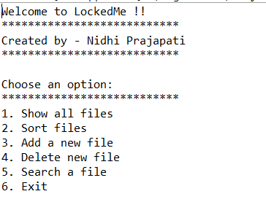

## User Choosing Invalid Option - Handling

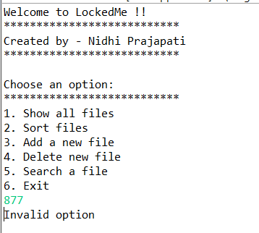

## User selected first option to show all the files – which by default shows in alphabetic order

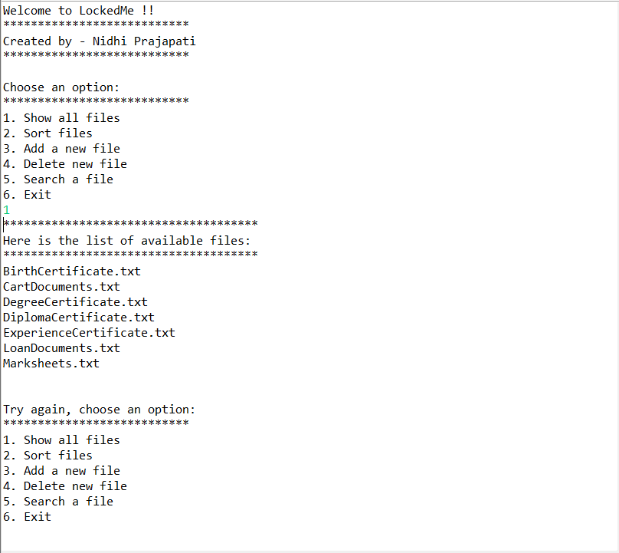

## User Selecting second option to sort files in reverse alphabetic order

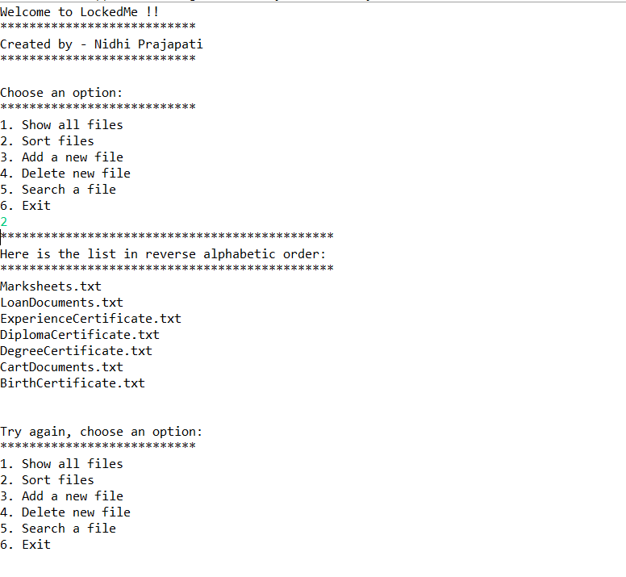

## User selecting third option to add a new file with some text content in it.

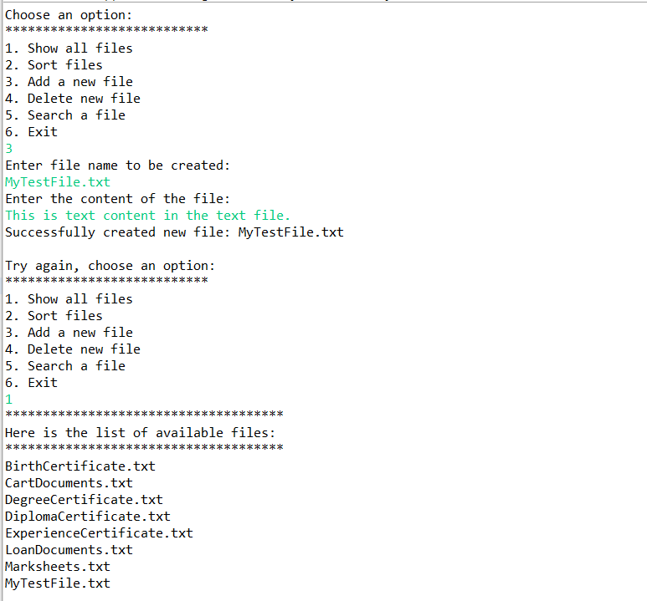

## Deleting a file from the folder

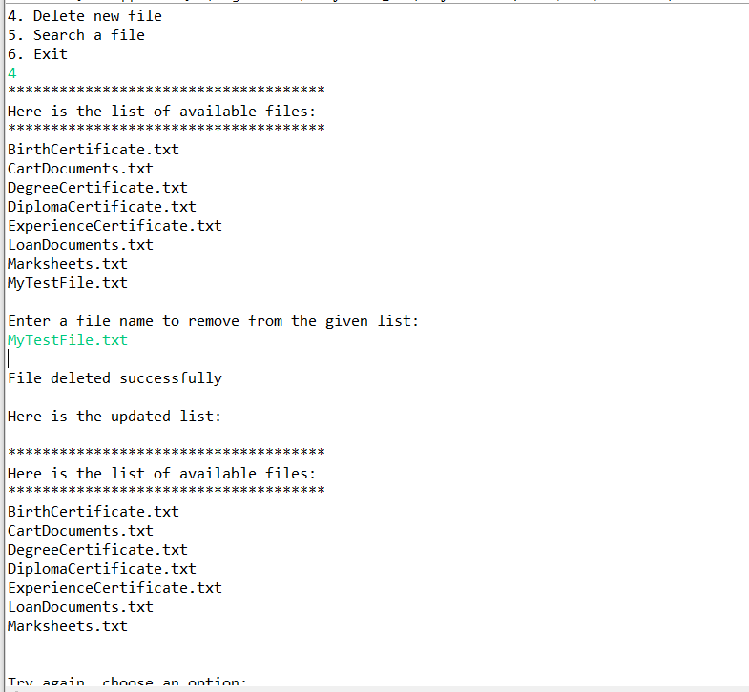

## Searching a file

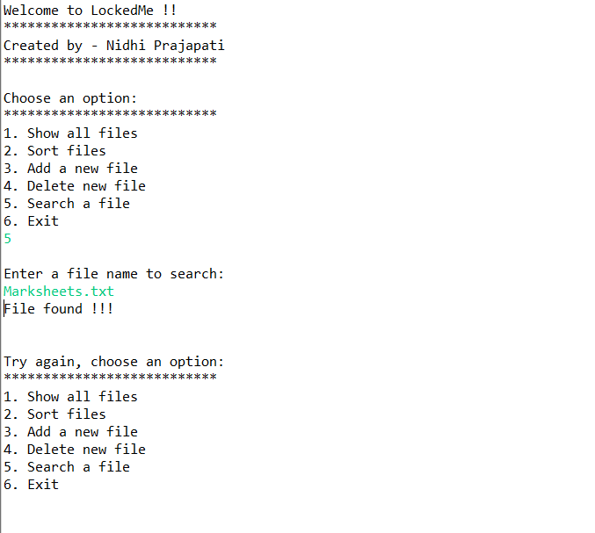

## Searching an invalid file

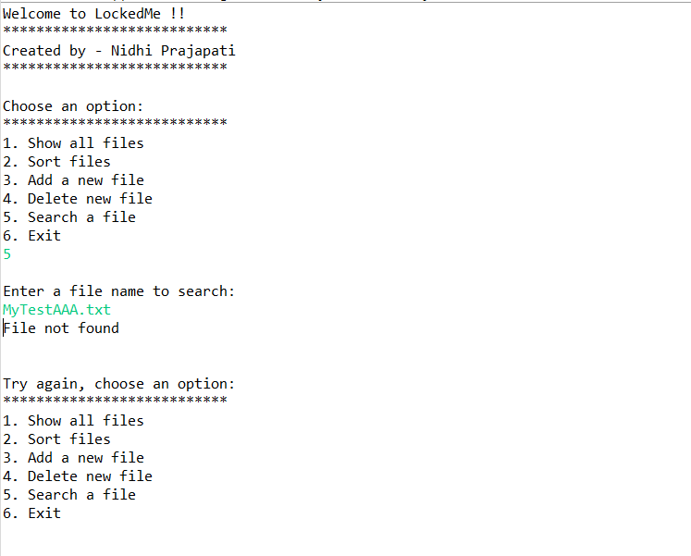

## Exiting from the application

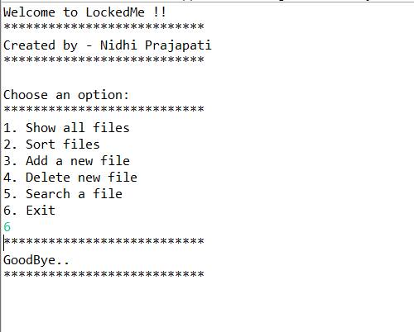

# User Interaction

# Sprint Details

# Developer Details

# Algorithm & Flow Chart

# Core Concepts Used

# GITHUB Details

# Conclusion on enhancing the project and USP