CSE 581

**Lab 6: Selects with Data Types**

**Nidhi Surya Prakash**

**SUID: 215895619**

**Purpose:**

Do SQL selections against the *Northwind* database.

**Deliverables:**

Multiple screenshots, showing your NETID, query code, last lines of datasets & time stamp, as described through the lab.

Scripts that you used to carry out the actions.

Submit electronic version to Blackboard.

1. Select all data from the Orders table, ordered by OrderDate, newest date on top, for orders shipped between January 1997 and August 1997.

Script: SELECT * FROM ORDERS WHERE ShippedDate

BETWEEN '1997-01-01' AND '1997-08-31' ORDER BY OrderDate DESC

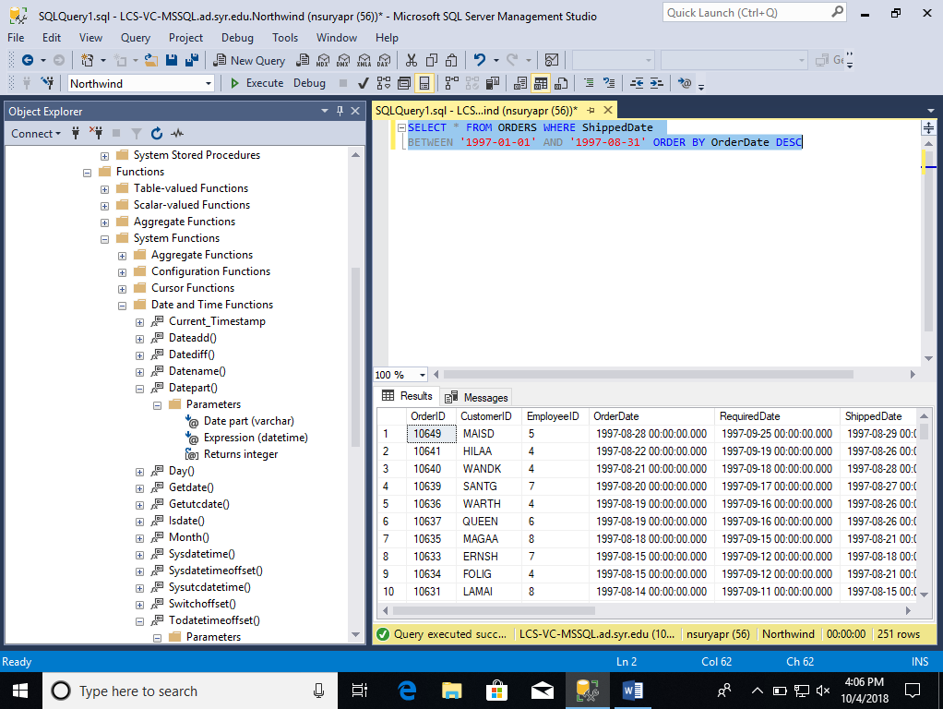

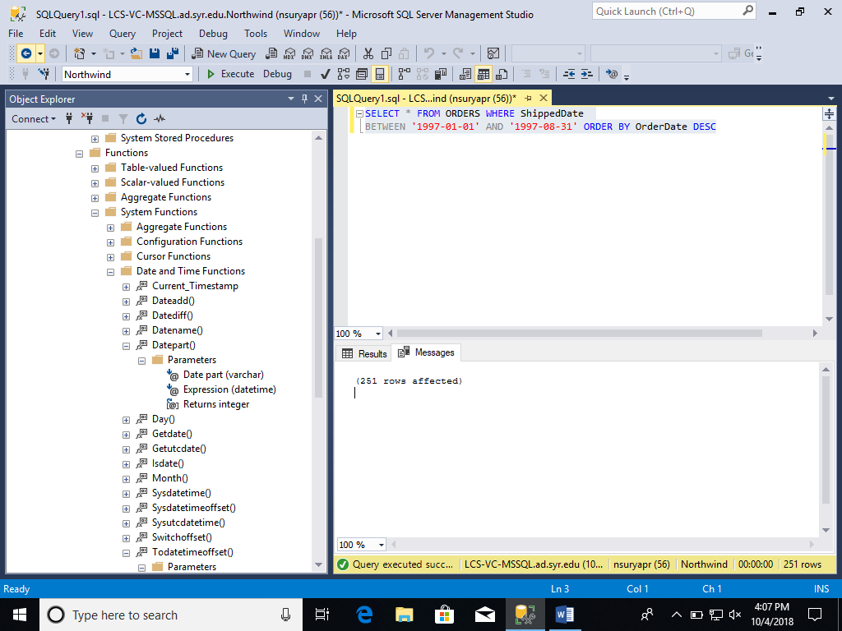

1. Select all data from the Orders table, ordered by OrderDate, newest date on top, for orders placed between July 1996 and January 1997.

Script: SELECT * FROM ORDERS WHERE OrderDate

BETWEEN '1996-07-01' AND '1997-01-31' ORDER BY OrderDate DESC

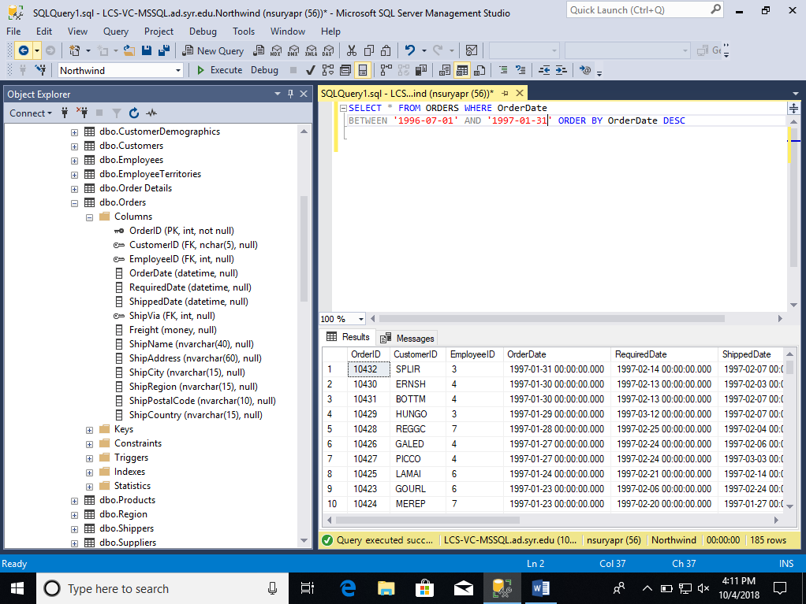

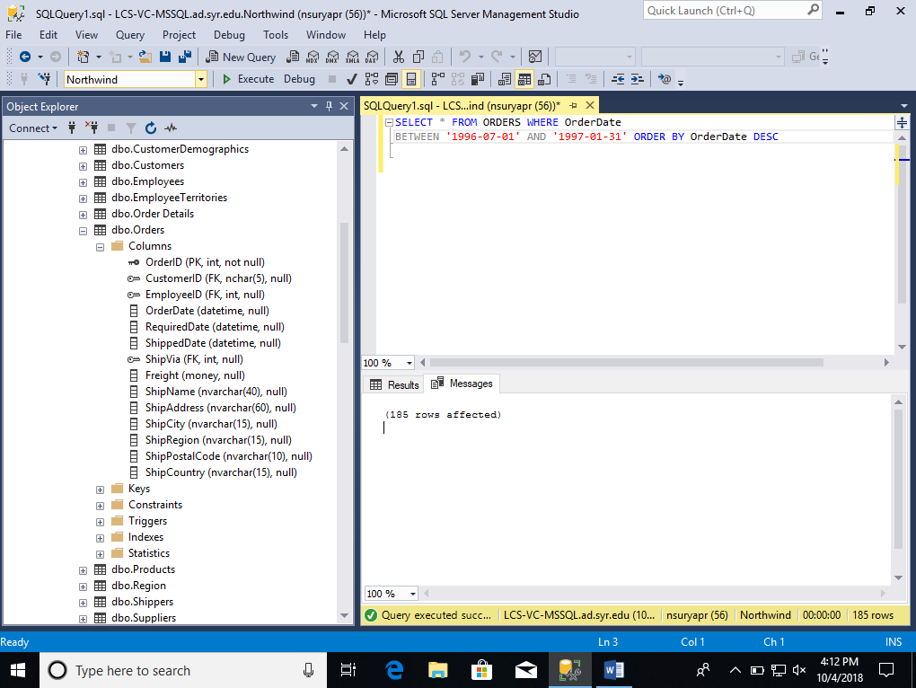

1. Select all data from the Orders table, for orders placed in January 1998.

Script: SELECT * FROM ORDERS WHERE YEAR(OrderDate)=1998 AND MONTH(OrderDate)=01

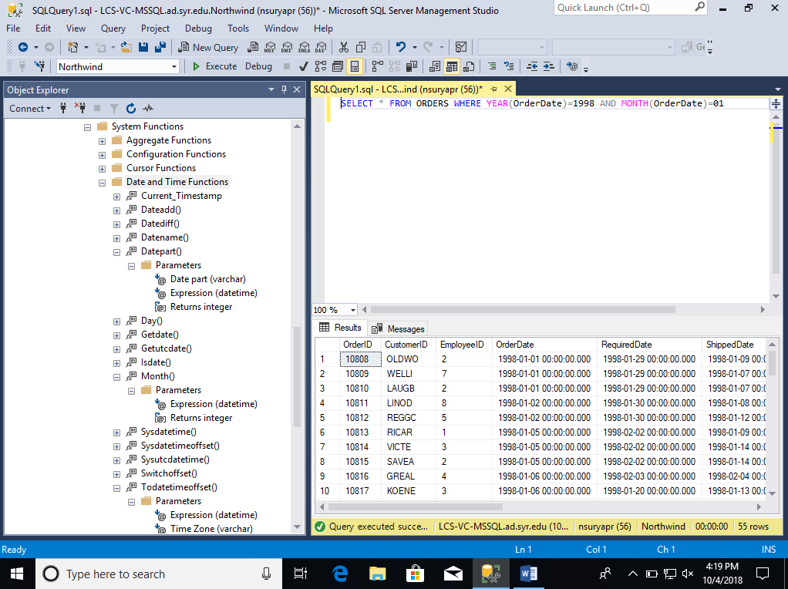

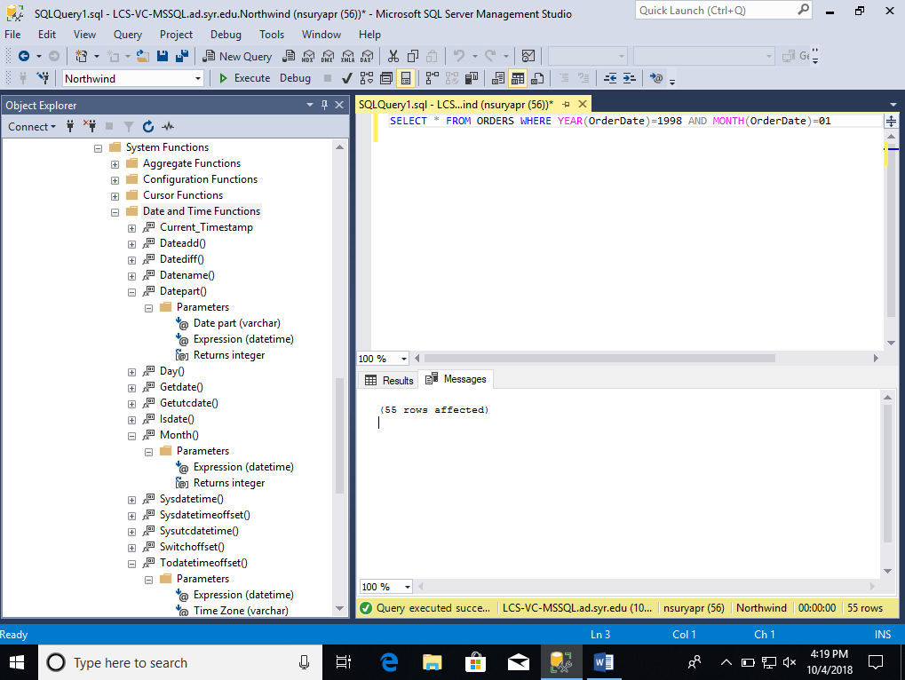

1. Select count of Orders shipped in 1996, 1997 and 1998. (one query containing all values) -> 2 columns (count and year), 3 rows (1 row per year).

Script: SELECT COUNT(*) AS COUNT, YEAR(ShippedDate) AS YEAR FROM ORDERS

WHERE YEAR(ShippedDate) IN (1996,1997,1998) GROUP BY YEAR(ShippedDate)

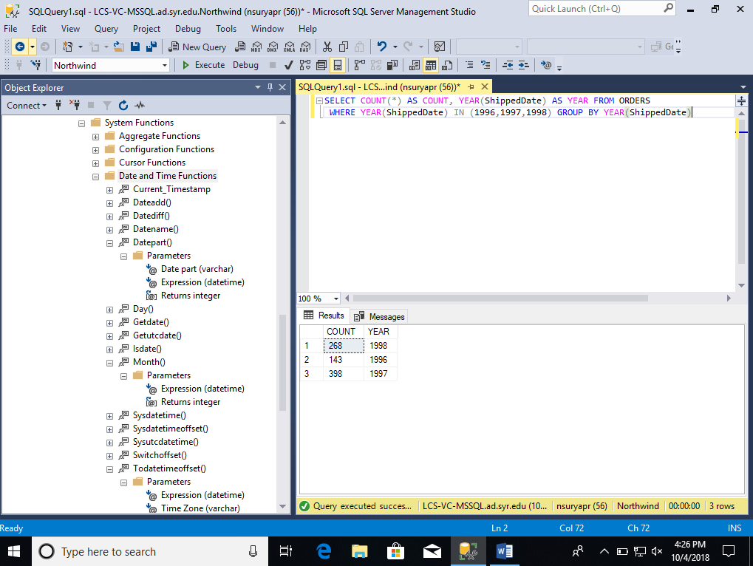

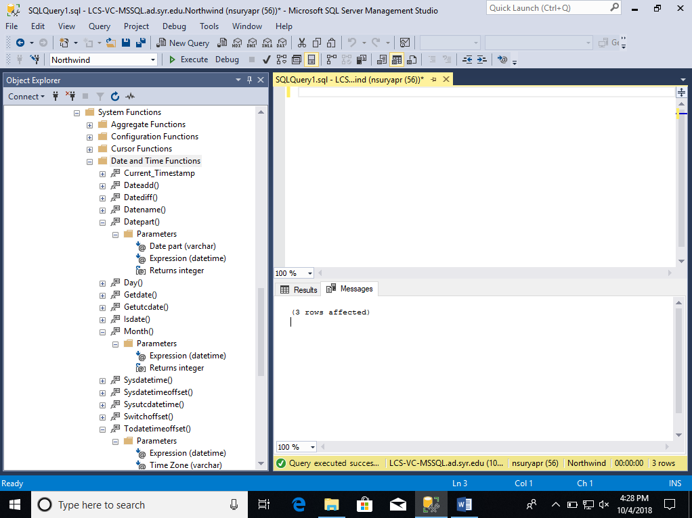

1. Select all records from Employee table that any title related to “Sale”.

Script: SELECT * FROM Employees WHERE Title LIKE '%SALES%'

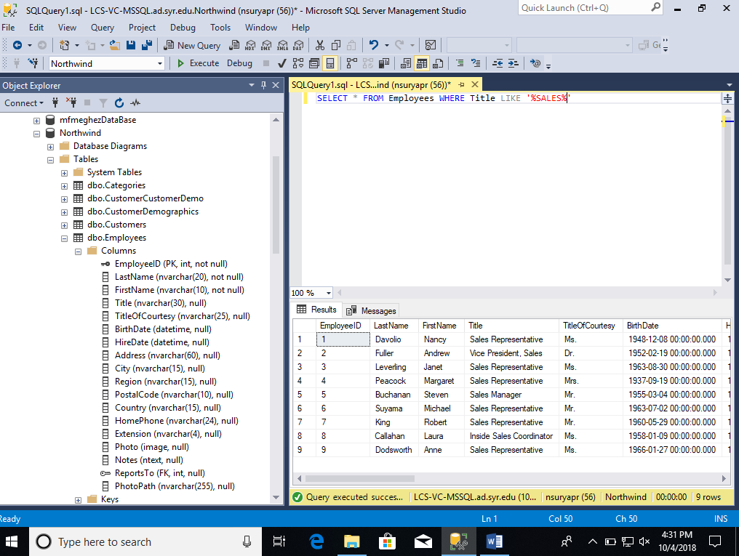

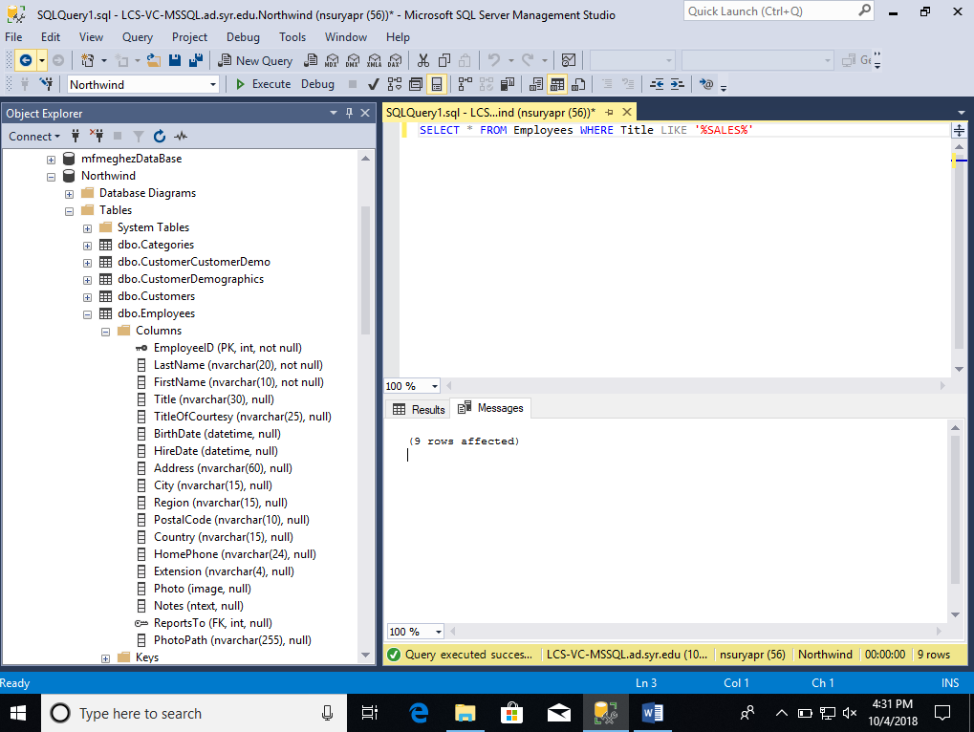

1. Select all data from Orders table whose freight is more than 500.

Script: SELECT * FROM ORDERS WHERE Freight > 500

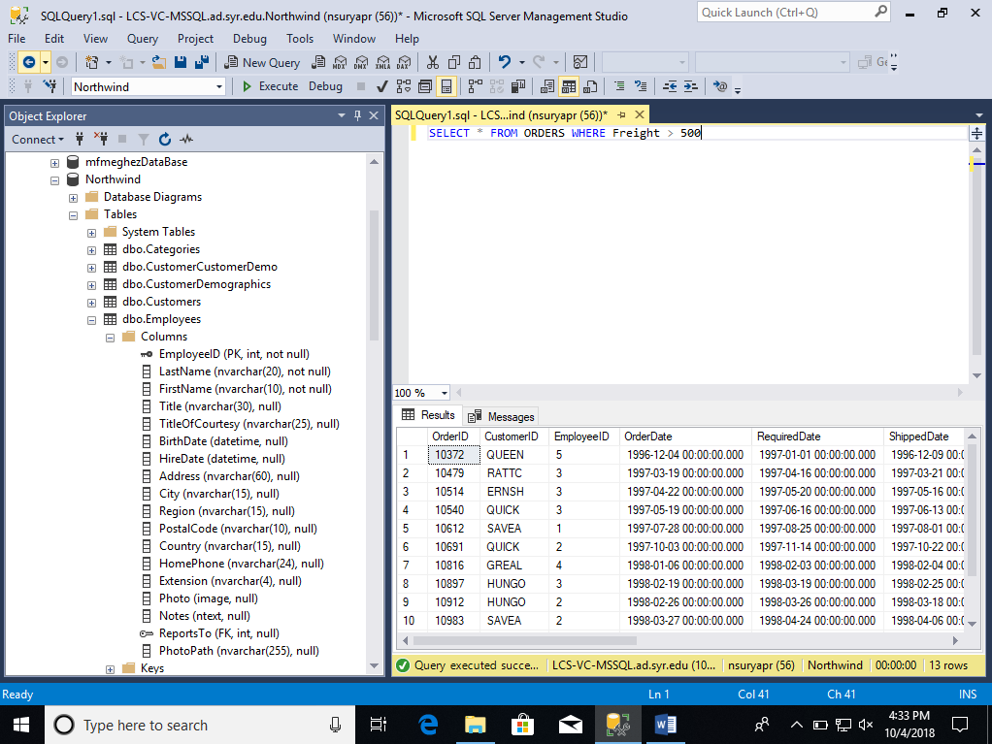

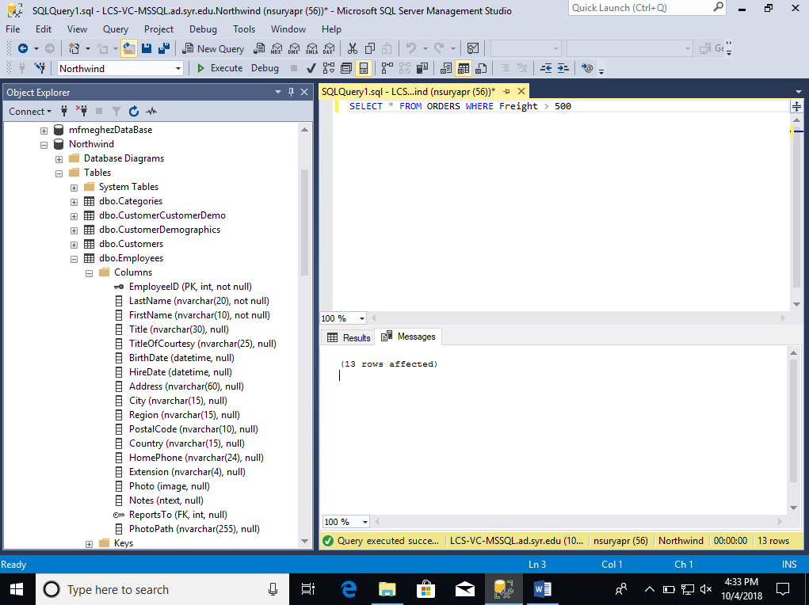

1. List all employees who have worked in company Northwind for more than 25 years.

Script: SELECT * FROM Employees WHERE DATEDIFF(YEAR,HireDate,CURRENT_TIMESTAMP) >= 25

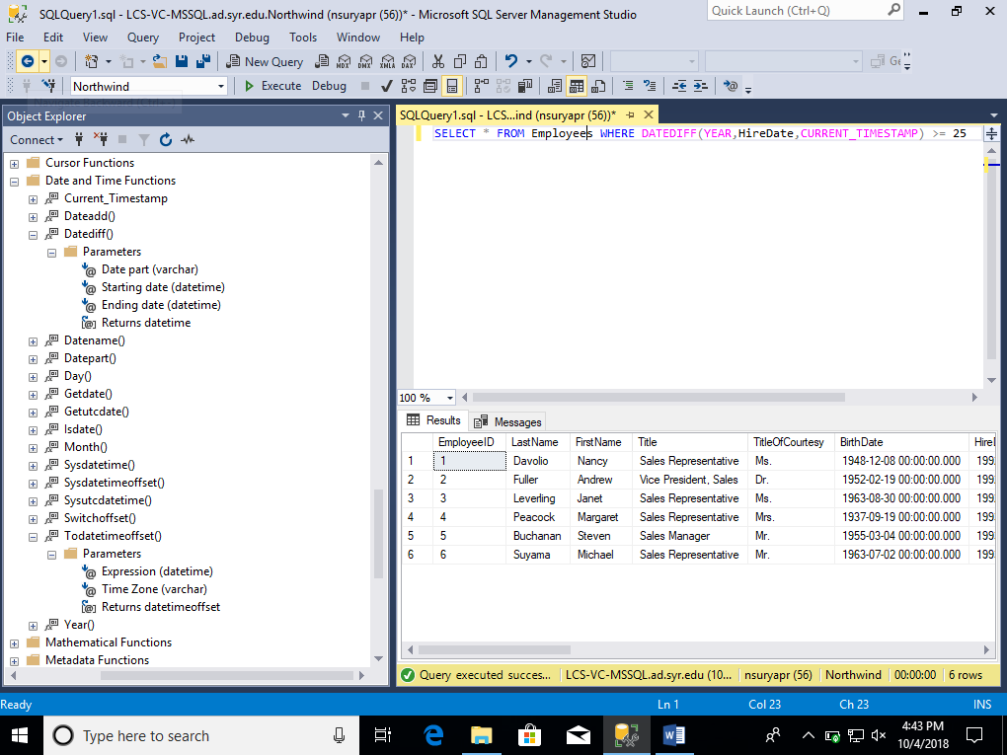

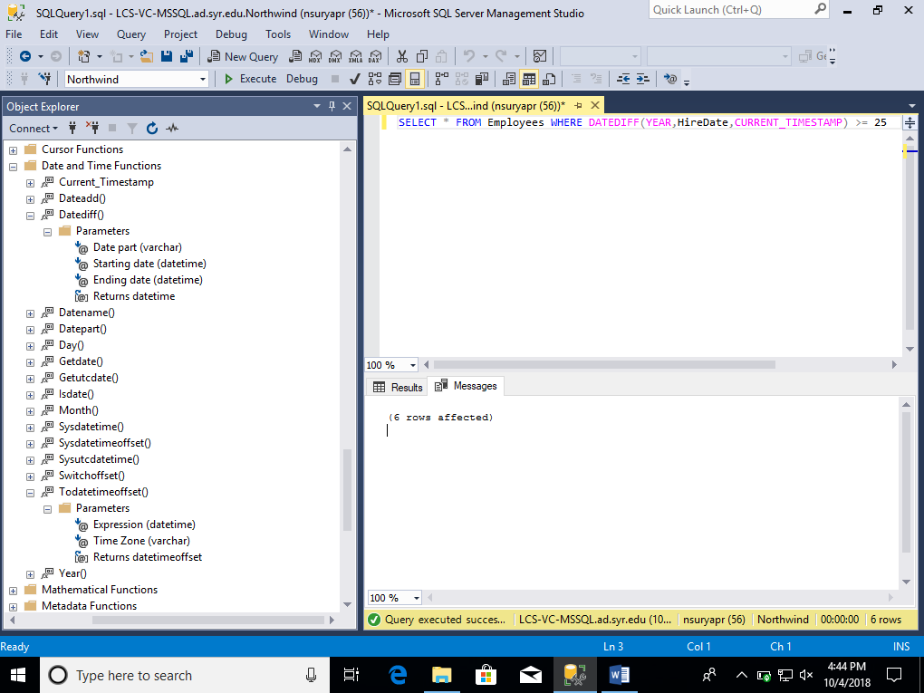

1. Calculate the average number of days it takes Northwind for all orders from “Ordered” (OrderDate) to “Shipped” (ShippedDate) status.

Script: SELECT AVG(DATEDIFF(DAY,OrderDate,ShippedDate)) AS AVERAGE_DAYS FROM Orders

