CSE 581

**Lab 5: System Functions Exercise**

**Nidhi Surya Prakash**

**SUID: 215895619**

**Purpose:**

Do SQL selections against **Northwind** database.

**Deliverables:**

Multiple screenshots, showing your NETID, query code, last lines of datasets & time stamp, as described through the lab.

Scripts that you used to carry out the actions.

Submit electronic version to Blackboard.

1. List all employee names in the following format: LAST NAME, first name. (Uppercased last name, followed by comma and space, followed by lowercased first name).

Script: Select UPPER(LastName)+ ',' +LOWER(FirstName) Names from Employees;

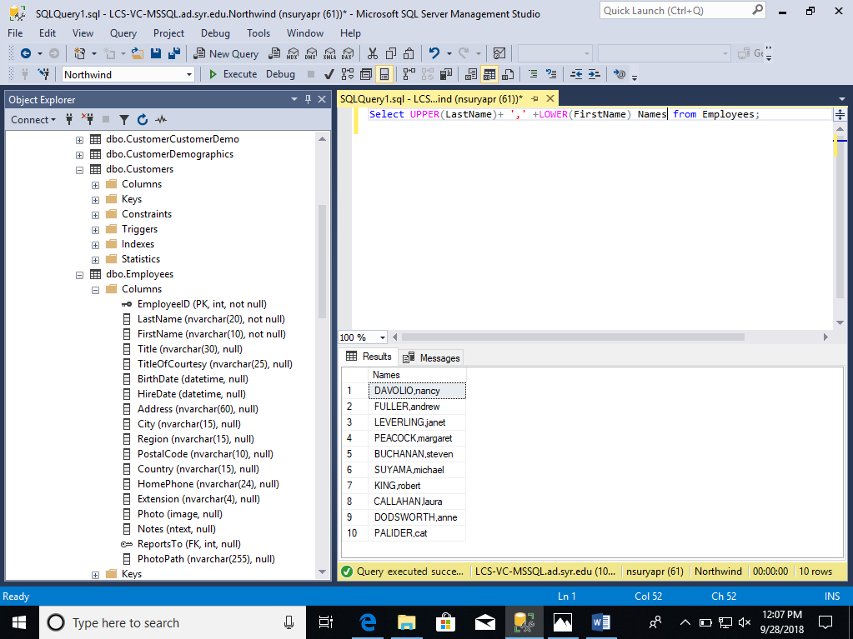

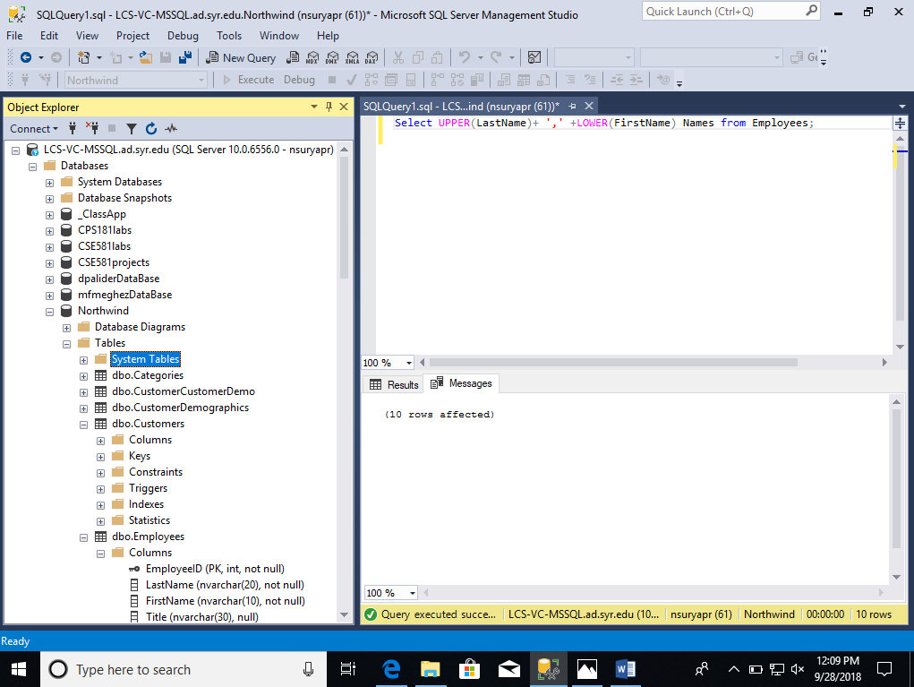

1. List all company names as well as the length of their name, from the Customers table. 2 Columns – Company Name, Text length.

Script: Select CompanyName,LEN(CompanyName)length from Customers ;

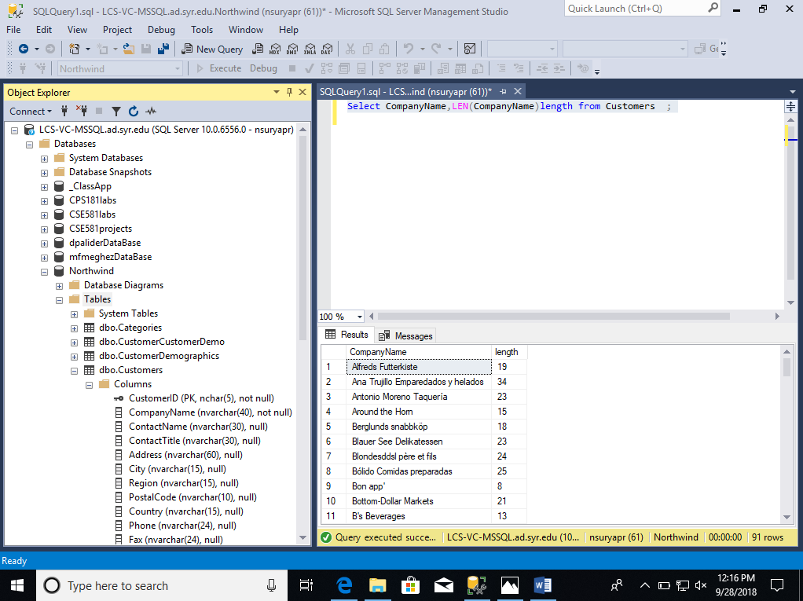

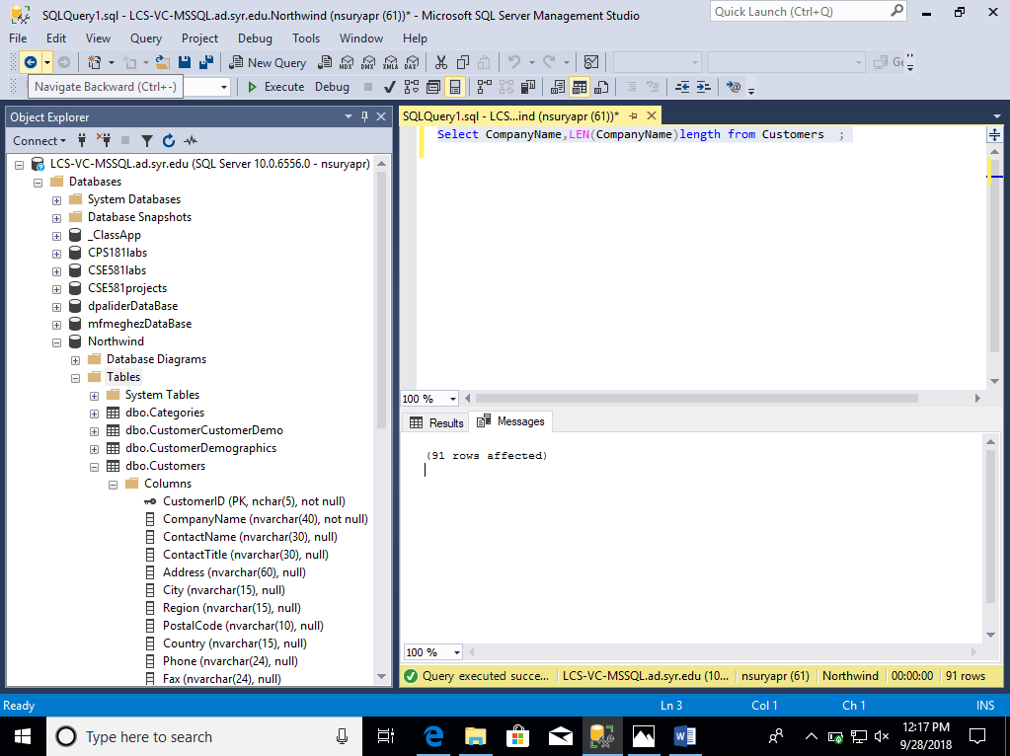

1. List all shipped dates as well as expected delivery dates from the Orders table WHERE SHIP DATE IS NOT NULL. (Expected delivery date is 5 days from the ship date).

Script: Select ShippedDate, DATEADD(DAY,5,ShippedDate) as expected_delivery

from Orders where ShippedDate is not null ;

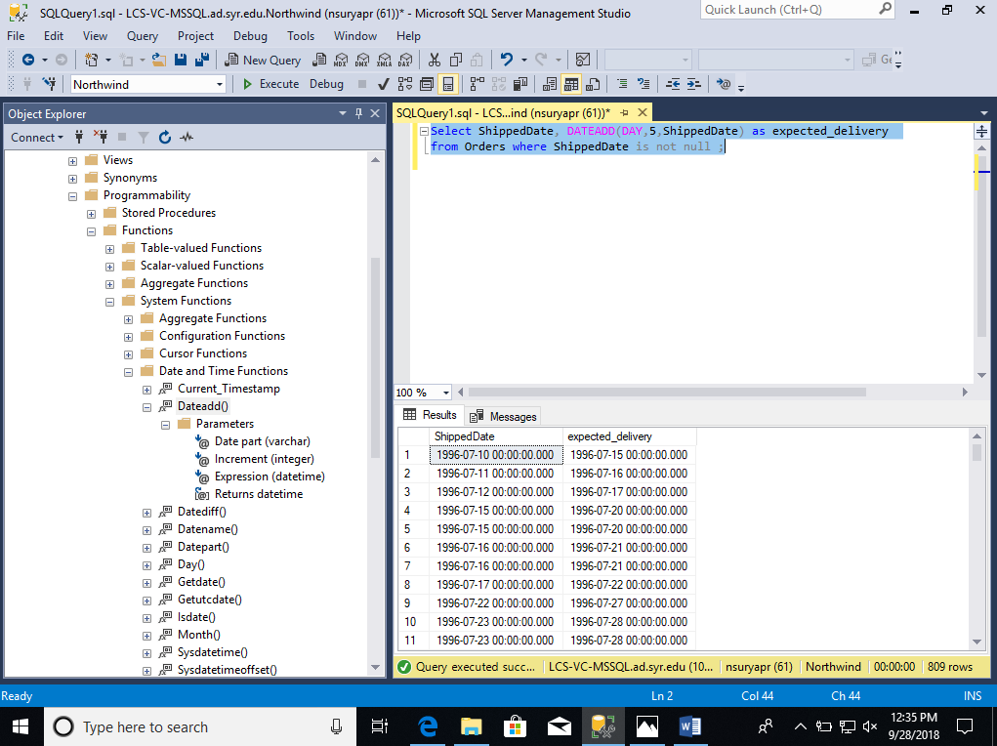

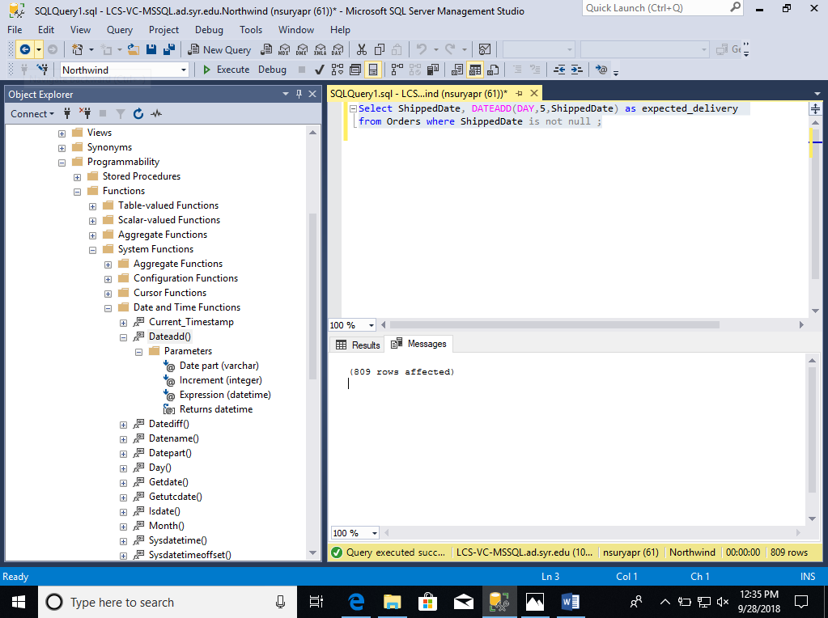

1. List all orders from the Orders table that were shipped in 1998.

Script: SELECT * FROM Orders WHERE YEAR(ShippedDate) = 1998;

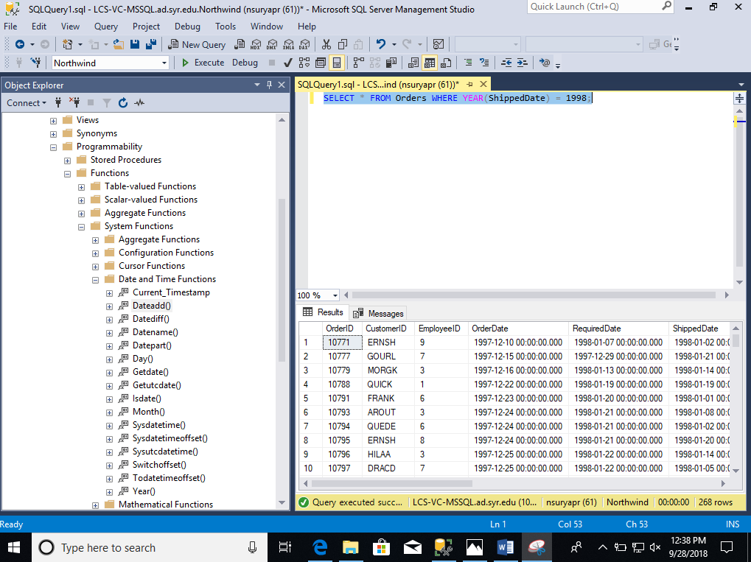

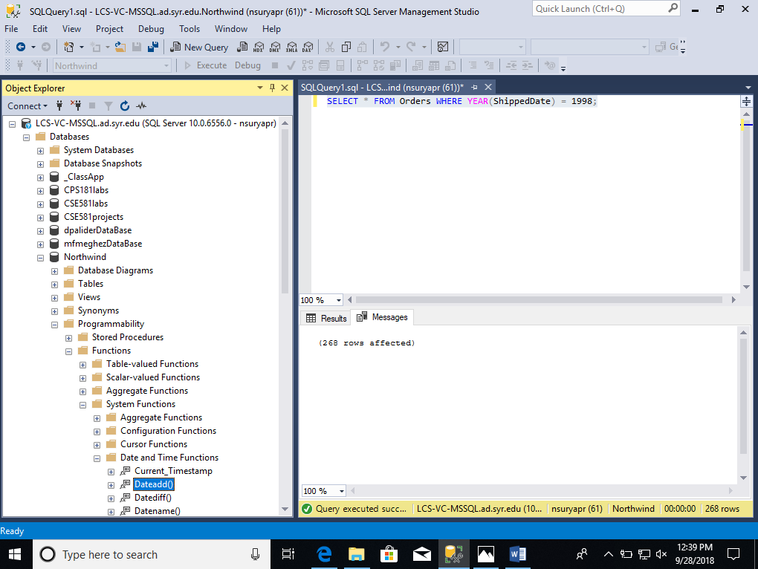

1. List all orders placed on January 1st 1997, from the Orders table.

Script: SELECT * FROM Orders WHERE OrderDate = '01/01/1997';

Or

Script: SELECT * FROM Orders WHERE YEAR(OrderDate) = '1997' and MONTH(OrderDate) = '01' and DAY(OrderDate)='01';

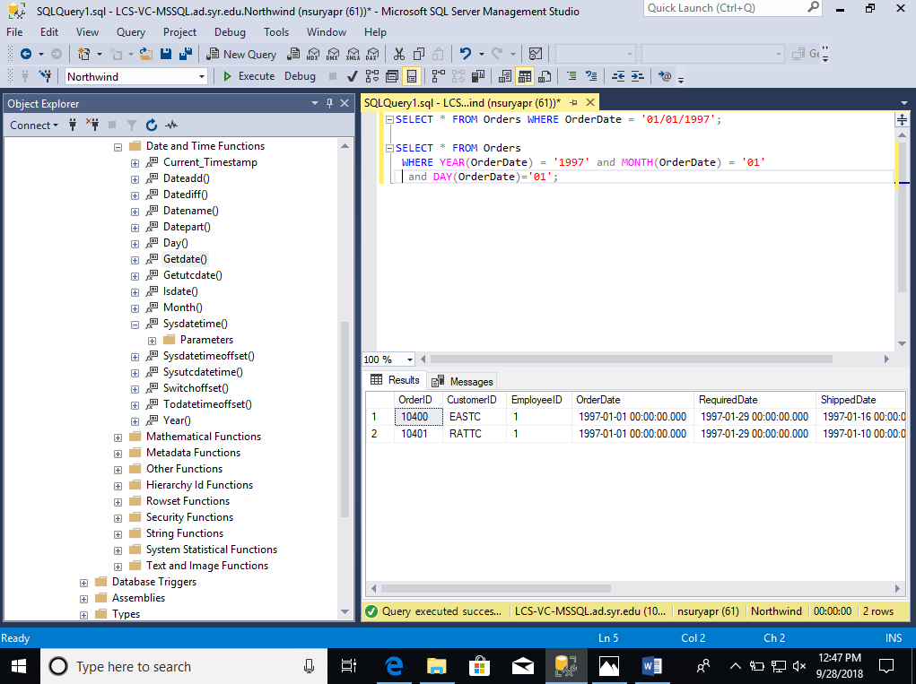

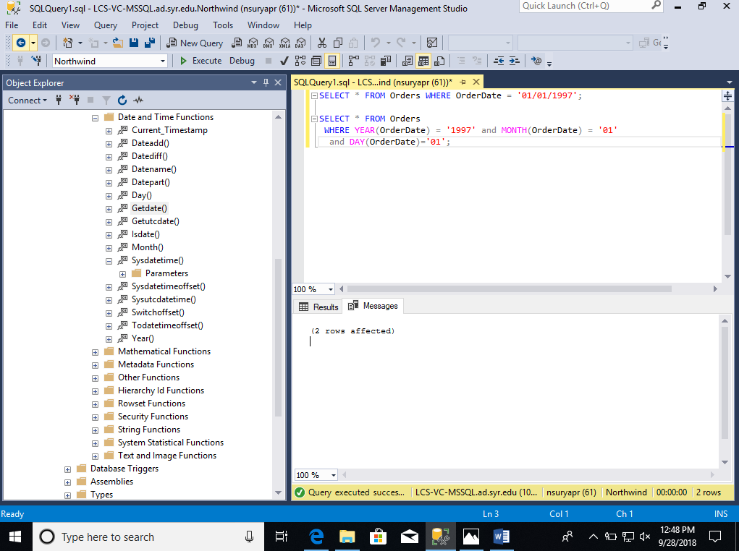

1. Find the oldest / youngest employee’s date of birth from Employee table.

Script: SELECT MIN(BirthDate) oldest, MAX(BirthDate) youngest FROM Employees;

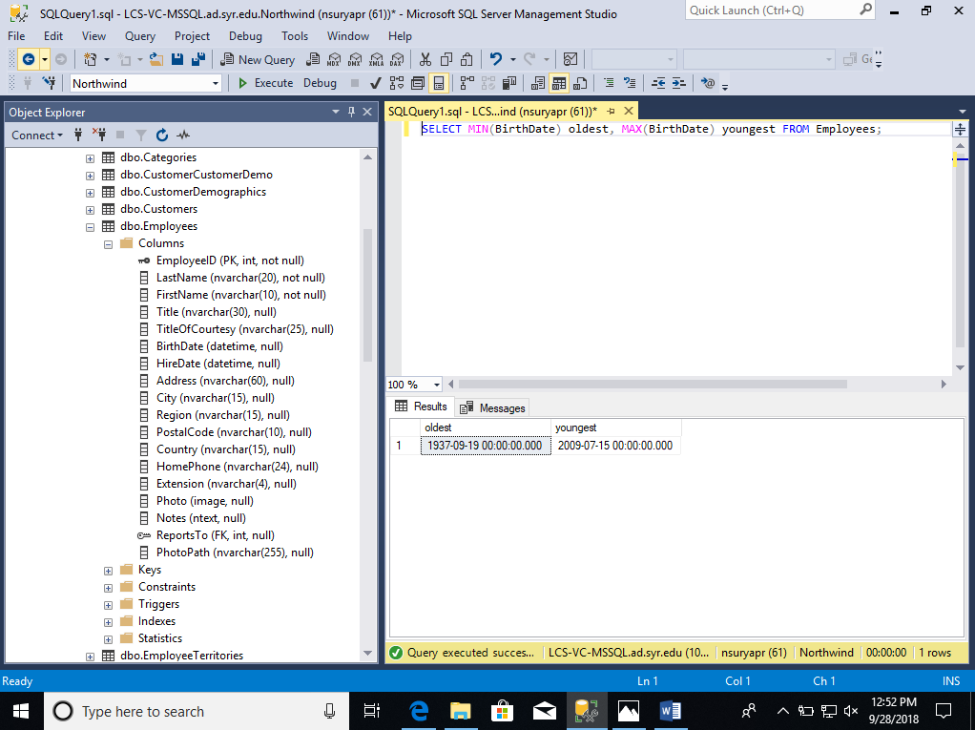

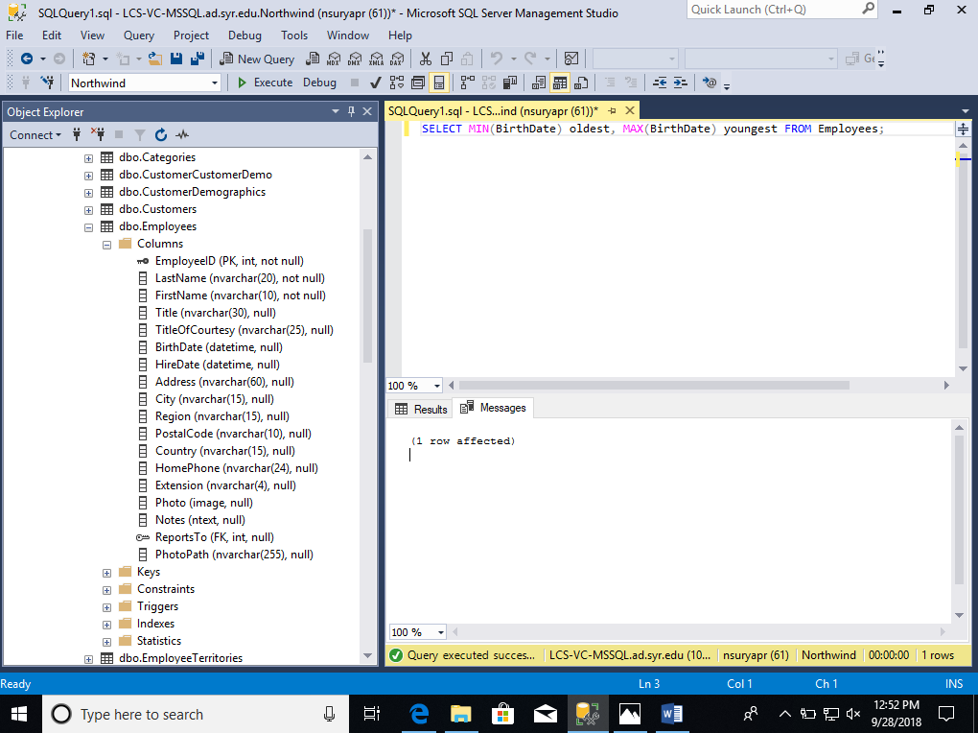

1. Calculate the average freight (rounded up to cent) for each Ship City from Orders table.

Script: SELECT ROUND(AVG(Freight),2) AVG_FREIGHT,ShipCity FROM Orders GROUP BY ShipCity;

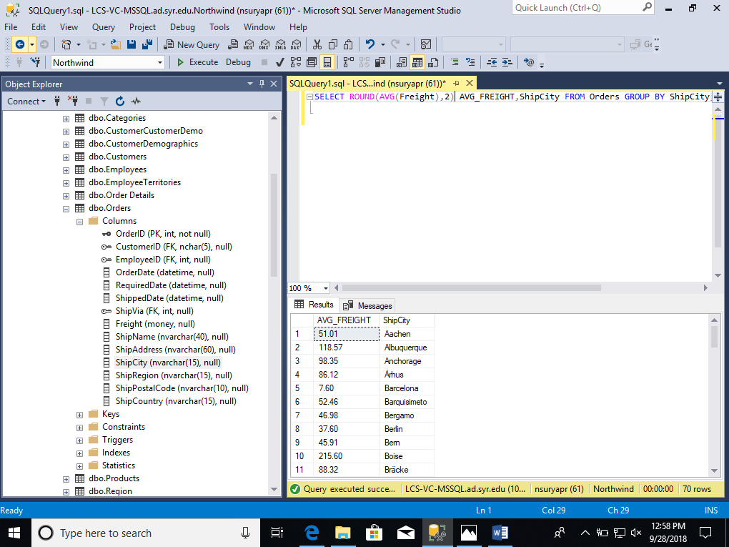

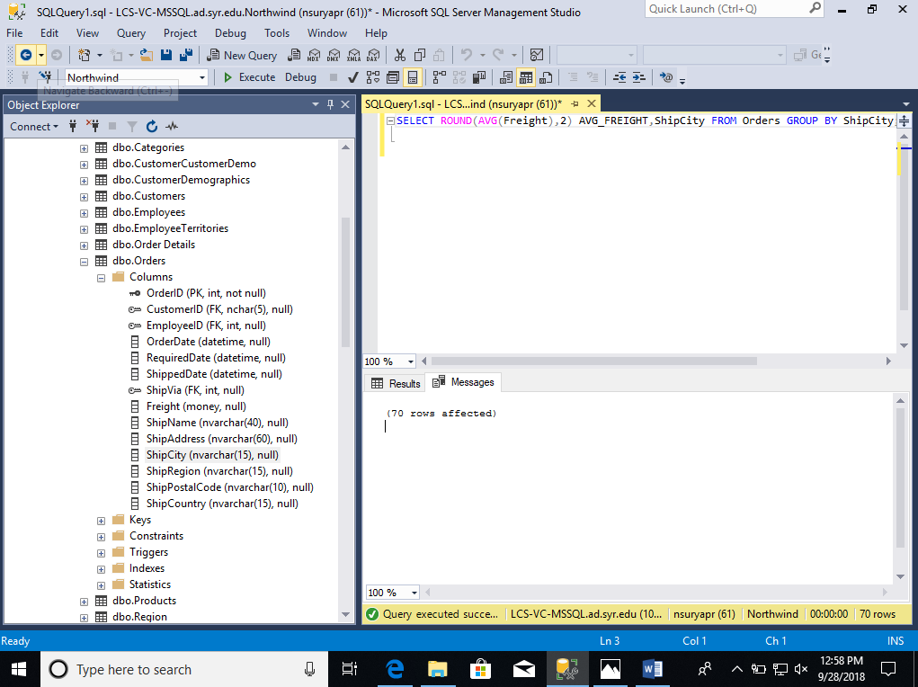

1. Count how many unique orders from [Order Details] table.

Script: select Count(distinct OrderID) FROM [Order Details];

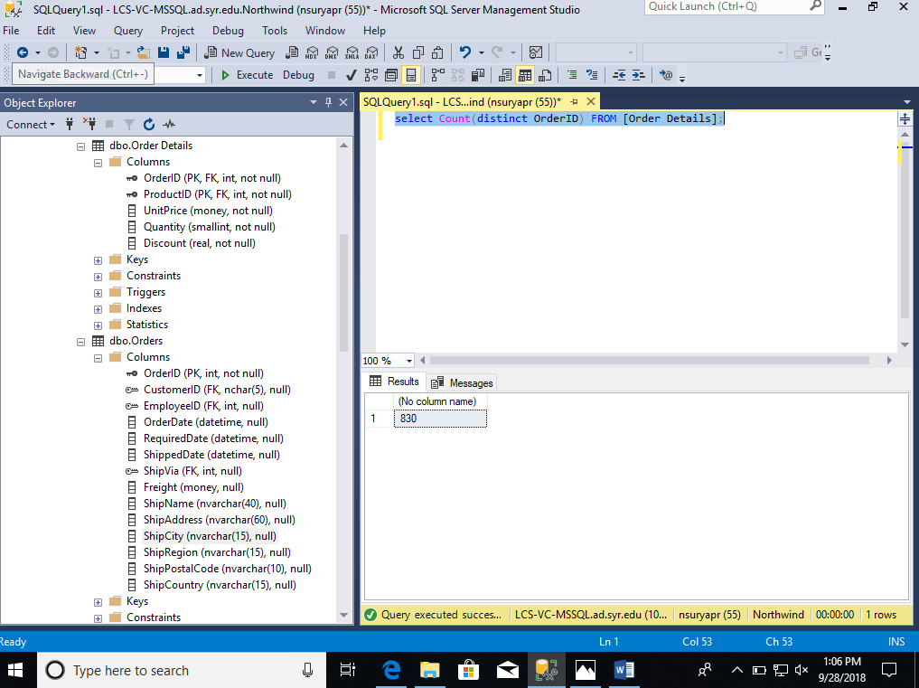

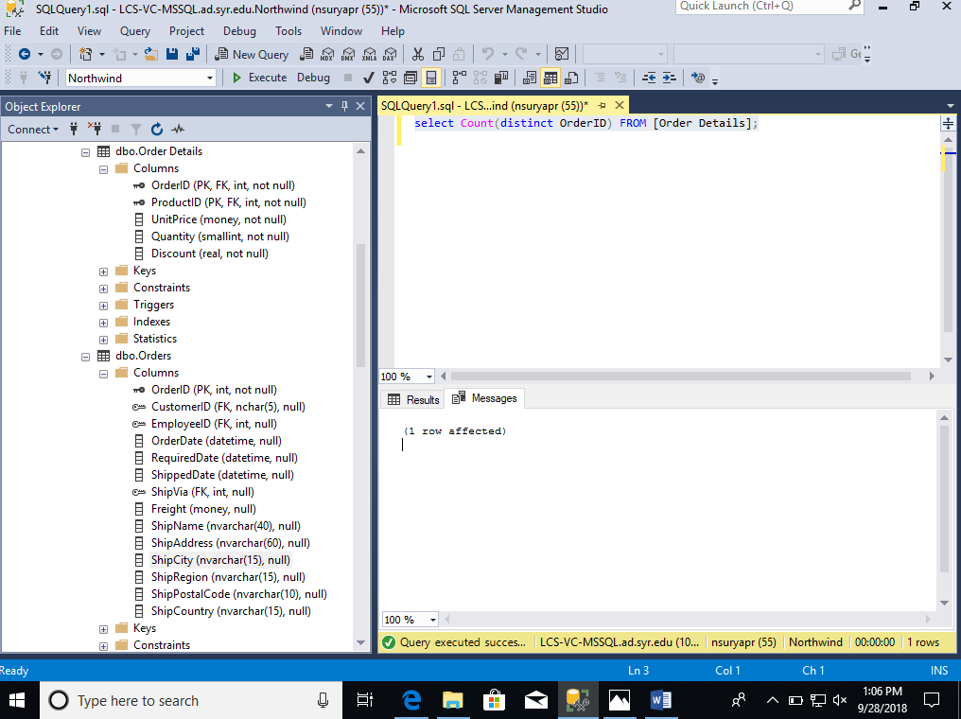

1. Get dates of First and Last orders placed (Orders table)

Script: select MIN(OrderDate) lastDate, MAX(OrderDate) firstDate FROM Orders;

